

A HISTORY OF SUCCESS

A FUTURE OF OPPORTUNITY

B U I L D I N G
MOMENTUM

ANNUAL REPORT 2025

OREGON

4 PROPERTIES

- Retail

2 Office

- Multifamily

HAWAII

3 PROPERTIES

2 Retail

1 Mixed-Use

WASHINGTON
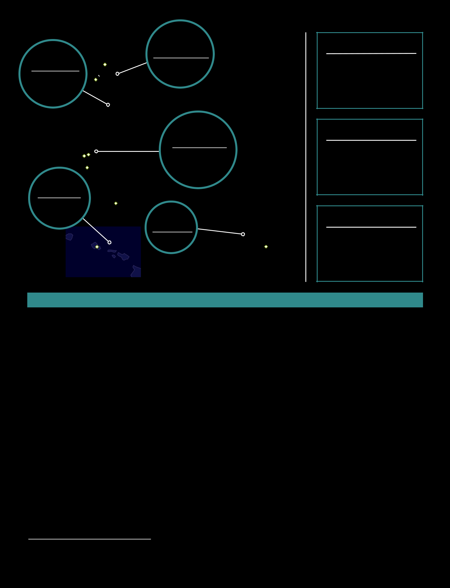
4 PROPERTIES

4 Office

CALIFORNIA

19 PROPERTIES

- Retail

6 Office

6 Multifamily

TEXAS

1 PROPERTY

1 Retail

2025 HIGHLIGHTS*

SQ FT. OF OFFICE

4.3M

SQ FT. OF RETAIL

2.5M

MULTIFAMILY UNITS

2,302

- Generated $153.5 million in Funds From Operations (FFO), or $2.00 per diluted share/unit, for the year ended December 31, 2025.

- Reported total revenue of $436.2 million and $266.6 million in net operating income (NOI) for 2025.

- Achieved 9.8%, 5.4% and 4.7% compounded annual growth in net income, total revenue and FFO per share, respectively, since our initial public offering in 2011.

- Paid a record dividend of $1.36 per share, totaling over $105.2 million, a 1.5% increase over 2024.

- Completion of a seamless CEO succession effective January 1, 2025, with Adam Wyll appointed as Chief Executive Officer.

- Acquired Genesee Park Apartments, a nearly 200-unit multifamily community in San Diego, on February 28, 2025, providing an opportunity to unlock substantial value through operational improvements and long-term redevelopment potential.

- Leased 616,680 square feet of office space in 2025, of which 370,619 square feet was comparable leasing (a 50% increase over 2024) and 246,061 square feet was non-comparable leasing (no tenant in the prior six months).

- Leased 546,406 square feet of retail space in 2025, of which 509,924 was comparable leasing (a 30% increase over 2024).

- Set records for average monthly base rent per square foot for both office and retail portfolios in Q4 2025.

- Office portfolio realized 2.3% same-store cash NOI growth year-over-year.

- Retail portfolio realized 1.2% same-store cash NOI growth year-over-year.

- Comparable office leasing spreads increased 6.4% on a cash basis and 13.8% on a GAAP basis in 2025.

- Comparable retail leasing spreads increased 7.1% on a cash basis and 21.8% on a GAAP basis in 2025.

- Maintained investment grade credit ratings from all three major U.S. rating agencies.

- Held liquidity of approximately $529 million, comprised of approximately $129 million in cash and cash equivalents and $400 million available on our revolving line of credit as of December 31, 2025.

- FFO and NOI are non-GAAP financial measures of real estate companies’ operating performance. Please see discussion of calculation and reconciliation in Item 7 “Management’s Discussion and Analysis of Financial Condition and Results of Operations” in our Form 10-K. Retail square footage includes mixed-use retail.

As of December 31, 2025

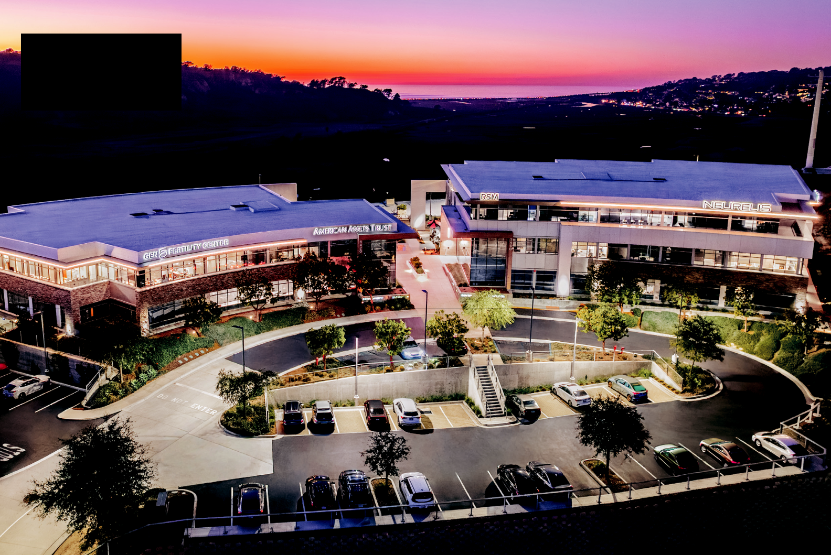
AAT CORPORATE HQ

Torrey Point

San Diego, CA

AMERICAN ASSETS TRUST, INC. is a full-service, vertically integrated and self-administered real estate investment trust, or REIT, headquartered in San Diego, California.

We have over 55 years of experience in acquiring, improving, developing and managing premier office, retail and residential properties throughout the United States in some of the nation’s most dynamic, high-barrier-to-entry markets primarily in Southern California, Northern California, Washington, Oregon and Hawaii.
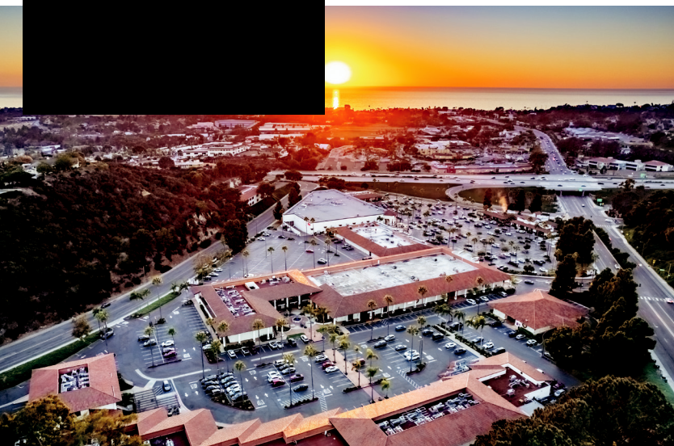

LOMAS SANTA FE PLAZA

San Diego, CA

LA JOLLA COMMONS
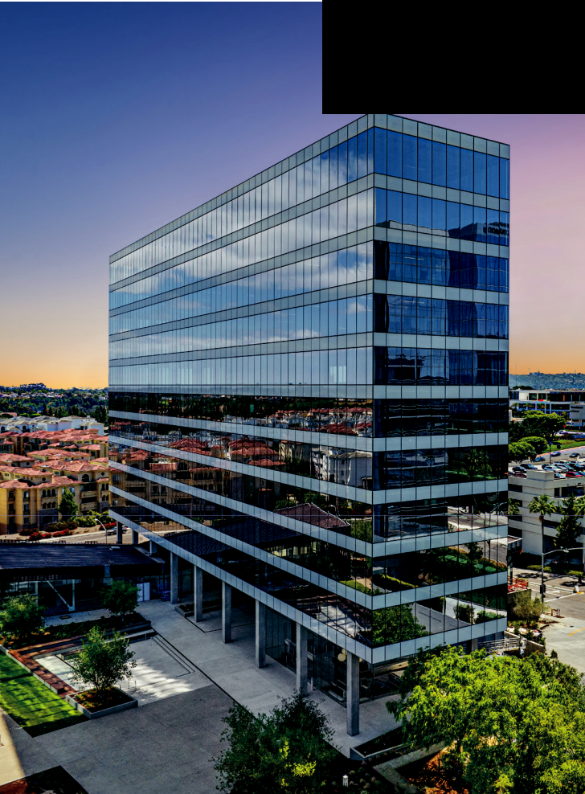

San Diego, CA

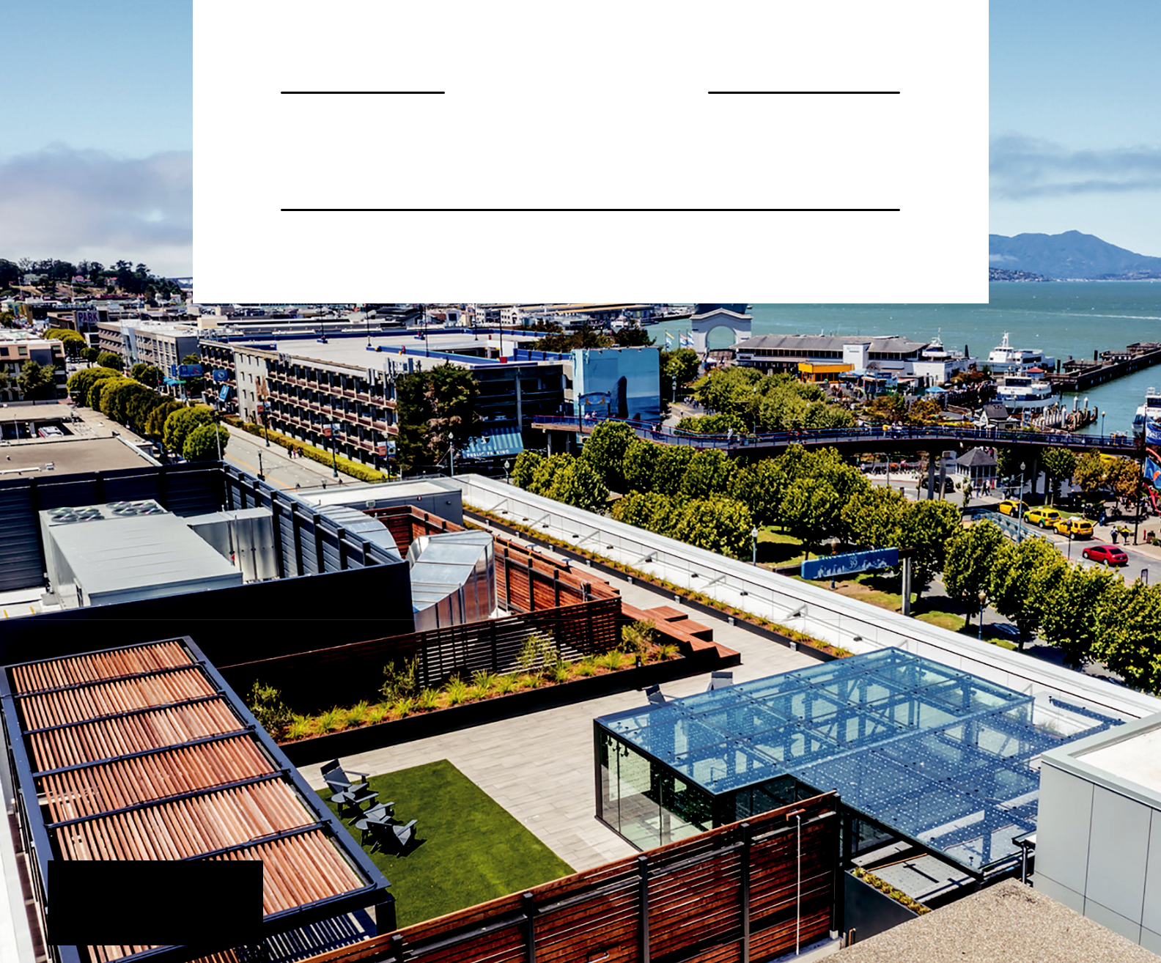
B U I L D I N G
MOMENTUM

ONE BEACH STREET

San Francisco, CA


DEAR FELLOW

STOCKHOLDERS...

At American Assets Trust, we approach every cycle with disci-pline, consistency and a long-term perspective. That mindset guided us through 2025, a year we viewed as a reset, and it continues to guide us as we enter 2026 with momentum build-ing across our portfolio and platform.

In 2025, we delivered funds from operations of $2.00 per share, modestly exceeding our initial expectations despite

- mixed macroeconomic environment. Portfolio-wide same-store cash NOI finished the year slightly positive, supported by strong collections, rigorous expense management and continued leasing progress. These results reflect the quality of

our assets, the resilience of our platform and the strength of the teams executing across our markets.

For us, “Building Momentum” is both operational and strategic: it means owning and operating properties that tenants consistently choose and translating that demand into commenced revenue, durable cash flow and long-term value creation. While external conditions remain dynamic, we believe our strategy of owning irreplaceable coastal real estate, maintaining balance sheet strength and operating through a vertically integrated platform continues to serve our stockholders well.

2 | AMERICAN ASSE TS TRUST, INC.

BUILDING MOMENTUM ACROSS THE PORTFOLIO

Our properties remain well positioned due to their premier locations, modern amenities and strong tenant mix. Across asset classes, we continue to see demand for high quality real estate, particularly in markets characterized by high house-hold incomes, strong employment bases and long-term pop-ulation and innovation trends.

OFFICE

Office leasing activity improved meaningfully in the second half of the year, with demand increasingly concentrated in Class A space, precisely where our portfolio is positioned. Leasing volume increased materially year over year (a 50% increase in comparable office leasing compared to 2024), and we achieved our highest average office rents to date. Importantly, we ended the year with a substantial pipeline of signed leases yet to commence, providing visible forward momentum and embedded revenue growth as these leases begin paying rent.

At La Jolla Commons Tower 3 and One Beach Street, tenant engagement accelerated and leasing traction has carried into early 2026. While the office recovery remains uneven across markets, we are encouraged by stabilizing conditions, improving decision timelines and the growing preference for best-in-class assets.

We are also optimistic about the role that AI-driven innova-tion may play in supporting office demand over time. In our coastal markets, where innovation ecosystems and highly educated workforces are key economic drivers, the modern-ization of technical teams and workflows tends to favor the high-quality, amenitized space that defines our portfolio. We expect our office portfolio to contribute more meaningfully to cash flow in 2026 and beyond as leasing momentum con-verts into commenced rent.

RETAIL

Retail remained a cornerstone of stability in 2025. Our port-folio ended the year nearly 98% leased, supported by strong tenant sales, consistent traffic and limited new supply in our high-barrier markets. Located in dense, supply-constrained trade areas with favorable demographics, our shopping cen-ters benefit from a strong mix of experiential, service focused and necessity-based tenants. Leasing spreads remained posi-tive and expirations are well laddered.

With national retail availability near historic lows and minimal new construction, we believe our retail assets are well posi-tioned to deliver durable cash flow and steady growth. We remain focused on maintaining tenant quality, curating the mix and investing in the customer experience.

ALAMO QUARRY MARKET
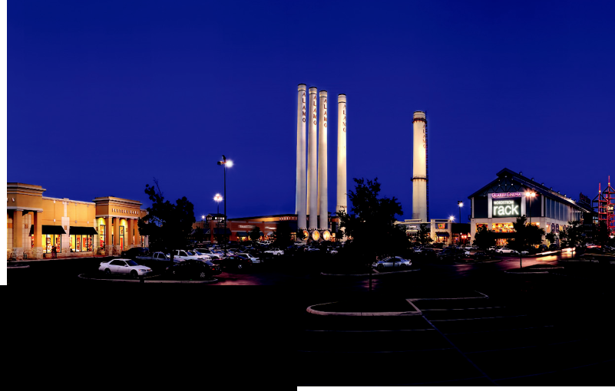
San Antonio, TX
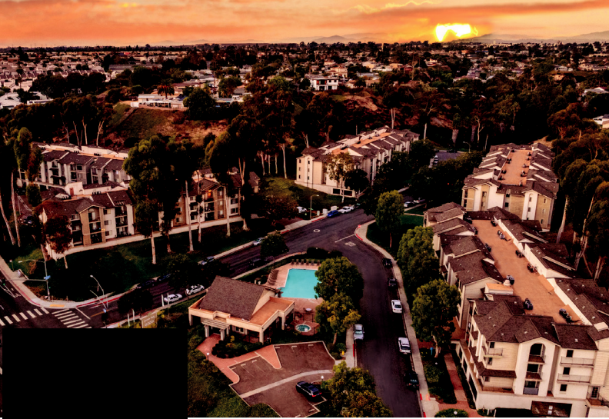

GENESEE PARK

San Diego, CA

MULTIFAMILY

Our multifamily portfolio performed steadily in a competitive environment shaped by elevated new supply, particularly in San Diego and Portland. Occupancy remained high as we focused on careful revenue management, resident retention and cost control. While near-term rent growth has been con-strained, we believe in the long-term fundamentals of our mar-kets and the embedded growth potential within our commu-nities. We will continue executing with rigor through this phase of the supply cycle while protecting long-term value. Genesee Park, our newest acquisition, continues to track with our un-derwriting expectations and reinforces our confidence in the long-term fundamentals of the San Diego market.

MIXED-USE

At Waikiki Beach Walk, softer tourism trends impacted hotel performance during the year, while the retail component con-tinued to perform well. Despite near-term pressure, the long-term value of this irreplaceable, fee-simple asset remains com-pelling. Recent land transactions involving other major Waikiki properties reinforce the scarcity and strategic value of fee ownership, which we believe will be increasingly recognized over time. We will continue to manage this asset with care, in-vest thoughtfully and remain responsive to market conditions.

2025 ANNUAL REPORT | 3

CAPITAL DISCIPLINE AND LONG-TERM VALUE
Throughout 2025, our priorities were thoughtful capital allocation, balance sheet strength and liquidity. We remain focused on nar-rowing the gap between our net asset value and public market recognition, a gap we intend to close through consistent perfor-mance, cash flow growth from our development and redevelop-ment pipeline and sound decision-making across cycles.

OUR PLATFORM, OUR TECHNOLOGY AND OUR PEOPLE

Our vertically integrated, self-managed platform differentiates us. By leveraging in-house expertise across leasing, property man-agement, legal, engineering and development, we maintain oper-ational control, enhance efficiency and respond quickly to market opportunities.

We are also investing in technology across our platform to better serve tenants and operate more efficiently. This includes expand-ing smart building systems, modernizing our work order and tenant communication tools and implementing process automation that reduces friction and improves speed of execution. We are build-ing our IT capabilities to ultimately support AI-driven initiatives, including predictive analytics to enhance preventive maintenance, improved operating insights and workflow enhancements that free our teams to focus on higher-value tenant engagement. Our objective in utilizing technology is straightforward: enhance the tenant experience while driving stronger operational efficiency.


Equally important are our people. Our executive leadership team, engaged Board of Directors and dedicated employees work co-hesively to execute our strategy with precision and integrity. Their commitment, judgment and depth of experience are fundamental to our success.

TOTAL SHAREHOLDER RETURNS

AAT // 3.2%

RMZ // 7.8%

FTSE // 7.8%

The performance graph above compares the annualized stockholder return of our shares of common stock since our initial public offering on January 13, 2011 through December 31, 2025 with the returns of the same period for the MSCI US REIT Index and FTSE NAREIT Index. Returns reflect the reinvestment of dividends. Past performance is not an indication or guarantee of future results.

LOOKING AHEAD

We view 2026 as an opportunity to build on the progress made during our reset year and to convert momentum into measurable results. Our priorities are clear:

- Convert office leasing momentum into commenced revenue

- Maintain retail strength through high occupancy and tenant quality

- Navigate the multifamily supply cycle with patience and focus

- Operate our mixed-use asset thoughtfully while remaining responsive to market conditions

- Strengthen the balance sheet and position the company for long-term value creation

Momentum is building across our portfolio and our platform. We remain clear-eyed about the challenges ahead, and equally clear about the opportunity: American Assets Trust is well-positioned to capitalize on improving fundamentals and deliver sustainable, long-term value for our stockholders.

On behalf of all of us at American Assets Trust, we thank you for your confidence and support.

Sincerely,

ERNEST RADY | ADAM WYLL
Executive Chairman | President and
 | Chief Executive Officer
ROBERT F. BARTON | JERRY GAMMIERI
ROBERT F. BARTON | Senior Vice President
Executive Vice President | of Construction and
and Chief Financial Officer | Development
CHRIS SULLIVAN | STEVE CENTER
Senior Vice President | Senior Vice President
of Retail Properties | of Office Properties
EMILY MANDIC | ABIGAIL REX
Vice President, | Vice President of
Regional Manager, | Multifamily, San Diego
Portland and Bellevue

4 | AMERICAN ASSE TS TRUST, INC.


THE LANDMARK @ ONE MARKET

San Francisco, CA

COMPARATIVE METRICS1
(As of December 31, 2025)

FFO Per Share 2 |  |  |  |  |  |  | Rental Income |  |  |  |  |  |  | Real Estate Assets 3
 |  |  |  |  |  |  | ($ in millions) |  |  |  |  |  |  | (At cost, $ in millions) |  |  |  | $3,742
 |  |  |  |  | $2.58 |  |  |  |  |  | $ | 419 | $424 | $ |  |  | $3,671 | $3,742 | $3,626 | $3,764
 |  |  | $2.20 | $2.34 | $2.40 |  |  |  |  |  | $403 | 419 |  | 410 | $3,189 | $3,247 | $3,529
 |  | $2.09 | $2.20 |  |  |  |  |  |  | $344 | $360 |  |  |  | $3,189
 |  | $2.09 | $ | 2.00 | $ | 2.00 |  |  |  | $344 | $330
 |  | $1.92 |  |  |  |  |  |  |  |  | $330
$ | $1.85 | $1.92 | $1.89 | 2.00 |  | 2.00 | $ | $299 | $310 |  |  |  |  |  | $_{2,614}^{$2,630}
$1.62 | 1.76 |  |  |  |  |  | $ | 279 |  |  |  |  |  |  | $2,301
$1.62 |  |  |  |  |  |  | $262 | 279 |  |  |  |  |  |  | $2,301
$1.62 |  |  |  |  |  |  | $262 |  |  |  |  |  |  | $ | $2,301
 |  |  |  |  |  |  | $246 |  |  |  |  |  |  | $2,137 | 2,246

‘14 ’15 ’16 ’17 ’18 ’19 ’20 ’21 ’22 ’23 ‘24 ‘25 ‘14 ’15 ’16 ’17 ’18 ’19 ’20 ’21 ’22 ’23 ’24 ’25 ‘14 ’15 ’16 ’17 ’18 ’19 ’20 ’21 ’22 ’23 ’24 ’25

- All capitalized terms used on this page, unless specifically defined herein, shall have the same meaning as the capitalized terms used in our Annual Report on Form 10-K.

- FFO is defined as follows: net income, computed in accordance with GAAP plus depreciation and amortization of real estate assets and excluding extraordinary items, gains and losses on sale of real estate and impairment losses. Comparison of our presentation of FFO may not be comparable to other REITs. A reconciliation of FFO to net income can be found in our Annual Report on Form 10-K.

- As reported in our Annual Report on Form 10-K.


WAIKIKI BEACH WALK

Honolulu, HI

PORTFOLIO SUMMARY

(As of December 31, 2025)*

- 31 office, retail, multifamily and mixed-use properties

- Approximately 6.8 million rentable square feet of office and retail space (including mixed-use retail space), 2,302 residential units (including 120 RV spaces) and a 369-room hotel

- Land at two of our properties is classified as held for development and construction in progress

OFFICE | RETAIL | MULTIFAMILY | MIXED-USE

83.1% | 97.7% | 93.7% | 96.2%
Leased | Leased | Leased 1 | Leased, WBW—Retail
2.3% | 1.2% | 3.2% | 82.3%
Increase in same | Increase in same | Decrease in same | Average Occupancy,
store cash NOI | store cash NOI | store cash NOI | WBW—Embassy Suites

- NOI is a non-GAAP financial measure of real estate companies operating performance. Please see discussion of calculation and reconciliation in Item 7 “Management’s Discussion and Analysis of Financial Condition and Results of Operations” in our Form 10-K. Percentage change of NOI listed above is on a year-over-year basis.

- Percentage leased includes total units rented and occupied. Additionally, excludes Santa Fe Park RV Resort to reflect traditional multifamily leased percentage.

6 | AMERICAN ASSE TS TRUST, INC.



AMERICAN ASSETS TRUST

2025 FORM 10-K

2025 ANNUAL REPORT | 7

UNITED STATES

SECURITIES AND EXCHANGE COMMISSION

WASHINGTON, D.C. 20549

FORM 10-K

- ANNUAL REPORT PURSUANT TO SECTION 13 OR 15(D) OF THE SECURITIES EXCHANGE ACT OF 1934

For the fiscal year ended December 31, 2025

or

- TRANSITION REPORT PURSUANT TO SECTION 13 OR 15(D) OF THE SECURITIES EXCHANGE ACT OF 1934

For the transition period from to
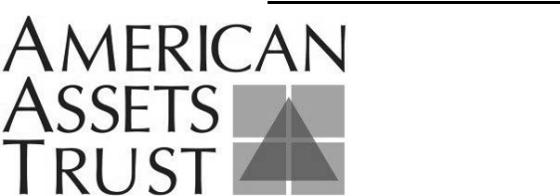

AMERICAN ASSETS TRUST, INC.

(Exact Name of Registrant as Specified in its Charter)

Commission file number: 001-35030

AMERICAN ASSETS TRUST, L.P.

(Exact Name of Registrant as Specified in its Charter)

Commission file number: 33-202342-01

Maryland | (American Assets Trust, Inc.) |  |  |  |  |  | 27-3338708 (American Assets Trust, Inc.)
Maryland | (American Assets Trust, L.P.) |  |  |  |  |  | 27-3338894 (American Assets Trust, L.P.)
(State or other jurisdiction of incorporation or organization) |  |  |  |  |  |  |  | (IRS Employer Identification No.)
 |  |  |  | 3420 Carmel Mountain Road, Suite 100
 |  |  |  |  | San Diego, California 92121
 |  |  |  | (Address of Principal Executive Offices and Zip Code)
 |  |  |  | (858) 350-2600
 |  |  |  | (Registrant’s Telephone Number, Including Area Code)
 |  |  | Securities registered pursuant to Section 12(b) of the Act:
 |  | Registrant |  |  | Title of Each Class |  |  | Trading Symbol |  | Name Of Each Exchange On Which
 |  |  |  |  |  |  |  |  |  |  | Registered
American Assets Trust, Inc. |  |  |  | Common Stock, $.01 par value |  |  |  | AAT |  | New York Stock Exchange
 |  |  |  |  | per share
American Assets Trust, L.P. |  |  |  |  | None |  |  | None |  |  | None

Securities registered pursuant to Section 12(g) of the Act:

American Assets Trust, Inc. |  | None
American Assets Trust, L.P. |  | None

Indicate by check mark if the Registrant is a well-known seasoned issuer, as defined in Rule 405 of the Securities Act.

American Assets Trust, Inc.

American Assets Trust, L.P.

☒ Yes ☐ Yes

☐ No
☒ No

Indicate by check mark if the Registrant is not required to file reports pursuant to Section 13 or Section 15(d) of the Act.

American Assets Trust, Inc. ☐ Yes ☒ No
American Assets Trust, L.P. ☐ Yes ☒ No

Indicate by check mark whether the Registrant (1) has filed all reports required to be filed by Section 13 or 15(d) of the Securities Exchange Act of 1934 during the preceding 12 months (or for such shorter period that the Registrant was required to file such reports), and (2) has been subject to such filing requirements for the past 90

American Assets Trust, Inc. ☒ Yes ☐ No American Assets Trust, L.P. ☒ Yes ☐ No days.

Indicate by check mark whether the Registrant has submitted electronically and posted on its corporate Website, if any, every Interactive Data File required to be submitted and posted pursuant to Rule 405 of Regulation S-T during the preceding 12 months (or for such shorter period that the Registrant was required to submit and post such
American Assets Trust, Inc. | ☒ | Yes | ☐ | No
_{files).} American Assets Trust, L.P. | ☒ | Yes | ☐ | No
Indicate by check mark if disclosure of delinquent filers pursuant to Item 405 of Regulation S-K is not contained herein, and will not be contained, to the best of Registrant’s knowledge, in definitive proxy or information statements incorporated by

reference in Part III of this Form 10-K or any amendment to this Form 10-K. ☒

Indicate by check mark whether the Registrant is a large accelerated filer, an accelerated filer, a non-accelerated filer or a smaller reporting company. See definitions of “large accelerated filer,” “accelerated filer,” “smaller reporting company” and "emerging growth company" in Rule 12b-2 of the Exchange Act. (Check one):

American Assets Trust, Inc.

Large Accelerated Filer

☒

Accelerated Filer

☐

Non-Accelerated Filer Emerging Growth Company

☐

☐

Smaller reporting company

☐

If an emerging growth company, indicate by check mark if the registrant has elected not to use the extended transition period for complying with any new or revised financial accounting standards provided pursuant to Section 13(a) of the Exchange Act. o

American Assets Trust, L.P.

Large Accelerated Filer

☐

Accelerated Filer

☐

Non-Accelerated Filer Emerging Growth Company

☒

☐

Smaller reporting company

☐

If an emerging growth company, indicate by check mark if the registrant has elected not to use the extended transition period for complying with any new or revised financial accounting standards provided pursuant to Section 13(a) of the Exchange Act. ☐

Indicate by check mark whether the registrant has filed a report on and attestation to its management’s assessment of the effectiveness of its internal control over financial reporting under Section 404(b) of the Sarbanes-Oxley Act (15 U.S.C.

7562(b)) by the registered public accounting firm that prepared or issued its audit report. ☒

If securities are registered pursuant to Section 12(b) of the Act, indicate by check mark whether the financial statements of the registrant included in the filing reflect the correction of an error to previously issued financial statements. ☐

Indicate by check mark whether any of those error corrections are restatements that required a recovery analysis of incentive-based compensation received by any of the registrant’s executive officers during the relevant recovery period pursuant to §240.10D-1(b). ☐

Indicate by check mark whether the Registrant is a shell company (as defined in Rule 12b-2 of the Exchange

American Assets Trust, Inc. | ☐ | Yes | ☒ | No
_{Act).} American Assets Trust, L.P. | ☐ | Yes | ☒ | No
The aggregate market value of American Assets Trust, Inc.'s common shares held by non-affiliates of the Registrant, based upon the closing sales price of the Registrant's common shares on June 30, 2025 was $1.042 billion.

The number of American Assets Trust, Inc.’s common shares outstanding on February 6, 2026 was 61,390,936.

DOCUMENTS INCORPORATED BY REFERENCE

Portions of American Assets Trust, Inc.'s Proxy Statement with respect to its 2026 Annual Meeting of Stockholders to be filed

not later than 120 days after the end of its fiscal year are incorporated by reference into Part III hereof.

EXPLANATORY NOTE

This report combines the annual reports on Form 10-K for the year ended December 31, 2025 of American Assets Trust, Inc., a Maryland corporation, and American Assets Trust, L.P., a Maryland limited partnership, of which American Assets Trust, Inc. is the parent company and sole general partner. Unless otherwise indicated or unless the context requires otherwise, all references in this report to “we,” “us,” “our” or “the company” refer to American Assets Trust, Inc. together with its consolidated subsidiaries, including American Assets Trust, L.P. In statements regarding qualification as a real estate investment trust, or REIT, such terms refer solely to American Assets Trust, Inc. Unless otherwise indicated or unless the context requires otherwise, all references in this report to “our Operating Partnership” or “the Operating Partnership” refer to American Assets Trust, L.P. together with its consolidated subsidiaries.

American Assets Trust, Inc. operates as a REIT and is the sole general partner of the Operating Partnership. As of December 31, 2025, American Assets Trust, Inc. owned an approximate 78.95% partnership interest in the Operating Partnership. The remaining 21.05% partnership interests are owned by non-affiliated investors and certain of our directors and executive officers. As the sole general partner of the Operating Partnership, American Assets Trust, Inc. has full, exclusive and complete authority and control over the Operating Partnership’s day-to-day management and business, can cause it to enter into certain major transactions, including acquisitions, dispositions and refinancings, and can cause changes in its line of business, capital structure and distribution policies.

The company believes that combining the annual reports on Form 10-K of American Assets Trust, Inc. and the Operating Partnership into a single report will result in the following benefits:

- better reflects how management and the analyst community view the business as a single operating unit;

- enhance investors' understanding of American Assets Trust, Inc. and the Operating Partnership by enabling them to view the business as a whole and in the same manner as management;
- greater efficiency for American Assets Trust, Inc. and the Operating Partnership and resulting savings in time, effort and expense; and
- greater efficiency for investors by reducing duplicative disclosure by providing a single document for their review.

The management of American Assets Trust, Inc. and the Operating Partnership is the same and operates American Assets Trust, Inc. and the Operating Partnership as one enterprise.

There are certain differences between American Assets Trust, Inc. and the Operating Partnership, which are reflected in the disclosures in this report. We believe it is important to understand the differences between American Assets Trust, Inc. and the Operating Partnership in the context of how American Assets Trust, Inc. and the Operating Partnership operate as an interrelated consolidated company. American Assets Trust, Inc. is a REIT, whose only material asset is its ownership of partnership interests of the Operating Partnership. As a result, American Assets Trust, Inc. does not conduct business itself, other than acting as the sole general partner of the Operating Partnership, issuing public equity from time to time and guaranteeing certain debt of the Operating Partnership. American Assets Trust, Inc. itself does not hold any indebtedness. The Operating Partnership holds substantially all the assets of the company, directly or indirectly holds the ownership interests in the company's real estate ventures, conducts the operations of the business and is structured as a partnership with no publicly-traded equity. Except for net proceeds from public equity issuances by American Assets Trust, Inc., which are generally contributed to the Operating Partnership in exchange for partnership units, the Operating Partnership generates the capital required by the company’s business through the Operating Partnership’s operations, by the Operating Partnership’s direct or indirect incurrence of indebtedness or through the issuance of operating partnership units.

Noncontrolling interests and stockholders’ equity and partners’ capital are the main areas of difference between the consolidated financial statements of American Assets Trust, Inc. and those of American Assets Trust, L.P. The partnership interests in the Operating Partnership that are not owned by American Assets Trust, Inc. are accounted for as partners’ capital in the Operating Partnership’s financial statements and as noncontrolling interests in American Assets Trust, Inc.’s financial statements. To help investors understand the significant differences between American Assets Trust, Inc. and the Operating Partnership, this report presents the following separate sections for each of American Assets Trust, Inc. and the Operating Partnership:
- consolidated financial statements;

- the following notes to the consolidated financial statements:

  - Debt;

  - Equity/Partners' Capital; and

  - Earnings Per Share/Unit;

- Market for Registrant's Common Equity, Related Stockholder Matters and Issuer Purchases of Equity Securities; and

- Liquidity and Capital Resources in Management's Discussion and Analysis of Financial Condition and Results of Operations.

This report also includes separate Item 9A. Controls and Procedures sections and separate Exhibit 31 and 32 certifications for each of American Assets Trust, Inc. and the Operating Partnership in order to establish that the Chief Executive Officer and the Chief Financial Officer of American Assets Trust, Inc. have made the requisite certifications and American Assets Trust, Inc. and the Operating Partnership are compliant with Rule 13a-15 or Rule 15d-15 of the Securities Exchange Act of 1934 and 18 U.S.C. §1350.

AMERICAN ASSETS TRUST, INC. AND AMERICAN ASSETS TRUST, L.P.

ANNUAL REPORT ON FORM 10-K

FISCAL YEAR ENDED DECEMBER 31, 2025

TABLE OF CONTENTS

PART I | 5
ITEM 1. BUSINESS | 5
ITEM 1A. RISK FACTORS | 10
ITEM 1B. UNRESOLVED STAFF COMMENTS | 36
ITEM 1C. CYBERSECURITY | 36
ITEM 2. PROPERTIES | 38
ITEM 3. LEGAL PROCEEDINGS | 43
ITEM 4. MINE SAFETY DISCLOSURES | 43
PART II | 44
ITEM 5. MARKET FOR OUR COMMON EQUITY, RELATED STOCKHOLDER MATTERS AND ISSUER | 44
PURCHASES OF EQUITY SECURITIES | 44
ITEM 6. [RESERVED] | 46
ITEM 7. MANAGEMENT’S DISCUSSION AND ANALYSIS OF FINANCIAL CONDITION AND RESULTS | 47
OF OPERATIONS | 47
ITEM 7A. QUANTITATIVE AND QUALITATIVE DISCLOSURES ABOUT MARKET RISK | 66
ITEM 8. FINANCIAL STATEMENTS AND SUPPLEMENTARY DATA | 67
ITEM 9. CHANGES IN AND DISAGREEMENTS WITH ACCOUNTANTS ON ACCOUNTING AND | 67
FINANCIAL DISCLOSURE | 67
ITEM 9A. CONTROLS AND PROCEDURES | 67
ITEM 9B. OTHER INFORMATION | 70
PART III | 70
ITEM 10. DIRECTORS, EXECUTIVE OFFICERS AND CORPORATE GOVERNANCE | 70
ITEM 11. EXECUTIVE COMPENSATION | 70
ITEM 12. SECURITY OWNERSHIP OF CERTAIN BENEFICIAL OWNERS AND MANAGEMENT AND | 70
RELATED STOCKHOLDER MATTERS | 70
ITEM 13. CERTAIN RELATIONSHIPS AND RELATED TRANSACTIONS, AND DIRECTOR | 70
INDEPENDENCE | 70
ITEM 14. PRINCIPAL ACCOUNTING FEES AND SERVICES | 70
ITEM 15. DELINQUENT SECTION 16(A) REPORTS | 70
PART IV | 71
ITEM 16. EXHIBITS AND FINANCIAL STATEMENT SCHEDULES | 71
SIGNATURES | 75

Forward Looking Statements.

We make statements in this report that are forward-looking statements within the meaning of the Private Securities Litigation Reform Act of 1995 (set forth in Section 27A of the Securities Act of 1933, as amended, or the Securities Act, and Section 21E of the Securities Exchange Act of 1934, as amended, or the Exchange Act). In particular, statements pertaining to our capital resources, portfolio performance and results of operations contain forward-looking statements. Likewise, our statements regarding anticipated growth in our funds from operations and anticipated market conditions, demographics and results of operations are forward-looking statements. You can identify forward-looking statements by the use of forward-looking terminology such as “believes,” “expects,” “may,” “will,” “should,” “seeks,” “approximately,” “intends,” “plans,” “estimates” or “anticipates” or the negative of these words and phrases or similar words or phrases which are predictions of or indicate future events or trends and which do not relate solely to historical matters. You can also identify forward-looking statements by discussions of strategy, plans or intentions.

Forward-looking statements involve numerous risks and uncertainties and you should not rely on them as predictions of future events. Forward-looking statements depend on assumptions, data or methods which may be incorrect or imprecise and we may not be able to realize them. We do not guarantee that the transactions and events described will happen as described (or that they will happen at all). The following factors, among others, could cause actual results and future events to differ materially from those set forth or contemplated in the forward-looking statements:

- adverse economic or real estate developments in our markets;

- defaults on, early terminations of or non-renewal of leases by tenants, including significant tenants;

- decreased rental rates or increased vacancy rates;

- our failure to generate sufficient cash flows to service our outstanding indebtedness;

- fluctuations in interest rates and increased operating costs;

- our failure to obtain necessary outside financing;

- our inability to develop or redevelop our properties due to market conditions;

- investment returns from our developed properties may be less than anticipated;

- general economic conditions, including the impact of tariffs and other trade restrictions;

- the potential impact of a prolonged government shutdown;

- financial market fluctuations;

- risks that affect the general office, retail, multifamily and mixed-use environment;

- the competitive environment in which we operate;

- system failures or security incidents through cyberattacks;

- the impact of epidemics, pandemics, or other outbreaks of illness, disease or virus and the actions taken by government authorities and others related thereto, including the ability of our company, our properties and our tenants to operate;

- difficulties in identifying properties to acquire and completing acquisitions;

- our failure to successfully operate acquired properties and operations;

- risks related to joint venture arrangements;

- potential litigation;

- difficulties in completing dispositions;

- conflicts of interests with our officers or directors;

- lack or insufficient amounts of insurance;

- environmental uncertainties and risks related to adverse weather conditions and natural disasters;

- other factors affecting the real estate industry generally;

- limitations imposed on our business and our ability to satisfy complex rules in order for American Assets Trust, Inc. to continue to qualify as a real estate investment trust, or REIT, for U.S. federal income tax purposes; and

- changes in governmental regulations or interpretations thereof, such as real estate and zoning laws and increases in real property tax rates and taxation of REITs.

1

While forward-looking statements reflect our good faith beliefs, they are not guarantees of future performance. We disclaim any obligation to publicly update or revise any forward-looking statement to reflect changes in underlying assumptions or factors, or new information, data or methods, future events or other changes. For a further discussion of these and other factors that could impact our future results, performance or transactions, see the section entitled “Item 1A. Risk Factors.”

2

Summary of Risk Factors

An investment in our securities is subject to numerous risks and uncertainties, including those highlighted in the section entitled "Item 1.A Risk Factors." The following is a summary of some of the principal risks related to an investment in our company.

- Our portfolio of properties is dependent upon regional and local economic conditions and is geographically concentrated in California, Washington, Oregon, Texas and Hawaii, which may cause us to be more susceptible to adverse developments in those markets than if we owned a more geographically diverse portfolio.

- We have a substantial amount of indebtedness, which may expose us to the risk of default under our debt obligations.

- Work from home, flexible work schedules, open workplaces, videoconferencing, and teleconferencing have become common, which may reduce the demand for office space and cause a reduction of rental rates and property valuation at our office properties on a temporary and/or prolonged basis.

- We depend on significant tenants in our office properties, and a bankruptcy, insolvency or inability to pay rent of any of these tenants may adversely affect the income produced by our office properties and could have an adverse effect on our financial condition, results of operations, cash flow and the per share trading price of our common stock.

- Our retail shopping center properties depend on anchor stores or major tenants to attract shoppers and could be adversely affected by the loss of, or a store closure by, one or more of these tenants.

- Many of the leases at our retail properties contain “co-tenancy” or “go-dark” provisions, which, if triggered, may allow tenants to pay reduced rent, cease operations or terminate their leases, any of which could adversely affect our performance or the value of the applicable retail property.

- We may be unable to renew leases, lease vacant space or re-let space as leases expire, thereby increasing or prolonging vacancies, which could adversely affect our financial condition, results of operations, cash flow and per share trading price of our common stock.

- We face risks relating to system failures or security incidents through cyberattacks that could disrupt our information technology (“IT”) networks, enterprise applications, and related systems; cause loss of confidential information and other business disruptions.

- We face significant competition for acquisitions of real properties, which may reduce the number of acquisition opportunities available to us and increase the costs of these acquisitions.

- High mortgage rates and/or unavailability of mortgage debt may make it difficult for us to finance or refinance properties, which could reduce the number of properties we can acquire, our net income and the amount of cash distributions we can make.

- Mortgage debt obligations expose us to the possibility of foreclosure, which could result in the loss of our investment in a property or group of properties subject to mortgage debt.

- Our third amended and restated credit facility, note purchase agreements and amended and restated term loan agreement restrict our ability to engage in some business activities, including our ability to incur additional indebtedness, make capital expenditures and make certain investments, which could adversely affect our financial condition, results of operations, cash flow and per share trading price of our common stock.

- We are subject to risks that affect the general retail environment, such as weakness in the economy, the level of consumer spending, the adverse financial condition of large retailing companies and competition from discount and internet retailers, any of which could adversely affect market rents for retail space and the willingness or ability of retailers to lease space in our shopping centers.

- We face significant competition in the leasing market, which may decrease or prevent increases of the occupancy and rental rates of our properties.

- We are subject to the business, financial and operating risks inherent to the hospitality and tourism industries, including competition for guests with other hospitality properties and general and local economic conditions that may affect demand for travel in general, any of which could adversely affect the revenues generated by our hospitality or other properties.

- Our real estate development activities are subject to risks particular to development, such as unanticipated expenses, delays and other contingencies, any of which could adversely affect our financial condition, results of operations, cash flow and the per share trading price of our common stock.

- Our success depends on key personnel whose continued service is not guaranteed, and the loss of one or more of our key personnel could adversely affect our ability to manage our business and to implement our growth strategies, or could create a negative perception in the capital markets.

3

- Potential losses from fires, earthquakes, floods or other natural disasters may not be fully covered by insurance.

- We may be adversely affected by laws, regulations or other issues related to climate change.

- Our growth depends on external sources of capital that are outside of our control and may not be available to us on commercially reasonable terms or at all, which could limit our ability, among other things, to meet our capital and operating needs or make the cash distributions to American Assets Trust, Inc.'s stockholders necessary to maintain our qualification as a REIT.

- Our performance and value are subject to risks associated with real estate assets and the real estate industry, including local oversupply, reduction in demand or adverse changes in financial conditions of buyers, sellers and tenants of properties, which could decrease revenues or increase costs, which would adversely affect our financial condition, results of operations, cash flow and the per share trading price of our common stock.

- Our property taxes could increase due to property tax rate changes or reassessment, which would adversely impact our cash flows.

- As an owner of real estate, we could incur significant costs and liabilities related to environmental matters.

- Failure to maintain our qualification as a REIT would have significant adverse consequences to us and the value of our common stock.

- To maintain our REIT status, we may be forced to borrow funds during unfavorable market conditions, and the unavailability of such capital on favorable terms at the desired times, or at all, may cause us to curtail our investment activities and/or to dispose of assets at inopportune times, which could adversely affect our financial condition, results of operations, cash flow and per share trading price of our common stock.

4

PART I

ITEM 1. BUSINESS

General

Unless otherwise indicated or unless the context requires otherwise, references to “we,” “our,” “us” and “our company” refer to American Assets Trust, Inc., a Maryland corporation, together with our consolidated subsidiaries, including American Assets Trust, L.P., a Maryland limited partnership, of which we are the sole general partner and which we refer to in this report as our Operating Partnership. In statements regarding qualification as a REIT, such terms refer solely to American Assets Trust, Inc.

We are a full service, vertically integrated and self-administered real estate investment trust, or REIT, that owns, operates, acquires and develops high quality office, retail, multifamily and mixed-use properties in attractive, high-barrier-to-entry markets in Southern California, Northern California, Washington, Oregon, Texas and Hawaii. As of December 31, 2025, our portfolio is comprised of twelve office properties; eleven retail shopping centers; a mixed-use property consisting of a 369-room all-suite hotel and a retail shopping center; and seven multifamily properties. Additionally, as of December 31, 2025, we owned land at two of our properties that we classified as held for development and construction in progress. Our core markets include San Diego, California; the San Francisco Bay Area, California; Bellevue, Washington; Portland, Oregon and Oahu, Hawaii.

American Assets Trust, Inc. is a Maryland corporation that was formed on July 16, 2010 to acquire the entities owning various controlling and noncontrolling interests in real estate assets owned and/or managed by Ernest S. Rady or his affiliates, including the Ernest Rady Trust U/D/T March 13, 1983, or the Rady Trust, and did not have any operating activity until the consummation of our initial public offering and the related acquisition of such interest on January 19, 2011. After the completion of our initial public offering and the related acquisitions, our operations have been carried on through our Operating Partnership. American Assets Trust, Inc., as the sole general partner of our Operating Partnership, has control of our Operating Partnership and owned 78.95% of our Operating Partnership as of December 31, 2025. Accordingly, we consolidate the assets, liabilities and results of operations of our Operating Partnership.

Our Competitive Strengths

We believe the following competitive strengths distinguish us from other owners and operators of commercial real estate and will enable us to take advantage of new acquisition and development opportunities, as well as growth opportunities within our portfolio:

- Irreplaceable Portfolio of High Quality Office, Retail and Multifamily Properties. We have acquired and developed a high quality portfolio of office, retail and multifamily properties located in affluent neighborhoods and sought-after business centers in San Diego, California, the San Francisco Bay Area, California, Bellevue, Washington; Portland, Oregon; San Antonio, Texas and Oahu, Hawaii. Many of our properties are located in in-fill locations where developable land is scarce or where we believe current zoning, environmental and entitlement regulations significantly restrict new development. We believe that the location of many of our properties will provide us an advantage in terms of generating higher internal revenue growth on a relative basis.

- Experienced and Committed Senior Management Team with Strong Sponsorship. The members of our senior management team have significant experience in all aspects of the commercial real estate industry.

- Properties Located in High-Barrier-to-Entry Markets with Strong Real Estate Fundamentals. Our core markets currently include Southern California, Northern California, Washington, Oregon and Hawaii, which we believe have attractive long-term real estate fundamentals driven by favorable supply and demand characteristics.

- Extensive Market Knowledge and Long-Standing Relationships Facilitate Access to a Pipeline of Acquisition and Leasing Opportunities. We believe that our in-depth market knowledge and extensive network of long-standing relationships in the real estate industry provide us access to an ongoing pipeline of attractive acquisition and investment opportunities in and near our core markets, while also facilitating our leasing efforts and providing us with opportunities to increase occupancy rates at our properties.

- Internal Growth Prospects through Development, Redevelopment and Repositioning. The development and redevelopment potential at several of our properties presents compelling growth prospects and our expertise enhances our ability to capitalize on these opportunities.

5

- Broad Real Estate Expertise with Office, Retail and Multifamily Focus. Our senior management team has strong experience and capabilities across the real estate sector with significant expertise in the office, retail and multifamily asset classes, which provides for flexibility in pursuing attractive acquisition, development and repositioning opportunities. Ernest Rady, our Executive Chairman, Adam Wyll, our President and Chief Executive Officer, and Robert Barton, our Chief Financial Officer, and the other members of senior management, each have over 25 years of commercial real estate experience.

Business and Growth Strategies

Our primary business objectives are to increase operating cash flows, generate long-term growth and maximize stockholder value. Specifically, we pursue the following strategies to achieve these objectives:

- Capitalizing on Acquisition Opportunities in High-Barrier-to-Entry Markets. We intend to pursue growth through the strategic acquisition of attractively priced, high quality properties that are well located in their submarkets, focusing on markets that generally are characterized by strong supply and demand characteristics, including high barriers to entry and diverse industry bases, that appeal to institutional investors.

- Repositioning/Redevelopment and Development of Office, Retail and Multifamily Properties. Our strategy is to selectively reposition and redevelop several of our existing or newly-acquired properties, and we will also selectively pursue ground-up development of undeveloped land where we believe we can generate attractive risk-adjusted returns.

- Disciplined Capital Recycling Strategy. Our strategy is to pursue an efficient asset allocation strategy that maximizes the value of our investments by selectively disposing of properties whose returns appear to have been maximized and redeploying capital into acquisition, repositioning, redevelopment and development opportunities with higher return prospects, in each case in a manner that is consistent with our qualification as a REIT.

- Proactive Asset and Property Management. We actively manage our properties, employ targeted leasing strategies, leverage our existing tenant relationships and focus on reducing operating expenses to increase occupancy rates at our properties, attract high quality tenants and increase property cash flows, thereby enhancing the value of our properties.

Human Capital

At December 31, 2025, we had 232 employees. None of our employees are represented by a collective bargaining unit. We believe that our relationship with our employees is good. We believe our commitment to our human capital resources is an important component of our business that enables us to deliver superior performance in the ownership, operation, acquisition, and development of our high quality office, retail, multifamily and mixed-use properties and tenant relationships. We provide all employees with the opportunity to share their opinions in open dialogues with our human resources department and senior management. We also provide all employees with a wide range of professional development experiences, both formal and informal.

The safety and well-being of our employees is a paramount value for us, and the health and wellness of our employees is critical to our success. We provide our employees with access to a variety of flexible and convenient health and wellness programs designed to support their physical and mental health by providing tools and resources to help them improve or maintain their health and encourage healthy behaviors.

Additionally, we provide competitive compensation and benefits. In addition to salaries, employees may be eligible to receive annual bonuses, stock-based compensation awards, a 401(k) plan with employee matching opportunities, healthcare and insurance benefits, health savings and flexible spending accounts, paid time off, family leave, and family care resources.

Tax Status

We have elected to be taxed as a REIT and believe we are organized and operate in a manner that has allowed us to qualify and will allow us to remain qualified as a REIT for federal income tax purposes. To maintain REIT status, we must meet a number of organizational and operational requirements, including a requirement that we annually distribute at least 90% of our net taxable income to our stockholders (excluding any net capital gains).

6

Insurance

We carry comprehensive general liability and property insurance, including fire, extended coverage, business interruption and rental loss insurance covering all of the properties in our portfolio under a blanket insurance policy or standalone policy, in addition to other coverages, such as trademark, cyber and pollution coverage, that may be appropriate for our operations or certain of our properties. We believe the policy specifications and insured limits are appropriate and adequate for our properties given the relative risk of loss, the cost of the coverage and industry practice; however, our insurance coverage may not be sufficient to fully cover our losses or may contain certain exclusions. We do not carry insurance for certain losses, including losses caused by riots or war. Some of our policies, like those covering losses due to terrorism, hail, flood, named storm, fire and earthquakes, are insured subject to limitations involving large deductibles or co-payments and policy limits that may not be sufficient to cover losses for such events. In addition, all our properties except our property located in San Antonio, Texas are subject to an increased risk of earthquakes. While we carry earthquake insurance on all of our properties, the limits of our earthquake insurance coverage may not be sufficient to fully cover losses from earthquakes. We may elect to self-insure, reduce or discontinue casualty, earthquake, terrorism or other insurance on some or all of our properties in the future if the cost of premiums for any of these policies exceeds, in our judgment, the value of the coverage discounted for the risk of loss. Also, if any property is destroyed, we may not be able to rebuild it due to current zoning and land use regulations. As a result, we may be required to incur significant costs in the event of adverse weather conditions and natural disasters. In addition, our title insurance policies may not insure for the current aggregate market value of our portfolio, and we do not intend to increase our title insurance coverage if the market value of our portfolio increases. If we or one or more of our tenants experiences a loss that is uninsured or that exceeds applicable policy limits, we could lose the capital invested in the damaged properties as well as the anticipated future cash flows from those properties. In addition, if the damaged properties are subject to recourse indebtedness, we would continue to be liable for the indebtedness, even if these properties were irreparably damaged. Furthermore, we may not be able to obtain adequate insurance coverage at reasonable costs in the future if the costs associated with property and casualty insurance renewals become higher than anticipated or insurance carriers no longer offer certain coverage.

Regulation

Our properties are subject to various covenants, laws, ordinances and regulations, including laws such as the Americans with Disabilities Act of 1990, or the ADA, and the Fair Housing Amendment Act of 1988, or the FHAA, that impose further restrictions on our properties and operations. Under the ADA and the FHAA, all public accommodations must meet federal requirements related to access and use by disabled persons. Some of our properties may currently be in non-compliance with the ADA or the FHAA. If one or more of the properties in our portfolio is not in compliance with the ADA, the FHAA or any other regulatory requirements, we may be required to incur additional costs to bring the property into compliance and we might incur governmental fines or be required to pay damages to private litigants. In addition, we do not know whether existing requirements will change or whether future requirements will require us to make significant unanticipated expenditures. For additional information, see the section titled “Risk Factors – Risks Related to the Real Estate Industry – We may incur significant costs complying with various federal, state and local laws, regulations and covenants that are applicable to our properties.”

Under various federal, state and local laws and regulations relating to the environment, as a current or former owner or operator of real property, we may be liable for costs and damages resulting from the presence or discharge of hazardous or toxic substances, waste or petroleum products at, on, in, under or migrating from such property, including costs to investigate and clean up such contamination and liability for harm to natural resources. Such laws often impose liability without regard to whether the owner or operator knew of, or was responsible for, the presence of such contamination, and the liability may be joint and several. These liabilities could be substantial and the cost of any required remediation, removal, fines or other costs could exceed the value of the property and/or our aggregate assets. In addition, the presence of contamination or the failure to remediate contamination at our properties may expose us to third-party liability for costs of remediation and/or personal or property damage or materially adversely affect our ability to sell, lease or develop our properties or use our properties as collateral for future borrowings. In addition, environmental laws may create liens on contaminated sites in favor of the government for damages and costs it incurs to address such contamination. Moreover, if contamination is discovered on our properties, environmental laws may impose restrictions on the manner in which property may be used or businesses may be operated, and these restrictions may require substantial expenditures.

7

Some of our properties have been or may be impacted by contamination arising from current or prior uses of the property, or adjacent properties, for commercial or industrial purposes. Such contamination may arise from spills of petroleum or hazardous substances or releases from tanks used to store such materials. Though we possess environmental site assessments for certain of the properties in our portfolio, these assessments are limited in scope and may have failed to identify all environmental conditions or concerns. Furthermore, we do not have environmental site assessment reports for all of the properties in our portfolio and, as such, we may not be aware of all potential or existing environmental contamination liabilities at the properties in our portfolio. As a result, we could potentially incur material liability for these issues, which could adversely impact our financial condition, results of operations, cash flow and the per share trading price of our common stock.

As the owner of the buildings on our properties, we could face liability for the presence of hazardous materials (e.g., asbestos or lead) or other adverse conditions (e.g., poor indoor air quality) in our buildings. Environmental laws govern the presence, maintenance, and removal of hazardous materials in buildings, and if we do not comply with such laws, we could face fines for such noncompliance. Also, we could be liable to third parties (e.g., occupants of the buildings) for damages related to exposure to hazardous materials or adverse conditions in our buildings, and we could incur material expenses with respect to abatement or remediation of hazardous materials or other adverse conditions in our buildings. In addition, some of our tenants routinely handle and use hazardous or regulated substances and wastes as part of their operations at our properties, which are subject to regulation. Such environmental and health and safety laws and regulations could subject us or our tenants to liability resulting from these activities. For additional information, see the section titled “Risk Factors – Risks Related to the Real Estate Industry – As an owner of real estate, we could incur significant costs and liabilities related to environmental matters.”

Competition

We compete with a number of developers, owners and operators of office, retail, multifamily and mixed-use real estate, many of which own properties similar to ours in the same markets in which our properties are located and some of which have greater financial resources than we do. In operating and managing our portfolio, we compete for tenants based on a number of factors, including location, rental rates, security, flexibility and expertise to design space to meet prospective tenants needs and the manner in which the property is operated, maintained and marketed. As leases at our properties expire, we may encounter significant competition to renew or re-let space in light of the large number of competing properties within the markets in which we operate. As a result, we may be required to provide rent concessions or abatements, incur charges for tenant improvements and other inducements, including early termination rights or below market renewal options, or we may not be able to timely lease vacant space. In such cases, our financial condition, results of operations, cash flow, per share trading price of our common stock and ability to satisfy our debt service obligations and to pay dividends may be adversely affected.

We also face competition when pursuing acquisition and disposition opportunities. Our competitors may be able to pay higher property acquisition prices, may have private access to opportunities not available to us and otherwise may be in a better position to acquire a property. Competition may also have the effect of reducing the number of suitable acquisition opportunities available to us, increasing the price required to consummate an acquisition opportunity and generally reducing the demand for office, retail, mixed-use and multifamily space in our markets. Likewise, competition with sellers of similar properties to locate suitable purchasers may result in us receiving lower proceeds from a sale or in us not being able to dispose of a property at a time of our choosing due to the lack of an acceptable return.

Segments

We operate in four business segments: office, retail, multifamily and mixed-use. Information related to our business segments for 2025, 2024 and 2023 is set forth in Note 17 to our consolidated financial statements in Item 8 of this Report.

Tenants Accounting for over 10% of Revenues

None of our tenants accounted for more than 10% of total revenues in any of the years ended December 31, 2025, 2024 or 2023. LPL Holdings, Inc. at La Jolla Commons accounted for approximately 13.1%, 12.3%, and 13.2% of total office segment revenues for the years ended December 31, 2025, 2024 and 2023, respectively. Google LLC at The Landmark at One Market accounted for approximately 13.3%, 12.3%, and 10.4% of total office segment revenues for the years ended December 31, 2025, 2024 and 2023, respectively.

Foreign Operations

We do not engage in any foreign operations or derive any revenue from foreign sources.

8

Available Information

We file our annual report on Form 10-K, quarterly reports on Form 10-Q, current reports on Form 8-K, and all amendments to those reports with the Securities and Exchange Commission, or the SEC. You may obtain copies of these documents by accessing the SEC’s website at www.sec.gov. In addition, as soon as reasonably practicable after such materials are furnished to the SEC, we make copies of these documents available to the public free of charge through our website at www.americanassetstrust.com, or by contacting our Secretary at our principal office, which is located at 3420 Carmel Mountain Road, Suite 100, San Diego, California 92121. Our telephone number is (858) 350-2600. Specifically, we use the investor relations section of our website as a means of disclosing material non-public information and for complying with our disclosure obligations under Regulation FD. Investors should monitor such website, in addition to following our press releases, SEC filings and public calls and webcasts. The information contained on our website and accessible through the SEC’s website is not a part of this report and is not incorporated herein by reference.

Our Corporate Governance Guidelines, Code of Business Conduct and Ethics, Policies and Procedures for Complaints Regarding Accounting, Internal Accounting Controls, Fraud or Auditing Matters, Insider Trading Compliance Program and the charters of our Audit Committee, Compensation Committee and Nominating and Corporate Governance Committee are all available in the Governance section of the Investors page of our website.

9

ITEM 1A. RISK FACTORS

The following section includes the most significant factors that may adversely affect our business and operations. The risk factors describe risks that may affect these statements but are not all-inclusive, particularly with respect to possible future events. Moreover, we operate in a very competitive and rapidly changing environment. New risk factors emerge from time to time and it is not possible for us to predict all such risk factors, nor can we assess the impact of all such risk factors on our business or the extent to which any factor, or combination of factors, may cause actual results to differ materially from those contained in any forward-looking statements. This discussion of risk factors includes many forward-looking statements. For cautions about relying on forward-looking statements, please refer to the section entitled “Forward Looking Statements” at the beginning of this Report immediately prior to Item 1.

Risks Related to Our Business and Operations

Our portfolio of properties is dependent upon regional and local economic conditions and is geographically concentrated in California, Washington, Oregon, Texas and Hawaii, which may cause us to be more susceptible to adverse developments in those markets than if we owned a more geographically diverse portfolio.

Our properties are located in California, Washington, Oregon, Texas and Hawaii, and substantially all of our properties are concentrated in California, Washington, Oregon and Hawaii, which exposes us to greater economic risks than if we owned a more geographically diverse portfolio. As a result, we are particularly susceptible to adverse economic or other conditions in these markets (such as periods of economic slowdown or recession, business layoffs or downsizing, industry slowdowns, changes in the local or global tourism industry, relocations of businesses, increases in real estate and other taxes and the cost of complying with governmental regulations or increased regulation), as well as to natural disasters that occur in these markets (such as earthquakes, wildfires, tropical storms, hurricanes, tornadoes and other events). If there is a downturn in the economy in these markets, our operations and our revenue and cash available for distribution, including cash available to pay distributions to American Assets Trust, Inc.'s stockholders or American Assets Trust, L.P.'s unitholders, could be materially adversely affected. We cannot assure you that these markets will grow or that underlying real estate fundamentals will be favorable to owners and operators of office, retail, mixed-use or multifamily properties. Our operations may also be affected if competing properties are built in any of these markets. Moreover, submarkets within any of our core markets may be dependent upon a limited number of industries. In addition, the State of California is regarded as more litigious, highly regulated and taxed than many other states, all of which may reduce demand for office, retail, mixed-use or multifamily space in California. Any adverse economic or real estate developments in the California, Washington, Oregon, Texas or Hawaii markets, or any decrease in demand for office, retail, multifamily or mixed-use space resulting from the regulatory environment, business climate or energy or fiscal problems, could adversely impact our financial condition, results of operations, cash flow, our ability to satisfy our debt service obligations and our ability to pay distributions to American Assets Trust, Inc.'s stockholders or American Assets Trust, L.P.'s unitholders.

We may be adversely affected by trends in office real estate.

In 2025, approximately 52% of our net operating income was from our office properties. Work from home, flexible work schedules, open workplaces, videoconferencing, and teleconferencing have become common, particularly as a result of the pandemic. These practices may enable businesses to reduce their office space requirements. There is also an increasing trend among some businesses to utilize shared office spaces and co-working spaces. A continuation of the movement towards these practices could, over time, erode the overall demand for office space and, in turn, place downward pressure on occupancy, rental rates and property valuations, which may adversely affect our financial condition, results of operations and cash flow.

10

We have a substantial amount of indebtedness, which may expose us to the risk of default under our debt obligations.

At February 6, 2026, we had total debt outstanding of $1.70 billion, excluding debt issuance costs, a portion of which contains non-recourse carve-out guarantees and environmental indemnities from us and our Operating Partnership, and we may incur significant additional debt to finance future acquisition and development activities. At December 31, 2025, we also had a third amended and restated credit facility with a capacity of $500 million, consisting of a revolving line of credit of $400 million and an unsecured term loan of $100 million (Term Loan A). Payments of principal and interest on borrowings may leave us with insufficient cash resources to operate our properties or to pay the dividends currently contemplated or necessary to maintain our REIT qualification. Our level of debt and the limitations imposed on us by our debt agreements could have significant adverse consequences, including the following:

- our cash flow may be insufficient to meet our required principal and interest payments;

- we may be unable to borrow additional funds as needed or on favorable terms, which could, among other things, adversely affect our ability to meet operational needs;

- we may be unable to refinance our indebtedness at maturity or the refinancing terms may be less favorable than the terms of our original indebtedness;

- we may be forced to dispose of one or more of our properties, possibly on unfavorable terms or in violation of certain covenants to which we may be subject;

- we may violate restrictive covenants in our loan documents, which would entitle the lenders to accelerate our debt obligations; and

- our default under any loan with cross-default provisions could result in a default on other indebtedness.

If any one of these events were to occur, our financial condition, results of operations, cash flow and per share trading price of our common stock could be adversely affected. Furthermore, foreclosures could create taxable income without accompanying cash proceeds, which could hinder our ability to meet the REIT distribution requirements imposed by the Internal Revenue Code of 1986, or the Code.

We depend on significant tenants in our office properties, and a bankruptcy, insolvency or inability to pay rent of any of these tenants may adversely affect the income produced by our office properties and could have an adverse effect on our financial condition, results of operations, cash flow and the per share trading price of our common stock.

As of December 31, 2025, the three largest tenants in our office portfolio - Google LLC, LPL Holdings, Inc. and Autodesk, Inc. - represented approximately 31% of the total annualized base rent in our office portfolio in the aggregate, and 13.7%, 10.5% and 6.8%, respectively, of the annualized base rent generated by our office properties. Google LLC is a subsidiary of Alphabet, Inc. and provides internet related products and services. LPL Holdings, Inc. is a subsidiary of LPL Financial Holdings, Inc. and provides an integrated platform of brokerage and investment advisory services to independent financial advisors and financial advisors at financial institutions in the United States. Autodesk, Inc. is an American multinational corporation that focuses on 3-D design software for use in the architecture, engineering, construction, manufacturing, media and entertainment industries. The inability of a significant tenant to pay rent or the bankruptcy or insolvency of a significant tenant may adversely affect the income produced by our office properties. If a tenant becomes bankrupt or insolvent, federal law may prohibit us from evicting such tenant based solely upon such bankruptcy or insolvency. In addition, a bankrupt or insolvent tenant may be authorized to reject and terminate its lease with us. Any claim against such tenant for unpaid, future rent would be subject to a statutory cap that might be substantially less than the remaining rent owed under the lease. If any of these tenants were to experience a downturn in its business or a weakening of its financial condition resulting in its failure to make timely rental payments or causing it to default under its lease, we may experience delays in enforcing our rights as landlord and may incur substantial costs in protecting our investment. Any such event could have an adverse effect on our financial condition, results of operations, cash flow and the per share trading price of our common stock.

11

Our retail shopping center properties depend on anchor stores or major tenants to attract shoppers and could be adversely affected by the loss of, or a store closure by, one or more of these tenants.

Our retail shopping center properties typically are anchored by large, nationally recognized tenants. At any time, our tenants may experience a downturn in their business that may significantly weaken their financial condition. As a result, our tenants, including our anchor and other major tenants, may fail to comply with their contractual obligations to us, seek concessions in order to continue operations or declare bankruptcy, any of which could result in the termination of such tenants' leases and the loss of rental income attributable to the terminated leases. In addition, certain of our tenants may cease operations while continuing to pay rent, which could decrease customer traffic, thereby decreasing sales for our other tenants at the applicable retail property. In addition to these potential effects of a business downturn, mergers or consolidations among large retail establishments could result in the closure of existing stores or duplicate or geographically overlapping store locations, which could include stores at our retail properties.

Loss of, or a store closure by, an anchor or major tenant could significantly reduce our occupancy level or the rent we receive from our retail properties, and we may not have the right to re-lease vacated space or we may be unable to re-lease vacated space at attractive rents or at all. Moreover, in the event of default by a major tenant or anchor store, we may experience delays and costs in enforcing our rights as landlord to recover amounts due to us under the terms of our agreements with those parties. The occurrence of any of the situations described above, particularly if it involves an anchor tenant with leases in multiple locations, could seriously harm our performance and could adversely affect the value of the applicable retail property.

As of December 31, 2025, our largest anchor tenants were Lowe's, Sprouts Farmers Market and Marshalls, which together represented approximately 11.7% of our total annualized base rent of our retail portfolio in the aggregate, and 5.8%, 3.2% and 2.7%, respectively, of the annualized base rent generated by our retail properties.

Many of the leases at our retail properties contain “co-tenancy” or “go-dark” provisions, which, if triggered, may allow tenants to pay reduced rent, cease operations or terminate their leases, any of which could adversely affect our performance or the value of the applicable retail property.

Many of the leases at our retail properties contain “co-tenancy” provisions that condition a tenant's obligation to remain open, the amount of rent payable by the tenant or the tenant's obligation to continue occupancy on certain conditions, including:

- the presence of a certain anchor tenant or tenants; (2) the continued operation of an anchor tenant's store; and (3) minimum occupancy levels at the applicable retail property. If a co-tenancy provision is triggered by a failure of any of these or other applicable conditions, a tenant could have the right to cease operations, to terminate its lease early or to a reduction of its rent. In periods of prolonged economic decline or government-imposed restrictions on operations (such as restrictions intended to reduce the spread of illness), there is a higher than normal risk that co-tenancy provisions will be triggered as there is a higher risk of tenants closing stores or terminating leases during these periods. In addition to these co-tenancy provisions, certain of the leases at our retail properties contain “go-dark” provisions that allow the tenant to cease operations while continuing to pay rent. This could result in decreased customer traffic at the applicable retail property, thereby decreasing sales for our other tenants at that property, which may result in our other tenants being unable to pay their minimum rents or expense recovery charges. These provisions also may result in lower rental revenue generated under the applicable leases. To the extent co-tenancy or go-dark provisions in our retail leases result in lower revenue or tenant sales or tenants' rights to terminate their leases early or to a reduction of their rent, our performance or the value of the applicable retail property could be adversely affected.

We may be unable to identify and complete acquisitions of properties that meet our criteria, which may impede our growth.

Our business strategy involves the acquisition of office, retail, multifamily and mixed-use properties. These activities require us to identify suitable acquisition candidates or investment opportunities that meet our criteria and are compatible with our growth strategies. We continue to evaluate the market of available properties and may attempt to acquire properties when strategic opportunities exist. However, we may be unable to acquire properties identified as potential acquisition opportunities. Our ability to acquire properties on favorable terms, or at all, may be exposed to the following significant risks:

- we may incur significant costs and divert management attention in connection with evaluating and negotiating potential acquisitions, including ones that we are subsequently unable to complete;

- even if we enter into agreements for the acquisition of properties, these agreements are subject to conditions to closing, which we may be unable to satisfy; and

- we may be unable to finance the acquisition on favorable terms or at all.

12

If we are unable to finance property acquisitions or acquire properties on favorable terms, or at all, our financial condition, results of operations, cash flow and per share trading price of our common stock could be adversely affected. In addition, failure to identify or complete acquisitions of suitable properties could slow our growth.

We face significant competition for acquisitions of real properties, which may reduce the number of acquisition opportunities available to us and increase the costs of these acquisitions.

The current market for acquisitions continues to be extremely competitive. This competition may increase the demand for the types of properties in which we typically invest and, therefore, reduce the number of suitable acquisition opportunities available to us and increase the prices paid for such acquisition properties. We also face significant competition for attractive acquisition opportunities from an indeterminate number of investors, including publicly traded and privately held REITs, private equity investors and institutional investment funds, some of which have greater financial resources than we do, a greater ability to borrow funds to acquire properties and the ability to accept more risk than we can prudently manage, including risks with respect to the geographic proximity of investments and the payment of higher acquisition prices. This competition will increase if investments in real estate become more attractive relative to other forms of investment. Competition for investments may reduce the number of suitable investment opportunities available to us and may have the effect of increasing prices paid for such acquisition properties and/or reducing the rents we can charge and, as a result, adversely affecting our operating results.

We may be unable to renew leases, lease vacant space or re-let space as leases expire, thereby increasing or prolonging vacancies, which could adversely affect our financial condition, results of operations, cash flow and per share trading price of our common stock.

As of December 31, 2025, leases representing 6.7% of the square footage and 8.2% of the annualized base rent of the properties in our office, retail and retail portion of our mixed-use portfolios will expire in 2026, and an additional 11.5% of the square footage of the properties in our office, retail and retail portion of our mixed-use portfolios was available. We cannot assure you that leases will be renewed or that our properties will be re-let at rental rates equal to or above the current average rental rates or that substantial rent abatements, tenant improvements, early termination rights or below market renewal options will not be offered to attract new tenants or retain existing tenants. In addition, our ability to lease our multifamily properties at favorable rates, or at all, is dependent upon the overall level of spending in the economy, which is adversely affected by, among other things, job losses and unemployment levels, recession, personal debt levels, the downturn in the housing market, stock market volatility and uncertainty about the future. If the rental rates for our properties decrease, our existing tenants do not renew their leases or we do not re-let a significant portion of our available space and space for which leases will expire, our financial condition, results of operations, cash flow and per share trading price of our common stock could be adversely affected.

Our ability to grow will be limited if we cannot obtain additional capital.

If economic conditions and conditions in the capital markets are not favorable at the time we need to raise capital, including as a result of factors such as economic recessions causing volatility and disruption in the capital and credit markets and/or a high interest rate environment, we may need to obtain capital on less favorable terms than our current debt financings or may otherwise be unable to refinance our existing debt facilities on more favorable terms. Equity capital could include our common shares or preferred shares. We cannot guarantee that additional financing, refinancing or other capital will be available in the amounts we desire or on favorable terms. Our access to debt or equity capital depends on a number of factors, including the market's perception of our growth potential, our ability to pay dividends, and our current and potential future earnings. Depending on the outcome of these factors as well as the impact of the economic environment, we could experience delay or difficulty in implementing our growth strategy, including the development and redevelopment of our assets, on satisfactory terms, or be unable to implement this strategy.

13

High mortgage rates and/or unavailability of mortgage debt may make it difficult for us to finance or refinance properties, which could reduce the number of properties we can acquire, our net income and the amount of cash distributions we can make.

If mortgage debt is unavailable at reasonable rates, we may not be able to finance the purchase of properties. If we place mortgage debt on properties, we may be unable to refinance the properties when the loans become due, or to refinance on favorable terms. If interest rates are higher when we refinance our properties, our income could be reduced. If any of these events occur, our cash flow could be reduced. This, in turn, could reduce cash available for distribution to our stockholders and unitholders and may hinder our ability to raise more capital by issuing more stock or by borrowing more money.

Mortgage debt obligations expose us to the possibility of foreclosure, which could result in the loss of our investment in a property or group of properties subject to mortgage debt.

Incurring mortgage and other secured debt obligations increases our risk of property losses because defaults on indebtedness secured by properties may result in foreclosure actions initiated by lenders and ultimately our loss of the property securing any loans for which we are in default. Any foreclosure on a mortgaged property or group of properties could adversely affect the overall value of our portfolio of properties. Moreover, repayment of mortgage and other secured debt obligations could limit the funds that are available to repay our unsecured debt obligations. For tax purposes, a foreclosure on any of our properties that is subject to a nonrecourse mortgage loan would be treated as a sale of the property for a purchase price equal to the outstanding balance of the debt secured by the mortgage. If the outstanding balance of the debt secured by the mortgage exceeds our tax basis in the property, we would recognize taxable income on foreclosure, but would not receive any cash proceeds, which could hinder our ability to meet the REIT distribution requirements imposed by the Code.

Our future acquisitions may not yield the returns we expect, and we may otherwise be unable to operate these properties to meet our financial expectations, which could adversely affect our financial condition, results of operations, cash flow and per share trading price of our common stock.

Our future acquisitions and our ability to successfully operate the properties we acquire in such acquisitions may be exposed to the following significant risks:

- even if we are able to acquire a desired property, competition from other potential acquirers may significantly increase the purchase price;

- we may acquire properties that are not accretive to our results upon acquisition, and we may not successfully manage and lease those properties to meet our expectations;

- our cash flow may be insufficient to meet our required principal and interest payments;

- we may spend more than budgeted amounts to make necessary improvements or renovations to acquired properties;

- we may be unable to quickly and efficiently integrate new acquisitions, particularly acquisitions of portfolios of properties, into our existing operations, and as a result our results of operations and financial condition could be adversely affected;

- market conditions may result in higher than expected vacancy rates and lower than expected rental rates; and

- we may acquire properties subject to liabilities and without any recourse, or with only limited recourse, with respect to unknown liabilities, such as liabilities for clean-up of undisclosed environmental contamination, claims by tenants, vendors or other persons dealing with the former owners of the properties, liabilities incurred in the ordinary course of business and claims for indemnification by general partners, directors, officers and others indemnified by the former owners of the properties.

If we cannot operate acquired properties to meet our financial expectations, our financial condition, results of operations, cash flow and per share trading price of our common stock could be adversely affected.

We may not be able to control our operating costs or our expenses may remain constant or increase, even if our revenues do not increase, causing our results of operations to be adversely affected.

Factors that may adversely affect our ability to control operating costs include the need to pay for insurance and other operating costs, including real estate taxes, which could increase over time, the need periodically to repair, renovate and re-lease space, the cost of compliance with governmental regulation, including zoning and tax laws, the potential for liability under applicable laws, interest rate levels and the availability of financing. If our operating costs increase as a result of any of the foregoing factors, our results of operations may be adversely affected.

14

The expense of owning and operating a property is not necessarily reduced when circumstances such as market factors and competition cause a reduction in income from the property. As a result, if revenues decline, we may not be able to reduce our expenses accordingly. Costs associated with real estate investments, such as real estate taxes, insurance, loan payments and maintenance, generally will not be reduced even if a property is not fully occupied or other circumstances cause our revenues to decrease. If we are unable to decrease operating costs when demand for our properties decreases and our revenues decline, our financial condition, results of operations and our ability to make distributions to American Assets Trust, Inc.'s stockholders or American Assets Trust, L.P.'s unitholders may be adversely affected.

Some of our financing arrangements involve balloon payment obligations, which may adversely affect our ability to make distributions.

Some of our financing arrangements require us to make a lump-sum or “balloon” payment at maturity. Our ability to make a balloon payment at maturity is uncertain and may depend upon our ability to obtain additional financing or our ability to sell the property. At the time the balloon payment is due, we may or may not be able to refinance the existing financing on terms as favorable as the original loan or sell the property at a price sufficient to make the balloon payment. The effect of a refinancing or sale could affect the rate of return to stockholders and the projected time of disposition of our assets. In addition, payments of principal and interest made to service our debts may leave us with insufficient cash to pay the distributions that we are required to pay to maintain our qualification as a REIT.

Failure to hedge effectively against interest rate changes may adversely affect our financial condition, results of operations, cash flow and per share trading price of our common stock.

Rules and regulations applicable to REITs impose certain restrictions on our ability to utilize hedges, swaps and other types of derivatives to hedge our liabilities. Subject to these restrictions, we may enter into hedging transactions to protect us from the effects of interest rate fluctuations on floating rate debt. Our hedging transactions may include entering into interest rate cap agreements or interest rate swap agreements. As described under Note 8. "Derivative and Hedging Activities," to the accompanying consolidated financial statements, we have entered into several interest rate swap agreements that are intended to reduce the interest rate variability exposure with respect to certain of our indebtedness. These agreements involve risks, such as the risk that such arrangements would not be effective in reducing our exposure to interest rate changes or that a court could rule that such an agreement is not legally enforceable. In addition, interest rate hedging can be expensive, particularly during periods of rising and volatile interest rates. Hedging could reduce the overall returns on our investments. Failure to hedge effectively against interest rate changes could materially adversely affect our financial condition, results of operations, cash flow and per share trading price of our common stock. In addition, while such agreements would be intended to lessen the impact of rising interest rates on us, they could also expose us to the risk that the other parties to the agreements would not perform, we could incur significant costs associated with the settlement of the agreements or that the underlying transactions could fail to qualify as highly-effective cash flow hedges under Financial Accounting Standards Board, or FASB, Accounting Standards Codification, or ASC, Topic 815, Derivatives and Hedging.

Our third amended and restated credit facility, note purchase agreements and amended and restated term loan agreement restrict our ability to engage in some business activities, including our ability to incur additional indebtedness, make capital expenditures and make certain investments, which could adversely affect our financial condition, results of operations, cash flow and per share trading price of our common stock.

Our third amended and restated credit facility, note purchase agreements and amended and restated term loan agreement contain customary negative covenants and other financial and operating covenants that, among other things:

- restrict our ability to incur additional indebtedness;

- restrict our ability to incur additional liens;

- restrict our ability to make certain investments (including certain capital expenditures);

- restrict our ability to merge with another company;

- restrict our ability to sell or dispose of assets;

- restrict our ability to make distributions to American Assets Trust, Inc.'s stockholders or American Assets Trust, L.P.'s unitholders; and

- require us to satisfy minimum financial coverage ratios, minimum tangible net worth requirements and/or maximum leverage ratios.

These limitations restrict our ability to engage in some business activities, which could adversely affect our financial condition, results of operations, cash flow and per share trading price of our common stock. In addition, our credit facility contains specific cross-default provisions with respect to specified other indebtedness, giving the lenders and/or note purchasers the right to declare a default if we are in default under other loans in some circumstances.

15

The effective subordination of our unsecured indebtedness may reduce amounts available for payment on our unsecured indebtedness.

Our third amended and restated credit facility, the notes issued under our note purchase agreements, our amended and restated term loan agreement, our 3.375% senior notes due 2031 and our 6.150% senior notes due 2034 represent unsecured indebtedness. The holders of our secured debt may foreclose on the assets securing such debt, reducing the cash flow from the foreclosed property available for payment of unsecured debt. The holders of any of our secured debt also would have priority over unsecured creditors in the event of a bankruptcy, liquidation or similar proceeding.

If we invest in mortgage receivables, including originating mortgages, such investment would be subject to several risks, any of which could decrease the value of such investments and result in a significant loss to us.

From time to time, we may invest in mortgage receivables, including originating mortgages. In general, investments in mortgages are subject to several risks, including:

- borrowers may fail to make debt service payments or pay the principal when due, which may make it necessary for us to foreclose our mortgages or engage in costly negotiations;

  - the value of the mortgaged property may be less than the principal amount of the mortgage note securing the property;

  - interest rates payable on the mortgages may be lower than our cost for the funds to acquire these mortgages; and

  - the mortgages may be or become subordinated to mechanics' or materialmen's liens or property tax liens, in which case we would need to make payments to maintain the current status of a prior lien or discharge it in its entirety to protect such mortgage investment.

If any of these risks were to be realized, the total amount we would recover from our mortgage receivables may be less than our total investment, resulting in a loss and our mortgage receivables may be materially and adversely affected.

Adverse economic and geopolitical conditions and dislocations in the credit markets could have a material adverse effect on our financial condition, results of operations, cash flow and per share trading price of our common stock.

Our business may be affected by market and economic challenges experienced by the U.S. economy or real estate industry as a whole, including dislocations in the credit markets. These conditions, or similar conditions existing in the future, may adversely affect our financial condition, results of operations, cash flow and per share trading price of our common stock as a result of the following potential consequences, among others:

- decreased demand for office, retail, multifamily and mixed-use space, which would cause market rental rates and property values to be negatively impacted;

- reduced values of our properties may limit our ability to dispose of assets at attractive prices or to obtain debt financing secured by our properties and may reduce the availability of unsecured loans;

- our ability to obtain financing on terms and conditions that we find acceptable, or at all, may be limited, which could reduce our ability to pursue acquisition and development opportunities and refinance existing debt, reduce our returns from our acquisition and development activities and increase our future interest expense; and

- one or more lenders under our third amended and restated credit facility could refuse to fund their financing commitment to us or could fail and we may not be able to replace the financing commitment of any such lenders on favorable terms, or at all.

Changes in Trade Policies, Including the Imposition of Tariffs, Could Adversely Affect Our Tenants, Ability to Lease Space, Development Activities, and Operating Costs

Changes in international trade policies and the implementation or expansion of tariffs or other trade restrictions could adversely affect our business, financial condition, and results of operations. Tariffs imposed on consumer goods could negatively impact the operations and profitability of some of our tenants, potentially affecting their ability to meet rent obligations or renew leases. Tariffs may further impact our ability to lease unoccupied space by affecting market demand. Tariffs on construction materials, appliances, fixtures, and other goods used in the development, renovation, and maintenance of our properties may lead to increased project costs and delays. To the extent that our tenants or service providers are adversely affected by such trade policies, or if our own property-related costs increase materially, our financial performance could be adversely impacted.

16

A Prolonged Federal Government Shutdown Could Adversely Affect Some of Our Tenants

We lease space to U.S. government agencies through the General Services Administration (GSA). A prolonged federal government shutdown could result in delayed or suspended funding for these agencies, potentially affecting their ability to meet rent obligations. In addition, some of our other tenants may rely heavily on federal funding, grants, or contracts. A sustained shutdown could weaken their financial condition, affect their ability to meet rent obligations, and decrease the likelihood of lease renewals. To the extent our tenants are adversely impacted by a federal government shutdown, our financial performance could be adversely impacted.

We are subject to risks that affect the general retail environment, such as weakness in the economy, the level of consumer spending, the adverse financial condition of large retailing companies and competition from discount and internet retailers, any of which could adversely affect market rents for retail space and the willingness or ability of retailers to lease space in our shopping centers.

A portion of our properties are in the retail real estate market. This means that we are subject to factors that affect the retail sector generally, as well as the market for retail space. The retail environment and the market for retail space have previously been, and could again be, adversely affected by weakness in the national, regional and local economies, inflation, high interest rate environments, the level of consumer spending and consumer confidence, the adverse financial condition of some large retailing companies, the ongoing consolidation in the retail sector, the excess amount of retail space in a number of markets, increasing competition from discount retailers, outlet malls, internet retailers (including Amazon.com) and other online businesses. Increases in consumer spending via the internet may significantly affect our retail tenants' ability to generate sales in their stores and could affect the way future tenants lease space. In addition, some of our retail tenants face competition from the expanding market for digital content and hardware. New and enhanced technologies, including new digital technologies and new web services technologies, may increase competition for certain of our retail tenants. While we devote considerable effort and resources to analyze and respond to tenant trends, preferences and consumer spending patterns, we cannot predict with certainty what future tenants will want, what future retail spaces will look like and how much revenue will be generated at traditional “brick and mortar” locations. If we are unable to anticipate and respond promptly to trends in the market, our occupancy levels and rental amounts may decline. We also might be susceptible to weakness in retail real estate as a result of trends relating to consumers preference to utilize e-commerce in lieu of in-person shopping experiences.

Any of the foregoing factors could adversely affect the financial condition of our retail tenants and the willingness of retailers to lease space in our shopping centers. In turn, these conditions could negatively affect market rents for retail space and could materially and adversely affect our financial condition, results of operations, cash flow, the trading price of our common shares and our ability to satisfy our debt service obligations and to pay distributions to American Assets Trust, Inc.'s stockholders or American Assets Trust, L.P.'s unitholders.

We face significant competition in the leasing market, which may decrease or prevent increases of the occupancy and rental rates of our properties.

We compete with numerous developers, owners and operators of real estate, many of which own properties similar to ours in the same submarkets in which our properties are located. If our competitors offer space at rental rates below current market rates, or below the rental rates we currently charge our tenants, we may lose existing or potential tenants and we may be pressured to reduce our rental rates below those we currently charge or to offer more substantial rent abatements, tenant improvements, early termination rights or below market renewal options in order to retain tenants when our tenants' leases expire. As a result, our financial condition, results of operations, cash flow and per share trading price of our common stock could be adversely affected.

We may be required to make rent or other concessions and/or significant capital expenditures to improve our properties in order to retain and attract tenants, causing our financial condition, results of operations, cash flow and per share trading price of our common stock to be adversely affected.

We may be required, upon expiration of leases at our properties, to make rent or other concessions to tenants, accommodate requests for renovations, build-to-suit remodeling and other improvements or provide additional services to our tenants. As a result, we may have to make significant capital or other expenditures in order to retain tenants whose leases expire and to attract new tenants in sufficient numbers. Additionally, we may need to raise capital to make such expenditures. If we are unable to do so or capital is otherwise unavailable, we may be unable to make the required expenditures. This could result in non-renewals by tenants upon expiration of their leases, which could cause an adverse effect to our financial condition, results of operations, cash flow and per share trading price of our common stock.

17

The actual rents we receive for the properties in our portfolio may be less than our asking rents, and we may experience lease roll down from time to time, which could negatively impact our ability to generate cash flow growth.

As a result of various factors, including competitive pricing pressure in our submarkets, adverse conditions in the California, Washington, Oregon, Texas and Hawaii real estate markets and the desirability of our properties compared to other properties in our submarkets, we may be unable to realize the asking rents across the properties in our portfolio. In addition, the degree of discrepancy between our asking rents and the actual rents we are able to obtain may vary both from property to property and among different leased spaces within a single property. If we are unable to obtain rental rates that are on average comparable to our asking rents across our portfolio, then our ability to generate cash flow growth will be negatively impacted. In addition, depending on asking rental rates at any given time as compared to expiring leases in our portfolio, from time to time rental rates for expiring leases may be higher than starting rental rates for new leases.

We may acquire properties or portfolios of properties through tax deferred contribution transactions, which could result in stockholder dilution and limit our ability to sell or refinance such assets.

In the future we may acquire properties or portfolios of properties through tax deferred contribution transactions in exchange for partnership interests in our Operating Partnership, which may result in stockholder dilution through the issuance of Operating Partnership units that may be exchanged for shares of our common stock. This acquisition structure may have the effect of, among other things, reducing the amount of tax depreciation we could deduct over the tax life of the acquired properties, and may require that we agree to protect the contributors' ability to defer recognition of taxable gain through restrictions on our ability to dispose of, or refinance the debt on, the acquired properties. Similarly, we may be required to incur or maintain debt we would otherwise not incur so we can allocate the debt to the contributors to maintain their tax bases. These restrictions could limit our ability to sell an asset at a time, or on terms, that would be favorable absent such restrictions.

We are subject to the business, financial and operating risks inherent to the hospitality and tourism industries, including competition for guests with other hospitality properties and general and local economic conditions that may affect demand for travel in general, any of which could adversely affect the revenues generated by our hospitality or other properties.

Because we own the Waikiki Beach Walk-Embassy Suites™ in Hawaii and the Santa Fe Park RV Resort in California, we are susceptible to risks associated with the hospitality industry, including:

- competition for guests with other hospitality properties, some of which may have greater marketing and financial resources than the managers of our hospitality properties;

- increases in operating costs from inflation, labor costs (including the impact of unionization), workers' compensation and healthcare related costs, utility costs, insurance and other factors that the managers of our hospitality properties may not be able to offset through higher rates;

- the fluctuating and seasonal demands of business travelers and tourism, which seasonality may cause quarterly fluctuations in our revenues;

- general and local economic conditions that may affect demand for travel in general;

- periodic oversupply resulting from excessive new development;

- unforeseen events beyond our control, such as terrorist attacks, travel-related health concerns, including pandemics and epidemics, imposition of taxes or surcharges by regulatory authorities, travel-related accidents, climate change and unusual weather patterns, including natural disasters such as earthquakes, wildfires, tropical storms, hurricanes and tornadoes; and

- decreased reimbursement revenue from the licensor for traveler reward programs.

If our hospitality properties do not generate sufficient revenues, our financial position, results of operations, cash flow, per share trading price of our common stock and ability to satisfy our debt service obligations and to pay distributions to American Assets Trust, Inc.'s stockholders or American Assets Trust, L.P.'s unitholders may be adversely affected.

In addition, because tourism is a major component of both the local economies in Hawaii and California, our properties in California and Hawaii may be impacted by the local and global tourism industry. These properties are susceptible to any factors that affect travel and tourism related to Hawaii and California, including cost and availability of air services and the impact of any events that disrupt air or other travel to and from these regions. Moreover, these properties may be affected by risks such as acts of terrorism and natural disasters, including major fires, floods and earthquakes, as well as severe or inclement weather, which could also decrease tourism activity in Hawaii or California.

18

We must rely on third-party management companies to operate the Waikiki Beach Walk-Embassy Suites™ in order to maintain our qualification as a REIT under the Code, and, as a result, we will have less control than if we were operating the hotel directly.

In order to assist us in maintaining our qualification as a REIT, we have leased the Waikiki Beach Walk-Embassy Suites™ to WBW Hotel Lessee, LLC (a wholly owned subsidiary of our taxable REIT subsidiary), or the TRS Lessee, and engaged a third-party management company to operate our hotel. While we have some input into operating decisions for the hotel leased by our TRS Lessee and operated under a management agreement, we have less control than if we managed the hotel ourselves. Even if we believe that our hotel is not being operated efficiently, we may not have sufficient rights under the management agreement to enable us to force the management company to change its method of operation. We cannot assure you that the management company will successfully manage our hotel. A failure by the management company to successfully manage the hotel could lead to an increase in our operating expenses or a decrease in our revenue, or both, which could adversely impact our financial condition, results of operations, cash flow, our ability to satisfy our debt service obligations and our ability to pay distributions to American Assets Trust, Inc.'s stockholders or American Assets Trust, L.P.'s unitholders.

If our relationship with the franchisor of the Waikiki Beach Walk-Embassy Suites™ was to deteriorate or terminate, it could have a material adverse effect on our business, financial condition, results of operations and our ability to make distributions to American Assets Trust, Inc.'s stockholders or American Assets Trust, L.P.'s unitholders.

We cannot assure you that disputes between us and the franchisor of the Waikiki Beach Walk- Embassy Suites™ will not arise. If our relationship with the franchisor were to deteriorate as a result of disputes regarding the franchise agreement under which our hotel operates or for other reasons, the franchisor could, under certain circumstances, terminate our current license with them or decline to provide licenses for hotels that we may acquire in the future. If any of the foregoing were to occur, it could have a material adverse effect on our business, financial condition, results of operations and our ability to make distributions to American Assets Trust, Inc.'s stockholders or American Assets Trust, L.P.'s unitholders.

Our franchisor, Embassy Suites™, could cause us to expend additional funds on upgraded operating standards, which may adversely affect our results of operations and reduce cash available for distribution to stockholders and unitholders.

Under the terms of our franchise license agreement, our hotel operator must comply with operating standards and terms and conditions imposed by the franchisor of the hotel brand, Embassy Suites™. Failure by us, our TRS Lessees or any hotel management company that we engage to maintain these standards or other terms and conditions could result in the franchise license being canceled or the franchisor requiring us to undertake a costly property improvement program. If the franchise license is terminated due to our failure to make required improvements or to otherwise comply with its terms, we may be liable to the franchisor for a termination payment, which we expect could be as high as approximately $7.9 million based on operating performance through December 31, 2025. In addition, our franchisor may impose upgraded or new brand standards, such as substantially upgrading the bedding, enhancing the complimentary breakfast or increasing the value of guest awards under its “frequent guest” program, which can add substantial expense for the hotel. Furthermore, under certain circumstances, the franchisor may require us to make certain capital improvements to maintain the hotel in accordance with system standards, the cost of which can be substantial and may adversely affect our results of operations and reduce cash available for distribution to our stockholders and unitholders.

19

Embassy Suites™, our franchisor, has a right of first offer with respect to the Waikiki Beach Walk-Embassy Suites™, which may limit our ability to obtain the highest price possible for the hotel.

Pursuant to the terms of our franchise agreement for the Waikiki Beach Walk-Embassy Suites™, the franchisor has a right of first offer to purchase the hotel if we propose to sell all or a portion of the hotel or any interest therein. In the event that we choose to dispose of the hotel, we would be required to notify the franchisor, prior to offering the hotel to any other potential buyer, of the price and conditions on which we would be willing to sell the hotel, and the franchisor would have the right, within 30 days of receiving such notice, to make an offer to purchase the hotel. If the franchisor makes an offer to purchase that is equal to or greater than the price and on substantially the same terms set forth in our notice, then we will be obligated to sell the hotel to the franchisor at that price and on those terms. If the franchisor makes an offer to purchase for less than the price stated in our notice or on less favorable terms, then we may reject the franchisor's offer. The existence of this right of first offer could adversely impact our ability to obtain the highest possible price for the hotel as, during the term of the franchise agreement, we would not be able to offer the hotel to potential purchasers through a competitive bid process or in a similar manner designed to maximize the value obtained for the property without first offering to sell this property to the franchisor.

Our real estate development activities are subject to risks particular to development, such as unanticipated expenses, delays and other contingencies, any of which could adversely affect our financial condition, results of operations, cash flow and the per share trading price of our common stock.

We may engage in development and redevelopment activities with respect to certain of our properties. To the extent that we do so, we will be subject to the following risks associated with such development and redevelopment activities:

- unsuccessful development or redevelopment opportunities could result in direct expenses to us;

- construction or redevelopment costs of a project may exceed original estimates, possibly making the project less profitable than originally estimated, or unprofitable;

- time required to complete the construction or redevelopment of a project or to lease up the completed project may be greater than originally anticipated, thereby adversely affecting our cash flow and liquidity;

- contractor and subcontractor disputes, strikes, labor disputes or supply disruptions;

- failure to achieve expected occupancy and/or rent levels within the projected time frame, if at all;

- delays with respect to obtaining or the inability to obtain necessary zoning, occupancy, land use and other governmental permits, and changes in zoning and land use laws;

- occupancy rates and rents of a completed project may not be sufficient to make the project profitable;

- our ability to dispose of properties developed or redeveloped with the intent to sell could be impacted by the ability of prospective buyers to obtain financing given the current state of the credit markets; and

- the availability and pricing of financing to fund our development activities on favorable terms or at all.

These risks could result in substantial unanticipated delays or expenses and, under certain circumstances, could prevent completion of development or redevelopment activities once undertaken, any of which could have an adverse effect on our financial condition, results of operations, cash flow and the per share trading price of our common stock.

Our success depends on key personnel whose continued service is not guaranteed, and the loss of one or more of our key personnel could adversely affect our ability to manage our business and to implement our growth strategies, or could create a negative perception in the capital markets.

Our continued success and our ability to manage anticipated future growth depend, in large part, upon the efforts of key personnel, particularly Messrs. Rady, Wyll and Barton who have extensive market knowledge and relationships and exercise substantial influence over our operational, financing, acquisition and disposition activity. Among the reasons that these individuals are important to our success is that each has a national or regional industry reputation that attracts business and investment opportunities and assists us in negotiations with lenders, existing and potential tenants and industry personnel. If we lose their services, our relationships with such personnel could diminish.

Many of our other senior executives also have extensive experience and strong reputations in the real estate industry, which aid us in identifying opportunities, having opportunities brought to us and negotiating with tenants and build-to-suite prospects. The loss of services of one or more members of our senior management team, or our inability to attract and retain highly qualified personnel, could adversely affect our business, diminish our investment opportunities and weaken our relationships with lenders, business partners, existing and prospective tenants and industry participants, which could adversely affect our financial condition, results of operations, cash flow and per share trading price of our common stock.

20

We may be subject to on-going or future litigation and otherwise in the ordinary course of business, which could have a material adverse effect on our financial condition, results of operations, cash flow and per share trading price of our common stock.

We may be subject to on-going litigation at our properties and otherwise in the ordinary course of business. Some of these claims may result in significant defense costs and potentially significant judgments against us, some of which are not, or cannot be, insured against. We generally intend to vigorously defend ourselves; however, we cannot be certain of the ultimate outcomes of currently asserted claims or of those that may arise in the future. Resolution of these types of matters against us may result in our having to pay significant fines, judgments, or settlements, which, if uninsured, or if the fines, judgments, and settlements exceed insured levels, could adversely impact our earnings and cash flows, thereby having an adverse effect on our financial condition, results of operations, cash flow and per share trading price of our common stock. Certain litigation or the resolution of certain litigation may affect the availability or cost of some of our insurance coverage, which could adversely impact our results of operations and cash flows, expose us to increased risks that would be uninsured, and/or adversely impact our ability to attract officers and directors.

Potential losses from earthquakes, fires, floods or other natural disasters may not be fully covered by insurance.

Many of the properties we currently own are located in areas especially subject to earthquakes, fires, floods and other natural disasters. While we carry earthquake, flood and property insurance on all of our properties, the amount of our insurance coverage may not be sufficient to fully cover losses caused by such natural disasters and will be subject to limitations involving large deductibles or co-payments. In addition, we may reduce or discontinue certain insurance policies on some or all of our properties in the future if the cost of premiums for any such policies exceeds, in our judgment, the value of the coverage discounted for the risk of loss. As a result, in the event of a natural disaster, we may be required to incur significant costs, and, to the extent that a loss exceeds policy limits, we could lose the capital invested in the damaged properties as well as the anticipated future cash flows from those properties. In addition, if the damaged properties are subject to recourse indebtedness, we would continue to be liable for the indebtedness, even if these properties were irreparably damaged.

We may be adversely affected by laws, regulations or other issues related to climate change.

We may become subject to laws or regulations related to climate change, which could cause our business, results of operations and financial condition to be impacted adversely. The federal government has enacted, and some of the states and localities in which we operate may enact, certain climate change laws and regulations or have begun regulating carbon footprints and greenhouse gas emissions. Although these laws and regulations have not had any known material adverse effects on our business to date, they could result in substantial costs, including compliance costs, increased energy costs, retrofit costs and construction costs, including monitoring and reporting costs, and capital expenditures for environmental control facilities and other new equipment. Furthermore, our reputation could be negatively affected if we violate climate change laws or regulations. We cannot predict how future laws and regulations, or future interpretations of current laws and regulations, related to climate change will affect our properties, business, results of operations and financial condition.

Climate change may adversely impact our properties directly, and may lead to additional compliance obligations and costs as well as additional taxes and fees.

We cannot reliably predict the extent, rate, or impact of climate change. As such, the potential physical impacts of climate change on our operations are highly uncertain, and would be particular to the geographic circumstances in areas in which we operate. These may include changes in global weather patterns, which could include local changes in rainfall and storm patterns and intensities, water shortages, increased risks of wildfires, changing sea levels and changing temperature averages or extremes. Further, population migration may occur in response to these or other factors and negatively impact our properties. Climate and other environmental changes may result in volatile or decreased demand for space at certain of our properties or, in extreme cases, our inability to operate certain properties at all. Climate change may also have indirect effects on our business by increasing the cost of insurance, or making insurance unavailable. Although we strive to identify, analyze, and respond to the risk and opportunities that climate change presents, at this time, there can be no assurance that climate change will not have an adverse effect on the value of our properties and our financial performance.

21

Geographic concentration of our properties makes our business more vulnerable to natural disasters, severe weather conditions and climate change.

A significant number of our properties are located in areas that are susceptible to earthquakes, tropical storms, tornadoes, wildfires, and sea-level rise due to climate change, and other natural disasters. At December 31, 2025, 54.1% of the gross leaseable area of our portfolio is located in the State of California. Additionally, 15.2%, 14.4%, and 8.7% of the gross leaseable area of our portfolio is located in the States of Washington, Oregon and Texas, respectively, and we have a meaningful presence in Oahu, Hawaii. Insurance costs for properties in these areas have increased, and recent intense weather conditions may cause property insurance premiums to increase significantly in the future. We recognize that the frequency and/or intensity of extreme weather events, wildfires, sea-level rise, and other climatic changes may continue to increase, and as a result, our exposure to these events may increase. These weather conditions may disrupt our business and the business of our tenants, which may affect the ability of some tenants to pay rent and may reduce the willingness of tenants or residents to remain in or move to these affected areas. Therefore, as a result of the geographic concentration of our properties, we face risks, including disruptions to our business and the businesses of our tenants and higher costs, such as uninsured property losses, higher insurance premiums, and potential additional regulatory requirements by government agencies in response to perceived risks.

We may not be able to rebuild our existing properties to their existing specifications if we experience a substantial or comprehensive loss of such properties.

In the event that we experience a substantial or comprehensive loss of one of our properties, we may not be able to rebuild such property to its existing specifications. Further, reconstruction or improvement of such a property would likely require significant upgrades to meet zoning and building code requirements. Environmental and legal restrictions could also restrict the rebuilding of our properties. For example, if we experienced a substantial or comprehensive loss of Torrey Point in San Diego, California, reconstruction could be delayed or prevented by the California Coastal Commission, which regulates land use in the California coastal zone.

Joint venture investments could be adversely affected by our lack of sole decision-making authority, our reliance on co-venturers' financial condition and disputes between us and our co-venturers.

We may co-invest in the future with other third parties through partnerships, joint ventures or other entities, acquiring non-controlling interests in or sharing responsibility for managing the affairs of a property, partnership, joint venture or other entity. Consequently, with respect to any such arrangement we may enter into in the future, we would not be in a position to exercise sole decision-making authority regarding the property, partnership, joint venture or other entity. Investments in partnerships, joint ventures or other entities may, under certain circumstances, involve risks not present were a third-party not involved, including the possibility that partners or co-venturers might become bankrupt or fail to fund their share of required capital contributions. Partners or co-venturers may have economic or other business interests or goals which are inconsistent with our business interests or goals, and may be in a position to take actions contrary to our policies or objectives, and they may have competing interests in our markets that could create conflict of interest issues. Such investments may also have the potential risk of impasses on decisions, such as a sale, because neither we nor the partner or co-venturer would have full control over the partnership or joint venture. In addition, a sale or transfer by us to a third-party of our interests in the joint venture may be subject to consent rights or rights of first refusal, in favor of our joint venture partners, which would in each case restrict our ability to dispose of our interest in the joint venture. Where we are a limited partner or non-managing member in any partnership or limited liability company, if such entity takes or expects to take actions that could jeopardize our status as a REIT or require us to pay tax, we may be forced to dispose of our interest in such entity. Disputes between us and partners or co-venturers may result in litigation or arbitration that would increase our expenses and prevent our officers and/or directors from focusing their time and effort on our business. Consequently, actions by or disputes with partners or co-venturers might result in subjecting properties owned by the partnership or joint venture to additional risk. In addition, we may in certain circumstances be liable for the actions of our third-party partners or co-venturers. Our joint ventures may be subject to debt and, in the current volatile credit market, the refinancing of such debt may require equity capital calls.

Increased competition and increased affordability of residential homes could limit our ability to retain our residents, lease apartment homes or increase or maintain rents at our multifamily apartment communities.

Our multifamily apartment communities compete with numerous housing alternatives in attracting residents, including other multifamily apartment communities and single-family rental homes, as well as owner occupied single and multifamily homes. Competitive housing in a particular area and an increase in the affordability of owner occupied single and multifamily homes due to, among other things, housing prices, oversupply, mortgage interest rates and tax incentives and government programs to promote home ownership, could adversely affect our ability to retain residents, lease apartment homes and increase or maintain rents.

22

Our growth depends on external sources of capital that are outside of our control and may not be available to us on commercially reasonable terms or at all, which could limit our ability, among other things, to meet our capital and operating needs or make the cash distributions to American Assets Trust, Inc.'s stockholders necessary to maintain our qualification as a REIT.

In order to maintain our qualification as a REIT, we are required under the Code, among other things, to distribute annually at least 90% of our REIT taxable income, determined without regard to the dividends paid deduction and excluding any net capital gain. In addition, we will be subject to federal corporate income tax to the extent that we distribute less than 100% of our REIT taxable income, including any net capital gains. Because of these distribution requirements, we may not be able to fund future capital needs, including any necessary acquisition financing, from operating cash flow. Consequently, we intend to rely on third-party sources to fund our capital needs. We may not be able to obtain such financing on favorable terms or at all and any additional debt we incur will increase our leverage and likelihood of default. Our access to third-party sources of capital depends, in part, on:

- general market conditions;

- the market's perception of our growth potential;

- our current debt levels;

- our current and expected future earnings;

- our cash flow and cash distributions; and

- the market price per share of our common stock.

If we cannot obtain capital from third-party sources, we may not be able to acquire or develop properties when strategic opportunities exist, meet the capital and operating needs of our existing properties, satisfy our debt service obligations or make the cash distributions to American Assets Trust, Inc.'s stockholders necessary to maintain our qualification as a REIT.

We rely on information technology in our operations, and are subject to laws and regulations concerning data privacy and security. Any breach, interruption or security failure of that technology or any failure to comply with applicable laws could have a negative impact on our business, operations and/or financial condition.

Information security risks have generally increased in recent years due to the rise in new technologies and the increased sophistication and activities of perpetrators of cyberattacks. We rely on the reasonable secure processing of personal, confidential and other sensitive information in our computer systems, hardware, software, technology infrastructure and online sites and networks as well as those provided by third parties (collectively, “IT Systems”). Our IT Systems are essential to the operation of our business and our ability to perform day-to-day operations, and, in some cases, may be critical to the operations of certain of our tenants. We and our third-party providers face risks associated with security breaches, whether through cyberattacks or cyber-intrusions over the internet, bugs, malware, computer viruses, attachments to e-mails and/or employees or third-parties with access to our IT Systems, all of which create an ever-evolving landscape of cybersecurity risks that threaten the confidentiality, integrity and availability of our IT Systems and data that we and our providers process. We face the risk of ransomware or other cyberattacks aimed at disrupting the availability of systems, applications, networks or data important to our business operations. Threat actors use increasingly sophisticated techniques and tools – including artificial intelligence – that circumvent security controls, evade detection and remove forensic evidence. Further, we offer the flexibility to work remotely in certain limited circumstances, which introduces heightened cybersecurity risks as remote working environments can be less secure and more susceptible to cyberattacks due to cybersecurity risks associated with managing remote computing assets and security vulnerabilities that are present in many non-corporate and home networks.

We mitigate the risk of disruptions, breaches or disclosure of this personal, confidential personally and other sensitive information by implementing a variety of security measures including (among others) engaging reputable, recognized firms to help us design and maintain our information technology and data security systems, and to test and verify their proper and secure operations on a periodic basis. However, we cannot guarantee that we or our providers will not suffer successful security breaches, cyberattacks, acts of vandalism, computer viruses, malware, ransomware, denial-of-service attacks, human error issues or other similar events. Like many companies, we have experienced and will continue to experience incidents. Although none of these actual or attempted cyberattacks has had a material adverse impact on our operations or financial condition, we cannot guarantee that any such incidents will not have such an impact in the future.

23

There can be no assurance that our efforts to maintain the confidentiality, integrity, and availability and controls of our (or our third-party service providers') IT networks and related data and systems will be effective or that attempted security breaches or disruptions would not be successful or damaging. A security breach or other significant disruption involving our (or our third-party service providers') IT networks and related systems could materially and adversely impact our income, cash flow, results of operations, financial condition, liquidity, the ability to service our debt obligations, the market price of our common stock, our ability to pay dividends and/or other distributions to our shareholders and unitholders. A security breach could additionally cause the disclosure or misuse of confidential or proprietary information (including personal information of our residents and/or employees), resulting in litigation (including class actions) and potential liability, paying damages, regulatory inquiries, investigations or actions, and damage to our reputation. Although we maintain errors or omissions and cyber liability insurance, the costs related to an incident or other security threats or disruptions may not be fully insured or indemnified by other means and insurance and other safeguards might only partially reimburse us for our losses, if at all. We also cannot guarantee that applicable insurance will be available to us in the future on economically reasonable terms or at all.

Additionally, as part of our normal business activities,we collect and hold personal information of our residents and prospective residents in connection with our leasing activities at our multifamily locations. We also collect and hold personal information of our employees in connection with their employment. As such, we are subject to various federal, state and local laws, regulations and industry standards. The regulatory environment surrounding information security and privacy is increasingly demanding, with frequent imposition of new and changing requirements that are subject to differing interpretations. In the United States, there are numerous federal and state data privacy and security laws, rules and regulations governing the collection, use, storage, sharing, transmission and other processing of personal information, including federal and state data privacy laws, data breach notification laws and consumer protection laws. Any failure or perceived failure by us to comply with laws, regulations, policies or regulatory guidance relating to privacy or data security may result in governmental investigations and enforcement actions, litigation, fines and penalties or adverse publicity, and could cause our customers and consumers to lose trust in us, which could have an adverse effect on our reputation and business.

We use AI Technologies in our business, and the use of these technologies involve technological and legal risks

We use artificial intelligence (“AI”) and machine learning technologies (collectively, “AI Technologies”) in our business. As with many technological innovations, there are significant risks involved in maintaining and deploying these technologies and there can be no assurance that our investments in or use of such technologies will always enhance our services or be beneficial to our business, including our efficiency or profitability. In particular, if the models underlying our AI Technologies are: incorrectly designed or implemented; trained or reliant on incomplete, inadequate, inaccurate, biased or otherwise poor quality data; used without sufficient oversight and governance; and/or adversely impacted by unforeseen defects, technical challenges, cybersecurity threats, data privacy concerns, or material performance issues, the performance of our services and business, as well as our reputation, could suffer or we could incur liability resulting from the violation of laws or contracts to which we are a party or civil claims.

The regulatory framework for AI Technologies is rapidly evolving as many federal and state government bodies and agencies have enacted or are currently considering laws and regulations governing AI. Such regulations may impact our ability to use, procure and commercialize AI Technologies in the future. Additionally, existing laws and regulations may be interpreted or enforced in ways that would affect the operation of our AI Technologies. As a result, implementation standards and enforcement practices are likely to remain uncertain for the foreseeable future, and we cannot yet determine the impact future laws, regulations, standards, or market perception of their requirements may have on our business and may not always be able to anticipate how to respond. It is also possible that the AI Technologies we use may have, or may be viewed as having, unintended biases or discriminatory outcomes, exposing us to risks that we have discriminated against persons belonging to a protected class. Any resulting investigation or litigation could have an adverse impact on our results of operations due to the associated costs and any related fines, and could also have an adverse impact on our customer relationships. We may incur significant costs complying with various federal, state and local laws, regulations and covenants that are applicable to our properties.

24

Risks Related to the Real Estate Industry

Our performance and value are subject to risks associated with real estate assets and the real estate industry, including local oversupply, reduction in demand or adverse changes in financial conditions of buyers, sellers and tenants of properties, which could decrease revenues or increase costs, which would adversely affect our financial condition, results of operations, cash flow and the per share trading price of our common stock.

Our ability to make expected distributions to American Assets Trust, Inc.'s stockholders or American Assets Trust, L.P.'s unitholders depends on our ability to generate revenues in excess of expenses, scheduled principal payments on debt and capital expenditure requirements. Events and conditions generally applicable to owners and operators of real property that are beyond our control may decrease cash available for distribution and the value of our properties. These events include many of the risks set forth above under “Risks Related to Our Business and Operations,” as well as the following:

- local oversupply or reduction in demand for office, retail, multifamily or mixed-use space;

- adverse changes in financial conditions of buyers, sellers and tenants of properties;

- vacancies or our inability to rent space on favorable terms, including possible market pressures to offer tenants rent abatements, tenant improvements, early termination rights or below market renewal options, and the need to periodically repair, renovate and re-let space;

- increased operating costs, including insurance premiums, utilities, real estate taxes and state and local taxes;

- a favorable interest rate environment that may result in a significant number of potential residents of our multifamily apartment communities deciding to purchase homes instead of renting;

- rent control or stabilization laws, or other laws regulating rental housing, which could prevent us from raising rents to offset increases in operating costs;

- civil unrest, acts of war, terrorist attacks, pandemics and natural disasters, including earthquakes, wildfires, tropical storms, hurricanes, tornadoes and floods, which may result in uninsured or underinsured losses;

- decreases in the underlying value of our real estate;

- changing submarket demographics; and

- changing traffic patterns.

In addition, periods of economic downturn or recession, inflation, rising interest rates or declining demand for real estate, or the public perception that any of these events may occur, could result in a general decline in rents or an increased incidence of defaults under existing leases, which would adversely affect our financial condition, results of operations, cash flow and per share trading price of our common stock.

Illiquidity of real estate investments could significantly impede our ability to respond to adverse changes in the performance of our properties and harm our financial condition.

The real estate investments made, and to be made, by us are relatively difficult to sell quickly. As a result, our ability to promptly sell one or more properties in our portfolio in response to changing economic, financial and investment conditions is limited. Return of capital and realization of gains, if any, from an investment generally will occur upon disposition or refinancing of the underlying property. We may be unable to realize our investment objectives by sale, other disposition or refinancing at attractive prices within any given period of time or may otherwise be unable to complete any exit strategy. In particular, our ability to dispose of one or more properties within a specific time period is subject to weakness in or even the lack of an established market for a property, changes in the financial condition or prospects of prospective purchasers, changes in national or international economic conditions, such as the recent economic downturn, and changes in laws, regulations or fiscal policies of jurisdictions in which the property is located.

In addition, the Code imposes restrictions on a REIT's ability to dispose of properties that are not applicable to other types of real estate companies. In particular, the tax laws applicable to REITs effectively require that we hold our properties for investment, rather than primarily for sale in the ordinary course of business, which may cause us to forgo or defer sales of properties that otherwise would be in our best interest. Therefore, we may not be able to vary our portfolio in response to economic or other conditions promptly or on favorable terms, which may adversely affect our financial condition, results of operations, cash flow and per share trading price of our common stock.

25

Our property taxes could increase due to property tax rate changes or reassessment, which would adversely impact our cash flows.

Even if we continue to qualify as a REIT for federal income tax purposes, we will be required to pay some state and local taxes on our properties. The real property taxes on our properties may increase as property tax rates change or as our properties are assessed or reassessed by taxing authorities. If the property taxes we pay increase, our cash flow would be adversely impacted, and our ability to pay any expected dividends to our stockholders and unitholders could be adversely affected.

As an owner of real estate, we could incur significant costs and liabilities related to environmental matters.

Under various federal, state and local laws and regulations relating to the environment, as a current or former owner or operator of real property, we may be liable for costs and damages resulting from the presence or discharge of hazardous or toxic substances, waste or petroleum products at, on, in, under or migrating from such property, including costs to investigate, clean up such contamination and liability for harm to natural resources. Such laws often impose liability without regard to whether the owner or operator knew of, or was responsible for, the presence of such contamination, and the liability may be joint and several. These liabilities could be substantial and the cost of any required remediation, removal, fines or other costs could exceed the value of the property and/or our aggregate assets. In addition, the presence of contamination or the failure to remediate contamination at our properties may expose us to third-party liability for costs of remediation and/or personal or property damage or materially adversely affect our ability to sell, lease or develop our properties or to borrow using the properties as collateral. In addition, environmental laws may create liens on contaminated sites in favor of the government for damages and costs it incurs to address such contamination. Moreover, if contamination is discovered on our properties, environmental laws may impose restrictions on the manner in which property may be used or businesses may be operated, and these restrictions may require substantial expenditures.

Some of our properties have been or may be impacted by contamination arising from current or prior uses of the property, or adjacent properties, for commercial or industrial purposes. Such contamination may arise from spills of petroleum or hazardous substances or releases from tanks used to store such materials. Although we possess environmental site assessments for certain of the properties in our portfolio, these assessments are limited in scope and may have failed to identify all environmental conditions or concerns. Furthermore, we do not have environmental site assessment reports for all of the properties in our portfolio and, as such, we may not be aware of all potential or existing environmental contamination liabilities at the properties in our portfolio. As a result, we could potentially incur material liability for these issues, which could adversely impact our financial condition, results of operations, cash flow and the per share trading price of our common stock.

As the owner of the buildings on our properties, we could face liability for the presence of hazardous materials (e.g., asbestos or lead) or other adverse conditions (e.g., poor indoor air quality) in our buildings. Environmental laws govern the presence, maintenance, and removal of hazardous materials in buildings, and if we do not comply with such laws, we could face fines for such noncompliance. Also, we could be liable to third parties (e.g., occupants of the buildings) for damages related to exposure to hazardous materials or adverse conditions in our buildings, and we could incur material expenses with respect to abatement or remediation of hazardous materials or other adverse conditions in our buildings. In addition, some of our tenants routinely handle and use hazardous or regulated substances and wastes as part of their operations at our properties, which are subject to regulation. Such environmental and health and safety laws and regulations could subject us or our tenants to liability resulting from these activities. Environmental liabilities could affect a tenant's ability to make rental payments to us, and changes in laws could increase the potential liability for noncompliance. This may result in significant unanticipated expenditures or may otherwise materially and adversely affect our operations, or those of our tenants, which could in turn have an adverse effect on us.

We cannot assure you that costs or liabilities incurred as a result of environmental issues will not affect our ability to make distributions to you or that such costs or other remedial measures will not have an adverse effect on our financial condition, results of operations, cash flow and per share trading price of our common stock. If we do incur material environmental liabilities in the future, we may face significant remediation costs, and we may find it difficult to sell any affected properties.

26

Our properties may contain or develop harmful mold or suffer from other air quality issues, which could lead to liability for adverse health effects and costs of remediation.

When excessive moisture accumulates in buildings or on building materials, mold growth may occur, particularly if the moisture problem remains undiscovered or is not addressed over a period of time. Some molds may produce airborne toxins or irritants. Indoor air quality issues can also stem from inadequate ventilation, chemical contamination from indoor or outdoor sources, and other biological contaminants such as pollen, viruses and bacteria. Indoor exposure to airborne toxins or irritants above certain levels can be alleged to cause a variety of adverse health effects and symptoms, including allergic or other reactions. As a result, the presence of significant mold or other airborne contaminants at any of our properties could require us to undertake a costly remediation program to contain or remove the mold or other airborne contaminants from the affected property or increase indoor ventilation. In addition, the presence of significant mold or other airborne contaminants could expose us to liability from our tenants, employees of our tenants or others if property damage or personal injury is alleged to have occurred.

We may incur significant costs complying with various federal, state and local laws, regulations and covenants that are applicable to our properties.

The properties in our portfolio are subject to various covenants and federal, state and local laws and regulatory requirements, including permitting and licensing requirements. Local regulations, including municipal or local ordinances, zoning restrictions and restrictive covenants imposed by community developers may restrict our use of our properties and may require us to obtain approval from local officials or restrict our use of our properties and may require us to obtain approval from local officials of community standards organizations at any time with respect to our properties, including prior to acquiring a property or when undertaking renovations of any of our existing properties. Among other things, these restrictions may relate to fire and safety, seismic or hazardous material abatement requirements. There can be no assurance that existing laws and regulatory policies will not adversely affect us or the timing or cost of any future acquisitions or renovations, or that additional regulations will not be adopted that increase such delays or result in additional costs. Our growth strategy may be affected by our ability to obtain permits, licenses and zoning relief. Our failure to obtain such permits, licenses and zoning relief or to comply with applicable laws could have an adverse effect on our financial condition, results of operations, cash flow and per share trading price of our common stock.

In addition, federal and state laws and regulations, including laws such as the ADA and the FHAA, impose further restrictions on our properties and operations. Under the ADA and the FHAA, all public accommodations must meet federal requirements related to access and use by disabled persons. Some of our properties may currently be in non-compliance with the ADA or the FHAA. If one or more of the properties in our portfolio is not in compliance with the ADA, the FHAA or any other regulatory requirements, we may be required to incur additional costs to bring the property into compliance and we might incur governmental fines or be required to pay damages to private litigants. In addition, we do not know whether existing requirements will change or whether future requirements will require us to make significant unanticipated expenditures that will adversely impact our financial condition, results of operations, cash flow and per share trading price of our common stock.

Risks Related to Our Organizational Structure

Ernest S. Rady and his affiliates, directly or indirectly, own a substantial beneficial interest in our company on a fully diluted basis and have the ability to exercise significant influence on our company and our Operating Partnership, including the approval of significant corporate transactions.

As of December 31, 2025, Mr. Rady and his affiliates owned approximately 16.5% of our outstanding common stock and 19.3% of our outstanding common units, which together represent an approximate 35.6% beneficial interest in our company on a fully diluted basis. Consequently, Mr. Rady may be able to significantly influence the outcome of matters submitted for stockholder action, including the approval of significant corporate transactions, including business combinations, consolidations and mergers. In addition, we may not, without prior limited partner approval, directly or indirectly transfer all or any portion of our interest in the Operating Partnership before the later of the death of Mr. Rady and the death of his wife, in connection with a merger, consolidation or other combination of our assets with another entity, a sale of all or substantially all of our assets, a reclassification, recapitalization or change in any outstanding shares of our stock or other outstanding equity interests or an issuance of shares of our stock, in any case that requires approval by our common stockholders. As a result, Mr. Rady has substantial influence on us and could exercise his influence in a manner that conflicts with the interests of other stockholders.

27

Conflicts of interest may exist or could arise in the future between the interests of our stockholders and the interests of holders of units in our Operating Partnership, which may impede business decisions that could benefit our stockholders.

Conflicts of interest may exist or could arise in the future as a result of the relationships between us and our affiliates, on the one hand, and our Operating Partnership or any partner thereof, on the other. Our directors and officers have duties to our company under Maryland law in connection with their management of our company. At the same time, we, as the general partner of our Operating Partnership, have fiduciary duties and obligations to our Operating Partnership and its limited partners under Maryland law and pursuant to the partnership agreement of our Operating Partnership in connection with the management of our Operating Partnership. Our fiduciary duties and obligations as the general partner of our Operating Partnership may conflict with the duties of our directors and officers to our company.

Under Maryland law, a general partner of a Maryland limited partnership has fiduciary duties of loyalty and care to the partnership and its partners and must discharge its duties and exercise its rights as general partner under the partnership agreement or Maryland law consistently with the obligation of good faith and fair dealing. The partnership agreement provides that, in the event of a conflict between the interests of our Operating Partnership or any partner, on the one hand, and the separate interests of our company or our stockholders, on the other hand, we, in our capacity as the general partner of our Operating Partnership, are under no obligation not to give priority to the separate interests of our company or our stockholders, and that any action or failure to act on our part or on the part of our directors that gives priority to the separate interests of our company or our stockholders that does not result in a violation of the contract rights of the limited partners of the Operating Partnership under its partnership agreement does not violate the duty of loyalty that we, in our capacity as the general partner of our Operating Partnership, owe to the Operating Partnership and its partners.

Additionally, the partnership agreement provides that we will not be liable to the Operating Partnership or any partner for monetary damages for losses sustained, liabilities incurred or benefits not derived by the Operating Partnership or any limited partner, except for liability for our intentional harm or gross negligence. Our Operating Partnership must indemnify us, our directors and officers, officers of our Operating Partnership and our designees from and against any and all claims that relate to the operations of our Operating Partnership, unless (1) an act or omission of the person was material to the matter giving rise to the action and either was committed in bad faith or was the result of active and deliberate dishonesty, (2) the person actually received an improper personal benefit in violation or breach of the partnership agreement or (3) in the case of a criminal proceeding, the indemnified person had reasonable cause to believe that the act or omission was unlawful. Our Operating Partnership must also pay or reimburse the reasonable expenses of any such person upon its receipt of a written affirmation of the person's good faith belief that the standard of conduct necessary for indemnification has been met and a written undertaking to repay any amounts paid or advanced if it is ultimately determined that the person did not meet the standard of conduct for indemnification. Our Operating Partnership will not indemnify or advance funds to any person with respect to any action initiated by the person seeking indemnification without our approval (except for any proceeding brought to enforce such person's right to indemnification under the partnership agreement) or if the person is found to be liable to our Operating Partnership on any portion of any claim in the action. No reported decision of a Maryland appellate court has interpreted provisions similar to the provisions of the partnership agreement of our Operating Partnership that modify and reduce our fiduciary duties or obligations as the general partner or reduce or eliminate our liability for money damages to the Operating Partnership and its partners, and we have not obtained an opinion of counsel as to the enforceability of the provisions set forth in the partnership agreement that purport to modify or reduce the fiduciary duties that would be in effect were it not for the partnership agreement.

28

Our charter and bylaws, the partnership agreement of our Operating Partnership and Maryland law contain provisions that may delay, defer or prevent a change of control transaction that might involve a premium price for our common stock or that our stockholders otherwise believe to be in their best interest.

Our charter contains certain ownership limits with respect to our stock. Our charter, subject to certain exceptions, authorizes our board of directors to take such actions as it determines are advisable to preserve our qualification as a REIT. Our charter also prohibits the actual, beneficial or constructive ownership by any person of more than 7.275% in value or number of shares, whichever is more restrictive, of the outstanding shares of our common stock or more than 7.275% in value of the aggregate outstanding shares of all classes and series of our stock, excluding any shares that are not treated as outstanding for federal income tax purposes. Our board of directors, in its sole and absolute discretion, may exempt a person, prospectively or retroactively, from these ownership limits if certain conditions are satisfied. Our board of directors has granted to each of (1) Mr. Rady (and certain of his affiliates), (2) Cohen & Steers Management, Inc. and (3) BlackRock, Inc. an exemption from the ownership limits that will allow them to own, in the aggregate, up to 19.9%, 10.0% and 10.0%, respectively, in value or in number of shares, whichever is more restrictive, of our outstanding common stock, subject to various conditions and limitations. The restrictions on ownership and transfer of our stock may (a) discourage a tender offer or other transactions or a change in management or of control that might involve a premium price for our common stock or that our stockholders otherwise believe to be in their best interests; or (b) result in the transfer of shares acquired in excess of the restrictions to a trust for the benefit of a charitable beneficiary and, as a result, the forfeiture by the acquirer of the benefits of owning the additional shares.

We could increase the number of authorized shares of stock, classify and reclassify unissued stock and issue stock without stockholder approval.

Our board of directors, without stockholder approval, has the power under our charter to amend our charter to increase the aggregate number of shares of stock or the number of shares of stock of any class or series that we are authorized to issue, to authorize us to issue authorized but unissued shares of our common stock or preferred stock and to classify or reclassify any unissued shares of our common stock or preferred stock into one or more classes or series of stock and set the terms of such newly classified or reclassified shares. As a result, we may issue series or classes of common stock or preferred stock with preferences, dividends, powers and rights, voting or otherwise, that are senior to, or otherwise conflict with, the rights of holders of our common stock. Although our board of directors has no such intention at the present time, it could establish a class or series of preferred stock that could, depending on the terms of such series, delay, defer or prevent a transaction or a change of control that might involve a premium price for our common stock or that our stockholders otherwise believe to be in their best interest.

Certain provisions of Maryland law could inhibit changes in control, which may discourage third parties from conducting a tender offer or seeking other change of control transactions that could involve a premium price for our common stock or that our stockholders otherwise believe to be in their best interest.

Certain provisions of the Maryland General Corporation Law, or MGCL, may have the effect of inhibiting a third-party from making a proposal to acquire us or of impeding a change of control under circumstances that otherwise could provide the holders of shares of our common stock with the opportunity to realize a premium over the then-prevailing market price of such shares, including (1) “business combination” provisions that, subject to limitations, prohibit certain business combinations between us and an “interested stockholder” (defined generally as any person who beneficially owns 10% or more of the voting power of our shares or an affiliate thereof or an affiliate or associate of ours who was the beneficial owner, directly or indirectly, of 10% or more of the voting power of our then outstanding voting stock at any time within the two-year period immediately prior to the date in question) for five years after the most recent date on which the stockholder becomes an interested stockholder, and thereafter impose fair price and/or supermajority and stockholder voting requirements on these combinations; and (2) “control share” provisions that provide that “control shares” of our company (defined as shares that, when aggregated with other shares controlled by the stockholder, entitle the stockholder to exercise one of three increasing ranges of voting power in electing directors) acquired in a “control share acquisition” (defined as the direct or indirect acquisition of ownership or control of issued and outstanding “control shares”) have no voting rights with respect to their control shares, except to the extent approved by our stockholders by the affirmative vote of at least two-thirds of all the votes entitled to be cast on the matter, excluding all interested shares. As permitted by the MGCL, our board of directors has, by board resolution, elected to opt out of the business combination provisions of the MGCL. However, we cannot assure you that our board of directors will not opt to be subject to such business combination provisions of the MGCL in the future.

29

Certain provisions of the MGCL permit our board of directors, without stockholder approval and regardless of what is currently provided in our charter or bylaws, to implement certain corporate governance provisions, some of which (e.g., a classified board) are not currently applicable to us. These provisions may have the effect of limiting or precluding a third-party from making an unsolicited acquisition proposal for us or of delaying, deferring or preventing a change in control of us under circumstances that otherwise could provide the holders of shares of our common stock with the opportunity to realize a premium over the then current market price. Our charter contains a provision whereby we elected to be subject to certain provisions the MGCL relating to the filling of vacancies on our board of directors.

Certain provisions in the partnership agreement of our Operating Partnership may delay or prevent unsolicited acquisitions of us.

Provisions in the partnership agreement of our Operating Partnership may delay, or make more difficult, unsolicited acquisitions of us or changes of our control. These provisions could discourage third parties from making proposals involving an unsolicited acquisition of us or change of our control, although some stockholders might consider such proposals, if made, desirable. These provisions include, among others:

- redemption rights of qualifying parties;

- a requirement that we may not be removed as the general partner of our Operating Partnership without our consent;

- transfer restrictions on common units;

- our ability, as general partner, in some cases, to amend the partnership agreement and to cause the Operating Partnership to issue units with terms that could delay, defer or prevent a merger or other change of control of us or our Operating Partnership without the consent of the limited partners; and

- the right of the limited partners to consent to direct or indirect transfers of the general partnership interest, including as a result of a merger or a sale of all or substantially all of our assets, in the event that such transfer requires approval by our common stockholders.

In particular, we may not, without prior “partnership approval,” directly or indirectly transfer all or any portion of our interest in our Operating Partnership, before the later of the death of Mr. Rady and the death of his wife, in connection with a merger, consolidation or other combination of our assets with another entity, a sale of all or substantially all of our assets, a reclassification, recapitalization or change in any outstanding shares of our stock or other outstanding equity interests or an issuance of shares of our stock, in any case that requires approval by our common stockholders. The “partnership approval” requirement is satisfied, with respect to such a transfer, when the sum of (1) the percentage interest of limited partners consenting to the transfer of our interest, plus (2) the product of (a) the percentage of the outstanding common units held by us multiplied by (b) the percentage of the votes that were cast in favor of the event by our common stockholders equals or exceeds the percentage required for our common stockholders to approve the event resulting in the transfer. As of December 31, 2025, the limited partners, including Mr. Rady and his affiliates and our other executive officers and directors, owned approximately 23.0% of our outstanding common units and approximately 23.1% of our outstanding common stock, which together represent an approximate 39.2% beneficial interest in our company on a fully diluted basis.

Our charter and bylaws, the partnership agreement of our Operating Partnership and Maryland law also contain other provisions that may delay, defer or prevent a transaction or a change of control that might involve a premium price for our common stock or that our stockholders otherwise believe to be in their best interest.

Our board of directors may change our investment and financing policies without stockholder approval and we may become more highly leveraged, which may increase our risk of default under our debt obligations.

Our investment and financing policies are exclusively determined by our board of directors. Accordingly, our stockholders do not control these policies. Further, our charter and bylaws do not limit the amount or percentage of indebtedness, funded or otherwise, that we may incur. Our board of directors may alter or eliminate our current policy on borrowing at any time without stockholder approval. If this policy changed, we could become more highly leveraged which could result in an increase in our debt service. Higher leverage also increases the risk of default on our obligations. In addition, a change in our investment policies, including the manner in which we allocate our resources across our portfolio or the types of assets in which we seek to invest, may increase our exposure to interest rate risk, real estate market fluctuations and liquidity risk. Changes to our policies with regards to the foregoing could adversely affect our financial condition, results of operations, cash flow and per share trading price of our common stock.

30

Our rights and the rights of our stockholders to take action against our directors and officers are limited.

As permitted by Maryland law, our charter eliminates the liability of our directors and officers to us and our stockholders for money damages, except for liability resulting from (1) actual receipt of an improper benefit or profit in money, property or services; or (2) a final judgment based upon a finding of active and deliberate dishonesty by the director or officer that was material to the cause of action adjudicated.

As a result, we and our stockholders may have more limited rights against our directors and officers than might otherwise exist. Accordingly, in the event that actions taken in good faith by any of our directors or officers impede the performance of our company, your ability to recover damages from such director or officer will be limited.

We are a holding company with no direct operations and, as such, we will rely on funds received from our Operating Partnership to pay liabilities, and the interests of our stockholders will be structurally subordinated to all liabilities and obligations of our Operating Partnership and its subsidiaries.

We are a holding company and conduct substantially all of our operations through our Operating Partnership. We do not have, apart from an interest in our Operating Partnership, any independent operations. As a result, we rely on distributions from our Operating Partnership to pay any dividends we might declare on shares of our common stock. We also rely on distributions from our Operating Partnership to meet our obligations, including any tax liability on taxable income allocated to us from our Operating Partnership. In addition, because we are a holding company, claims of stockholders are structurally subordinated to all existing and future liabilities and obligations (whether or not for borrowed money) of our Operating Partnership and its subsidiaries. Therefore, in the event of our bankruptcy, liquidation or reorganization, our assets and those of our Operating Partnership and its subsidiaries will be available to satisfy the claims of our stockholders only after all of our and our Operating Partnership's and its subsidiaries' liabilities and obligations have been paid in full.

Our Operating Partnership may issue additional partnership units to third parties without the consent of our stockholders, which would reduce our ownership percentage in our Operating Partnership and would have a dilutive effect on the amount of distributions made to us by our Operating Partnership and, therefore, the amount of distributions we can make to American Assets Trust, Inc.'s stockholders or American Assets Trust, L.P.'s unitholders.

We may, in connection with our acquisition of properties or otherwise, issue additional partnership units to third parties. Such issuances would reduce our ownership percentage in our Operating Partnership and affect the amount of distributions made to us by our Operating Partnership and, therefore, the amount of distributions we can make to American Assets Trust, Inc.'s stockholders or American Assets Trust, L.P.'s unitholders. To the extent that our stockholders do not directly own partnership units, our stockholders will not have any voting rights with respect to any such issuances or other partnership level activities of our Operating Partnership.

Our operating structure subjects us to the risk of increased hotel operating expenses.

Our lease with our TRS Lessee requires our TRS Lessee to pay us rent based in part on revenues from the Waikiki Beach Walk-Embassy Suites™. Our operating risks include decreases in hotel revenues and increases in hotel operating expenses, which would adversely affect our TRS Lessee's ability to pay us rent due under the lease, including but not limited to the increases in:

- wage and benefit costs;

- repair and maintenance expenses;

- energy costs;

- property taxes;

- insurance costs; and

- other operating expenses.

Increases in these operating expenses can have an adverse impact on our financial condition, results of operations, the market price of our common stock and our ability to make distributions to American Assets Trust, Inc.'s stockholders or American Assets Trust, L.P.'s unitholders.

31

Future sales of common stock or common units by our directors and officers, or their pledgees, as a result of margin calls or foreclosures could adversely affect the price of our common stock and could, in the future, result in a loss of control of our company.

Our directors and officers may pledge shares of common stock or common units owned or controlled by them as collateral for loans or for margin purposes in favor of third parties. Depending on the status of the various loan obligations for which the stock or units ultimately serve as collateral and the trading price of our common stock, our directors and/or officers, and their affiliates, may experience a foreclosure or margin call that could result in the sale of the pledged stock or units, in the open market or otherwise. Unlike for our directors and officers, sales by these pledgees may not be subject to the volume limitations of Rule 144 of the Securities Act. A sale of pledged stock or units by pledgees could result in a loss of control of our company, depending upon the number of shares of stock or units sold and the ownership interests of other stockholders. In addition, sale of these shares or units, or the perception of possible future sales, could have a materially adverse effect on the trading price of our common stock or make it more difficult for us to raise additional capital through sales of equity securities.

Risks Related to Our Status as a REIT

Failure to maintain our qualification as a REIT would have significant adverse consequences to us and the value of our common stock.

We have elected to be taxed as a REIT and believe we are organized and operate in a manner that has allowed us to qualify and will allow us to remain qualified as a REIT for federal income tax purposes. We have not requested and do not plan to request a ruling from the Internal Revenue Service, or IRS, that we qualify as a REIT. Therefore, we cannot assure you that we have qualified as a REIT, or that we will remain qualified as such in the future. If we lose our REIT status, we will face serious tax consequences that would substantially reduce the funds available for distribution to you for each of the years involved because:

- we would not be allowed a deduction for distributions to American Assets Trust, Inc.'s stockholders in computing our taxable income and would be subject to the regular U.S. federal corporate income tax rate (and we could be subject to the federal alternative minimum tax for taxable years prior to 2018);

- we also could be subject to increased state and local taxes; and

- unless we are entitled to relief under applicable statutory provisions, we could not elect to be taxed as a REIT for four taxable years following the year during which we were disqualified.

Any such corporate tax liability could be substantial and would reduce our cash available for, among other things, our operations and distributions to American Assets Trust, Inc.'s stockholders or American Assets Trust, L.P.'s unitholders. In addition, if we fail to maintain our qualification as a REIT, we will not be required to make distributions to American Assets Trust, Inc.'s stockholders. As a result of all these factors, our failure to maintain our qualification as a REIT also could impair our ability to expand our business and raise capital, and could materially and adversely affect the value of our common stock.

Qualification as a REIT involves the application of highly technical and complex Code provisions for which there are only limited judicial and administrative interpretations. The complexity of these provisions and of the applicable Treasury regulations that have been promulgated under the Code, or the Treasury Regulations, is greater in the case of a REIT that, like us, holds its assets through a partnership. The determination of various factual matters and circumstances not entirely within our control may affect our ability to maintain our qualification as a REIT. In order to maintain our qualification as a REIT, we must satisfy a number of requirements, including requirements regarding the ownership of our stock, requirements regarding the composition of our assets and requirements regarding the sources of our gross income. Also, we must make distributions to American Assets Trust, Inc.'s stockholders aggregating annually at least 90% of our net taxable income, excluding net capital gains. In addition, legislation, new regulations, administrative interpretations or court decisions may materially adversely affect our investors, our ability to maintain our qualification as a REIT for federal income tax purposes or the desirability of an investment in a REIT relative to other investments.

Even if we maintain our qualification as a REIT for federal income tax purposes, we may be subject to some federal, state and local income, property and excise taxes on our income or property and, in certain cases, a 100% penalty tax, in the event we sell property as a dealer. In addition, our taxable REIT subsidiaries will be subject to tax as regular corporations in the jurisdictions they operate.

32

If our Operating Partnership failed to qualify as a partnership for federal income tax purposes, we would cease to qualify as a REIT and suffer other adverse consequences.

We believe that our Operating Partnership is treated as a partnership for federal income tax purposes. As a partnership, our Operating Partnership is not subject to federal income tax on its income. Instead, each of its partners, including us, is allocated, and may be required to pay tax with respect to, its share of our Operating Partnership's income. We cannot be assured, however, that the IRS will not challenge the status of our Operating Partnership or any other subsidiary partnership in which we own an interest, as a partnership for federal income tax purposes, or that a court would not sustain such a challenge. If the IRS were successful in treating our Operating Partnership or any such other subsidiary partnership as an entity taxable as a corporation for federal income tax purposes, we would fail to meet the gross income tests and certain of the asset tests applicable to REITs and, accordingly, we would likely cease to qualify as a REIT. Also, the failure of our Operating Partnership or any subsidiary partnerships to qualify as a partnership could cause it to become subject to federal and state corporate income tax, which would reduce significantly the amount of cash available for debt service and for distribution to its partners, including us.

The asset tests applicable to REITs limit our ability to own taxable REIT subsidiaries, and we will be required to pay a 100% penalty tax on certain income or deductions if our transactions with our taxable REIT subsidiaries are not conducted on arm's length terms.

We own an interest in one taxable REIT subsidiary and may acquire securities in additional taxable REIT subsidiaries in the future. A taxable REIT subsidiary is a corporation other than a REIT in which a REIT directly or indirectly holds stock, and that has made a joint election with such REIT to be treated as a taxable REIT subsidiary. If a taxable REIT subsidiary owns more than 35% of the total voting power or value of the outstanding securities of another corporation, such other corporation will also be treated as a taxable REIT subsidiary. Other than some activities relating to lodging and health care facilities, a taxable REIT subsidiary may generally engage in any business, including the provision of customary or non-customary services to tenants of its parent REIT. A taxable REIT subsidiary is subject to federal income tax as a regular C corporation. In addition, a 100% excise tax will be imposed on certain transactions between a taxable REIT subsidiary and its parent REIT that are not conducted on an arm's length basis.

Not more than 20% of the value of a REIT’s total assets may be represented by the securities of one or more taxable REIT subsidiaries. A REIT's ownership of securities of a taxable REIT subsidiary is not subject to the 5% or 10% asset tests applicable to REITs. Not more than 25% of a REIT's total assets may be represented by securities (including securities of one or more taxable REIT subsidiaries), other than those securities includable in the 75% asset test. We anticipate that the aggregate value of the stock and securities of our taxable REIT subsidiaries and other nonqualifying assets will be less than 25% of the value of our total assets, and we will monitor the value of these investments to ensure compliance with applicable ownership limitations. In addition, we intend to structure our transactions with our taxable REIT subsidiaries to ensure that they are entered into on arm's length terms to avoid incurring the 100% excise tax described above. There can be no assurance, however, that we will be able to comply with these ownership limitations or to avoid application of the 100% excise tax discussed above.

To maintain our REIT status, we may be forced to borrow funds during unfavorable market conditions, and the unavailability of such capital on favorable terms at the desired times, or at all, may cause us to curtail our investment activities and/or to dispose of assets at inopportune times, which could adversely affect our financial condition, results of operations, cash flow and per share trading price of our common stock.

To maintain our REIT status, we generally must distribute to our stockholders at least 90% of our net taxable income each year, excluding net capital gains, and we will be subject to regular U.S. federal corporate income taxes to the extent that we distribute less than 100% of our net taxable income each year, including net capital gains. In addition, we will be subject to a 4% nondeductible excise tax on the amount, if any, by which distributions paid by us in any calendar year are less than the sum of 85% of our ordinary income, 95% of our capital gain net income and 100% of our undistributed income from prior years. In order to maintain our REIT status and avoid the payment of income and excise taxes, we may need to borrow even if the then-prevailing market conditions are not favorable for these borrowings. These borrowing needs could result from, among other things, differences in timing between the actual receipt of cash and inclusion of income for federal income tax purposes, or the effect of non-deductible capital expenditures, the creation of reserves or required debt or amortization payments. These sources, however, may not be available on favorable terms or at all. Our access to third-party sources of capital depends on a number of factors, including the market's perception of our growth potential, our current debt levels, the market price of our common stock, and our current and potential future earnings. We cannot assure you that we will have access to such capital on favorable terms at the desired times, or at all, which may cause us to curtail our investment activities and/or to dispose of assets at inopportune times, and could adversely affect our financial condition, results of operations, cash flow and per share trading price of our common stock.

33

We may in the future choose to make dividends payable partly in our common stock, in which case you may be required to pay tax in excess of the cash you receive.

To maintain our REIT status, we generally must distribute to our stockholders at least 90% of our net taxable income each year, excluding net capital gains. In order to preserve cash to repay debt or for other reasons, we may choose to satisfy the REIT distribution requirements by distributing taxable dividends that are payable partly in our stock and partly in cash. Taxable stockholders receiving such dividends will be required to include the full amount of the dividend as ordinary income to the extent of our current and accumulated earnings and profits for federal income tax purposes. As a result, a U.S. stockholder may be required to pay tax with respect to such dividends in excess of the cash received. If a U.S. stockholder sells the stock it receives as a dividend in order to pay this tax, the sales proceeds may be less than the amount included in income with respect to the dividend, depending on the market price of our stock at the time of the sale. Furthermore, with respect to non-U.S. stockholders, we may be required to withhold U.S. tax with respect to such dividends, including in respect of all or a portion of such dividend that is payable in stock. In addition, if a significant number of our stockholders determine to sell shares of our stock in order to pay taxes owed on dividends, such sales may have an adverse effect on the per share trading price of our common stock.

Dividends payable by REITs do not qualify for the reduced tax rates available for some dividends.

The maximum tax rate applicable to dividends treated as “qualified dividend income” payable to U.S. stockholders that are individuals, trusts and estates is 20%. Dividends payable by REITs, however, generally are not eligible for the 20% rate. Although these rules do not adversely affect the taxation of REITs or dividends payable by REITs, investors who are individuals, trusts and estates may perceive investments in REITs to be relatively less attractive than investments in the stocks of non-REIT corporations that pay dividends, which could adversely affect the value of the shares of REITs, including the per share trading price of our common stock. Non-corporate stockholders, including individuals, generally may deduct 20% of dividends from a REIT, other than capital gain dividends and dividends treated as qualified dividend income, for taxable years beginning before January 1, 2026. If we fail to qualify as a REIT, such stockholders may not claim this deduction with respect to dividends paid by us.

The tax imposed on REITs engaging in “prohibited transactions” may limit our ability to engage in transactions which would be treated as sales for federal income tax purposes.

A REIT's net income from prohibited transactions is subject to a 100% penalty tax. In general, prohibited transactions are sales or other dispositions of property, other than foreclosure property, held primarily for sale to customers in the ordinary course of business. Although we do not intend to hold any properties that would be characterized as held for sale to customers in the ordinary course of our business, unless a sale or disposition qualifies under certain statutory safe harbors, such characterization is a factual determination and no guarantee can be given that the IRS would agree with our characterization of our properties or that we will always be able to make use of the available safe harbors.

Complying with REIT requirements may affect our profitability and may force us to liquidate or forgo otherwise attractive investments.

To maintain our qualification as a REIT, we must continually satisfy tests concerning, among other things, the nature and diversification of our assets, the sources of our income and the amounts we distribute to our stockholders. We may be required to liquidate or forgo otherwise attractive investments in order to satisfy the asset and income tests or to qualify under certain statutory relief provisions. We also may be required to make distributions to American Assets Trust, Inc.'s stockholders or American Assets Trust, L.P.'s unitholders at disadvantageous times or when we do not have funds readily available for distribution. As a result, having to comply with the distribution requirement could cause us to: (1) sell assets in adverse market conditions; (2) borrow on unfavorable terms; or (3) distribute amounts that would otherwise be invested in future acquisitions, capital expenditures or repayment of debt. Accordingly, satisfying the REIT requirements could have an adverse effect on our business results, profitability and ability to execute our business plan. Moreover, if we are compelled to liquidate our investments to meet any of these asset, income or distribution tests, or to repay obligations to our lenders, we may be unable to comply with one or more of the requirements applicable to REITs or may be subject to a 100% tax on any resulting gain if such sales constitute prohibited transactions.

34

Legislative or other actions affecting REITs could have a negative effect on our investors or us, including our ability to maintain our qualification as a REIT or the federal income tax consequences of such qualification.

The rules dealing with federal income taxation are constantly under review by persons involved in the legislative process and by the IRS and the U.S. Department of the Treasury. Changes to the tax laws, with or without retroactive application, could adversely affect our investors or us. We cannot predict how changes in the tax laws might affect our investors or us. New legislation, Treasury Regulations, administrative interpretations or court decisions could significantly and negatively affect our ability to qualify as a REIT, the federal income tax consequences of such qualification or the federal income tax consequences of such qualification or the federal income tax consequences of an investment in us. Also, the law relating to the tax treatment of other entities, or an investment in other entities, could change, making an investment in such other entities more attractive relative to an investment in a REIT.

Pandemics and related governmental or business restrictions could adversely impact our business, financial condition, results of operations, cash flows, liquidity and ability to satisfy our debt service obligations and to pay dividends and distributions to security holders.

The COVID-19 pandemic and governmental and business restrictions intended to prevent the viruses spread had a significant adverse impact on economic and market conditions around the world, including in the United States and specifically in the markets in which we own properties. Whether we will experience another pandemic or similar health-related crisis and if so, the extent and duration of any governmental or business measures aimed to contain such illness, such as quarantines, restrictions on travel, stay-at-home orders, density limitations, social distancing measures, restrictions on business operations and/or construction projects, is highly unpredictable. As a result, we may not be able to avoid another pandemic’s adverse impacts on our business, financial condition, results of operations, cash flows, liquidity and ability to satisfy our debt service obligations and to pay dividends and distributions to security holders. For instance, we previously saw a material reduction in rent collections from certain tenants, particularly retail tenants, as a result of the COVID-19 pandemic and related governmental and business measures.

The impact of a future pandemic could have significant adverse impacts on our business, financial condition, results of operations, cash flows, liquidity and ability to satisfy our debt service obligations and to pay dividends and distributions to security holders and could also have a material adverse effect on the market value of our securities in a variety of ways that are difficult to predict. Such adverse impacts could depend on, among other factors:

- the financial condition of our tenants and their ability or willingness to pay rent in full on a timely basis;

- state, local, federal and industry-initiated efforts that may adversely affect landlords, including us, and their ability to collect rent and/or enforce remedies for the failure to pay rent;

- our need to defer or forgive rent and restructure leases with our tenants and our ability to do so on favorable terms or at all;

- significant job losses in the industries of our tenants, which may decrease demand for our office and retail space, causing market rental rates and property values to be negatively impacted;

- increased working from home, which may decrease demand for office space causing market rental rates and property values to be negatively impacted;

- our ability to stabilize our development projects, renew leases or re-lease available space in our proprieties on favorable terms or at all, including as a result of a general decrease in demand for our office and retail space and occupancy in our hotel, deterioration in the economic and market conditions in the markets in which we own properties or due to pandemic-related restrictions that frustrate our leasing activities;

- a severe and prolonged disruption and instability in the global financial markets, including the debt and equity capital markets, all of which have already experienced and may continue to experience significant volatility, or deteriorations in credit and financing conditions, may affect our or our tenants’ ability to access capital necessary to fund our respective business operations or replace or renew maturing liabilities on a timely basis, on attractive terms or at all and may adversely affect the valuation of financial assets and liabilities, any of which could affect our and our tenants’ ability to meet liquidity and capital expenditure requirements;

- a refusal or failure of one or more lenders under our revolving line of credit to fund their respective financing commitments to us may affect our ability to access capital necessary to fund our business operations and to meet our liquidity and capital expenditure requirements;

- the ability of potential buyers of properties identified for potential future capital recycling transactions to obtain debt financing, which has been and may continue to be constrained for some potential buyers;

- a reduction in the values of our properties that could result in impairments or limit our ability to dispose of them at attractive prices or obtain debt financing secured by our properties;

35

- complete or partial shutdowns of one or more of our tenants’ manufacturing facilities or distribution centers, temporary or long-term disruptions in our tenants’ supply chains from local, national and international suppliers or delays in the delivery of products, services or other materials necessary for our tenants’ operations, which could force our tenants to reduce, delay or eliminate offerings of their products and services, reduce or eliminate their revenues and liquidity and/ or result in their bankruptcy or insolvency;

- our ability to avoid delays or cost increases associated with building materials or construction services necessary for construction that could adversely impact our ability to continue or complete construction as planned, on budget or at all;

- our and our tenants’ ability to manage our respective businesses to the extent our and their management or personnel are impacted in significant numbers by a pandemic and are not willing, available or allowed to conduct work;

- certain of our tenants filing for bankruptcy due to financial hardships they suffered as a result of a pandemic; and

- our and our tenants’ ability to ensure business continuity in the event our continuity of operations plan is not effective or improperly implemented or deployed to the extent necessary due to the unpredictable impacts of a pandemic.

ITEM 1B. UNRESOLVED STAFF COMMENTS

None.

ITEM 1C. CYBERSECURITY

Cybersecurity Risk Management and Strategy

We have developed and implemented a cybersecurity risk management program intended to protect the security, confidentiality, integrity, and availability of our critical systems and information. Our cybersecurity risk management program includes a cybersecurity incident response plan.

Our cybersecurity risk management program is integrated into our overall enterprise risk management program, and shares common methodologies, reporting channels and governance processes that apply across the enterprise risk management program to other legal, compliance, strategic, operational, and financial risk areas.

Our cybersecurity risk management program includes:

- risk assessments designed to help identify material cybersecurity risks to our critical systems, information, products, services, and our broader enterprise information technology (“IT”) environment;

- a team of employees (as further described below), or our Response Team responsible for managing (1) our cybersecurity risk assessment processes, (2) our security controls, and (3) our response to cybersecurity incidents;

- the use of reputable, recognized external service providers that assess, test and otherwise assist with aspects of our cybersecurity controls;

- periodic cybersecurity awareness training of our employees, incident response personnel, and senior management;

- an incident response plan that includes procedures for responding to cybersecurity incidents; and

- a risk management process with respect to IT-related third-party service providers.

We have not identified risks from known cybersecurity threats, including as a result of any prior cybersecurity incidents, that have materially affected or are reasonably likely to materially affect us, including our operations, business strategy, results of operations, or financial condition. As of December 31, 2025, we have not had any known instances of material cybersecurity incidents and we are not aware of any material breaches affecting in-scope applications provided by third-parties, during any of the prior three fiscal years.

Cybersecurity Governance

Our Board considers cybersecurity risk as part of its risk oversight function and has delegated to the Audit Committee oversight of cybersecurity and other IT risks. The Audit Committee reviews and approves our cybersecurity risk management program.

The Audit Committee receives quarterly reports from management on our cybersecurity risks. In addition, management updates the Audit Committee, as necessary, regarding any material cybersecurity incidents, as well as any incidents with lesser impact potential.

36

The Audit Committee reports to the full Board regarding its activities, including those related to cybersecurity. The full Board also receives briefings from management on our cyber risk management program. Board members receive presentations on cybersecurity topics from our Director of IT and Legal Department or external experts as part of the Board’s continuing education on topics that impact public companies.

Our Response Team is responsible for assessing and managing our material risks from cybersecurity threats, has primary responsibility for our overall cybersecurity risk management program and supervises both our internal cybersecurity personnel and our retained external cybersecurity consultants. Our Response Team includes our President and Chief Executive Officer, our Executive Vice President and Chief Financial Officer, our Director of IT, our Business Systems Manager, our Corporate Controller, our Cybersecurity Engineer and our Senior Business Systems Analyst. The Response Team members' relevant experience includes overseeing IT departments, reviewing existing security measures, and implementing solutions to mitigate security risks that may pose threats to a business.

Our Response Team supervises efforts to prevent, detect, mitigate, and remediate cybersecurity risks and incidents through various means, which may include briefings from internal security personnel; threat intelligence and other information obtained from governmental, public or private sources, including third-party consultants engaged by us; and alerts and reports produced by security tools deployed in the IT environment.

37

ITEM 2. PROPERTIES

Our Portfolio

As of December 31, 2025, our operating portfolio was comprised of 31 office, retail, multifamily and mixed-use properties with an aggregate of approximately 6.8 million rentable square feet of office and retail space (including mixed-use retail space), 2,302 residential units (including 120 RV spaces) and a 369-room hotel. Additionally, as of December 31, 2025, we owned land at two of our properties that we classified as held for development or construction in progress.

Retail and Office Portfolios

 |  |  |  |  |  |  |  | Net |  |  |  |  |  |  |  |  | Annualized
 |  |  |  |  |  |  |  | Net |  |  |  |  |  |  |  |  | Base Rent
 |  |  |  |  |  | Year Built/ |  | Rentable |  | Percentage |  |  | Annualized |  |  |  | Per Leased
 | Property |  |  | Location |  | Year Built/ |  | Square |  |  |  |  |  |  |  |  | Square
 |  |  |  | Location |  | Most Recent Renovation |  | Feet |  | Leased ⁽²⁾ |  |  | Base Rent ⁽¹⁾ |  |  |  | Foot
 | OFFICE PROPERTIES
 | La Jolla Commons I & II |  |  | San Diego, CA | 2008 |  | 725,439 |  | 98.5 |  | % | $ |  | 48,403,724 | $ |  | 67.74
 | La Jolla Commons III |  |  | San Diego, CA | 2025 |  | 206,231 |  | 34.7 |  |  |  |  | 2,643,758 |  |  | 36.94
 | Coastal Collection at Torrey Reserve ⁽³⁾ |  |  | San Diego, CA | 1996/2022 |  | 552,276 |  | 82.2 |  |  |  |  | 25,033,359 |  |  | 55.14
 | Torrey Point |  |  | San Diego, CA | 2017 |  | 94,854 |  | 99.6 |  |  |  |  | 6,119,373 |  |  | 64.77
 | Solana Crossing |  |  | Solana Beach, CA | 1982/2022 |  | 224,009 |  | 81.3 |  |  |  |  | 8,833,711 |  |  | 48.51
 | The Landmark at One Market ⁽⁴⁾ |  |  | San Francisco, CA | 1917/2000 |  | 422,426 |  | 98.3 |  |  |  |  | 41,830,682 |  |  | 100.74
 | One Beach Street |  |  | San Francisco, CA | 1924/2024 |  | 89,067 |  | 14.5 |  |  |  |  | — |  |  | —
 | First & Main |  |  | Portland, OR | 2010 |  | 362,633 |  | 74.9 |  |  |  |  | 8,937,842 |  |  | 32.91
 | Lloyd Portfolio |  |  | Portland, OR | 1940/2022 |  | 568,270 |  | 84.1 |  |  |  |  | 16,051,144 |  |  | 33.59
 | City Center Bellevue |  |  | Bellevue, WA | 1987/2023 |  | 498,606 |  | 92.0 |  |  |  |  | 27,649,275 |  |  | 60.28
 | 14Acres |  |  | Bellevue, WA | 1985/2024 |  | 276,060 |  | 63.5 |  |  |  |  | 5,962,845 |  |  | 34.02
 | Timber Ridge |  |  | Bellevue, WA | 1986 |  | 160,509 |  | 97.5 |  |  |  |  | 7,280,357 |  |  | 46.52
 | Timber Springs |  |  | Bellevue, WA | 1983 |  |  | 93,295 |  | 73.0 |  |  |  | 2,589,179 |  |  | 38.02
 | Subtotal / Weighted Average Office Portfolio ⁽⁵⁾ |  |  |  |  |  | 4,273,675 |  | 83.1 |  | % | $ |  | 201,335,249 | $ |  | 56.69
 | RETAIL PROPERTIES
 | Carmel Country Plaza |  |  | San Diego, CA | 1991 |  | 78,098 |  | 98.0 |  | % | $ |  | 4,316,334 | $ |  | 56.40
 | Carmel Mountain Plaza ⁽⁶⁾ |  |  | San Diego, CA | 1994/2020 |  | 528,416 |  | 99.8 |  |  |  |  | 14,602,922 |  |  | 27.69
 | South Bay Marketplace ⁽⁶⁾ |  |  | San Diego, CA | 1997/2018 |  | 132,877 |  | 97.8 |  |  |  |  | 2,535,608 |  |  | 19.51
 | Gateway Marketplace ⁽⁶⁾ |  |  | San Diego, CA | 1997/2016 |  | 127,861 |  | 98.9 |  |  |  |  | 2,473,675 |  |  | 19.56
 | Lomas Santa Fe Plaza |  |  | Solana Beach, CA | 1972/1997 |  | 208,297 |  | 96.6 |  |  |  |  | 6,613,353 |  |  | 32.87
 | Solana Beach Towne Centre |  |  | Solana Beach, CA | 1973/2004 |  | 246,651 |  | 97.5 |  |  |  |  | 7,423,168 |  |  | 30.87
 | Geary Marketplace |  |  | Walnut Creek, CA | 2012 |  | 35,097 |  | 100.0 |  |  |  |  | 1,299,574 |  |  | 37.03
 | The Shops at Kalakaua |  |  | Honolulu, HI | 1971/2006 |  | 11,893 |  | 100.0 |  |  |  |  | 1,206,000 |  |  | 101.40
 | Waikele Center |  |  | Waipahu, HI | 1993/2008 |  | 418,395 |  | 97.2 |  |  |  |  | 12,637,563 |  |  | 31.07
 | Alamo Quarry Market ⁽⁶⁾ |  |  | San Antonio, TX | 1997/1999 |  | 588,148 |  | 99.2 |  |  |  |  | 16,311,778 |  |  | 27.96
 | Hassalo on Eighth - Retail |  |  | Portland, OR | 2015 |  |  | 44,236 |  | 57.5 |  |  |  | 857,552 |  |  | 33.71
 | Subtotal / Weighted Average Retail Portfolio ⁽⁵⁾ |  |  |  |  |  |  | 2,419,969 |  | 97.7 | % |  | $ | 70,277,527 |  | $ | 29.72
 | Total / Weighted Average Retail and Office Portfolio ⁽⁵⁾ |  |  |  |  |  | 6,693,644 |  | 88.4 % |  |  | $ |  | 271,612,776 | $ |  | 45.90


Mixed-Use Portfolio

 |  |  |  |  | Net |  |  |  |  |  |  |  |  | Annualized
 |  |  |  |  |  |  |  |  |  |  |  |  |  |  | Base Rent
 |  |  | Year Built/ |  | Rentable |  |  |  | Percentage |  | Annualized |  |  | Per Leased
Retail Portion | Location |  | Year Built/ |  | Square |  |  |  | Percentage |  |  |  |  |  | Square
Retail Portion | Location |  | Renovated |  | Feet |  |  |  | Leased ⁽²⁾ |  | Base Rent ⁽¹⁾ |  |  |  | Foot
Waikiki Beach Walk—Retail | Honolulu, HI | 2006 |  | 93,925 |  |  | 96.2 % |  |  | $ |  | 9,628,291 | $ |  | 106.56
 |  |  |  |  |  |  |  |  |  |  |  |  |  |  | Revenue
 |  |  | Year Built/ |  |  |  |  |  | Average |  |  | Average |  |  | per
Hotel Portion | Location |  | Year Built/ |  | Units |  |  |  | Average |  |  | Average |  |  | Available
Hotel Portion | Location |  | Renovated |  | Units |  |  |  | Occupancy |  | Daily Rate |  |  |  | Room
Waikiki Beach Walk—Embassy SuitesTM | Honolulu, HI | 2008/2020 |  | 369 |  |  | 82.3 % |  |  | $ |  | 359.93 | $ |  | 296.35

38

Multifamily Portfolio

 |  |  | Year Built/ |  |  |  | Percentage |  | Percentage |  | Annualized |  |  | Average Monthly
Property | Location |  | Year Built/ |  | Units |  | Percentage |  | Percentage |  |  |  |  |  | Base Rent per
Property | Location |  | Renovated |  | Units |  | Leased ⁽²⁾ |  | Occupied ⁽²⁾ |  | Base Rent ⁽¹⁾ |  |  |  | Occupied Unit
Loma Palisades | San Diego, CA | 1958/2022 |  | 548 |  | 96.7 % |  | 94.9 % |  | $ |  | 18,131,064 | $ |  | 2,905
Imperial Beach Gardens | Imperial Beach, CA | 1959/2023 |  | 160 |  | 95.0 |  | 91.3 |  |  |  | 4,754,016 |  |  | 2,712
Mariner’s Point | Imperial Beach, CA | 1986 |  | 88 |  | 93.2 |  | 92.1 |  |  |  | 1,928,100 |  |  | 1,982
Pacific Ridge Apartments | San Diego, CA | 2013 |  | 533 |  | 99.1 |  | 98.1 |  |  |  | 24,977,172 |  |  | 3,981
Genesee Park | San Diego, CA | 1985 |  | 192 |  | 98.4 |  | 96.9 |  |  |  | 4,878,144 |  |  | 2,185
Hassalo on Eighth - Multifamily ⁽⁷⁾ | Portland, OR | 2015 |  |  | 657 |  | 91.2 |  | 89.0 |  |  | 11,814,288 |  |  | 1,684
Total / Weighted Average Multifamily |  |  |  | 2,178 |  | 95.5 % |  | 93.7 % |  | $ |  | 66,482,784 | $ |  | 2,715
Santa Fe Park RV Resort ⁽⁸⁾ | San Diego, CA | 1971/2008 |  | 124 |  | 45.2 % |  | 45.2 % |  | $ |  | 1,064,856 | $ |  | 1,583
Total / Weighted Average Multifamily (including Santa Fe Park RV
Resort) |  |  |  | 2,302 |  | 92.8 % |  | 91.1 % |  | $ |  | 67,547,640 | $ |  | 2,684
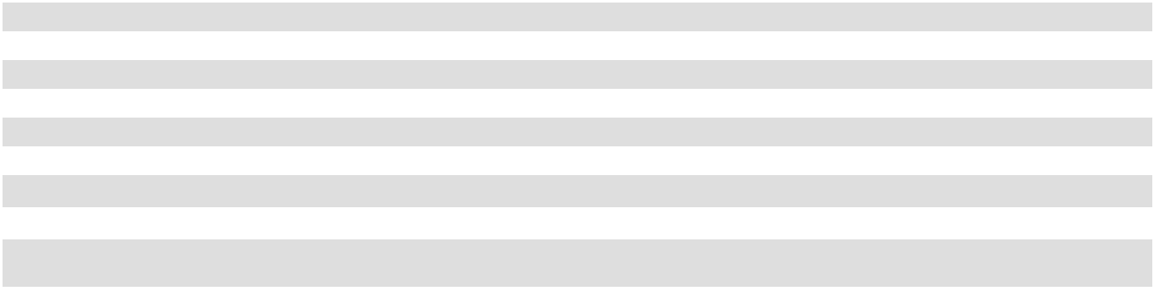

- Annualized base rent is calculated by multiplying base rental payments (defined as cash base rents (before abatements)) under commenced leases for the month ended December 31, 2025 by 12. In the case of triple net or modified gross leases, annualized base rent does not include tenant reimbursements for real estate taxes, insurance, common area or other operating expenses. The foregoing notwithstanding:

  - The annualized base rent for La Jolla Commons has been adjusted for this presentation to reflect that the contractual triple net leases were instead structured as modified gross leases, by adding the contractual annualized triple net base rent of $37,801,285 to our estimate of annual triple net operating expenses of $10,602,439 for an estimated annualized base rent on a modified gross lease basis of $48,403,724 for La Jolla Commons.
  - The annualized base rent for 14Acres has been adjusted for this presentation to reflect that the contractual triple net leases were instead structured as modified gross leases, by adding the contractual annualized triple net base rent of $4,081,195 to our estimate of annual triple net operating expenses of $1,881,650 for an estimated annualized base rent on a modified gross lease basis of $5,962,845 for 14Acres.

  - The annualized base rent for Timber Ridge has been adjusted for this presentation to reflect that the contractual triple net leases were instead structured as modified gross leases, by adding the contractual annualized triple net base rent of $5,297,966 to our estimate of annual triple net operating expenses of $1,982,391 for an estimated annualized base rent on a modified gross lease basis of $7,280,357 for Timber Ridge.

  - The annualized base rent for Timber Springs has been adjusted for this presentation to reflect that the contractual triple net leases were instead structured as modified gross leases, by adding the contractual annualized triple net base rent of $1,822,289 to our estimate of annual triple net operating expenses of $766,890 for an estimated annualized base rent on a modified gross lease basis of $2,589,179 for Timber Springs.

- Percentage leased for each of our retail and office properties and the retail portion of the mixed-use property is calculated as square footage under lease as of December 31, 2025, divided by net rentable square feet, expressed as a percentage. The square footage under lease includes leases which may not have commenced as of December 31, 2025. Percentage occupied for each of our multifamily properties includes total units rented and occupied as of December 31, 2025. Percentage leased for each of our multifamily properties includes units leased but not occupied as of December 31, 2025, divided by total units available, expressed as a percentage.

- Coastal Collection at Torrey Reserve was formerly known as Torrey Reserve Campus.

- This property contains 422,426 net rentable square feet consisting of The Landmark at One Market (378,206 net rentable square feet) as well as a separate long-term leasehold interest in approximately 44,220 net rentable square feet of space located in an adjacent six-story leasehold known as the Annex. We currently lease the Annex from an affiliate of the Paramount Group pursuant to a long-term master lease effective through June 30, 2031.

- Lease data for signed but not commenced leases as of December 31, 2025 is in the following table:

 |  | Leased Square Feet |  |  |  |  |  | Annualized Base |  |  | Pro Forma Annualized
 |  | Under Signed But |  |  | Annualized |  |  | Rent per |  |  | Base Rent per
 | Not Commenced Leases (a) |  |  |  | Base Rent (b) |  | Leased Square Foot (b) |  |  |  | Leased Square Foot (c)
Office Portfolio | $ | 139,722 | $ |  | 7,204,628 | $ |  | 51.56 | $ |  | 58.71
Retail Portfolio |  | 11,300 |  |  | 570,430 | $ |  | 50.48 | $ |  | 29.97
Total Retail and Office Portfolio | $ | 151,022 | $ |  | 7,775,058 | $ |  | 51.48 | $ |  | 47.23

- Office portfolio leases signed but not commenced of 84,009, 35,861, 15,194, and 4,658 square feet are expected to commence during each quarter of 2026, respectively. Retail portfolio leases signed but not commenced of 1,700, 1,627, 5,255, and 2,718 square feet are expected to commence during each quarter of 2026, respectively.

- Annualized base rent is calculated by multiplying base rental payments (defined as cash base rents (before abatements)) for signed but not commenced leases as of December 31, 2025 by 12. In the case of triple net or modified gross leases, annualized base rent does not include tenant reimbursements for real estate taxes, insurance, common area or other operating expenses. Annualized base rent per leased square foot is calculated by dividing annualized base rent, by square footage for signed by not commenced leases.

- Pro forma annualized base rent is calculated by dividing annualized base rent for commenced leases and for signed but not commenced leases as of December 31, 2025, by square footage under lease as of December 31, 2025.

39

- Net rentable square feet at certain of our retail properties includes square footage leased pursuant to ground leases, as described in the following table:

 |  |  | Square Footage |  | Aggregate Annualized Base
Property | Number of Ground Leases |  | Leased Pursuant to
Property | Number of Ground Leases |  | Ground Leases |  |  | Rent
Carmel Mountain Plaza | 5 | 17,607 |  | $ |  | 1,051,461
South Bay Marketplace | 1 | 2,824 |  | $ |  | 114,552
Alamo Quarry Market | 4 | 31,994 |  | $ |  | 723,455
Gateway Marketplace | 1 | 18,903 |  | $ |  | 226,800
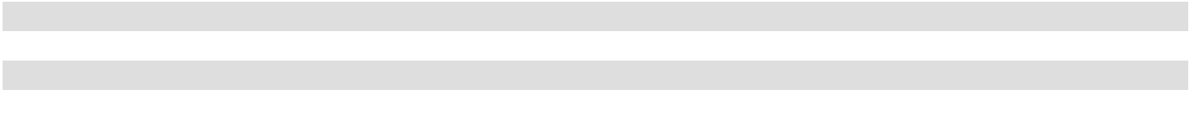

- The Hassalo on Eighth property is comprised of three multifamily buildings, each with a ground floor retail component: Velomor, Aster Tower and Elwood.

- The Santa Fe Park RV Resort is subject to seasonal variation, with higher rates of occupancy occurring during the summer months. The number of units at the Santa Fe Park RV Resort includes 120 RV spaces and four apartments. The Santa Fe Park RV Resort is excluded from the multifamily presentation above to accurately reflect true multifamily performance.

In the tables above:

- The net rentable square feet for each of our retail properties and the retail portion of our mixed-use property is the sum of (1) the square footages of existing leases, plus (2) for available space, the field-verified square footage. The net rentable square feet for each of our office properties is the sum of (a) the square footages of existing leases, plus (b) for available space, management's estimate of net rentable square feet based, in part, on past leases. The net rentable square feet included in such office leases is generally determined consistently with the Building Owners and Managers Association, or BOMA, 2017 measurement guidelines. Net rentable square footage may be adjusted from the prior period to reflect re-measurement of leased space at the properties.

- Annualized base rent is calculated by multiplying base rental payments (defined as cash base rents, before abatements) for the month ended December 31, 2025, by 12. Annualized base rent per leased square foot is calculated by dividing annualized base rent, by square footage under lease as of December 31, 2025. In the case of triple net or modified gross leases, annualized base rent does not include tenant reimbursements for real estate taxes, insurance, common area or other operating expenses. Total abatements for leases in effect as of December 31, 2025 for our retail and office portfolio equaled approximately $8.2 million for the year ended December 31, 2025. Total abatements for leases in effect as of December 31, 2025 for our mixed-use portfolio equaled approximately $0.1 million for the year ended December 31, 2025. Total abatements for leases in effect as of December 31, 2025 for our multifamily portfolio equaled approximately $2.2 million for the year ended December 31, 2025.

- Units represent the total number of units available for sale or rent at December 31, 2025.

- Average occupancy represents the percentage of available units that were sold during the 12-month period ended December 31, 2025, and is calculated by dividing the number of units sold by the product of the total number of units and the total number of days in the period. Average daily rate represents the average rate paid for the units sold and is calculated by dividing the total room revenue (i.e., excluding food and beverage revenues or other hotel operations revenues such as telephone, parking and other guest services) for the 12-month period ended December 31, 2025, by the number of units sold. Revenue per available room, or RevPAR, represents the total unit revenue per total available units for the 12-month period ended December 31, 2025 and is calculated by multiplying average occupancy by the average daily rate. RevPAR does not include food and beverage revenues or other hotel operations revenues such as telephone, parking and other guest services.

- Average monthly base rent per occupied unit represents the average monthly base rent per occupied unit as of December 31, 2025.

40

Tenant Diversification

At December 31, 2025, our operating portfolio had approximately 735 leases with office and retail tenants, of which 5 expired on December 31, 2025 and 23 had not yet commenced as of such date. Our residential properties had 2,041 leases with residential tenants at December 31, 2025, excluding Santa Fe Park RV Resort. The retail portion of our mixed-use property had approximately 66 leases with retailers. Only one tenant or affiliated group of tenants accounted for more than 9.8% of our annualized base rent as of December 31, 2025 for our office, retail and retail portion of our mixed-use property portfolio. The following table sets forth information regarding the 25 tenants with the greatest annualized base rent for our combined office, retail and retail portion of our mixed-use property portfolios as of December 31, 2025.

 |  |  |  |  |  |  |  | Rentable |  |  |  |  |  | Annualized
 |  |  |  |  |  |  |  | Square |  |  |  |  |  | Base Rent
 |  |  |  | Lease |  | Total Leased |  | Feet as a |  |  |  | Annualized |  | as a
Tenant |  | Property(ies) |  | Lease |  | Total Leased |  | Percentage |  |  |  | Annualized |  | Percentage
Tenant |  | Property(ies) |  | Expiration |  | Square Feet |  | of Total |  |  |  | Base Rent ⁽¹⁾ |  | of Total
Google LLC |  | The Landmark at One Market | 12/31/2029 |  | 253,198 |  | 3.7 |  | % | $ |  | 27,659,898 | 9.8 |  | %
LPL Holdings, Inc. |  | La Jolla Commons | 4/30/2029 |  | 421,001 |  | 6.2 |  |  |  |  | 21,048,719 | 7.5
Autodesk, Inc. |  | The Landmark at One Market | 12/31/2028 |  | 138,615 |  | 2.0 |  |  |  |  | 13,730,889 | 4.9
 |  |  | 6/30/2031
Smartsheet, Inc. |  | City Center Bellevue | 12/31/2026 |  | 123,041 |  | 1.8 |  |  |  |  | 7,340,059 | 2.6
 |  |  | 4/30/2029
 |  |  | 12/31/2032
Illumina, Inc. |  | La Jolla Commons | 10/31/2027 |  | 73,176 |  | 1.1 |  |  |  |  | 5,110,316 | 1.8
Databricks, Inc. |  | City Center Bellevue | 11/30/2027 |  | 69,104 |  | 1.0 |  |  |  |  | 4,183,793 | 1.5
 |  |  | 1/31/2028
 |  |  | 3/31/2028
 |  |  | 10/31/2028
Lowe's |  | Waikele Center | 5/31/2028 |  | 155,000 |  | 2.3 |  |  |  |  | 4,092,000 | 1.5
Industrious |  | City Center Bellevue | 4/30/2033 |  | 75,749 |  | 1.1 |  |  |  |  | 4,015,281 | 1.4
 |  | La Jolla Commons | 3/31/2034
 |  |  | 7/31/2035
VMWare, LLC |  | City Center Bellevue | 1/31/2026 |  | 55,683 |  | 0.8 |  |  |  |  | 3,667,357 | 1.3
 |  |  | 3/31/2028
State of Oregon: Department of |  | Lloyd Portfolio | 10/31/2031 |  | 87,787 |  | 1.3 |  |  |  |  | 3,207,179 | 1.1
Environmental Quality
Top technology tenant (2) |  | La Jolla Commons | 8/31/2030 |  | 40,800 |  | 0.6 |  |  |  |  | 2,674,996 | 1.0
Genentech, Inc. |  | Lloyd Portfolio | 10/31/2026 |  | 66,852 |  | 1.0 |  |  |  |  | 2,554,393 | 0.9
Sprouts Farmers Market |  | Solana Beach Towne Centre | 6/30/2029 |  | 71,431 |  | 1.1 |  |  |  |  | 2,248,554 | 0.8
 |  | Geary Marketplace | 9/30/2032
 |  | Carmel Mountain Plaza | 3/31/2035
Internal Revenue Service |  | First & Main | 8/31/2030 |  | 63,648 |  | 0.9 |  |  |  |  | 2,189,700 | 0.8
Perkins Coie, LLP |  | Coastal Collection at Torrey | 12/31/2028 |  | 36,980 |  | 0.5 |  |  |  |  | 2,092,997 | 0.7
 |  | Reserve
Veterans Benefits Administration |  | First and Main | 8/31/2030 |  | 73,001 |  | 1.1 |  |  |  |  | 1,997,006 | 0.7
Marshalls |  | Carmel Mountain Plaza | 1/31/2029 |  | 68,055 |  | 1.0 |  |  |  |  | 1,901,151 | 0.7
 |  | Solana Beach Towne Centre | 1/31/2035
US Bank |  | La Jolla Commons | 8/31/2027 |  | 40,858 |  | 0.6 |  |  |  |  | 1,852,546 | 0.7
 |  | Lomas Sante Fe Plaza | 8/31/2027
Nordstrom Rack |  | Carmel Mountain Plaza | 9/30/2027 |  | 69,047 |  | 1.0 |  |  |  |  | 1,804,269 | 0.6
 |  | Alamo Quarry Market | 10/31/2027
PIMCO |  | La Jolla Commons | 3/31/2034 |  | 24,464 |  | 0.4 |  |  |  |  | 1,632,825 | 0.6
Vons |  | Lomas Santa Fe Plaza | 12/31/2027 |  | 49,895 |  | 0.7 |  |  |  |  | 1,609,086 | 0.6
Petit Kohn Ingrassia Lutz & Dolin |  | Coastal Collection at Torrey | 12/31/2026 |  | 26,993 |  | 0.4 |  |  |  |  | 1,596,010 | 0.6
 |  | Reserve
Pillsbury Winthrop Shaw Pittman |  | Coastal Collection at Torrey | 12/31/2033 |  | 26,152 |  | 0.4 |  |  |  |  | 1,564,799 | 0.6
LLP |  | Reserve
Seismic Software, Inc. |  | Coastal Collection at Torrey | 1/31/2034 |  | 25,026 |  | 0.4 |  |  |  |  | 1,529,285 | 0.5
 |  | Reserve
Ruth's Chris Steak House |  | Waikiki Beach Walk Retail | 2/29/2028 |  | 14,833 |  | 0.2 |  |  |  |  | 1,499,217 | 0.5
 |  | Coastal Collection at Torrey | 1/31/2030
 |  | Reserve
TOTAL
TOTAL |  |  |  |  | 2,150,389 |  | 31.6 % |  |  | $ |  | 122,802,325 | 43.7 %
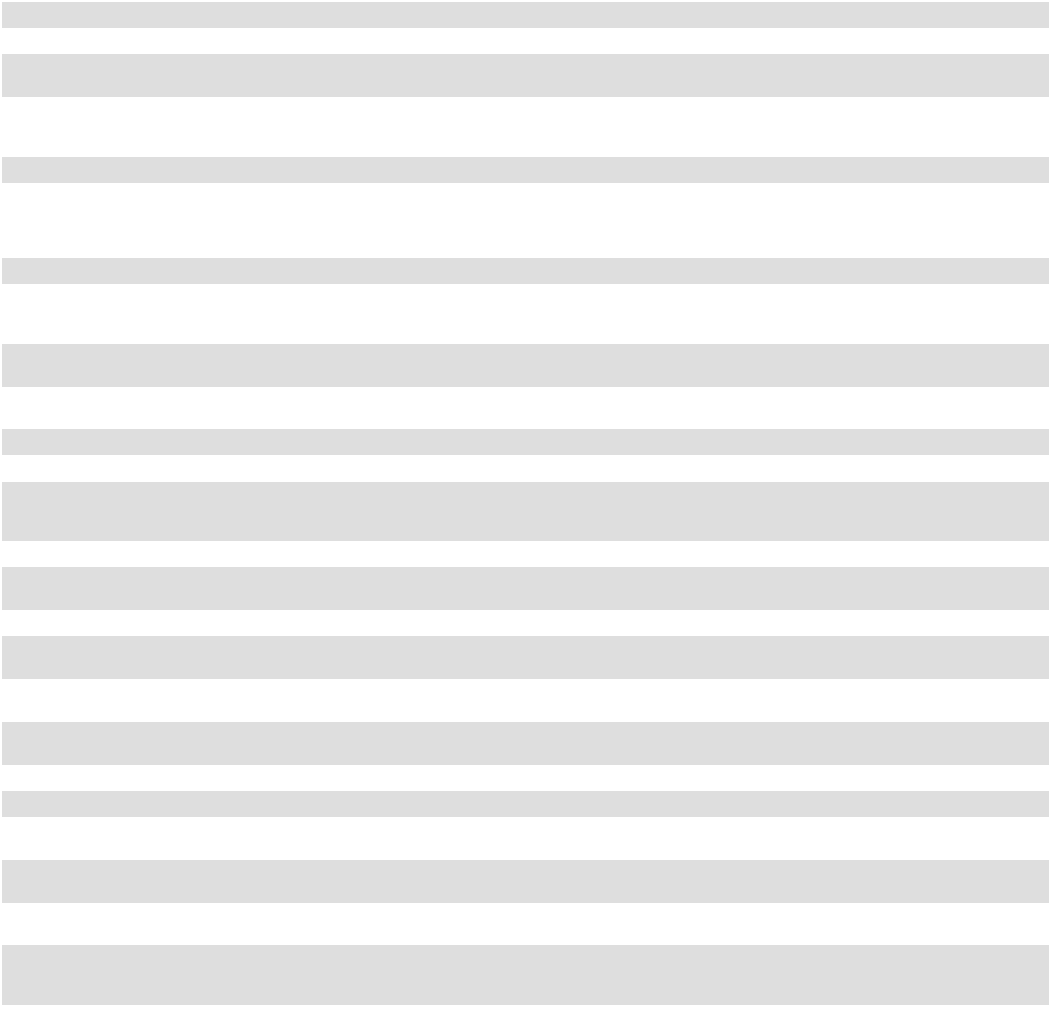

- Annualized base rent is calculated by multiplying (i) base rental payments (defined as cash base rents before abatements) for the month ended December 31, 2025 for the applicable lease(s) by (ii) 12.
- Name withheld at tenant's request.

41

Geographic Diversification

Our properties are located in Southern California, Northern California, Washington, Oregon, Texas and Hawaii. The following table shows the number of properties, the net rentable square feet and the percentage of total portfolio net rentable square footage in each region as of December 31, 2025. Our seven multifamily properties are excluded from the table below and are located in Southern California and Portland, Oregon. The hotel portion of our mixed-use property is also excluded and is located in Hawaii.

Region | Number of |  |  | Net Rentable Square Feet |  | Percentage of Net
Region | Properties |  |  | Net Rentable Square Feet |  | Rentable Square Feet ⁽¹⁾
Southern California |  | 10 | 3,125,009 |  | 46.0 |  | %
Northern California |  | 3 | 546,590 |  | 8.1
Washington |  | 4 | 1,028,470 |  | 15.2
Oregon |  | 3 | 975,139 |  | 14.4
Texas |  | 1 | 588,148 |  | 8.7
Hawaii ⁽²⁾ |  | 3 | 524,213 |  | 7.7
Total |  | 24 |  | 6,787,569 |  | 100.0 %
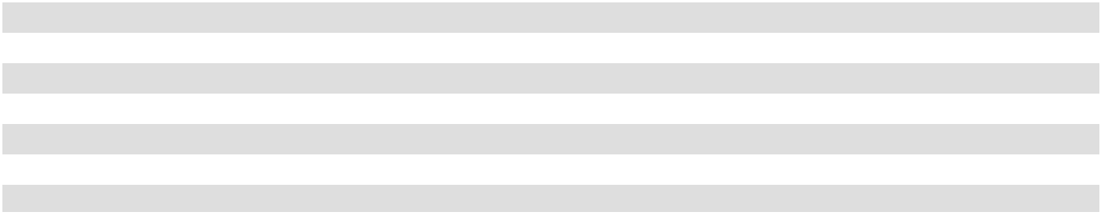

- Percentage of Net Rentable Square Feet is calculated based on the total net rentable square feet available in our retail portfolio, office portfolio and the retail portion of our mixed-use portfolio.
- Includes the retail portion related to the mixed-use property.

Segment Diversification

The following table sets forth information regarding the total property operating income for each of our segments for the year ended December 31, 2025 (dollars in thousands).

Segment | Number of |  |  |  | Property Operating |  | Percentage of Property
Segment | Properties |  |  |  | Income |  | Operating Income
Office |  | 12 | $ |  | 139,139 | 52.2 |  | %
Retail |  | 11 |  |  | 68,338 | 25.6 |  | %
Multifamily |  | 7 |  |  | 37,010 | 13.9 |  | %
Mixed-Use |  | 1 |  |  | 22,122 | 8.3 |  | %
Total |  | 31 |  | $ | 266,609 |  | 100.0 %

Lease Expirations

The following table sets forth a summary schedule of the lease expirations for leases in place as of December 31, 2025, plus available space, for each of the ten calendar years beginning January 1, 2026 at the properties in our retail portfolio, office portfolio and the retail portion of our mixed-use portfolio. The square footage of available space excludes the space from 5 leases that terminated on December 31, 2025. In 2026, we expect a similar level of leasing activity for new and expiring leases compared to prior years with overall positive increases in rental income. However, changes in rental income associated with individual signed leases on comparable spaces may be positive or negative, and we can provide no assurance that the rents on new leases will continue to increase at the above disclosed levels, if at all.

42

The lease expirations for our multifamily portfolio and the hotel portion of our mixed-use portfolio are excluded from this table because multifamily unit leases generally have lease terms ranging from seven to fifteen months, with a majority having twelve-month lease terms, and because rooms in the hotel are rented on a nightly basis. The information set forth in the table assumes that tenants do not exercise any renewal options.

 |  |  | Percentage
 | Square |  | of Portfolio |  |  |  |  |  | Percentage |  |  | Annualized
 | Square |  | Net |  |  |  |  |  | Percentage |  |  | Annualized
 | Footage of |  | Rentable |  |  | Annualized Base |  |  | of Portfolio |  | Base Rent Per
Year of Lease Expiration | Expiring |  | Square |  |  |  |  |  | Annualized |  |  | Leased
Year of Lease Expiration | Leases |  | Feet |  |  |  | Rent ⁽¹⁾ |  | Base Rent |  | Square Foot ⁽²⁾
Available | 779,962 | 11.5 |  | % | $ |  | — |  | — % | $ |  | —
Month to Month | 95,651 | 1.4 |  |  |  |  | 402,801 | 0.2 |  |  |  | 4.21
2026 | 454,358 | 6.7 |  |  |  |  | 21,740,653 | 8.2 |  |  |  | 47.85
2027 | 690,621 | 10.2 |  |  |  |  | 30,187,828 | 11.3 |  |  |  | 43.71
2028 | 1,134,670 | 16.7 |  |  |  |  | 49,141,525 | 18.5 |  |  |  | 43.31
2029 | 1,229,062 | 18.1 |  |  |  |  | 71,929,184 | 27.0 |  |  |  | 58.52
2030 | 522,823 | 7.7 |  |  |  |  | 22,297,008 | 8.4 |  |  |  | 42.65
2031 | 511,712 | 7.5 |  |  |  |  | 24,553,887 | 9.2 |  |  |  | 47.98
2032 | 246,524 | 3.6 |  |  |  |  | 10,288,552 | 3.9 |  |  |  | 41.73
2033 | 248,219 | 3.7 |  |  |  |  | 8,526,125 | 3.2 |  |  |  | 34.35
2034 | 253,951 | 3.7 |  |  |  |  | 11,774,510 | 4.4 |  |  |  | 46.37
2035 | 201,279 | 3.0 |  |  |  |  | 6,921,558 | 2.6 |  |  |  | 34.39
Thereafter | 260,482 | 3.8 |  |  |  |  | 8,244,064 | 3.1 |  |  |  | 31.65
Signed Leases Not Commenced | 158,255 | 2.3 |  |  |  |  | — |  | — |  |  | —
Total: | 6,787,569 |  | 100.0 % |  |  | $ | 266,007,695 |  | 100.0 % |  | $ | 39.19
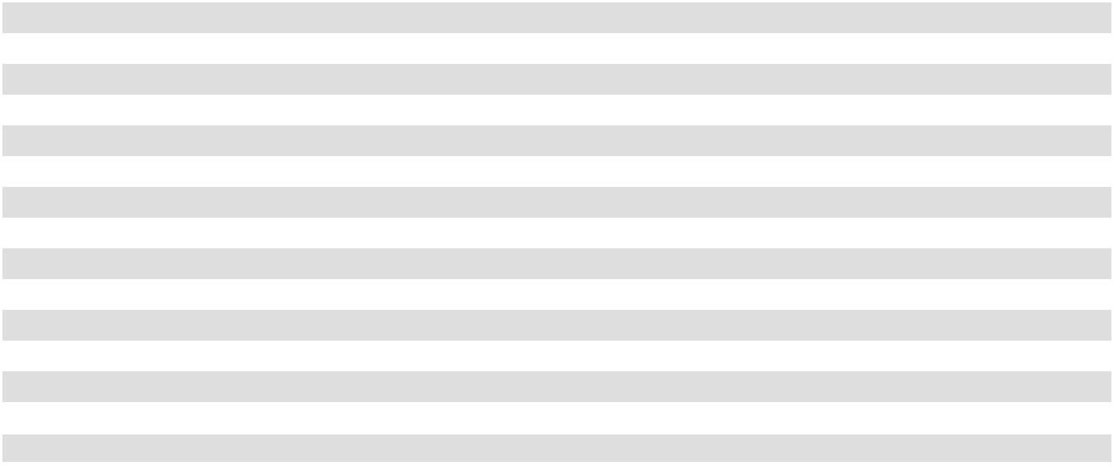

- Annualized base rent is calculated by multiplying base rental payments (defined as cash base rents (before abatements)) for the month ended December 31, 2025 for the leases expiring during the applicable period, by 12.
- Annualized base rent per leased square foot is calculated by dividing annualized base rent for leases expiring during the applicable period by square footage under such expiring leases.

ITEM 3. LEGAL PROCEEDINGS

We are not currently a party, as plaintiff or defendant, to any legal proceedings that we believe to be material or which, individually or in the aggregate, would be expected to have a material effect on our business, financial condition or results of operation if determined adversely to us. We may be subject to ongoing litigation and we expect to otherwise be party from time to time to various lawsuits, claims and other legal proceedings that arise in the ordinary course of our business.

ITEM 4. MINE SAFETY DISCLOSURES

Not applicable.

43

PART II

ITEM 5. MARKET FOR OUR COMMON EQUITY, RELATED STOCKHOLDER MATTERS AND ISSUER PURCHASES OF EQUITY SECURITIES

American Assets Trust, Inc. Market Information and Holders

Shares of American Assets Trust, Inc.'s common stock are listed on the NYSE under the symbol “AAT”. On February 3, 2026, we had 76 stockholders of record of our common stock. Certain shares are held in “street” name and accordingly, the number of beneficial owners of such shares is not known or included in the foregoing number.

American Assets Trust, L.P.

There is no established trading market for American Assets Trust, L.P.'s operating partnership units. As of February 3, 2026, we had 20 holders of record of American Assets Trust, L.P.'s operating partnership units, including American Assets Trust, Inc.

Distribution Policy

We pay and intend to continue to pay regular quarterly dividends to holders of our common stock and distributions to unitholders of our Operating Partnership and to make dividend distributions that will enable us to meet the distribution requirements applicable to REITs and to eliminate or minimize our obligation to pay income and excise taxes. Dividend amounts depend on our available cash flows, financial condition and capital requirements, the annual distribution requirements under the REIT provisions of the Code and such other factors as our board of directors deems relevant.

Recent Sales of Unregistered Equity Securities

No unregistered equity securities were sold by us during 2025.

Purchases of Equity Securities by the Issuer and Affiliated Purchasers

No equity securities were purchased by us during 2025.

Equity Compensation Plan Information

Information about our equity compensation plans is incorporated by reference in Item 12 of Part III of this annual report on Form 10-K.

44

Stock Performance Graph

The information below shall not be deemed to be “soliciting material” or to be “filed” with the SEC or subject to Regulation 14A or 14C, other than as provided in Item 201 of Regulation S-K, or to the liabilities of Section 18 of the Exchange Act, except to the extent we specifically request that such information be treated as soliciting material or specifically incorporate it by reference into a filing under the Securities Act or the Exchange Act.

The graph below compares the cumulative total return on the company’s common stock with that of the Standard & Poor's 500 Stock Index, or S&P 500 Index, and an industry peer group, S&P 600 Real Estate Index from December 31, 2020 through December 31, 2025. The stock price performance graph assumes that an investor invested $100 in each of American Assets Trust, Inc. and these indices, and the reinvestment of any dividends. The comparisons in the graph are provided in accordance with the SEC disclosure requirements and are not intended to forecast or be indicative of the future performance of American Assets Trust, Inc. shares of common stock.
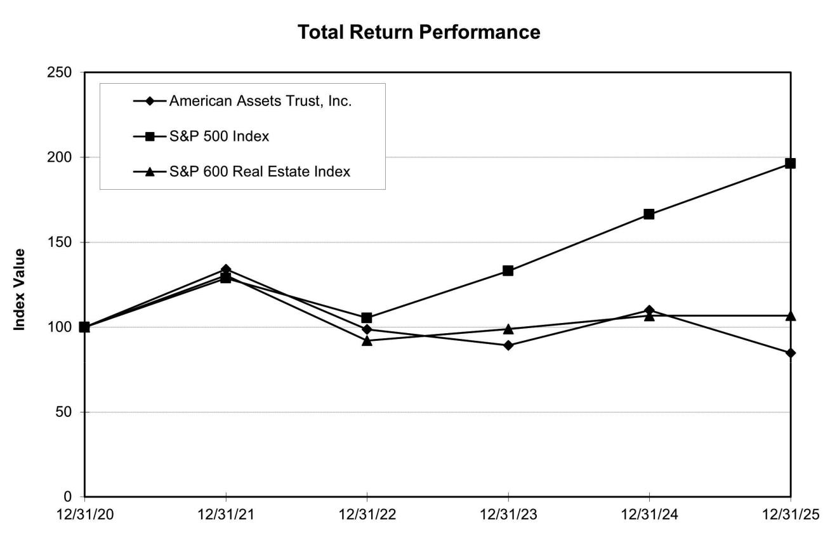

45

ITEM 6. [RESERVED]

46

ITEM 7. MANAGEMENT’S DISCUSSION AND ANALYSIS OF FINANCIAL CONDITION AND RESULTS OF OPERATIONS

The following discussion should be read in conjunction with the audited historical consolidated financial statements and notes thereto appearing in “Item 8. Financial Statements and Supplementary Data” of this report. As used in this section, unless the context otherwise requires, “we,” “us,” “our,” and “our company” mean American Assets Trust, Inc., a Maryland corporation and its consolidated subsidiaries, including American Assets Trust, L.P. In statements regarding qualification as a REIT, such terms refer solely to American Assets Trust, Inc. This discussion may contain forward-looking statements based upon current expectations that involve risks and uncertainties. Our actual results may differ materially from those anticipated in these forward looking statements as a result of various factors, including those set forth under “Item 1A. Risk Factors” or elsewhere in this document. See “Item 1A. Risk Factors” and “Forward-Looking Statements.”

Overview

Our Company

We are a full service, vertically integrated and self-administered REIT that owns, operates, acquires and develops high quality office, retail, multifamily and mixed-use properties in attractive, high-barrier-to-entry markets in Southern California, Northern California, Washington, Oregon, Texas, and Hawaii. As of December 31, 2025, our portfolio was comprised of twelve office properties; eleven retail shopping centers; a mixed-use property consisting of a 369-room all-suite hotel and a retail shopping center; and seven multifamily properties. Additionally, as of December 31, 2025, we owned land at two of our properties that we classified as held for development or construction in progress. La Jolla Commons - Land, related to the development of La Jolla Commons III, was previously classified as held for development. The development of La Jolla Commons III is now complete and the building, inclusive of the land, was placed in operations as of April 1, 2025. Our core markets include San Diego, California; the San Francisco Bay Area, California; Bellevue, Washington; Portland, Oregon, and Oahu, Hawaii. American Assets Trust, Inc., as the sole general partner of our Operating Partnership, has control of our Operating Partnership and owned 78.95% of our Operating Partnership as of December 31, 2025. Accordingly, we consolidate the assets, liabilities and results of operations of our Operating Partnership.

Taxable REIT Subsidiary

On November 5, 2010, we formed American Assets Services, Inc., a Delaware corporation that is wholly owned by our Operating Partnership and which we refer to as our services company. We have elected, together with our services company, to treat our services company as a taxable REIT subsidiary for federal income tax purposes. A taxable REIT subsidiary generally may provide non-customary and other services to our tenants and engage in activities that we may not engage in directly without adversely affecting our qualification as a REIT, provided a taxable REIT subsidiary may not operate or manage a lodging facility or provide rights to any brand name under which any lodging facility is operated. We may form additional taxable REIT subsidiaries in the future, and our Operating Partnership may contribute some or all of its interests in certain wholly owned subsidiaries or their assets to our services company. Any income earned by our taxable REIT subsidiaries will not be included in our taxable income for purposes of the 75% or 95% gross income tests, except to the extent such income is distributed to us as a dividend, in which case such dividend income will qualify under the 95%, but not the 75%, gross income test. Because a taxable REIT subsidiary is subject to federal income tax and state and local income tax (where applicable) as a regular corporation, the income earned by our taxable REIT subsidiaries generally will be subject to an additional level of tax as compared to the income earned by our other subsidiaries.

Outlook

We seek growth in earnings, funds from operations, and cash flows primarily through a combination of the following: growth in our same-store portfolio, growth in our portfolio from property development and redevelopments and expansion of our portfolio through property acquisitions. Our properties are located in some of the nation's most dynamic, high-barrier-to-entry markets primarily in Southern California, Northern California, Washington, Oregon and Hawaii, which we believe allow us to take advantage of redevelopment opportunities that enhance our operating performance through renovation, expansion, reconfiguration, and/or retenanting. We evaluate our properties on an ongoing basis to identify these types of opportunities.

47

We intend to opportunistically pursue projects in our development pipeline, including future phases of Lloyd Portfolio, other redevelopments at Waikele Center, as well as multifamily development opportunities within our existing portfolio, namely at Lomas Santa Fe Plaza, Solana Beach Towne Centre, Carmel Mountain Plaza, and Genesee Park. The commencement of these developments is based on, among other things, market conditions and our evaluation of whether such opportunities would generate appropriate risk-adjusted financial returns. Our redevelopment and development opportunities are subject to various factors, including market conditions and may not ultimately come to fruition. We continue to review acquisition opportunities in our primary markets that would complement our portfolio and provide long-term growth opportunities. Some of our acquisitions do not initially contribute significantly to earnings growth; however, we believe they provide long-term re-leasing growth, redevelopment opportunities and other strategic opportunities. Any growth from acquisitions is contingent on our ability to find properties that meet our qualitative standards at prices that meet our financial hurdles. Changes in interest rates may affect our success in achieving earnings growth through acquisitions by affecting both the price that must be paid to acquire a property, as well as our ability to economically finance a property acquisition. Generally, our acquisitions are initially financed by available cash, mortgage loans and/or borrowings under our credit facility, which may be repaid later with funds raised through the issuance of new equity or new long-term debt.

Same-store

We have provided certain information on a total portfolio, same-store and redevelopment same-store basis. Information provided on a same-store basis includes the results of properties that we owned and operated for the entirety of both periods being compared except for properties for which significant redevelopment or expansion occurred during either of the periods being compared, properties under development, properties classified as held for development and properties classified as discontinued operations. Information provided on a redevelopment same-store basis includes the results of properties undergoing significant redevelopment for the entirety or portion of both periods being compared. Same-store and redevelopment same-store are considered by management to be important measures because they assist in eliminating disparities due to the development, acquisition or disposition of properties during the particular period presented, and thus provide a more consistent performance measure for the comparison of the company's stabilized and redevelopment properties, as applicable. Additionally, redevelopment same-store is considered by management to be an important measure because it assists in evaluating the timing of the start and stabilization of our redevelopment opportunities and the impact that these redevelopments have in enhancing our operating performance.

While there is judgment surrounding changes in designations, we typically reclassify significant development, redevelopment or expansion properties into same-store properties once they are stabilized. Properties are deemed stabilized typically at the earlier of (1) reaching 90% occupancy or (2) four quarters following a property's inclusion in operating real estate. We typically remove properties from same-store properties when the development, redevelopment or expansion has or is expected to have a significant impact on the property's annualized base rent, occupancy and operating income within the calendar year. Our evaluation of significant impact related to development, redevelopment or expansion activity is based on quantitative and qualitative measures including, but not limited to, the following: the total budgeted cost of planned construction activity compared to the property’s annualized base rent, occupancy and operating income within the calendar year; percentage of development, redevelopment or expansion square footage to total property square footage; and the ability to maintain historic occupancy and rental rates. In consideration of these measures, we generally remove properties from same-store properties when we see a decline in a property's annualized base rent, occupancy and operating income within the calendar year as a direct result of ongoing redevelopment, development or expansion activity. Acquired properties are classified into same-store properties once we have owned such properties for the entirety of comparable period(s) and the properties are not under significant development or expansion.

Below is a summary of our same-store composition for the years ended December 31, 2025, 2024 and 2023. One Beach Street is identified as a non-same-store property for the years ended December 31, 2025 and 2024, due to significant redevelopment activity. Additionally, this property was placed into operations on August 1, 2024, approximately one year after completing renovations. Del Monte Center was removed as a same-store property when compared to the designations for the year ended December 31, 2024, as it was sold on February 25, 2025. Genesee Park is classified as a non-same-store property because it was acquired on February 28, 2025, and thus has not been owned for the comparable period. La Jolla Commons III is classified as a non-same store property when compared to the designations for the year ended December 31, 2024, as it was placed in operations on April 1, 2025. La Jolla Commons III is a part of the La Jolla Commons office project, and not a stand-alone property.

48

For the year ended December 31, 2024, when compared to the designations for the year ended December 31, 2023, Timber Springs was classified as a same-store property for the year ended December 31, 2024, because the property was acquired on March 8, 2022. The 710 building within the Lloyd Portfolio was classified as a same-store property when compared to the designation for the year ended December 31, 2023, because the property had been in operation for a full year since it was placed in service in November 2022. One Beach Street is identified as a non-same-store property for the years ended December 31, 2024 and 2023, due to significant redevelopment activity. Additionally, this property was placed into operations on August 1, 2024, approximately one year after completing renovations.

December 31,

 | 2025 |  |  | 2024 |  |  | 2023
Same-Store |  | 29 |  |  | 30 | 29
Non-Same Store |  | 2 |  |  | 1 |  | 2
Total Properties |  | 31 |  |  | 31 |  | 31
Total Development Properties |  | 2 |  |  | 3 | 3
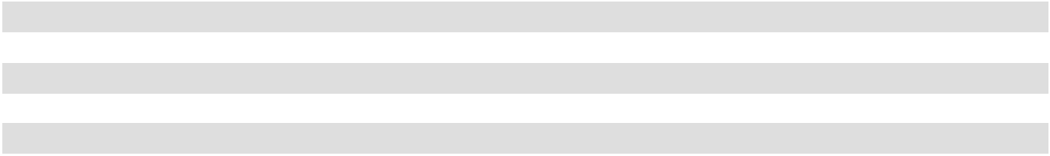

Revenue Base

Rental income consists of scheduled rent charges, straight-line rent adjustments and the amortization of above market and below market rents acquired. We also derive revenue from tenant recoveries and other property revenues, including parking income, lease termination fees, late fees, storage rents and other miscellaneous property revenues.

Office Leases. Our office portfolio included twelve properties with a total of approximately 4.3 million rentable square feet available for lease as of December 31, 2025. As of December 31, 2025, these properties were 83.1% leased. For the year ended December 31, 2025, the office segment contributed 47.2% of our total revenue. Historically, we have leased office properties to tenants primarily on a full service gross or a modified gross basis and to a limited extent on a triple-net lease basis. We expect to continue to do so in the future. A full-service gross or modified gross lease has a base year expense stop, whereby the tenant pays a stated amount of certain expenses as part of the rent payment, while future increases in property operating expenses (above the base year stop) are billed to the tenant based on such tenant's proportionate square footage of the property. The increased property operating expenses billed are reflected as operating expenses and amounts recovered from tenants are reflected as rental income in the statements of operations.

During the year ended December 31, 2025, we signed 82 office leases for 616,680 square feet with an average rent of

$55.50 per square foot during the initial year of the lease term. Of the leases, 46 represent comparable leases where there was a

prior tenant, with an increase of 6.4% in cash basis rent and an increase of 13.8% in straight-line rent compared to the prior

leases.

Retail Leases. Our retail portfolio included eleven properties with a total of approximately 2.4 million rentable square feet available for lease as of December 31, 2025. As of December 31, 2025, these properties were 97.7% leased. For the year ended December 31, 2025, the retail segment contributed 21.8%, of our total revenue. Historically, we have leased retail properties to tenants primarily on a triple-net lease basis, and we expect to continue to do so in the future. In a triple-net lease, the tenant is responsible for all property taxes and operating expenses. As such, the base rent payment does not include any operating expense, but rather all such expenses, to the extent they are paid by the landlord, are billed to the tenant. The full amount of the expenses for this lease type, to the extent they are paid by the landlord, is reflected in operating expenses, and the reimbursement is reflected as rental income in the statements of operations.

During the year ended December 31, 2025, we signed 91 retail leases for 546,406 square feet with an average rent of $32.59 per square foot during the initial year of the lease term, including leases signed for the retail portion of our mixed-use property. Of the leases, 80 represent comparable leases where there was a prior tenant, with an increase of 7.1% in cash basis rent and an increase of 21.8% in straight-line rent compared to the prior leases.

Multifamily Leases. Our multifamily portfolio included six apartment properties, as well as an RV resort, with a total of 2,302 units (including 120 RV spaces) available for lease as of December 31, 2025. As of December 31, 2025, these properties were 91.1% occupied. For the year ended December 31, 2025, the multifamily segment contributed 15.8% of our total revenue. Our multifamily leases, other than at our RV resort, generally have lease terms ranging from 7 to 15 months, with a majority having 12-month lease terms. Tenants normally pay a base rental amount, usually quoted in terms of a monthly rate for the respective unit. Spaces at the RV resort can be rented at a daily, weekly, or monthly rate. The average monthly base rent per occupied unit as of December 31, 2025 was $2,684, compared to $2,683 at December 31, 2024.

49

Mixed-Use Property Revenue. Our mixed-use property consists of approximately 94,000 rentable square feet of retail space and a 369-room all-suite hotel. Revenue from the mixed-use property consists of revenue earned from retail leases, and revenue earned from the hotel, which consists of room revenue, food and beverage services, parking and other guest services. As of December 31, 2025, the retail portion of the property was 96.2% leased, and for the year ended December 31, 2025, the hotel had an average occupancy of 82.3%. For the year ended December 31, 2025, the mixed-use segment contributed 15.1%, of our total revenue. We have leased the retail portion of such property to tenants primarily on a triple-net lease basis, and we expect to continue to do so in the future. As such, the base rent payment under such leases does not include any operating expenses, but rather all such expenses, to the extent they are paid by the landlord, are billed to the tenant. Rooms at the hotel portion of our mixed-use property are rented on a nightly basis.

Leasing

Our same-store growth is primarily driven by increases in rental rates on new leases and lease renewals and changes in portfolio occupancy. Over the long-term, we believe that the infill nature and strong demographics of our properties provide us with a strategic advantage, allowing us to maintain relatively high occupancy and increase rental rates. Furthermore, we believe the locations of our properties and diversified portfolio will mitigate some of the potentially negative impact of the current economic environment.

During the twelve months ended December 31, 2025, we signed 82 office leases for a total of 616,680 square feet of office space including 370,619 square feet of comparable space leases (leases for which there was a previous tenant), at an average rental rate increase on a cash and GAAP basis of 6.4% and 13.8%, respectively. New office leases for comparable spaces were signed for 119,206 square feet at an average rental rate increase on a cash and GAAP basis of 3.4% and 16.3%, respectively. Renewals for comparable office spaces were signed for 251,413 square feet at an average rental rate increase on a cash and GAAP basis of 7.7% and 12.8%, respectively. Tenant improvements and incentives were $28.33 per square foot of office space for comparable new leases for the twelve months ended December 31, 2025, mainly due to new tenants at City Center Bellevue, Lloyd Portfolio and 14Acres. There were $21.47 per square foot of office space of tenant improvement or incentives for comparable renewal leases for the twelve months ended December 31, 2025.

During the twelve months ended December 31, 2025, we signed 91 retail leases for a total of 546,406 square feet of retail space including 509,924 square feet of comparable space leases, at an average rental rate increase on a cash and GAAP basis of 7.1% and 21.8%, respectively. New retail leases for comparable spaces were signed for 25,372 square feet at an average rental rate increase on a cash and GAAP basis of 9.9% and 436.8% (due to the modification of prior tenants' rent to cash-basis, which precluded straight-line rent for comparison), respectively. Renewals for comparable retail spaces were signed for 484,552 square feet at an average rental rate increase on a cash and GAAP basis of 6.9% and 15.6%, respectively. Tenant improvements and incentives were $42.85 per square foot of retail space for comparable new leases for the twelve months ended December 31, 2025, mainly due to new tenants at Gateway Marketplace, Alamo Quarry Market, Lomas Santa Fe Plaza and Carmel Country Plaza. There were $5.78 per square foot of retail space of tenant improvement or incentives for comparable renewal leases for the twelve months ended December 31, 2025.

The rental increases associated with comparable spaces generally include all leases signed in arms-length transactions reflecting market leverage between landlords and tenants during the period. The comparison between average rent for expiring leases and new leases is determined by including minimum rent and percentage rent paid on the expiring lease and minimum rent and, in some instances, projections of first lease year percentage rent, to be paid on the new lease. In some instances, management exercises judgment as to how to most effectively reflect the comparability of spaces reported in this calculation. The change in rental income on comparable space leases is impacted by numerous factors including current market rates, location, individual tenant creditworthiness, use of space, market conditions when the expiring lease was signed, capital investment made in the space and the specific lease structure. Tenant improvements and incentives include the total dollars committed for the improvement of a space as it relates to a specific lease, but may also include base building costs (i.e., expansion, escalators or new entrances) which are required to make the space leasable. Incentives include amounts paid to tenants as an inducement to sign a lease that do not represent building improvements.

The leases signed in 2025 will typically become effective in 2026, though some may not become effective until 2027. Further, there is risk that some new tenants will not ultimately take possession of their space and that tenants for both new and renewal leases may not pay all of their contractual rent due to operating, financing or other matters.

50

Critical Accounting Policies and Estimates

The preparation of financial statements in conformity with GAAP requires management to make estimates and assumptions that in certain circumstances affect the reported amounts of assets and liabilities, disclosure of contingent assets and liabilities, and revenues and expenses. These estimates are prepared using management's best judgment, after considering past and current events and economic conditions. In addition, information relied upon by management in preparing such estimates includes internally generated financial and operating information, external market information, when available, and when necessary, information obtained from consultations with third-party experts. Actual results could differ from these estimates. A discussion of possible risks which may affect these estimates is included in the section above entitled “Item 1A. Risk Factors.” Management considers an accounting estimate to be critical if changes in the estimate could have a material impact on our consolidated results of operations or financial condition.

Our significant accounting policies are more fully described in the notes to the consolidated financial statements included elsewhere in this report; however, the most critical accounting policies, which involve the use of estimates and assumptions as to future uncertainties and, therefore, may result in actual amounts that differ from estimates, are as follows:

Revenue Recognition and Accounts Receivable

Our leases with tenants are classified as operating leases. Substantially all such leases contain fixed rent escalations which occur at specified times during the term of the lease. Base rents are recognized on a straight-line basis from when the tenant controls the space through the term of the related lease, net of valuation adjustments, based on management's assessment of credit, collection and other business risks. When we determine that we are the owner of tenant improvements and the tenant has reimbursed us for a portion or all of the tenant improvement costs, we consider the amount paid to be additional rent, which is recognized on a straight-line basis over the term of the related lease. For first generation tenants, in instances in which we fund tenant improvements and the improvements are deemed to be owned by us, revenue recognition will commence when the improvements are substantially completed and possession or control of the space is turned over to the tenant. When we determine that the tenant is the owner of tenant improvements, tenant allowances are recorded as lease incentives and we commence revenue recognition and lease incentive amortization when possession or control of the space is turned over to the tenant for tenant work to begin. Percentage rents, which represent additional rents based upon the level of sales achieved by certain tenants, are recognized at the end of the lease year or earlier if we have determined the required sales level is achieved and the percentage rents are collectible. Real estate tax and other cost reimbursements are recognized on an accrual basis over the periods in which the related expenditures are incurred.

Other property income includes parking income, general excise tax billed to tenants, fees charged to tenants at our multifamily properties and food and beverage sales at the hotel portion of our mixed-use property. Other property income is recognized when we satisfy performance obligations as evidenced by the transfer of control of our services to customers. For a tenant to terminate its lease agreement prior to the end of the agreed term, we may require that they pay a fee to cancel the lease agreement. Lease termination fees for which the tenant has relinquished control of the space are generally recognized on the later of the termination date or the satisfaction of all conditions precedent to the lease termination, including, without limitation, payment of all lease termination fees. When a lease is terminated early but the tenant continues to control the space under a modified lease agreement, the lease termination fee is generally recognized evenly over the remaining term of the modified lease agreement.

Current accounts receivable from tenants primarily relate to contractual minimum rent and percentage rent as well as real estate tax and other cost reimbursements. Accounts receivable from straight-line rent is typically longer term in nature and relates to the cumulative amount by which straight-line rental income recorded to date exceeds cash rents billed to date under the contractual lease agreement.

We recognize revenue on the hotel portion of our mixed-use property from the rental of hotel rooms and guest services when we satisfy performance obligations as evidenced by the transfer of control when the rooms are occupied and services have been provided. Food and beverage sales are recognized when the customer has been served or at the time the transaction occurs. Revenue from room rental is included in rental revenue on the statement of comprehensive income. Revenue from other sales and services provided is included in other property income on the statement of comprehensive income.

51

We make estimates of the collectability of our current accounts receivable and straight-line rents receivable which requires significant judgment by management. The collectability of receivables is affected by numerous different factors including current economic trends, changes in tenants' payment patterns, tenant bankruptcies, the status of collectability of current cash rents receivable, tenants' recent and historical financial and operating results, changes in our tenants' credit ratings, communications between our operating personnel and tenants, the extent of security deposits and letters of credits held with respect to tenants, and the ability of the tenant to perform under the terms of their lease agreement when evaluating the adequacy of the allowance for doubtful accounts. If our assessment of these factors indicates it is probable that we will be unable to collect substantially all rents, we recognize a charge to rental income and limit our rental income to the lesser of lease income on a straight-line basis plus variable rents when they become accruable or cash collected. If we change our conclusion regarding the probability of collecting rent payments required by a lessee, we may recognize an adjustment to rental income in the period we make a change to our prior conclusion.

Due to the nature of the accounts receivable from straight-line rents, the collection period of these amounts typically extends beyond one year. Our experience relative to unbilled straight-line rents is that a portion of the amounts otherwise recognizable as revenue is never billed to or collected from tenants due to early lease terminations, lease modifications, bankruptcies and other factors. Accordingly, the extended collection period for straight-line rents along with our evaluation of tenant credit risk may result in the nonrecognition of a portion of straight-line rental income until the collection of such income is reasonably assured. Any changes to our conclusion regarding these assessments of collectability would have a direct impact on our net income.

When we enter into a transaction to sell a property or a portion of a property, we evaluate the recognition of the sale under ASC 610-20, “Other Income - Gains and Losses from the Derecognition of Nonfinancial Assets,” to determine whether and when control transfers and how to measure the associated gain or loss. We determine the transaction price based on the consideration we expect to receive. Variable consideration is included in the transaction price to the extent it is probable that a significant reversal of a gain recognized will not occur. We analyze the risk of a significant gain reversal and if necessary, limit the amount of variable consideration recognized in order to mitigate this risk. The estimation of variable consideration may require us to make assumptions and apply significant judgment.

Real Estate

Depreciation and maintenance costs relating to our properties constitute substantial costs for us. Land, buildings and improvements are recorded at cost. Depreciation is computed using the straight-line method. Estimated useful lives range generally from 30 years to a maximum of 40 years on buildings and major improvements. Minor improvements, furniture and equipment are capitalized and depreciated over useful lives ranging from 3 to 15 years. Maintenance and repairs that do not improve or extend the useful lives of the related assets are charged to operations as incurred. Tenant improvements are capitalized and depreciated over the life of the related lease or their estimated useful life, whichever is shorter. If a tenant vacates its space prior to contractual termination of its lease, the undepreciated balance of any tenant improvements are written off if they are replaced or have no future value. Our estimates of useful lives have a direct impact on our net income. If expected useful lives of our real estate assets were shortened, we would depreciate the assets over a shorter time period, resulting in an increase to depreciation expense and a corresponding decrease to net income on an annual basis.

Acquisitions of properties are accounted for in accordance with the authoritative accounting guidance on acquisitions and business combinations. Our methodology of allocating the cost of acquisitions to assets acquired and liabilities assumed is based on estimated fair values, replacement cost and appraised values. When we acquire operating real estate properties, the purchase price is allocated to land and buildings, intangibles such as in-place leases, and to current assets and liabilities acquired, if any. Such valuations include a consideration of the noncancelable terms of the respective leases as well as any applicable renewal period(s). The fair values associated with below market renewal options are determined based on a review of several qualitative and quantitative factors on a lease-by-lease basis at acquisition to determine whether it is probable that the tenant would exercise its option to renew the lease agreement. These factors include: (1) the type of tenant in relation to the property it occupies, (2) the quality of the tenant, including the tenant's long term business prospects, and (3) whether the fixed rate renewal option was sufficiently lower than the fair rental of the property at the date the option becomes exercisable such that it would appear to be reasonably assured that the tenant would exercise the option to renew. Each of these estimates requires a great deal of judgment, and some of the estimates involve complex calculations. These allocation assessments have a direct impact on our results of operations because if we were to allocate more value to land, there would be no depreciation with respect to such amount. If we were to allocate more value to the buildings, as opposed to allocating to the value of tenant leases, this amount would be recognized as an expense over a much longer period of time, since the amounts allocated to buildings are depreciated over the estimated lives of the buildings whereas amounts allocated to tenant leases are amortized over the remaining terms of the leases.

52

The value allocated to in-place leases is amortized over the related lease term and reflected as depreciation and amortization in the consolidated statements of comprehensive income. The value of above and below market leases associated with the original noncancelable lease terms are amortized to rental income over the terms of the respective noncancelable lease periods and are reflected as either an increase (for below market leases) or a decrease (for above market leases) to rental income in the consolidated statement of comprehensive income. If a tenant vacates its space prior to contractual termination of its lease or the lease is not renewed, the unamortized balance of any in-place lease value is written off to rental income and amortization expense. The value of the leases associated with below market lease renewal options that are likely to be exercised are amortized to rental income over the respective renewal periods. We make assumptions and estimates related to below market lease renewal options, which impact revenue in the period in which the renewal options are exercised and could result in significant increases to revenue if the renewal options are not exercised at which time the related below market lease liabilities would be written off as an increase to revenue.

Transaction costs related to the acquisition of a business, such as broker fees, transfer taxes, legal, accounting, valuation, and other professional and consulting fees, are expensed as incurred and included in “general and administrative expenses” in our consolidated statements of comprehensive income. For asset acquisitions not meeting the definition of a business, transaction costs are capitalized as part of the acquisition cost.

Capitalized Costs

Certain external and internal costs directly related to the development and redevelopment of real estate, including pre-construction costs, real estate taxes, insurance, interest, construction costs and salaries and related costs of personnel directly involved, are capitalized. We capitalize costs under development until construction is substantially complete and the property is held available for occupancy. The determination of when a development project is substantially complete and when capitalization must cease involves a degree of judgment. We consider a construction project as substantially complete and held available for occupancy upon the completion of landlord-owned tenant improvements or when the lessee takes possession of the unimproved space for construction of its own improvements, but not later than one year from cessation of major construction activity. We cease capitalization on the portion substantially completed and occupied or held available for occupancy, and capitalize only those costs associated with any remaining portion under construction.

We capitalized external and internal costs related to new development, redevelopment, expansion and repositioning activities combined of $22.7 million and $16.3 million for the years ended December 31, 2025 and 2024, respectively.

We capitalized external and internal costs related to other property improvements combined of $55.5 million and $52.2 million for the years ended December 31, 2025 and 2024, respectively.

Interest costs on developments and major redevelopments are capitalized as part of developments and redevelopments not yet placed in service. Capitalization of interest commences when development activities and expenditures begin and end upon completion, which is when the asset is ready for its intended use as noted above. We make judgments as to the time period over which to capitalize such costs and these assumptions have a direct impact on net income because capitalized costs are not subtracted in calculating net income. If the time period for capitalizing interest is extended, more interest is capitalized, thereby decreasing interest expense and increasing net income during that period. We capitalized interest costs related to both development and redevelopment activities combined of $1.4 million and $7.5 million for the years ended December 31, 2025 and 2024, respectively.

53

Segment capital expenditures for the years ended December 31, 2025 and 2024 are as follows (dollars in thousands):

 |  |  |  |  |  |  |  |  | Year Ended December 31, 2025
 |  |  |  |  |  |  |  |  | Total Tenant
 |  |  | Tenant |  |  |  |  |  | Improvements,
 |  |  | Tenant |  |  |  |  |  | Leasing |  | Redevelopment,
 |  | Improvements and |  |  |  | Capital |  | Commissions and |  |  |  |  |  |  | New |  |  | Total Capital
Segment |  |  | Leasing |  |  | Capital |  |  | Capital |  | Expansions and |  |  |  | New |  |  | Total Capital
Segment |  |  | Commissions |  |  | Expenditures |  |  | Expenditures |  | Repositioning ⁽¹⁾ |  |  | Development |  |  |  | Expenditures
Office Portfolio |  | $ | 27,315 | $ |  | 14,133 | $ |  | 41,448 | $ |  | 6,587 | $ |  | 13,475 | $ |  | 61,510
Retail Portfolio |  |  | 5,346 |  |  | 5,466 |  |  | 10,812 |  |  | 698 |  |  | — |  |  | 11,510
Multifamily Portfolio |  |  | — |  |  | 3,014 |  |  | 3,014 |  |  | 2,080 |  |  | — |  |  | 5,094
Mixed-Use Portfolio |  |  | 543 |  |  | 1,763 |  |  | 2,306 |  |  | — |  |  | — |  |  | 2,306
Total |  | $ | 33,204 |  | $ | 24,376 |  | $ | 57,580 |  | $ | 9,365 |  | $ | 13,475 |  | $ | 80,420
 |  |  |  |  |  |  |  |  | Year Ended December 31, 2024
 |  |  |  |  |  |  |  |  | Total Tenant
 |  |  | Tenant |  |  |  |  |  | Improvements,
 |  |  | Tenant |  |  |  |  |  | Leasing
 |  | Improvements and |  |  |  | Capital |  | Commissions and |  |  | Redevelopment |  |  |  | New |  |  | Total Capital
Segment |  |  | Leasing |  |  | Capital |  |  | Capital |  |  |  |  |  | New |  |  | Total Capital
Segment |  |  | Commissions |  |  | Expenditures |  |  | Expenditures |  | and Expansions |  |  | Development |  |  |  | Expenditures
Office Portfolio |  | $ | 23,048 | $ |  | 18,329 | $ |  | 41,377 | $ |  | 1,979 | $ |  | 13,364 | $ |  | 56,720
Retail Portfolio |  |  | 9,158 |  |  | 4,410 |  |  | 13,568 |  |  | — |  |  | — |  |  | 13,568
Multifamily Portfolio |  |  | — |  |  | 5,637 |  |  | 5,637 |  |  | — |  |  | — |  |  | 5,637
Mixed-Use Portfolio |  |  | 425 |  |  | 1,057 |  |  | 1,482 |  |  | — |  |  | — |  |  | 1,482
Total |  | $ | 32,631 | $ |  | 29,433 | $ |  | 62,064 | $ |  | 1,979 | $ |  | 13,364 | $ |  | 77,407
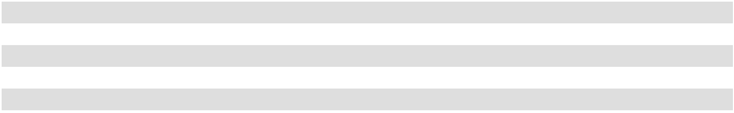

- Beginning with the three months ended June 30, 2025, this capital expenditures category includes spending related to repositioning initiatives at operating properties, as well as planned capital expenditures identified at the time of acquisition.

The increase in tenant improvements and leasing commissions for the year ended December 31, 2025 compared to the year ended December 31, 2024 was primarily related to new tenant build-outs at Coastal Collection at Torrey Reserve, Solana Crossing, 14 Acres, Timber Ridge and Carmel Country Plaza during the year ended December 31, 2025, partially offset by tenant build-outs completed at La Jolla Commons, City Center Bellevue and Alamo Quarry Market during the year ended December 31, 2024. Additionally, the decrease in retail tenant improvements and leasing commissions is due to the sale of Del Monte Center during the first quarter of 2025.

The decrease in capital expenditures for the year ended December 31, 2025 compared to the year ended December 31, 2024 was primarily related to the renovations completed at Imperial Beach, 14 Acres and Lloyd Portfolio during the year ended December 31, 2024, partially offset by an increase at La Jolla Commons I and II, First & Main and Alamo Quarry Market during the year ended December 31, 2025.

Beginning with the second quarter of 2025, this capital expenditures category includes spending related to repositioning initiatives at operating properties, as well as planned capital expenditures identified at the time of acquisition. The increase in redevelopment, expansions and repositioning expenditures for the year ended December 31, 2025 compared to the year ended December 31, 2024, is primarily due to the costs incurred at 14 Acres, Timber Springs, Timber Springs, Genesee Park and La Jolla Commons during the year ended December 31, 2025, partially offset by a decrease in redevelopment expenditures related to the completion of One Beach Street during the year ended December 31, 2024.

New development expenditures for the year ended December 31, 2025 includes the cost related to first generation tenant build-outs at La Jolla Commons III, compared to the costs incurred for the development of La Jolla Commons III during the year ended December 31, 2024.

54

Our capital expenditures for the year ending December 31, 2026 will depend upon acquisition opportunities, the level of improvements and renovations on existing properties and the timing and cost of development of our held for development and construction in progress properties. While the amount of future expenditures will depend on numerous factors, we expect expenditures incurred in the year ending December 31, 2026 to increase from the year ending December 31, 2025 as we continue our renovations at Genesee Park, build-out amenities and speculative suites at One Beach Street and incur first generation tenant improvements at La Jolla Commons III.

Derivative Instruments

We may use derivative instruments to manage exposure to variable interest rate risk. We may enter into interest rate swaps to manage our exposure to variable interest rate risk and treasury locks to manage the risk of interest rates rising prior to the issuance of debt.

Any interest rate swaps associated with our cash flow hedges are recorded at fair value on a recurring basis. We assess effectiveness of our cash flow hedges both at inception and on an ongoing basis. The effective portion of changes in fair value of the interest rate swaps associated with our cash flow hedges is recorded in other comprehensive income which is included in accumulated other comprehensive income on our consolidated balance sheet and our consolidated statement of equity. Our cash flow hedges become ineffective if critical terms of the hedging instrument and the debt instrument do not match, such as notional amounts, settlement dates, reset dates, calculation periods and the use of Secured Overnight Financing Rate (SOFR). In addition, we evaluate the default risk of the counterparty by monitoring the credit worthiness of the counterparty which includes reviewing debt ratings and financial performance. However, management does not anticipate non-performance by the counterparty. If a cash flow hedge is deemed ineffective, the ineffective portion of changes in fair value of the interest rate swaps associated with our cash flow hedges is recognized in earnings in the period affected.

Impairment of Long-Lived Assets

We review for impairment on a property by property basis. Impairment is recognized on properties held for use when the expected undiscounted cash flows for a property are less than its carrying amount at which time the property is written-down to fair value. The calculation of both discounted and undiscounted cash flows requires management to make estimates of future cash flows including revenues, operating expenses, required maintenance and development expenditures, market conditions, demand for space by tenants and rental rates over long periods. Since our properties typically have a long life, the assumptions used to estimate the future recoverability of book value requires significant management judgment. Actual results could be significantly different from the estimates. These estimates have a direct impact on net income because recording an impairment charge results in a negative adjustment to net income. The evaluation of anticipated cash flows is highly subjective and is based in part on assumptions regarding future occupancy, rental rates and capital requirements that could differ materially from actual results in future periods.

Properties held for sale are recorded at the lower of the carrying amount or the expected sales price less costs to sell. Although our strategy is to hold our properties over the long-term, if our strategy changes or market conditions otherwise dictate an earlier sale date, an impairment loss may be recognized to reduce the property to fair value and such loss could be material.

No impairment charges were recorded for the years ended December 31, 2025, 2024 or 2023.

Income Taxes

We elected to be taxed as a REIT under the Code commencing with the taxable year ended December 31, 2011. To maintain our qualification as a REIT, we are required to distribute at least 90% of our net taxable income to our stockholders, excluding net capital gains, and meet the various other requirements imposed by the Code relating to such matters as operating results, asset holdings, distribution levels and diversity of stock ownership. Provided we maintain our qualification for taxation as a REIT, we are generally not subject to corporate level income tax on the earnings distributed currently to our stockholders. If we fail to maintain our qualification as a REIT in any taxable year, and are unable to avail ourselves of certain savings provisions set forth in the Code, our taxable income generally would be subject to regular U.S. federal corporate income tax. Any such corporate tax liability could be substantial and would reduce our cash available for, among other things, our operations and distributions to American Assets Trust, Inc.'s stockholders or American Assets Trust, L.P.'s unitholders.

We, together with one of our subsidiaries, have elected to treat such subsidiary as a taxable REIT subsidiary for federal income tax purposes. A taxable REIT subsidiary is subject to federal and state income taxes.

55

Property Acquisitions and Dispositions

2025 Acquisitions and Dispositions

On February 28, 2025, we acquired Genesee Park in San Diego, California, consisting of a 192-unit apartment community. The purchase price was $67.9 million, excluding closing costs and prorations. We acquired the property with cash on hand, primarily from the proceeds received from the sale of Del Monte Center.

On February 25, 2025, we sold Del Monte Center, which is located in Monterey, California and was previously included in our retail segment. The sale price of this property of approximately $123.5 million, less closing costs and prorations, resulting in net proceeds of approximately $117.8 million. Accordingly, we recorded a gain on the sale of approximately $44.5 million for the year ended December 31, 2025.

2024 Acquisitions and Dispositions

During the year ended December 31, 2024, there were no acquisitions or dispositions.

2023 Acquisitions and Dispositions

During the year ended December 31, 2023, there were no acquisitions or dispositions.

Results of Operations

For our discussion of results of operations, we have provided information on a total portfolio and same-store basis.

For our discussion related to the results of operations and liquidity and capital resources for the year ended December 31, 2024 compared to the year ended December 31, 2023 please refer to Part II, Item 7. Management's Discussion and Analysis of Financial Condition and Results of Operations in our fiscal 2024 Form 10-K, filed with the Securities and Exchange Commission on February 12, 2025.

Comparison of the Year Ended December 31, 2025 to the Year Ended December 31, 2024

The following summarizes our consolidated results of operations for the year ended December 31, 2025 compared to our consolidated results of operations for the year ended December 31, 2024. As of December 31, 2025, our operating portfolio was comprised of 31 office, retail, multifamily and mixed-use properties with an aggregate of approximately 6.8 million rentable square feet of office and retail space (including mixed-use retail space), 2,302 residential units (including 120 RV spaces) and a 369-room hotel. Additionally, as of December 31, 2025, we owned land at two of our properties that we classified as held for development or construction in progress. As of December 31, 2024, our operating portfolio was comprised of 31 office, retail, multifamily and mixed-use properties with an aggregate of approximately 7.3 million rentable square feet of office and retail space (including mixed-use retail space), 2,110 residential units (including 120 RV spaces) and a 369-room hotel. Additionally, as of December 31, 2024, we owned land at three of our properties that we classified as held for development or construction in progress.

56

The following table sets forth selected data from our consolidated statements of comprehensive income for the years ended December 31, 2025 and 2024 (dollars in thousands):

 |  | Year Ended December 31,
 |  | 2025 |  |  | 2024 |  |  | Change | %
Revenues
Rental income | $ | 410,493 | $ |  | 423,611 | $ |  | (13,118) | (3)%
Other property income |  | 25,711 |  |  | 34,244 |  |  | (8,533) |  | (25)
Total property revenues |  | 436,204 |  |  | 457,855 |  |  | (21,651) | (5)
Expenses
Rental expenses |  | 124,601 |  |  | 123,503 |  |  | 1,098 | 1
Real estate taxes |  | 44,994 |  |  | 44,224 |  |  | 770 |  | 2
Total property expenses |  | 169,595 |  |  | 167,727 |  |  | 1,868 |  | 1
Total property operating income |  | 266,609 |  |  | 290,128 |  |  | (23,519) |  | (8)
General and administrative |  | (37,841) |  |  | (35,468) |  |  | (2,373) | 7
Depreciation and amortization |  | (127,312) |  |  | (125,461) |  |  | (1,851) | 1
Interest expense, net |  | (78,120) |  |  | (74,527) |  |  | (3,593) | 5
Gain on sale of real estate |  | 44,476 |  |  | — |  |  | 44,476 | 100
Other income, net |  | 3,558 |  |  | 18,147 |  |  | (14,589) |  | 80
Net income |  | 71,370 |  |  | 72,819 |  |  | (1,449) | (2)
Net income attributable to restricted shares |  | (852) |  |  | (787) |  |  | (65) | 8
Net income attributable to unitholders in the Operating Partnership |  | (14,870) |  |  | (15,234) |  |  | 364 |  | (2)
Net income attributable to American Assets Trust, Inc. | $ | 55,648 | $ |  | 56,798 | $ |  | (1,150) | (2)%
stockholders
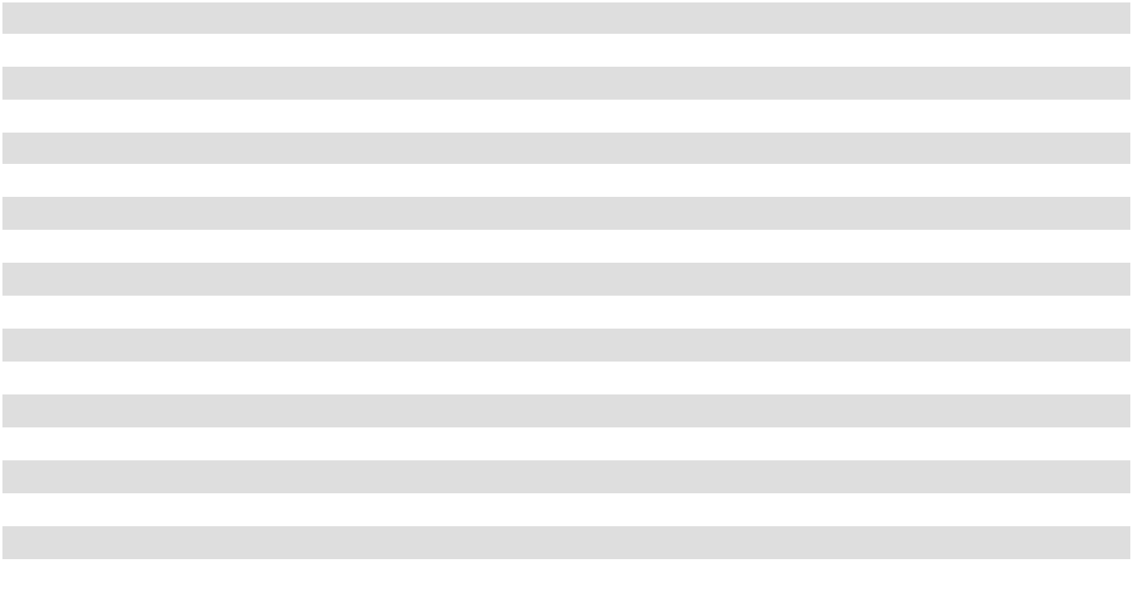

Revenue

Total property revenues. Total property revenue consists of rental revenue and other property income. Total property revenue decreased $21.7 million, or 5%, to $436.2 million for the year ended December 31, 2025, compared to $457.9 million for the year ended December 31, 2024. The percentage leased was as follows for each segment as of December 31, 2025 and 2024:

Percentage Leased ⁽¹⁾
Year Ended

December 31,

2025 |  | 2024
Office | 83.1 % | 85.0 %
Retail | 97.7 % | 94.5 %
Multifamily | 91.1 % | 91.8 %
Mixed-Use ⁽²⁾ | 96.2 % | 90.5 %
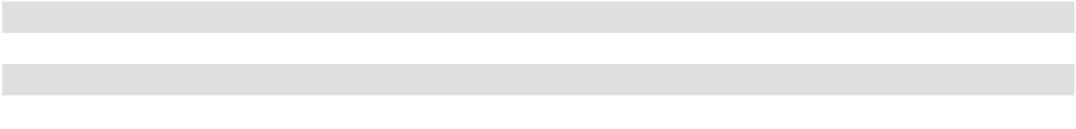

- The percentage leased includes the square footage under lease, including leases which may not have commenced as of December 31, 2025 or December 31, 2024, as applicable. Leased units for our multifamily properties include total units leased and occupied as of the applicable date.
- Includes the retail portion of the mixed-use property only.

The decrease in total property revenue was attributable primarily to the factors discussed below.

Rental revenues. Rental revenue includes minimum base rent, cost reimbursements, percentage rents and other rents. Rental revenue decreased $13.1 million, or 3%, to $410.5 million for the year ended December 31, 2025, compared to $423.6 million for the year ended December 31, 2024. Rental revenue by segment was as follows (dollars in thousands):

57

 |  |  |  |  | Total Portfolio |  |  |  |  |  |  |  |  |  | Same-Store Portfolio ⁽¹⁾
 |  | Year Ended December 31, |  |  |  |  |  |  |  |  |  |  | Year Ended December 31,
 |  | 2025 |  |  | 2024 |  |  | Change |  | % |  |  | 2025 |  |  | 2024 |  |  | Change |  | %
Office | $ | 197,418 | $ |  | 198,601 |  | $ | (1,183) | (1)% |  | $ |  | 196,406 | $ |  | 198,573 | $ |  | (2,167) | (1)%
Retail |  | 93,965 |  |  | 107,397 |  |  | (13,432) | (13) |  |  |  | 92,367 |  |  | 91,537 |  |  | 830 | 1
Multifamily |  | 65,010 |  |  | 61,448 |  |  | 3,562 | 6 |  |  |  | 61,133 |  |  | 61,448 |  |  | (315) | (1)
Mixed-Use |  | 54,100 |  |  | 56,165 |  |  | (2,065) |  | (4) |  |  | 54,100 |  |  | 56,165 |  |  | (2,065) |  | (4)
 | $ | 410,493 | $ |  | 423,611 |  | $ | (13,118) | (3)% |  | $ |  | 404,006 | $ |  | 407,723 | $ |  | (3,717) | (1)%
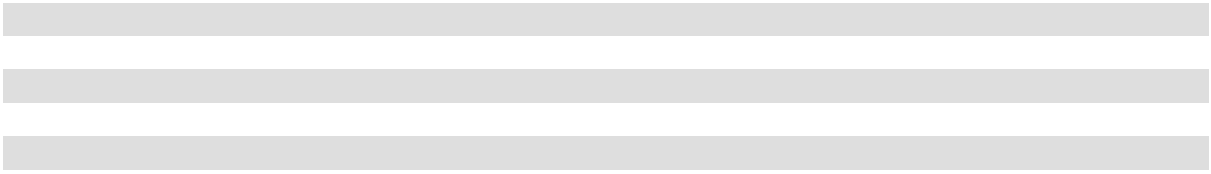

- For this table and the tables following, the same-store portfolio excludes: (i) One Beach Street (office) due to significant redevelopment; (ii) Del Monte Center (retail), which was sold on February 25, 2025; (iii) Genesee Park (multifamily), which was acquired on February 28, 2025, (iv) La Jolla Commons III (office), which was placed into operations on April 1, 2025 and (v) land held for development (office).

Total office rental revenue decreased $1.2 million for the year ended December 31, 2025 compared to the year ended December 31, 2024 primarily due to lower occupancy at Coastal Collection at Torrey Reserve and First & Main. This decrease was partially offset by an increase in occupancy and annualized base rents at City Center Bellevue and Timber Ridge. Additionally, with new tenant lease commencements at La Jolla Commons III, we recognized $1.0 million in non-same store rental revenue.

Total retail rental revenue decreased $13.4 million for the year ended December 31, 2025 compared to the year ended December 31, 2024 primarily due to the sale of Del Monte Center on February 25, 2025. Same-store retail rental revenue increased $0.8 million due to new tenant leases and scheduled rent increases at Carmel Mountain Plaza and Alamo Quarry Market.

Multifamily rental revenue increased $3.6 million for the year ended December 31, 2025 compared to the year ended December 31, 2024 primarily due to the acquisition of Genesee Park on February 28, 2025. Same-store multifamily rental revenue decreased $0.3 million due to a decrease in occupancy and a slight increase in average monthly base rent. Same-store average monthly base rent and occupancy was $2,775 and 89.5% for the year ended December 31, 2025, compared to $2,718 and 91.0% for the year ended December 31, 2024.

Mixed-use rental revenue decreased $2.1 million for the year ended December 31, 2025 compared to the year ended December 31, 2024 primarily due to a decrease in tourism, which led to a decrease in average occupancy and revenue per available room to 82.3% and $296 for the year ended December 31, 2025 compared to 85.9% and $319 for the year ended December 31, 2024. This decrease was partially offset by an increase in rental revenue at the retail portion of our mixed-use property, primarily due to new tenant leases commencing at higher base rents and an increase in cost recoveries.

Other property income. Other property income decreased $8.5 million, or 25%, to $25.7 million for the year ended December 31, 2025, compared to $34.2 million for the year ended December 31, 2024. Other property income by segment was as follows (dollars in thousands):

 |  |  |  |  | Total Portfolio |  |  |  |  |  |  |  |  |  | Same-Store Portfolio
 |  | Year Ended December 31, |  |  |  |  |  |  |  |  |  |  | Year Ended December 31,
 |  | 2025 |  |  | 2024 |  |  | Change |  | % |  |  | 2025 |  |  | 2024 |  |  | Change |  | %
Office | $ | 8,619 | $ |  | 17,177 |  | $ | (8,558) | (50)% |  | $ |  | 8,558 | $ |  | 17,146 | $ |  | (8,588) | (50)%
Retail |  | 1,157 |  |  | 1,643 |  |  | (486) | (30) |  |  |  | 1,161 |  |  | 1,650 |  |  | (489) | (30)
Multifamily |  | 3,951 |  |  | 3,924 |  |  | 27 | 1 |  |  |  | 3,918 |  |  | 3,924 |  |  | (6) |  | —
Mixed-Use |  | 11,984 |  |  | 11,500 |  |  | 484 |  | 4 |  |  | 11,984 |  |  | 11,500 |  |  | 484 |  | 4
 | $ | 25,711 | $ |  | 34,244 |  | $ | (8,533) | (25)% |  | $ |  | 25,621 | $ |  | 34,220 | $ |  | (8,599) | (25)%
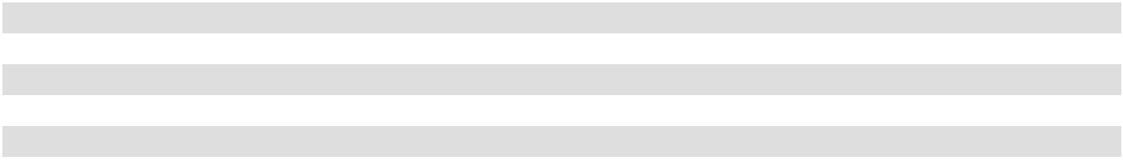

Total office other property income decreased $8.6 million for the year ended December 31, 2025 compared to the year ended December 31, 2024 primarily due to lease termination fees received at Coastal Collection at Torrey Reserve in 2024. This decrease was partially offset by lease termination fees received at 14Acres and Timber Ridge in 2025 and an increase in parking garage income at City Center Bellevue, First & Main and Lloyd Portfolio.

Retail other property income decreased $0.5 million for the year ended December 31, 2025 compared to the year ended December 31, 2024 primarily due to lease termination fees received at Alamo Quarry Market and Solana Beach Towne Center in 2024.

58

Mixed-use other property income increased $0.5 million for the year ended December 31, 2025 compared to the year ended December 31, 2024 primarily due to an increase in parking income and lease settlement fees received at the retail portion of our mixed-use property.

Property Expenses

Total Property Expenses. Total property expenses consist of rental expenses and real estate taxes. Total property expenses increased by $1.9 million, or 1%, to $169.6 million for the year ended December 31, 2025, compared to $167.7 million for the year ended December 31, 2024. This increase in total property expenses was attributable primarily to the factors discussed below.

Rental Expenses. Rental expenses increased $1.1 million, or 1%, to $124.6 million for the year ended December 31, 2025, compared to $123.5 million for the year ended December 31, 2024. Rental expense by segment was as follows (dollars in thousands):

 |  |  |  |  | Total Portfolio |  |  |  |  |  |  |  |  |  | Same-Store Portfolio
 |  | Year Ended December 31, |  |  |  |  |  |  |  |  |  |  | Year Ended December 31,
 |  | 2025 |  |  | 2024 |  |  | Change |  | % |  |  | 2025 |  |  | 2024 |  |  | Change |  | %
Office | $ | 46,223 | $ |  | 43,181 |  | $ | 3,042 | 7 % |  | $ |  | 43,237 | $ |  | 41,618 | $ |  | 1,619 | 4 %
Retail |  | 14,823 |  |  | 18,578 |  |  | (3,755) | (20) |  |  |  | 13,957 |  |  | 14,102 |  |  | (145) | (1)
Multifamily |  | 23,810 |  |  | 21,603 |  |  | 2,207 | 10 |  |  |  | 21,973 |  |  | 21,603 |  |  | 370 | 2
Mixed-Use |  | 39,745 |  |  | 40,141 |  |  | (396) |  | (1) |  |  | 39,745 |  |  | 40,141 |  |  | (396) |  | (1)
 | $ | 124,601 | $ |  | 123,503 |  | $ | 1,098 | 1 % |  | $ |  | 118,912 | $ |  | 117,464 | $ |  | 1,448 | 1 %

Total office rental expenses increased $3.0 million for the year ended December 31, 2025 compared to the year ended December 31, 2024 primarily due to a $1.5 million increase at La Jolla Commons Tower III related to new operations and amenities. Same-store office rental expense increased $1.6 million due to higher utilities expense, facilities services expense and repairs and maintenance expense.

Total retail rental expenses decreased $3.8 million for the year ended December 31, 2025 compared to the year ended December 31, 2024 primarily due to a $3.6 million decrease related to the sale of Del Monte Center in the first quarter of 2025. Same-store retail rental expenses decreased due to $0.5 million written off during the first quarter of 2024 for non-recurring costs related to construction in progress for then-prospective construction at Waikele Center. These decreases were offset by an increase in facilities services expense and repairs and maintenance expense.

Multifamily rental expenses increased $2.2 million for the year ended December 31, 2025 compared to the year ended December 31, 2024 primarily due to a $1.8 million increase related to the acquisition of Genesee Park in the first quarter of 2025. Same-store multifamily rental expenses increased due to an overall increase in insurance expense, facilities services expense and repairs and maintenance expense across most of our other multifamily properties.

Mixed-use rental expenses decreased $0.4 million for the year ended December 31, 2025 compared to the year ended December 31, 2024 primarily due to a decrease in room-related expenses at the hotel portion of our mixed-use property, partially offset by an increase in utilities expense and facilities services expense at the retail portion of our mixed-use property.

Real Estate Taxes. Real estate tax expense increased $0.8 million, or 2%, to $45.0 million for the year ended December 31, 2025, compared to $44.2 million for the year ended December 31, 2024. Real estate tax expense by segment was as follows (dollars in thousands):

 |  |  |  |  | Total Portfolio |  |  |  |  |  |  |  |  |  | Same-Store Portfolio
 |  | Year Ended December 31, |  |  |  |  |  |  |  |  |  |  | Year Ended December 31,
 |  | 2025 |  |  | 2024 |  |  | Change |  | % |  |  | 2025 |  |  | 2024 |  |  | Change |  | %
Office | $ | 20,675 | $ |  | 19,053 |  | $ | 1,622 | 9 % |  | $ |  | 18,509 | $ |  | 18,631 | $ |  | (122) | (1)%
Retail |  | 11,961 |  |  | 13,930 |  |  | (1,969) | (14) |  |  |  | 12,137 |  |  | 12,821 |  |  | (684) | (5)
Multifamily |  | 8,141 |  |  | 7,186 |  |  | 955 | 13 |  |  |  | 7,510 |  |  | 7,186 |  |  | 324 | 5
Mixed-Use |  | 4,217 |  |  | 4,055 |  |  | 162 |  | 4 |  |  | 4,217 |  |  | 4,055 |  |  | 162 |  | 4
 | $ | 44,994 | $ |  | 44,224 |  | $ | 770 | 2 % |  | $ |  | 42,373 | $ |  | 42,693 | $ |  | (320) | (1)%

59

Total office real estate taxes increased $1.6 million for the year ended December 31, 2025 compared to the year ended December 31, 2024 primarily due to an increase at La Jolla Commons III and One Beach Street since we stopped capitalizing real estate taxes when the buildings were placed into service on April 1, 2025 and August 1, 2024, respectively. Additionally, there was an increase at La Jolla Commons I and II due to real estate tax refunds received during the year ended December 31, 2024. These increases were offset by a decrease in property tax assessments at City Center Bellevue, 14Acres and Timber Ridge.

Retail real estate taxes decreased $2.0 million for the year ended December 31, 2025 compared to the year ended December 31, 2024 primarily due to the sale of Del Monte Center on February 25, 2025 and a decrease in property tax assessments at Alamo Quarry Market and real estate tax refunds received at Alamo Quarry Market and Carmel Mountain Plaza in 2025.

Multifamily real estate taxes increased $1.0 million for the year ended December 31, 2025 compared to the year ended December 31, 2024 primarily due to $0.6 million related to the acquisition of Genesee Park on February 28, 2025, and an increase in property tax assessments mainly at Pacific Ridge Apartments, Loma Palisades and Hassalo on Eighth - Multifamily.

Mixed-use real estate taxes increased $0.2 million for the year ended December 31, 2025 compared to the year ended December 31, 2024 primarily due to an increase in property tax assessments.

Property Operating Income.

Property operating income decreased $23.5 million, or 8%, to $266.6 million for the year ended December 31, 2025, compared to $290.1 million for the year ended December 31, 2024. Property operating income by segment was as follows (dollars in thousands):

 |  |  |  |  | Total Portfolio |  |  |  |  |  |  |  |  | Same-Store Portfolio
 |  | Year Ended December 31, |  |  |  |  |  |  |  |  |  | Year Ended December 31,
 |  | 2025 |  |  | 2024 |  | Change |  | % |  |  | 2025 |  |  | 2024 |  | Change |  | %
Office | $ | 139,139 | $ |  | 153,544 |  | $ (14,405) | (9)% |  | $ |  | 143,218 | $ |  | 155,470 | $ (12,252) |  | (8)%
Retail |  | 68,338 |  |  | 76,532 |  | (8,194) | (11) |  |  |  | 67,434 |  |  | 66,264 | 1,170 |  | 2
Multifamily |  | 37,010 |  |  | 36,583 |  | 427 | 1 |  |  |  | 35,568 |  |  | 36,583 | (1,015) |  | (3)
Mixed-Use |  | 22,122 |  |  | 23,469 |  | (1,347) |  | (6) |  |  | 22,122 |  |  | 23,469 |  | (1,347) |  | (6)
 | $ | 266,609 | $ |  | 290,128 |  | $ (23,519) | (8)% |  | $ |  | 268,342 | $ |  | 281,786 | $ (13,444) |  | (5)%
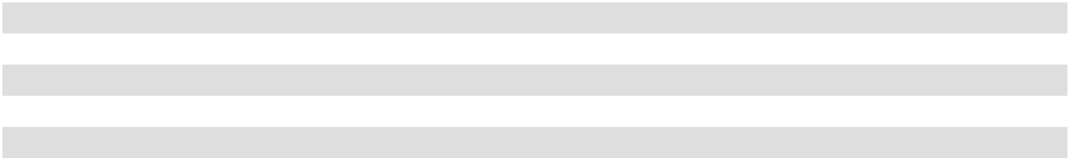

Total office operating income decreased $14.4 million for the year ended December 31, 2025 compared to the year ended December 31, 2024 primarily due to $11.0 million in lease termination fees received at Coastal Collection at Torrey Reserve in 2024, a decrease in rental revenue driven primarily by lower occupancy at Coastal Collection at Torrey Reserve and First & Main and an increase in utilities expense, facilities services expense, repairs and maintenance expense and real estate tax expense. These decreases were partially offset by an increase in occupancy and annualized base rents at City Center Bellevue, Timber Ridge and La Jolla Commons III, an increase in lease termination fees received at 14Acres and Timber Ridge in 2025 and an increase in parking garage income.

Retail operating income decreased $8.2 million for the year ended December 31, 2025 compared to the year ended December 31, 2024 primarily due to the sale of Del Monte Center. Same-store retail operating income increased $1.2 million due to new tenant leases and scheduled rent increases at Carmel Mountain Plaza and Alamo Quarry Market. Additionally, there was a decrease in real estate taxes due to lower property tax assessments at Alamo Quarry Market and an increase in real estate tax refunds received at Alamo Quarry Market and Carmel Mountain Plaza in 2025.

Multifamily operating income increased $0.4 million for the year ended December 31, 2025 compared to the year ended December 31, 2024 primarily due to the acquisition of Genesee Park. Same-store multifamily operating income decreased $1.0 million due to a decrease in average occupancy and a slight increase in monthly base rent of 89.5% and $2,775, respectively, for the year ended December 31, 2025 compared to 91.0% and $2,718, respectively, for the year ended December 31, 2024. Additionally, there was an increase in insurance expense, facilities services expense, repairs and maintenance expense and real estate tax expense.

60

Mixed-use operating income decreased $1.3 million for the year ended December 31, 2025 compared to the year ended December 31, 2024 primarily due to a decrease in tourism, which led to a decrease in average occupancy and revenue per available room to 82.3% and $296, respectively, for the year ended December 31, 2025, respectively, compared to 85.9% and $319, respectively, for the year ended December 31, 2024, respectively. This decrease was partially offset by an increase in parking income, lease settlement fees and rental revenue at the retail portion of our mixed-use property.

Other

General and administrative. General and administrative expenses increased $2.4 million, or 7%, to $37.8 million for the year ended December 31, 2025, compared to $35.5 million for the year ended December 31, 2024. This increase was primarily due to higher corporate legal expenses, consulting fees and employee-related costs, including, without limitation, with respect to base pay and benefits for certain salaried and hourly workers.

Depreciation and amortization. Depreciation and amortization expense increased $1.9 million, or 1%, to $127.3 million for the year ended December 31, 2025, compared to $125.5 million for the year ended December 31, 2024. This increase was primarily due to $2.5 million related to the acquisition of Genesee Park on February 28, 2025, $3.1 million related to La Jolla Commons III, which was placed in service on April 1, 2025, $0.9 million related to One Beach Street, which was placed in service on August 1, 2024 and new tenant improvements, building improvements and leasing commission assets placed into service. These increases were partially offset by lower depreciation expense at Coastal Collection at Torrey Reserve due to asset acceleration for a tenant vacating their space early in 2024 and Del Monte Center, which was sold on February 25, 2025.

Interest expense, net. Interest expense, net increased $3.6 million, or 5%, to $78.1 million for the year ended December 31, 2025 compared to $74.5 million for the year ended December 31, 2024. This increase was primarily due to the closing of our 6.150% Senior Notes on September 17, 2024 and a decrease in capitalized interest related to La Jolla Commons III being placed into service on April 1, 2025. This increase was partially offset by a decrease in interest expense related to the maturity and repayment of our Series F Notes on July 19, 2024, Series B Notes on December 2, 2024, Term Loan B and Term Loan C on January 2, 2025 and Series C Notes on February 3, 2025.

Gain on sale of real estate. The gain on sale of real estate of $44.5 million during the period was due to our sale of Del Monte Center on February 25, 2025.

Other Income, Net. Other income, net decreased $14.6 million, or 80%, to other income, net of $3.6 million for the year ended December 31, 2025 compared to other income, net of $18.1 million for the year ended December 31, 2024. This decrease was primarily due to the net settlement payment of approximately $10.0 million received during the three months ended March 31, 2024 relating to building specifications for one of the existing buildings at our office project in University Town Center (San Diego) and a decrease in interest and investment income attributed to a lower yield and average cash balance during the period.

Liquidity and Capital Resources of American Assets Trust, Inc.

In this “Liquidity and Capital Resources of American Assets Trust, Inc.” section, the term the “company” refers only to American Assets Trust, Inc. on an unconsolidated basis, and excludes the Operating Partnership and all other subsidiaries.

The company’s business is operated primarily through the Operating Partnership, of which the company is the parent company and sole general partner, and which it consolidates for financial reporting purposes. Because the company operates on a consolidated basis with the Operating Partnership, the section entitled “Liquidity and Capital Resources of American Assets Trust, L.P.” should be read in conjunction with this section to understand the liquidity and capital resources of the company on a consolidated basis and how the company is operated as a whole.

The company issues public equity from time to time, but does not otherwise generate any capital itself or conduct any business itself, other than incurring certain expenses in operating as a public company which are fully reimbursed by the Operating Partnership. The company itself does not have any indebtedness, and its only material asset is its ownership of partnership interests of the Operating Partnership. Therefore, the consolidated assets and liabilities and the consolidated revenues and expenses of the company and the Operating Partnership are the same on their respective financial statements. However, all debt is held directly or indirectly by the Operating Partnership. The company’s principal funding requirement is the payment of dividends on its common stock. The company’s principal source of funding for its dividend payments is distributions it receives from the Operating Partnership.

61

As of December 31, 2025, the company owned an approximate 78.95% partnership interest in the Operating Partnership. The remaining 21.05% are owned by non-affiliated investors and certain of the company's directors and executive officers. As the sole general partner of the Operating Partnership, American Assets Trust, Inc. has the full, exclusive and complete authority and control over the Operating Partnership’s day-to-day management and business, can cause it to enter into certain major transactions, including acquisitions, dispositions and refinancings, and can cause changes in its line of business, capital structure and distribution policies. The company causes the Operating Partnership to distribute such portion of its available cash as the company may in its discretion determine, in the manner provided in the Operating Partnership’s partnership agreement.

The liquidity of the company is dependent on the Operating Partnership’s ability to make sufficient distributions to the company. The primary cash requirement of the company is its payment of dividends to its stockholders. The company also guarantees some of the Operating Partnership’s debt, as discussed further in Note 7 of the Notes to Consolidated Financial Statements included elsewhere herein. If the Operating Partnership fails to fulfill certain of its debt requirements, which trigger the company’s guarantee obligations, then the company will be required to fulfill its cash payment commitments under such guarantees. However, the company’s only significant asset is its investment in the Operating Partnership.

We believe the Operating Partnership’s sources of working capital, specifically its cash flow from operations, and borrowings available under its unsecured line of credit, are adequate for it to make its distribution payments to the company and, in turn, for the company to make its dividend payments to its stockholders. As of December 31, 2025, the company has determined that it has adequate working capital to meet its dividend funding obligations for the next 12 months. However, we cannot assure you that the Operating Partnership’s sources of capital will continue to be available at all or in amounts sufficient to meet its needs, including its ability to make distribution payments to the company. The unavailability of capital could adversely affect the Operating Partnership’s ability to pay its distributions to the company, which would in turn, adversely affect the company’s ability to pay cash dividends to its stockholders.

Our short-term liquidity requirements consist primarily of funds to pay for future dividends expected to be paid to the company’s stockholders, operating expenses and other expenditures directly associated with our properties, interest expense and scheduled principal payments on outstanding indebtedness, general and administrative expenses, funding construction projects, capital expenditures, tenant improvements and leasing commissions.

The company may from time to time seek to repurchase or redeem the Operating Partnership’s outstanding debt, the company’s shares of common stock or other securities in open market purchases, privately negotiated transactions or otherwise. Such repurchases or redemptions, if any, will depend on prevailing market conditions, our liquidity requirements, contractual restrictions and other factors. The amounts involved may be material.

For the company to maintain its qualification as a REIT, it must pay dividends to its stockholders aggregating annually at least 90% of its REIT taxable income, excluding net capital gains. While historically the company has satisfied this distribution requirement by making cash distributions to American Assets Trust, Inc.'s stockholders, it may choose to satisfy this requirement by making distributions of cash or other property, including, in limited circumstances, the company’s own stock. As a result of this distribution requirement, the Operating Partnership cannot rely on retained earnings to fund its ongoing operations to the same extent that other companies whose parent companies are not REITs can. The company may need to continue to raise capital in the equity markets to fund the Operating Partnership’s working capital needs, acquisitions and developments. Although there is no intent at this time, if market conditions deteriorate, the company may also delay the timing of future development and redevelopment projects as well as limit future acquisitions, reduce the Operating Partnership’s operating expenditures, or re-evaluate its dividend policy.

The company is a well-known seasoned issuer. As circumstances warrant, the company may issue equity from time to time on an opportunistic basis, dependent upon market conditions and available pricing. When the company receives proceeds from preferred or common equity issuances, it is required by the Operating Partnership’s partnership agreement to contribute the proceeds from its equity issuances to the Operating Partnership in exchange for preferred or common partnership units of the Operating Partnership. The Operating Partnership may use the proceeds to repay debt, to develop new or existing properties, to acquire properties or for general corporate purposes.

In December 2023, the company filed a universal shelf registration statement on Form S-3ASR with the SEC, which became effective upon filing and which replaced the prior Form S-3ASR that was filed with the SEC in January 2021. The universal shelf registration statement may permit the company from time to time to offer and sell equity securities of the company. However, there can be no assurance that the company will be able to complete any such offerings of securities. Factors influencing the availability of additional financing include investor perception of our prospects and the general condition of the financial markets, among others.

62

On December 3, 2021, the company entered into a new at-the-market (“ATM”) equity program with five sales agents in

which we may, from time to time, offer and sell shares of our common stock having an aggregate offering price of up to

$250 million. The sales of shares of our common stock made through the ATM equity program, as amended, are made in “at-

the-market” offerings as defined in Rule 415 of the Securities Act of 1933, as amended. For the year ended December 31, 2025,

no shares of common stock were sold through the ATM equity program.

We intend to use the net proceeds from the ATM equity program to fund development or redevelopment activities, repay amounts outstanding from time to time under our revolving line of credit or other debt financing obligations, fund potential acquisition opportunities and/or for general corporate purposes. As of December 31, 2025, we had the capacity to issue up to $250 million in shares of common stock under our current ATM equity program. Actual future sales will depend on a variety of factors including, but not limited to, market conditions, the trading price of our common stock and our capital needs. As of December 31, 2025, we have no obligation to sell the remaining shares available for sale under the ATM equity program.

Liquidity and Capital Resources of American Assets Trust, L.P.

In this “Liquidity and Capital Resources of American Assets Trust, L.P.” section, the terms “we,” “our” and “us” refer to the Operating Partnership together with its consolidated subsidiaries, or the Operating Partnership and American Assets Trust, Inc. together with their consolidated subsidiaries, as the context requires. American Assets Trust, Inc. is our sole general partner and consolidates our results of operations for financial reporting purposes. Because we operate on a consolidated basis with American Assets Trust, Inc., the section entitled “Liquidity and Capital Resources of American Assets Trust, Inc.” should be read in conjunction with this section to understand our liquidity and capital resources on a consolidated basis.

Due to the nature of our business, we typically generate significant amounts of cash from operations. The cash generated from operations is used for the payment of operating expenses, capital expenditures, debt service and dividends to American Assets Trust, Inc.'s stockholders and our unitholders. As a REIT, American Assets Trust, Inc. must generally make annual distributions to its stockholders of at least 90% of its net taxable income.

Our short-term liquidity requirements consist primarily of operating expenses and other expenditures associated with our properties, regular debt service requirements, dividend payments to American Assets Trust, Inc.'s stockholders required to maintain its REIT status, distributions to our other unitholders, capital expenditures and, potentially, acquisitions. We expect to meet our short-term liquidity requirements through net cash provided by operations, reserves established from existing cash and, if necessary, borrowings available under our third amended and restated credit facility.

Our long-term liquidity needs consist primarily of funds necessary to pay for the repayment of debt at maturity, property acquisitions, tenant improvements and capital improvements. We expect to meet our long-term liquidity requirements to pay scheduled debt maturities and to fund property acquisitions and capital improvements with net cash from operations, long-term secured and unsecured indebtedness and, if necessary, the issuance of equity and debt securities. We also may fund property acquisitions and capital improvements using our third amended and restated credit facility pending permanent financing. We believe that we have access to multiple sources of capital to fund our long-term liquidity requirements, including the incurrence of additional debt, noting that during the third quarter of 2015, the company obtained investment grade credit ratings from Moody’s Investors Service (Baa3), Standard & Poor’s Ratings Services (BBB-) and Fitch Ratings, Inc. (BBB), and the issuance of additional equity. However, we cannot be assured that this will be the case. Our ability to incur additional debt will be dependent on a number of factors, including our degree of leverage, the value of our unencumbered assets and borrowing restrictions that may be imposed by lenders. Our ability to access the equity capital markets will be dependent on a number of factors as well, including general market conditions for REITs and market perceptions about our company. Given our past ability to access the capital markets, we expect debt or equity to be available to us. Although there is no intent at this time, if market conditions deteriorate, we may also delay the timing of future development and redevelopment projects as well as limit future acquisitions, reduce our operating expenditures, or re-evaluate our dividend policy.

Our overall capital requirements will depend upon acquisition opportunities, the level of improvements and redevelopments on existing properties and the timing and cost of developments. Our capital investments will be funded on a short-term basis with cash on hand, cash flow from operations and/or our third amended and restated credit facility.

We intend to operate with and maintain a conservative capital structure that will allow us to maintain strong debt service coverage and fixed-charge coverage ratios as part of our commitment to investment grade debt ratings. In the short and long term, we may seek to obtain funds through the issuance of additional equity, unsecured and/or secured debt financings, and property dispositions that are consistent with this conservative structure.

We currently believe that cash flows from operations, cash on hand, our ATM equity program, our third amended and restated credit facility and our general ability to access the capital markets will be sufficient to finance our operations and fund our debt service requirements and capital expenditures.

63

Contractual Obligations

The following table outlines the timing of required payments related to our commitments as of December 31, 2025 (dollars in thousands):

 |  |  |  |  |  |  | Payments by Period
Contractual Obligations |  | Total |  |  | Within |  | 2 Years |  |  | 3 Years |  |  | 4 Years |  | 5 Years |  | More than
Contractual Obligations |  | Total |  |  | 1 Year |  | 2 Years |  |  |  |  |  | 4 Years |  | 5 Years |  | 5 Years
Principal payments on long-term
indebtedness | $ | 1,700,000 | $ |  | — | $ 425,000 |  | $ |  | — |  |  | $ 100,000 | $ 150,000 |  | $1,025,000
Interest payments |  | 451,936 |  |  | 76,555 | 66,349 |  |  |  | 59,268 |  |  | 57,148 | 55,028 |  | 137,588
Operating lease |  | 20,818 |  |  | 3,584 | 3,637 |  |  |  | 3,746 |  |  | 3,859 | 3,975 |  | 2,017
Tenant-related commitments |  | 33,127 |  |  | 31,288 | 1,289 |  |  |  | 477 |  |  |  |  | — | 73
Construction-related commitments |  | 26,678 |  |  | 23,947 |  | 2,731 |  |  | — |  |  | — |  | — |  | —
Total | $ | 2,232,559 | $ |  | 135,374 | $ 499,006 |  | $ |  | 63,491 |  |  | $ 161,007 | $ 209,003 |  | $1,164,678
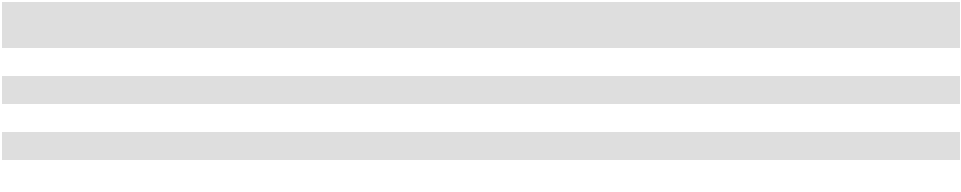

Off-Balance Sheet Arrangements

We currently do not have any off-balance sheet arrangements.

Cash Flows

Comparison of the year ended December 31, 2025 to the year ended December 31, 2024

Cash and cash equivalents were $129.4 million and $425.7 million at December 31, 2025 and 2024, respectively.

Net cash provided by operating activities decreased $40.0 million to $167.1 million for the year ended December 31, 2025, compared to $207.1 million for the year ended December 31, 2024. The decrease in cash from operations was primarily due to the net settlement received during the first quarter of 2024 relating to the building specifications for one of the existing buildings at our office project in University Town Center (San Diego), lease termination fees received at Coastal Collection at Torrey Reserve during 2024 and a decrease in rental revenue and changes in operating assets and liabilities.

Net cash used in investing activities decreased $46.9 million to $30.5 million for the year ended December 31, 2025, compared to $77.4 million for the year ended December 31, 2024. The decrease in cash used was primarily due to the proceeds from the sale of Del Monte Center, offset by the use of cash for the acquisition of Genesee Park and an increase in capital expenditures related to new tenant improvement projects, leasing commissions and building renovation capital projects.

Net cash used in financing activities increased $646.0 million to $432.9 million for the year ended December 31, 2025, compared to net cash provided by financing activities of $213.1 million for the year ended December 31, 2024. The increase in cash used in financing activities was primarily due to the repayment of the $225 million aggregate outstanding balance on our Term Loan B and Term Loan C on January 2, 2025 and the repayment of the $100 million outstanding balance on our Series C Notes, on February 3, 2025.

Net Operating Income

Net Operating Income (“NOI”), is a non-GAAP financial measure of performance. We define NOI as operating revenues (rental income, tenant reimbursements, lease termination fees, ground lease rental income and other property income) less property and related expenses (property expenses, ground lease expenses, property marketing costs, real estate taxes and insurance). NOI excludes general and administrative expenses, interest expense, depreciation and amortization, acquisition-related expense, other non-property income and losses, gains and losses from property dispositions, extraordinary items, tenant improvements and leasing commissions. Other REITs may use different methodologies for calculating NOI, and accordingly, our NOI may not be comparable to other REITs.

64

NOI is used by investors and our management to evaluate and compare the performance of our properties and to determine trends in earnings and to compute the fair value of our properties as it is not affected by (1) the cost of funds of the property owner, (2) the impact of depreciation and amortization expenses as well as gains or losses from the sale of operating real estate assets that are included in net income computed in accordance with GAAP, or (3) general and administrative expenses and other gains and losses that are specific to the property owner. The cost of funds is eliminated from net income because it is specific to the particular financing capabilities and constraints of the owner. The cost of funds is also eliminated because it is dependent on historical interest rates and other costs of capital as well as past decisions made by us regarding the appropriate mix of capital which may have changed or may change in the future. Depreciation and amortization expenses as well as gains or losses from the sale of operating real estate assets are eliminated because they may not accurately represent the actual change in value in our office, retail, multifamily or mixed-use properties that result from use of the properties or changes in market conditions. While certain aspects of real property do decline in value over time in a manner that is intended to be captured by depreciation and amortization, the value of the properties as a whole have historically increased or decreased as a result of changes in overall economic conditions instead of from actual use of the property or the passage of time. Gains and losses from the sale of real property vary from property to property and are affected by market conditions at the time of sale which will usually change from period to period. These gains and losses can create distortions when comparing one period to another or when comparing our operating results to the operating results of other real estate companies that have not made similarly timed purchases or sales. We believe that eliminating these costs from net income is useful because the resulting measure captures the actual revenue generated and actual expenses incurred in operating our properties as well as trends in occupancy rates, rental rates and operating costs.

However, the usefulness of NOI is limited because it excludes general and administrative costs, interest expense, interest income and other expense, depreciation and amortization expense and gains or losses from the sale of properties, and other gains and losses as stipulated by GAAP, the level of capital expenditures and leasing costs necessary to maintain the operating performance of our properties, all of which are significant economic costs. NOI may fail to capture significant trends in these components of net income which further limits its usefulness.

NOI is a measure of the operating performance of our properties but does not measure our performance as a whole. NOI is therefore not a substitute for net income as computed in accordance with GAAP. This measure should be analyzed in conjunction with net income computed in accordance with GAAP and discussions elsewhere in “Management's Discussion and Analysis of Financial Condition and Results of Operations” regarding the components of net income that are eliminated in the calculation of NOI. Other companies may use different methods for calculating NOI or similarly entitled measures and, accordingly, our NOI may not be comparable to similarly entitled measures reported by other companies that do not define the measure exactly as we do.

The following is a reconciliation of our NOI to net income for the years ended December 31, 2025, 2024 and 2023 computed in accordance with GAAP (in thousands):

 |  | Year Ended December 31,
 |  | 2025 |  |  | 2024 |  |  | 2023
Net operating income | $ | 266,609 | $ |  | 290,128 | $ |  | 277,207
General and administrative |  | (37,841) |  |  | (35,468) |  |  | (35,960)
Depreciation and amortization |  | (127,312) |  |  | (125,461) |  |  | (119,500)
Interest expense, net |  | (78,120) |  |  | (74,527) |  |  | (64,706)
Gain on sale of real estate |  | 44,476 |  |  | — |  |  | —
Other income, net |  | 3,558 |  |  | 18,147 |  |  | 7,649
Net income | $ | 71,370 | $ |  | 72,819 | $ |  | 64,690
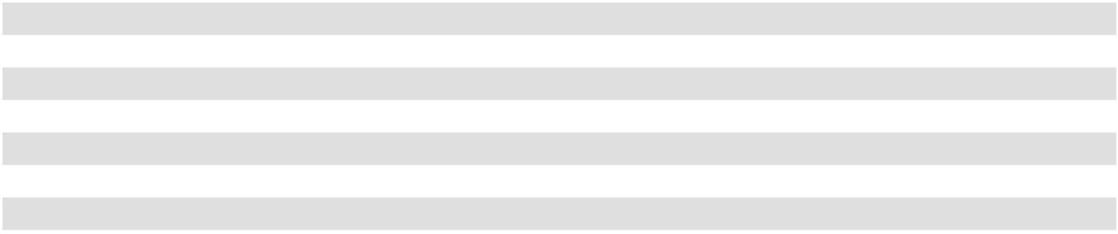

Funds from Operations

We present funds from operations (“FFO”) because we consider FFO an important supplemental measure of our operating performance and believe it is frequently used by securities analysts, investors and other interested parties in the evaluation of REITs, many of which present FFO when reporting their results. We calculate FFO in accordance with the standards established by the National Association of Real Estate Investment Trusts, or NAREIT. FFO represents net income (loss) (computed in accordance with GAAP), excluding gains (or losses) from sales of depreciable operating property, impairment losses, real estate related depreciation and amortization (excluding amortization of deferred financing costs) and after adjustments for unconsolidated partnerships and joint ventures.

65

FFO is a supplemental non-GAAP financial measure. Management uses FFO as a supplemental performance measure because it believes that FFO is beneficial to investors as a starting point in measuring our operational performance. Specifically, in excluding real estate related depreciation and amortization and gains and losses from property dispositions, which do not relate to or are not indicative of operating performance, FFO provides a performance measure that, when compared year over year, captures trends in occupancy rates, rental rates and operating costs. We also believe that, as a widely recognized measure of the performance of REITs, FFO will be used by investors as a basis to compare our operating performance with that of other REITs. However, because FFO excludes depreciation and amortization and captures neither the changes in the value of our properties that result from use or market conditions nor the level of capital expenditures and leasing commissions necessary to maintain the operating performance of our properties, all of which have real economic effects and could materially impact our results from operations, the utility of FFO as a measure of our performance is limited. In addition, other equity REITs may not calculate FFO in accordance with the NAREIT definition as we do, and, accordingly, our FFO may not be comparable to such other REITs' FFO. Accordingly, FFO should be considered only as a supplement to net income as a measure of our performance. FFO should not be used as a measure of our liquidity, nor is it indicative of funds available to fund our cash needs, including our ability to pay dividends or service indebtedness. FFO also should not be used as a supplement to or substitute for cash flow from operating activities computed in accordance with GAAP.

The following table sets forth a reconciliation of our FFO for the years ended December 31, 2025, 2024 and 2023 to net income, the nearest GAAP equivalent (in thousands, except per share and share data):

 |  | Year Ended December 31,
 |  | 2025 |  |  | 2024 |  |  | 2023
Net income | $ | 71,370 | $ |  | 72,819 | $ |  | 64,690
Plus: Real estate depreciation and amortization |  | 127,312 |  |  | 125,461 |  |  | 119,500
Less: Gain on sale of real estate |  | (44,476) |  |  | — |  |  | —
Funds from operations, as defined by NAREIT | $ | 154,206 | $ |  | 198,280 | $ |  | 184,190
Less: Nonforfeitable dividends on restricted stock awards |  | (757) |  |  | (754) |  |  | (749)
FFO attributable to common stock and units | $ | 153,449 |  | $ | 197,526 |  | $ | 183,441
FFO per diluted share/unit
FFO per diluted share/unit | $ | 2.00 |  | $ | 2.58 |  | $ | 2.40
Weighted average number of common shares and units, diluted ⁽¹⁾
 |  | 76,746,917 |  |  | 76,514,433 |  |  | 76,346,772
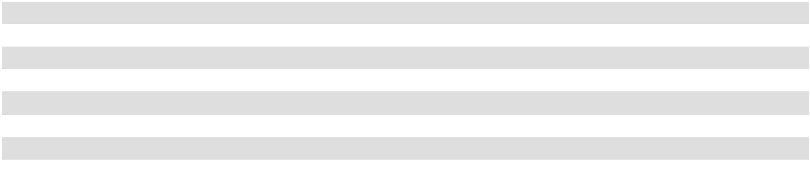

- For the years ended December 31, 2025, 2024 and 2023 the weighted average common shares used to compute FFO per diluted share include unvested restricted stock awards that are subject to time vesting, as the vesting of the restricted stock awards is dilutive in the computation of FFO per diluted shares, but is anti-dilutive for the computation of diluted EPS for the periods. Diluted shares exclude incentive restricted stock as these awards are considered contingently issuable.

Inflation

Substantially all of our office and retail leases provide for separate real estate tax and operating expense escalations. In addition, many of the leases provide for fixed base rent increases. We believe that inflationary increases may be at least partially offset by the contractual rent increases and expense escalations described above. In addition, our multifamily leases (other than at our RV resort where spaces can be rented at a daily, weekly or monthly rate) generally have lease terms ranging from seven to 15 months, with a majority having 12-month lease terms, and generally allow for rent adjustments at the time of renewal, which we believe reduces our exposure to the effects of inflation. For the hotel portion of our mixed-use property, we possess the ability to adjust room rates daily to reflect the effects of inflation. However, competitive pressures may limit our ability to raise room rates.

ITEM 7A. QUANTITATIVE AND QUALITATIVE DISCLOSURES ABOUT MARKET RISK

Our future income, cash flows and fair values relevant to financial instruments are dependent upon prevalent market interest rates. Market risk refers to the risk of loss from adverse changes in market prices and interest rates.

We may enter into certain types of derivative financial instruments to further reduce interest rate risk. We use interest rate swap agreements, for example, to convert some of our variable rate debt to a fixed-rate basis or to hedge anticipated financing transactions. We use derivatives for hedging purposes rather than speculation and do not enter into financial instruments for trading purposes. See the discussion under Note 8, “Derivative and Hedging Activities,” to the accompanying consolidated financial statements for certain quantitative details related to the interest rate swaps.

66

Interest Rate Risk

Outstanding Debt

The following discusses the effect of hypothetical changes in market rates of interest on the fair value of our total outstanding debt. Interest rate risk amounts were determined by considering the impact of hypothetical interest rates on our debt. Discounted cash flow analysis is generally used to estimate the fair value of our mortgages payable. Considerable judgment is necessary to estimate the fair value of financial instruments. This analysis does not purport to take into account all of the factors that may affect our debt, such as the effect that a changing interest rate environment could have on the overall level of economic activity or the action that our management might take to reduce our exposure to the change. This analysis assumes no change in our financial structure.

Fixed Interest Rate Debt

Except as described below, all of our outstanding debt obligations (maturing at various times through October 2034) have fixed interest rates which limit the risk of fluctuating interest rates. However, interest rate fluctuations may affect the fair value of our fixed rate debt instruments. At December 31, 2025, we had $1.6 billion of fixed-rate debt outstanding with an estimated fair value of $1.5 billion. If interest rates at December 31, 2025 had been 1.0% higher, the fair value of those debt instruments on that date would have decreased by approximately $44.1 million. If interest rates at December 31, 2025 had been 1.0% lower, the fair value of those debt instruments on that date would have increased by approximately $90.5 million. The carrying values of our revolving line of credit and term loan approximate fair value since the interest rates are variable and reset frequently based on SOFR. Additionally, we consider our $100 million debt outstanding as of December 31, 2025, related to Term Loan A to be fixed rate debt as the rate is effectively fixed by interest rate swap agreements.

Variable Interest Rate Debt

At December 31, 2025, we had $100 million of variable rate debt outstanding, all of which is subject to interest rate swaps as described above. We have historically entered into forward starting interest rate swaps in order to economically hedge against the risk of rising interest rates that would affect our interest expense related to our future anticipated debt issuances as part of our overall borrowing program. See the discussion under Note 8 of the Notes to Consolidated Financial Statements included elsewhere herein for certain quantitative details related to the interest rate swaps and for a discussion on how we value derivative financial instruments. Based upon this amount of variable rate debt and the specific terms, if market interest rates increased or decreased by 1.0%, our annual interest expense would not change, nor would there be a change in our net income and cash flows for the year, since this variable rate debt is effectively fixed by interest rate swap agreements.

ITEM 8. FINANCIAL STATEMENTS AND SUPPLEMENTARY DATA

Our consolidated financial statements and supplementary data are included as a separate section of this annual report on Form 10-K commencing on page F-1 and are incorporated herein by reference.

ITEM 9. CHANGES IN AND DISAGREEMENTS WITH ACCOUNTANTS ON ACCOUNTING AND FINANCIAL DISCLOSURE

None.

ITEM 9A. CONTROLS AND PROCEDURES

Controls and Procedures (American Assets Trust, Inc.)

Evaluation of Disclosure Controls and Procedures

American Assets Trust, Inc. maintains disclosure controls and procedures (as defined in Rule 13a-15(e) or Rule 15d-15(e) under the Exchange Act) that are designed to ensure that information required to be disclosed in its Exchange Act reports is recorded, processed, summarized and reported within the time periods specified in the SEC’s rules and forms, and that such information is accumulated and communicated to its management, including its Chief Executive Officer and Chief Financial Officer, as appropriate, to allow for timely decisions regarding required disclosure. In designing and evaluating the disclosure controls and procedures, management recognizes that any controls and procedures, no matter how well designed and operated, can provide only reasonable assurance of achieving the desired control objectives, and management is required to apply its judgment in evaluating the cost-benefit relationship of possible controls and procedures.

67

As required by Rule 13a-15(b) under the Exchange Act, American Assets Trust, Inc. carried out an evaluation, under the supervision and with the participation of its management, including its Chief Executive Officer and Chief Financial Officer, of the effectiveness of the design and operation of its disclosure controls and procedures. Based on the foregoing, American Assets Trust, Inc.’s Chief Executive Officer and Chief Financial Officer concluded that, as of the end of the period covered by this report, American Assets Trust, Inc.’s disclosure controls and procedures were effective and were operating at a reasonable assurance level.

Management’s Report on Internal Control over Financial Reporting

Internal control over financial reporting refers to the process designed by, or under the supervision of, American Assets Trust, Inc.’s Chief Executive Officer and Chief Financial Officer, and effected by American Assets Trust, Inc.’s board of directors, management and other personnel, to provide reasonable assurance regarding the reliability of financial reporting and the preparation of financial statements for external purposes in accordance with GAAP, and includes those policies and procedures that: (1) pertain to the maintenance of records that in reasonable detail accurately and fairly reflect the transactions and dispositions of the assets of the company; (2) provide reasonable assurance that transactions are recorded as necessary to permit preparation of financial statements in accordance with GAAP, and that receipts and expenditures of the company are being made only in accordance with authorizations of management and directors of the company; and (3) provide reasonable assurance regarding prevention or timely detection of unauthorized acquisition, use or disposition of the company’s assets that could have a material effect on the financial statements.

Internal control over financial reporting cannot provide absolute assurance of achieving financial reporting objectives because of its inherent limitations. Internal control over financial reporting is a process that involves human diligence and compliance and is subject to lapses in judgment and breakdowns resulting from human failures. Internal control over financial reporting also can be circumvented by collusion or improper management override. Because of such limitations, there is a risk that material misstatements may not be prevented or detected on a timely basis by internal control over financial reporting. However, these inherent limitations are known features of the financial reporting process. Therefore, it is possible to design into the process safeguards to reduce, though not eliminate, this risk.

Management is responsible for establishing and maintaining adequate internal control over financial reporting for the company, as such term is defined in Rule 13a-15(f) under the Exchange Act. Under the supervision and with the participation of management, including American Assets Trust, Inc.’s Chief Executive Officer and Chief Financial Officer, American Assets Trust, Inc. conducted an evaluation of the effectiveness of its internal control over financial reporting. Management has used the framework set forth in the report entitled “Internal Control — Integrated Framework (2013)” published by the Committee of Sponsoring Organizations of the Treadway Commission to evaluate the effectiveness of the company’s internal control over financial reporting. Based on its evaluation, management has concluded that the company’s internal control over financial reporting was effective as of December 31, 2025.

American Assets Trust, Inc.’s independent registered public accounting firm, Ernst & Young LLP, has issued an attestation report over American Assets Trust, Inc.’s internal control over financial reporting, which report is contained elsewhere in this annual report on Form 10-K.

Changes in Internal Control over Financial Reporting

There were no changes in American Assets Trust, Inc.'s internal control over financial reporting during the quarter ended December 31, 2025 that materially affected, or are reasonably likely to materially affect, American Assets Trust, Inc.'s internal control over financial reporting.

Controls and Procedures (American Assets Trust, L.P.)

Evaluation of Disclosure Controls and Procedures

The Operating Partnership maintains disclosure controls and procedures (as defined in Rule 13a-15(e) or Rule 15d-15(e) under the Exchange Act) that are designed to ensure that information required to be disclosed in its Exchange Act reports is recorded, processed, summarized and reported within the time periods specified in the SEC’s rules and forms, and that such information is accumulated and communicated to management, including the Chief Executive Officer and Chief Financial Officer of its general partner, as appropriate, to allow for timely decisions regarding required disclosure. In designing and evaluating the disclosure controls and procedures, management recognizes that any controls and procedures, no matter how well designed and operated, can provide only reasonable assurance of achieving the desired control objectives, and management is required to apply its judgment in evaluating the cost-benefit relationship of possible controls and procedures.

68

As required by Rule 13a-15(b) under the Exchange Act, the Operating Partnership carried out an evaluation, under the supervision and with the participation of management, including the Chief Executive Officer and Chief Financial Officer of its general partner, of the effectiveness of the design and operation of the Operating Partnership’s disclosure controls and procedures. Based on the foregoing, the Chief Executive Officer and Chief Financial Officer of the Operating Partnership's general partner concluded that, as of the end of the period covered by this report, the Operating Partnership’s disclosure controls and procedures were effective and were operating at a reasonable assurance level.

Management’s Report on Internal Control over Financial Reporting

Internal control over financial reporting refers to the process designed by, or under the supervision of, the Chief Executive Officer and Chief Financial Officer of the Operating Partnership's general partner and effected by the general partner's board of directors, management and other personnel, to provide reasonable assurance regarding the reliability of financial reporting and the preparation of financial statements for external purposes in accordance with GAAP, and includes those policies and procedures that: (1) pertain to the maintenance of records that in reasonable detail accurately and fairly reflect the transactions and dispositions of the assets of the Operating Partnership; (2) provide reasonable assurance that transactions are recorded as necessary to permit preparation of financial statements in accordance with GAAP, and that receipts and expenditures of the Operating Partnership are being made only in accordance with authorizations of management and directors of the general partner of the Operating Partnership; and (3) provide reasonable assurance regarding prevention or timely detection of unauthorized acquisition, use or disposition of the Operating Partnership’s assets that could have a material effect on the financial statements.

Internal control over financial reporting cannot provide absolute assurance of achieving financial reporting objectives because of its inherent limitations. Internal control over financial reporting is a process that involves human diligence and compliance and is subject to lapses in judgment and breakdowns resulting from human failures. Internal control over financial reporting also can be circumvented by collusion or improper management override. Because of such limitations, there is a risk that material misstatements may not be prevented or detected on a timely basis by internal control over financial reporting. However, these inherent limitations are known features of the financial reporting process. Therefore, it is possible to design into the process safeguards to reduce, though not eliminate, this risk.

Management is responsible for establishing and maintaining adequate internal control over financial reporting for the Operating Partnership, as such term is defined in Rule 13a-15(f) under the Exchange Act. Under the supervision and with the participation of management, including the Chief Executive Officer and Chief Financial Officer of the Operating Partnership's general partner, the Operating Partnership conducted an evaluation of the effectiveness of its internal control over financial reporting. Management has used the framework set forth in the report entitled “Internal Control — Integrated Framework (2013)” published by the Committee of Sponsoring Organizations of the Treadway Commission to evaluate the effectiveness of the Operating Partnership’s internal control over financial reporting. Based on its evaluation, management has concluded that the Operating Partnership’s internal control over financial reporting was effective as of December 31, 2025.

Changes in Internal Control over Financial Reporting

There were no changes in the Operating Partnership's internal control over financial reporting during the quarter ended December 31, 2025 that materially affected, or are reasonably likely to materially affect, the Operating Partnership's internal control over financial reporting.

69

ITEM 9B. OTHER INFORMATION

During the year ended December 31, 2025, no officers or directors adopted or terminated any contract, instruction or written plan for the purchase or sale of our securities that was intended to satisfy the affirmative defense conditions of Rule 10b5-1(c) or any “non-Rule 10b5-1 trading arrangement.”

ITEMS 9C. DISCLOSURE REGARDING FOREIGN JURISDICTIONS THAT PREVENT INSPECTIONS

Not applicable.

PART III

ITEM 10. DIRECTORS, EXECUTIVE OFFICERS AND CORPORATE GOVERNANCE

The information concerning our directors, executive officers and corporate governance required by Item 10 will be included in the Proxy Statement to be filed relating to American Assets Trust, Inc.'s 2026 Annual Meeting of Stockholders and is incorporated herein by reference.

Pursuant to instruction G(3) to Form 10-K, information concerning audit committee financial expert disclosure set forth under the heading “Information Regarding the Board - Committees of the Board - Audit Committee” will be included in the Proxy Statement to be filed relating to American Assets Trust, Inc.'s 2026 Annual Meeting of Stockholders and is incorporated herein by reference.

Pursuant to instruction G(3) to Form 10-K, information concerning compliance with Section 16(a) of the Exchange Act concerning our directors and executive officers set forth under the heading entitled “Delinquent - Section 16(a) Reports” is included herein as Item 15.

ITEM 11. EXECUTIVE COMPENSATION

The information concerning our executive compensation required by Item 11 will be included in the Proxy Statement to be filed relating to American Assets Trust, Inc.'s 2026 Annual Meeting of Stockholders and is incorporated herein by reference.

ITEM 12. SECURITY OWNERSHIP OF CERTAIN BENEFICIAL OWNERS AND MANAGEMENT AND RELATED STOCKHOLDER MATTERS

The information concerning the security ownership of certain beneficial owners and management and related stockholder matters required by Item 12 will be included in the Proxy Statement to be filed relating to American Assets Trust, Inc.'s 2026 Annual Meeting of Stockholders and is incorporated herein by reference.

ITEM 13. CERTAIN RELATIONSHIPS AND RELATED TRANSACTIONS, AND DIRECTOR INDEPENDENCE

The information concerning certain relationships and related transactions, and director independence required by Item 13 will be included in the Proxy Statement to be filed relating to American Assets Trust, Inc.'s 2026 Annual Meeting of Stockholders and is incorporated herein by reference.

ITEM 14. PRINCIPAL ACCOUNTING FEES AND SERVICES

The information concerning our principal accountant fees and services required by Item 14 will be included in the Proxy Statement to be filed relating to American Assets Trust, Inc.'s 2026 Annual Meeting of Stockholders and is incorporated herein by reference

ITEM 15. DELINQUENT SECTION 16(A) REPORTS

Section 16(a) of the Exchange Act requires our named executive officers, directors and persons who own more than 10% of our common stock to file reports of ownership and changes in ownership with the SEC. SEC regulations require us to identify anyone who failed to file a required report or filed a late report during the most recent fiscal year. Based solely on our review of the copies of such forms received by us, or written representations from certain reporting persons that no Forms 5 were required for such persons, we believe that, during the fiscal year ended December 31, 2025, our named executive officers, directors and 10% stockholders complied with all Section 16(a) filing requirements applicable to them.

70

PART IV

ITEM 16. EXHIBITS AND FINANCIAL STATEMENT SCHEDULES

(a)

(1) Financial Statements

Our consolidated financial statements and notes thereto, together with Report of Independent Registered Public Accounting Firm are included as a separate section of this annual report on Form 10-K commencing on page F-1.

(2) Financial Statement Schedule

Our financial statement schedule is included in a separate section of this annual report on Form 10-K commencing on page F-1.

(3) Exhibits

A list of exhibits to this annual report on Form 10-K is set forth on the Exhibit Index immediately preceding such exhibits and is incorporated herein by reference.

- See Exhibit Index

- Not Applicable

71

EXHIBIT INDEX

Exhibit No. Description

3.1(1) Articles of Amendment and Restatement of American Assets Trust, Inc.

3.2(2) Amended and Restated Bylaws of American Assets Trust, Inc.

3.3(3) Certificate of Limited Partnership of American Assets Trust, L.P.

4.1(1) Form of Certificate of Common Stock of American Assets Trust, Inc.

4.2(4) Indenture, dated January 26, 2021, by and among American Assets Trust, L.P., as issuer, American Assets Trust, Inc., as guarantor, and U.S. Bank National Association, as trustee

4.2(5) Officers’ Certificate, dated September 17, 2024, pursuant to Sections 102, 201, 301 and 303 of the Indenture, dated as of January 26, 2021, among American Assets Trust, L.P., as issuer, American Assets Trust, Inc., as guarantor, and U.S. Bank Trust Company, National Association, as successor in interest to U.S. Bank National Association, as trustee, establishing a series of securities entitled “6.150% Senior Notes due 2034,” including the form of 6.150% Senior Note due 2034 and the form of related guarantee.

4.3* Description of Securities

10.1(6) Amended and Restated Agreement of Limited Partnership of American Assets Trust, L.P., dated January 19, 2011

10.2(6) Registration Rights Agreement among American Assets Trust, Inc. and the persons named therein, dated January
19, 2011

10.3(1) American Assets Trust, Inc. and American Assets Trust, L.P. Amended and Restated 2011 Equity Incentive Award Plan

10.4(1) Form of Indemnification Agreement between American Assets Trust, Inc. and its directors and officers

10.5* Form of American Assets Trust, Inc. Restricted Stock Award Agreement (Performance Vesting)

10.6(21) Form of American Assets Trust, Inc. Restricted Stock Award Agreement (Time Vesting)

10.7(21) Amended and Restated Independent Director Compensation Policy effective January 1, 2025

10.8(6) Transition Services Agreement between American Assets, Inc. and American Assets Trust, L.P., dated January 19,
2011

10.9(1) Management Agreement for Waikiki Beach Walk®—Retail between ABW Holdings LLC and Retail Resort Properties LLC, dated as of November 1, 2007

10.10(1) Outrigger Hotels Hawaii—Hotel Management Agreement—Embassy SuitesTM—Waikiki Beach WalkTM Hotel by and among EBW Hotel LLC, Waikele Venture Holdings, LLC, Broadway 225 Sorrento Holdings, LLC, Broadway 225 Stonecrest Holdings, LLC and Outrigger Hotels Hawaii, dated as of January 10, 2006

10.11(6) Franchise License Agreement—Embassy Suites—Waikiki Beach Walk—Honolulu, Hawaii between Embassy Suites Franchise LLC and WBW Hotel Lessee, LLC, dated January 19, 2011

10.12(7) American Assets Trust, Inc. and American Assets Trust, L.P. Amended and Restated Incentive Bonus Plan, effective as of December 5, 2019

10.13(8) Amended and Restated Employment Agreement among American Assets Trust, Inc., American Assets Trust, L.P. and Ernest S. Rady dated March 25, 2014

10.14(8) Amended and Restated Employment Agreement among American Assets Trust, Inc., American Assets Trust, L.P. and Robert F. Barton dated March 25, 2014

10.15(9) Amended and Restated Employment Agreement among American Assets Trust, Inc., American Assets Trust, L.P. and Adam Wyll dated March 25, 2014

10.16(21) Amended and Restated Employment Agreement among American Assets Trust, Inc., American Assets Trust, L.P. and Ernest S. Rady dated January 1, 2025

10.17(21) Amended and Restated Employment Agreement among American Assets Trust, Inc., American Assets Trust, L.P. and Adam Wyll dated January 1, 2025

10.18(9) Note Purchase Agreement, dated as of October 31, 2014 by and among American Assets Trust, Inc., American Assets Trust, L.P. and the purchasers named therein. (Series A, B and C)

10.19(10) Joinder and First Amendment to Term Loan Agreement, dated as of May 2, 2016, among American Assets Trust, Inc., the American Assets Trust, L.P., the Lenders party thereto and U.S. Bank National Association, as Administrative Agent

10.20(11) Note Purchase Agreement, dated as of March 1, 2017 by and among American Assets Trust, Inc., American Assets Trust, L.P. and the purchasers named therein. (Series D)

10.21(12) Note Purchase Agreement, dated as of May 23, 2017 by and among American Assets Trust, Inc., American Assets Trust, L.P. and the purchasers named therein. (Series E)

72

Exhibit No. Description

10.22(12) Second Amendment to the Amended and Restated Credit Agreement dated as of May 23, 2017, by and among American Assets Trust, Inc., American Assets Trust, L.P., the lenders from time to time party thereto, Bank of America, N.A., as Administrative Agent, Swing Line Lender and L/C Issuer, and the other entities named therein

10.23(12) Second Amendment to the Term Loan Agreement dated as of May 23, 2017, by and among American Assets Trust, Inc., American Assets Trust, L.P., the lenders from time to time party thereto, U.S. Bank National Association, as Administrative Agent, and the other entities named therein

10.24(12) First Amendment, dated as of May 23, 2017, to the Note Purchase Agreement, dated as if October 31, 2014, by and among American Assets Trust, Inc., American Assets Trust, L.P. and the purchasers named therein. (Series E)

10.25(12) First Amendment, dated as of May 23, 2017, to the Note Purchase Agreement, dated as of March 1, 2017, by and among American Assets Trust, Inc., American Assets Trust, L.P. and the purchasers named therein. (Series E)

10.26(13) Note Purchase Agreement, dated as of July 19, 2017, by and among American Assets Trust, Inc., American Assets Trust, L.P. and the purchasers named therein. (Series F)

10.27(14)

10.28(14)

10.29(15)

Second Amended and Restated Credit Agreement dated January 9, 2018, by and among American Assets Trust, Inc., American Assets Trust, L.P., Bank of America, N.A., as Administrative Agent, and other entities named therein.

Third Amendment to Term Loan Agreement dated January 9, 2018, by and among the American Assets Trust, Inc., American Assets Trust, L.P., each lender from time to time party thereto, and U.S. Bank National Association, as Administrative Agent.

First Amendment to Second Amended and Restated Credit Agreement dated January 9, 2019, by and among the American Assets Trust, Inc., American Assets Trust, L.P., Bank of America, N.A., as Administrative Agent, and other entities named therein.

10.30(16) Note Purchase Agreement, dated as of July 30, 2019, by and among American Assets Trust, Inc., American Assets Trust, L.P., and the purchasers named therein.

10.31(17) Equity Distribution Agreement, dated December 3, 2021, by and among American Assets Trust, Inc., American Assets Trust, L.P., and Wells Fargo Securities, LLC

10.32(17) Equity Distribution Agreement, dated December 3, 2021, by and among American Assets Trust, Inc., American Assets Trust, L.P., and BofA Securities, Inc.

10.33(17) Equity Distribution Agreement, dated December 3, 2021, by and among American Assets Trust, Inc., American Assets Trust, L.P., and Jefferies LLC

10.34(17) Equity Distribution Agreement, dated December 3, 2021, by and among American Assets Trust, Inc., American Assets Trust, L.P., and Mizuho Securities USA LLC

10.35(17) Equity Distribution Agreement, dated December 3, 2021, by and among American Assets Trust, Inc., American Assets Trust, L.P., and BTIG, LLC

10.36(18) Third Amended and Restated Credit Agreement dated January 5, 2022, by and among American Assets Trust, Inc., American Assets Trust, L.P., Bank of America, N.A., as Administrative Agent, and other entities named therein.

10.37(19) Amended and Restated Term Loan Agreement dated January 5, 2023, by and among American Assets Trust, Inc., American Assets Trust, L.P., each lender from time-to-time party thereto, and U.S. Bank National Association, as Administrative Agent.

19.1* Insider Trading Compliance Program

21.1* List of Subsidiaries of American Assets Trust, Inc.

22.1* Subsidiary Guarantors and Issuers of Guaranteed Securities

23.1* Consent of Independent Registered Public Accounting Firm for American Assets Trust, Inc.

23.2* Consent of Independent Registered Public Accounting Firm for American Assets Trust, L.P.

31.1* Certification of Chief Executive Officer pursuant to Section 302 of the Sarbanes-Oxley Act of 2002 of American Assets Trust, Inc.

31.2* Certification of Chief Executive Officer pursuant to Section 302 of the Sarbanes-Oxley Act of 2002 of American Assets Trust, L.P.

31.3* Certification of Chief Financial Officer pursuant to Section 302 of the Sarbanes-Oxley Act of 2002 of American Assets Trust, Inc.

31.4* Certification of Chief Financial Officer pursuant to Section 302 of the Sarbanes-Oxley Act of 2002 of American Assets Trust, L.P.

32.1* Certification of Chief Executive Officer and Chief Financial Officer of American Assets Trust, Inc. pursuant to 18 U.S.C. Section 1350, as adopted pursuant to Section 906 of the Sarbanes-Oxley Act of 2002

32.2* Certification of Chief Executive Officer and Chief Financial Officer of American Assets Trust, L.P. pursuant to 18 U.S.C. Section 1350, as adopted pursuant to Section 906 of the Sarbanes-Oxley Act of 2002

73

Exhibit No. |  | Description
97(20) |  | Policy Relating to Recovery of Erroneously Awarded Compensation
101.INS* |  | Inline XBRL Instance Document – the instance document does not appear in the Interactive Data File because its
 |  | XBRL tags are embedded within the Inline XBRL Document.
101.SCH* |  | Inline XBRL Taxonomy Extension Schema Document
101.CAL* |  | Inline XBRL Taxonomy Extension Calculation Linkbase Document
101.DEF* |  | Inline XBRL Taxonomy Extension Definition Linkbase Document
101.LAB* |  | Inline XBRL Taxonomy Extension Label Linkbase Document
101.PRE* |  | Inline XBRL Taxonomy Extension Presentation Linkbase Document

    - Cover Page Interactive Data File (formatted as Inline XBRL and contained in Exhibit 101). * Filed herewith.
  - Incorporated herein by reference to American Assets Trust, Inc.'s Registration Statement on Form S-11, as amended (File No. 333-169326), filed with the Securities and Exchange Commission on September 13, 2010.

  - Incorporated herein by reference to American Assets Trust, Inc.'s Current Report on Form 8-K filed with the Securities and Exchange Commission on July 25, 2023.
  - Incorporated herein by reference to American Assets Trust, Inc.'s Current Report on Form 10-K filed with the Securities and Exchange Commission on February 20, 2015.
  - Incorporated herein by reference to American Assets Trust, Inc.’s Current Report on Form 8-K filed with the Securities and Exchange Commission on January 26, 2021.

  - Incorporated herein by reference to American Assets Trust, Inc.'s Current Report on Form 8-K filed with the Securities and Exchange Commission on September 17, 2024.
  - Incorporated herein by reference to American Assets Trust, Inc.'s Current Report on Form 8-K filed with the Securities and Exchange Commission on January 19, 2011.
  - Incorporated herein by reference to American Assets Trust, Inc.'s Current Report on Form 10-K filed with the Securities and Exchange Commission on February 14, 2020.
  - Incorporated herein by reference to American Assets Trust, Inc’s Current Report on Form 10-Q filed with the Securities and Exchange Commission on May 2, 2014.
  - Incorporated herein by reference to American Assets Trust, Inc.'s Current Report on Form 8-K filed with the Securities and Exchange Commission on October 31, 2014.
  - Incorporated herein by reference to American Assets Trust, Inc's Current Report on Form 10-Q filed with the Securities and Exchange Commission on July 29, 2016.
  - Incorporated herein by reference to American Assets Trust, Inc's Current Report on Form 8-K filed with the Securities and Exchange Commission on March 1, 2017.
  - Incorporated herein by reference to American Assets Trust, Inc's Current Report on Form 8-K filed with the Securities and Exchange Commission on May 23, 2017.
  - Incorporated herein by reference to American Assets Trust, Inc's Current Report on Form 8-K filed with the Securities and Exchange Commission on July 19, 2017.
  - Incorporated herein by reference to American Assets Trust, Inc's Current Report on Form 8-K filed with the Securities and Exchange Commission on January 9, 2018.
  - Incorporated herein by reference to American Assets Trust, Inc's Current Report on Form 8-K filed with the Securities and Exchange Commission on January 9, 2019.
  - Incorporated herein by reference to American Assets Trust, Inc's Current Report on Form 8-K filed with the Securities and Exchange Commission on July 30, 2019.
  - Incorporated herein by reference to American Assets Trust, Inc's Current Report on Form 8-K filed with the Securities and Exchange Commission on December 3, 2021.
  - Incorporated herein by reference to American Assets Trust, Inc's Current Report on Form 8-K filed with the Securities and Exchange Commission on January 5, 2022.
  - Incorporated herein by reference to American Assets Trust, Inc's Current Report on Form 8-K filed with the Securities and Exchange Commission on January 5, 2023.
  - Incorporated herein by reference to American Assets Trust, Inc.'s Current Report on Form 10-K filed with the Securities and Exchange Commission on February 14, 2024.
  - Incorporated herein by reference to American Assets Trust, Inc.'s Current Report on Form 10-K filed with the Securities and Exchange Commission on February 12, 2025.

74

SIGNATURES

Pursuant to the requirements of Section 13 or 15(d) of the Securities Exchange Act of 1934, as amended, the Registrants have duly caused this Report to be signed on their behalf by the undersigned thereunto duly authorized this 6th day of February, 2026.

American Assets Trust, Inc. |  | American Assets Trust, L.P.
 |  | By: American Assets Trust, Inc.
 |  | Its: General Partner
/s/ ADAM WYLL |  | /s/ ADAM WYLL
Adam Wyll |  | Adam Wyll
President and Chief Executive Officer |  | President and Chief Executive Officer
(Principal Executive Officer) |  | (Principal Executive Officer)
/s/ ROBERT F. BARTON |  | /s/ ROBERT F. BARTON
Robert F. Barton |  | Robert F. Barton
Executive Vice President and Chief Financial Officer |  | Executive Vice President and Chief Financial Officer
(Principal Financial and Accounting Officer) |  | (Principal Financial and Accounting Officer)

Pursuant to the requirements of the Securities Exchange Act of 1934, as amended, this Report has been signed below by the following persons on behalf of the Registrants and in the capacities and on the dates indicated.

Signature | Title | Date
/s/ ADAM WYLL | President and Chief Executive Officer | February 6, 2026
Adam Wyll
/s/ ROBERT F. BARTON | Executive Vice President, Chief Financial | February 6, 2026
 | Officer and Treasurer
Robert F. Barton | Officer and Treasurer
/s/ ERNEST RADY | Executive Chairman | February 6, 2026
Ernest Rady
/s/ JOY L. SCHAEFER | Director | February 6, 2026
Joy L. Schaefer
/s/ NINA TRAN | Director | February 6, 2026
Nina Tran
/s/ THOMAS S. OLINGER | Director | February 6, 2026
Thomas S. Olinger
/s/ ROBERT S. SULLIVAN | Director | February 6, 2026
Robert S. Sullivan

75

[This page intentionally left blank]

Item 8 and Item 16(a) (1) and (2)

Index to Consolidated Financial Statements and Schedule

Reports of Independent Registered Public Accounting Firm (PCAOB ID: 42) | F-2
American Assets Trust, Inc.
Consolidated Balance Sheets as of December 31, 2025 and 2024 | F-7
Consolidated Statements of Comprehensive Income for the years ended December 31, 2025, 2024, and 2023 | F-8
Consolidated Statements of Equity for the years ended December 31, 2025, 2024, and 2023 | F-9
Consolidated Statements of Cash Flows for the years ended December 31, 2025, 2024, and 2023 | F-10
American Assets Trust, L.P.
Consolidated Balance Sheets as of December 31, 2025 and 2024 | F-11
Consolidated Statements of Comprehensive Income for the years ended December 31, 2025, 2024, and 2023 | F-12
Consolidated Statements of Partners' Capital for the years ended December 31, 2025, 2024, and 2023 | F-13
Consolidated Statements of Cash Flows for the years ended December 31, 2025, 2024, and 2023 | F-14
Notes to Consolidated Financial Statements of American Assets Trust, Inc. and American Assets Trust, L.P. | F-15
Schedule III—Consolidated Real Estate and Accumulated Depreciation | F-46

F-1

Report of Independent Registered Public Accounting Firm

To the Stockholders and the Board of Directors of American Assets Trust, Inc.

Opinion on the Financial Statements

We have audited the accompanying consolidated balance sheets of American Assets Trust, Inc. (the Company) as of December 31, 2025 and 2024, the related consolidated statements of comprehensive income, equity and cash flows for each of the three years in the period ended December 31, 2025, and the related notes and financial statement schedule listed in the Index at Item 16(a) (collectively referred to as the “consolidated financial statements”). In our opinion, the consolidated financial statements present fairly, in all material respects, the financial position of the Company at December 31, 2025 and 2024, and the results of its operations and its cash flows for each of the three years in the period ended December 31, 2025, in conformity with U.S. generally accepted accounting principles.

We also have audited, in accordance with the standards of the Public Company Accounting Oversight Board (United States) (PCAOB), the Company's internal control over financial reporting as of December 31, 2025, based on criteria established in Internal Control—Integrated Framework issued by the Committee of Sponsoring Organizations of the Treadway Commission (2013 framework), and our report dated February 6, 2026 expressed an unqualified opinion thereon.

Basis for Opinion

These financial statements are the responsibility of the Company's management. Our responsibility is to express an opinion on the Company’s financial statements based on our audits. We are a public accounting firm registered with the PCAOB and are required to be independent with respect to the Company in accordance with the U.S. federal securities laws and the applicable rules and regulations of the Securities and Exchange Commission and the PCAOB.

We conducted our audits in accordance with the standards of the PCAOB. Those standards require that we plan and perform the audit to obtain reasonable assurance about whether the financial statements are free of material misstatement, whether due to error or fraud. Our audits included performing procedures to assess the risks of material misstatement of the financial statements, whether due to error or fraud, and performing procedures that respond to those risks. Such procedures included examining, on a test basis, evidence regarding the amounts and disclosures in the financial statements. Our audits also included evaluating the accounting principles used and significant estimates made by management, as well as evaluating the overall presentation of the financial statements. We believe that our audits provide a reasonable basis for our opinion.

Critical Audit Matter

The critical audit matter communicated below is a matter arising from the current period audit of the financial statements that was communicated or required to be communicated to the audit committee and that: (1) relates to accounts or disclosures that are material to the financial statements and (2) involved our especially challenging, subjective or complex judgments. The communication of the critical audit matter does not alter in any way our opinion on the consolidated financial statements, taken as a whole, and we are not, by communicating the critical audit matter below, providing a separate opinion on the critical audit matter or on the accounts or disclosures to which it relates.

F-2

Description of the Matter

How We Addressed the Matter in Our Audit

Impairment of real estate properties

The Company’s net real estate properties totaled $2.62 billion as of December 31, 2025. As discussed in Note 1 to the consolidated financial statements, the Company reviews for impairment on a property by property basis whenever events or changes in circumstances indicate that the carrying value of a property may not be fully recoverable. Impairment is recognized on properties held for use when the expected undiscounted cash flows for a property are less than its carrying amount, at which time the property is written down to its estimated fair value. Properties classified as held for sale are recorded at the lower of the carrying amount or the expected sales price less costs to sell. There were no impairment charges during the year ended December 31, 2025.

Auditing the Company's impairment assessment for real estate properties is challenging because of the subjective auditor judgment necessary in evaluating management’s identification of indicators of potential impairment and the related assessment of the severity of such indicators in determining whether a triggering event has occurred that requires the Company to evaluate the recoverability of the asset.

We obtained an understanding, evaluated the design and tested the operating effectiveness of controls over the Company’s property impairment review process. For example, we tested controls over management’s process for identifying and evaluating potential impairment indicators.

Our testing of the Company’s impairment assessment included, among other procedures, evaluating significant judgments applied in determining whether indicators of impairment were present at any given property by obtaining evidence to corroborate such judgments and searching for evidence contrary to such judgments. For example, we searched for tenants or groups of tenants with large reserved balances or upcoming lease expirations that occupy a substantial portion of any particular property and searched for significant declines in operating results of any particular property due to occupancy changes, tenant bankruptcies, environmental issues, adverse changes in legal factors or natural disasters.

/s/ Ernst & Young LLP

We have served as the Company’s auditor since 2010.

San Diego, California

February 6, 2026

F-3

Report of Independent Registered Public Accounting Firm

To the Stockholders and the Board of Directors of American Assets Trust, Inc.

Opinion on Internal Control over Financial Reporting

We have audited American Assets Trust, Inc.’s internal control over financial reporting as of December 31, 2025, based on criteria established in Internal Control-Integrated Framework issued by the Committee of Sponsoring Organizations of the Treadway Commission (2013 Framework) (the COSO criteria). In our opinion, American Assets Trust, Inc. (the Company) maintained, in all material respects, effective internal control over financial reporting as of December 31, 2025, based on the COSO criteria.

We also have audited, in accordance with the standards of the Public Company Accounting Oversight Board (United States) (PCAOB), the consolidated balance sheets of the Company as of December 31, 2025 and 2024, the related consolidated statements of comprehensive income, equity, and cash flows for each of the three years in the period ended December 31, 2025, and the related notes and financial statement schedule listed in the Index at Item 16(a) and our report dated February 6, 2026 expressed an unqualified opinion thereon.

Basis for Opinion

The Company’s management is responsible for maintaining effective internal control over financial reporting and for its assessment of the effectiveness of internal control over financial reporting included in the accompanying Management’s Report on Internal Control over Financial Reporting. Our responsibility is to express an opinion on the Company’s internal control over financial reporting based on our audit. We are a public accounting firm registered with the PCAOB and are required to be independent with respect to the Company in accordance with the U.S. federal securities laws and the applicable rules and regulations of the Securities and Exchange Commission and the PCAOB.

We conducted our audit in accordance with the standards of the PCAOB. Those standards require that we plan and perform the audit to obtain reasonable assurance about whether effective internal control over financial reporting was maintained in all material respects.

Our audit included obtaining an understanding of internal control over financial reporting, assessing the risk that a material weakness exists, testing and evaluating the design and operating effectiveness of internal control based on the assessed risk, and performing such other procedures as we considered necessary in the circumstances. We believe that our audit provides a reasonable basis for our opinion.

Definition and Limitations of Internal Control Over Financial Reporting

A company’s internal control over financial reporting is a process designed to provide reasonable assurance regarding the reliability of financial reporting and the preparation of financial statements for external purposes in accordance with generally accepted accounting principles. A company’s internal control over financial reporting includes those policies and procedures that (1) pertain to the maintenance of records that, in reasonable detail, accurately and fairly reflect the transactions and dispositions of the assets of the company; (2) provide reasonable assurance that transactions are recorded as necessary to permit preparation of financial statements in accordance with generally accepted accounting principles, and that receipts and expenditures of the company are being made only in accordance with authorizations of management and directors of the company; and (3) provide reasonable assurance regarding prevention or timely detection of unauthorized acquisition, use, or disposition of the company’s assets that could have a material effect on the financial statements.

Because of its inherent limitations, internal control over financial reporting may not prevent or detect misstatements. Also, projections of any evaluation of effectiveness to future periods are subject to the risk that controls may become inadequate because of changes in conditions, or that the degree of compliance with the policies or procedures may deteriorate.

/s/ Ernst & Young LLP

San Diego, California

February 6, 2026

F-4

Report of Independent Registered Public Accounting Firm

To the Partners of American Assets Trust, L.P.

Opinion on the Financial Statements

We have audited the accompanying consolidated balance sheets of American Assets Trust, L.P. (the Company) as of December 31, 2025 and 2024, the related consolidated statements of comprehensive income, partners’ capital, and cash flows for each of the three years in the period ended December 31, 2025, and the related notes and financial statement schedule listed in the Index at Item 16(a) (collectively referred to as the “consolidated financial statements”). In our opinion, the consolidated financial statements present fairly, in all material respects, the financial position of the Company at December 31, 2025 and 2024, and the results of its operations and its cash flows for each of the three years in the period ended December 31, 2025, in conformity with U.S. generally accepted accounting principles.

Basis for Opinion

These financial statements are the responsibility of the Company’s management. Our responsibility is to express an opinion on the Company’s financial statements based on our audits. We are a public accounting firm registered with the Public Company Accounting Oversight Board (United States) (PCAOB) and are required to be independent with respect to the Company in accordance with the U.S. federal securities laws and the applicable rules and regulations of the Securities and Exchange Commission and the PCAOB.

We conducted our audits in accordance with the standards of the PCAOB. Those standards require that we plan and perform the audit to obtain reasonable assurance about whether the financial statements are free of material misstatement, whether due to error or fraud. The Company is not required to have, nor were we engaged to perform, an audit of its internal control over financial reporting. As part of our audits we are required to obtain an understanding of internal control over financial reporting but not for the purpose of expressing an opinion on the effectiveness of the Company's internal control over financial reporting. Accordingly, we express no such opinion.

Our audits included performing procedures to assess the risks of material misstatement of the financial statements, whether due to error or fraud, and performing procedures that respond to those risks. Such procedures included examining, on a test basis, evidence regarding the amounts and disclosures in the financial statements. Our audits also included evaluating the accounting principles used and significant estimates made by management, as well as evaluating the overall presentation of the financial statements. We believe that our audits provide a reasonable basis for our opinion.

Critical Audit Matter

The critical audit matter communicated below is a matter arising from the current period audit of the financial statements that was communicated or required to be communicated to the audit committee and that: (1) relates to accounts or disclosures that are material to the financial statements and (2) involved our especially challenging, subjective or complex judgments. The communication of the critical audit matter does not alter in any way our opinion on the consolidated financial statements, taken as a whole, and we are not, by communicating the critical audit matter below, providing a separate opinion on the critical audit matter or on the accounts or disclosures to which it relates.

F-5

Description of the Matter

How We Addressed the Matter in Our Audit

Impairment of real estate properties

The Company’s net real estate properties totaled $2.62 billion as of December 31, 2025. As discussed in Note 1 to the consolidated financial statements, the Company reviews for impairment on a property by property basis whenever events or changes in circumstances indicate that the carrying value of a property may not be fully recoverable. Impairment is recognized on properties held for use when the expected undiscounted cash flows for a property are less than its carrying amount, at which time the property is written down to its estimated fair value. Properties classified as held for sale are recorded at the lower of the carrying amount or the expected sales price less costs to sell. There were no impairment charges during the year ended December 31, 2025.

Auditing the Company's impairment assessment for real estate properties is challenging because of the subjective auditor judgment necessary in evaluating management’s identification of indicators of potential impairment and the related assessment of the severity of such indicators in determining whether a triggering event has occurred that requires the Company to evaluate the recoverability of the asset.

We obtained an understanding, evaluated the design and tested the operating effectiveness of controls over the Company’s property impairment review process. For example, we tested controls over management’s process for identifying and evaluating potential impairment indicators.

Our testing of the Company’s impairment assessment included, among other procedures, evaluating significant judgments applied in determining whether indicators of impairment were present at any given property by obtaining evidence to corroborate such judgments and searching for evidence contrary to such judgments. For example, we searched for tenants or groups of tenants with large reserved balances or upcoming lease expirations that occupy a substantial portion of any particular property and searched for significant declines in operating results of any particular property due to occupancy changes, tenant bankruptcies, environmental issues, adverse changes in legal factors or natural disasters.

/s/ Ernst & Young LLP

We have served as the Company’s auditor since 2014.

San Diego, California

February 6, 2026

F-6

American Assets Trust, Inc.

Consolidated Balance Sheets

(In Thousands, Except Share Data)

 | December 31, 2025 |  |  | December 31, 2024
ASSETS
Real estate, at cost
Operating real estate | $ | 3,694,203 | $ |  | 3,449,009
Construction in progress |  | 68,937 |  |  | 176,868
Held for development |  | 487 |  |  | 487
 |  | 3,763,627 |  |  | 3,626,364
Accumulated depreciation |  | (1,144,259) |  |  | (1,038,878)
Net real estate |  | 2,619,368 |  |  | 2,587,486
Cash and cash equivalents |  | 129,362 |  |  | 425,659
Accounts receivable, net |  | 7,407 |  |  | 6,905
Deferred rent receivables, net |  | 84,642 |  |  | 88,059
Other assets, net |  | 80,497 |  |  | 87,737
Real estate assets held for sale |  | — |  |  | 77,519
TOTAL ASSETS | $ | 2,921,276 | $ |  | 3,273,365
LIABILITIES AND EQUITY
LIABILITIES:
Secured notes payable, net | $ | 74,849 | $ |  | 74,759
Unsecured notes payable, net |  | 1,612,761 |  |  | 1,935,756
Accounts payable and accrued expenses |  | 71,094 |  |  | 63,693
Security deposits payable |  | 10,063 |  |  | 8,896
Other liabilities and deferred credits |  | 61,304 |  |  | 62,588
Liabilities related to real estate assets held for sale |  | — |  |  | 3,352
Total liabilities |  | 1,830,071 |  |  | 2,149,044
Commitments and contingencies (Note 12)
EQUITY:
American Assets Trust, Inc. stockholders' equity
Common stock, $0.01 par value, 490,000,000 shares authorized, 61,390,936
and 61,138,238 shares issued and outstanding at December 31, 2025 and
December 31, 2024, respectively |  | 614 |  |  | 611
Additional paid-in capital |  | 1,479,870 |  |  | 1,474,869
Accumulated dividends in excess of net income |  | (331,086) |  |  | (304,339)
Accumulated other comprehensive income |  | 1,419 |  |  | 4,760
Total American Assets Trust, Inc. stockholders' equity |  | 1,150,817 |  |  | 1,175,901
Noncontrolling interests |  | (59,612) |  |  | (51,580)
Total equity |  | 1,091,205 |  |  | 1,124,321
TOTAL LIABILITIES AND EQUITY | $ | 2,921,276 | $ |  | 3,273,365


The accompanying notes are an integral part of these consolidated financial statements.

F-7

American Assets Trust, Inc.

Consolidated Statements of Comprehensive Income

(In Thousands, Except Shares and Per Share Data)

 |  | Year Ended December 31,
 |  | 2025 |  |  | 2024 |  |  | 2023
REVENUE: | $ | 410,493 | $ |  | 423,611 | $ |  | 419,373
Rental income
Other property income |  | 25,711 |  |  | 34,244 |  |  | 21,791
Total revenue |  | 436,204 |  |  | 457,855 |  |  | 441,164
EXPENSES: |  | 124,601 |  |  | 123,503 |  |  | 118,801
Rental expenses |  | 124,601 |  |  | 123,503 |  |  | 118,801
Real estate taxes |  | 44,994 |  |  | 44,224 |  |  | 45,156
General and administrative |  | 37,841 |  |  | 35,468 |  |  | 35,960
Depreciation and amortization |  | 127,312 |  |  | 125,461 |  |  | 119,500
Total operating expenses |  | 334,748 |  |  | 328,656 |  |  | 319,417
Gain on sale of real estate |  | 44,476 |  |  | — |  |  | —
OPERATING INCOME |  | 145,932 |  |  | 129,199 |  |  | 121,747
Interest expense, net |  | (78,120) |  |  | (74,527) |  |  | (64,706)
Other income, net |  | 3,558 |  |  | 18,147 |  |  | 7,649
NET INCOME |  | 71,370 |  |  | 72,819 |  |  | 64,690
Net income attributable to restricted shares |  | (852) |  |  | (787) |  |  | (761)
Net income attributable to unitholders in the Operating Partnership |  | (14,870) |  |  | (15,234) |  |  | (13,551)
NET INCOME ATTRIBUTABLE TO AMERICAN ASSETS TRUST, | $ | 55,648 | $ |  | 56,798 | $ |  | 50,378
INC. STOCKHOLDERS
EARNINGS PER COMMON SHARE, BASIC
Basic income attributable to common stockholders per share | $ | 0.92 | $ |  | 0.94 | $ |  | 0.84
Weighted average shares of common stock outstanding - basic
Weighted average shares of common stock outstanding - basic |  | 60,555,010 |  |  | 60,333,055 |  |  | 60,158,976
EARNINGS PER COMMON SHARE, DILUTED
Diluted income attributable to common stockholders per share | $ | 0.92 | $ |  | 0.94 | $ |  | 0.84
Weighted average shares of common stock outstanding - diluted
 |  | 76,736,547 |  |  | 76,514,592 |  |  | 76,340,513
COMPREHENSIVE INCOME
Net income | $ | 71,370 | $ |  | 72,819 | $ |  | 64,690
Other comprehensive loss - unrealized loss on swap derivatives during the |  | (3,205) |  |  | (2,748) |  |  | (1,827)
period |  | (3,205) |  |  | (2,748) |  |  | (1,827)
Other comprehensive loss - unrealized loss on treasury locks during the |  | — |  |  | (1,345) |  |  | —
period |  | — |  |  | (1,345) |  |  | —
Reclassification of amortization of forward starting swap included in interest |  | (1,031) |  |  | (377) |  |  | (1,149)
expense, net |  | (1,031) |  |  | (377) |  |  | (1,149)
Comprehensive income |  | 67,134 |  |  | 68,349 |  |  | 61,714
Comprehensive income attributable to noncontrolling interest |  | (13,975) |  |  | (14,286) |  |  | (12,917)
Comprehensive income attributable to American Assets Trust, Inc. | $ | 53,159 | $ |  | 54,063 | $ |  | 48,797


The accompanying notes are an integral part of these consolidated financial statements.

F-8

American Assets Trust, Inc.

Consolidated Statements of Equity

(In Thousands, Except Share Data)

 | American Assets Trust, Inc. Stockholders' Equity |  |  |  |  |  |  |  |  |  |  |  | Noncontrolling
 |  |  |  |  |  |  |  |  |  |  |  |  |  | Interests -
 | Common Shares |  |  |  |  |  |  | Accumulated |  |  | Accumulated |  |  | Interests -
 |  |  |  |  |  | Additional |  | Dividends in |  |  | Other |  | Unitholders in
 | Shares |  | Amount |  |  | Paid-in |  | Excess of Net |  | Comprehensive |  |  | the Operating |  |  | Total
 | Shares |  |  |  |  | Capital |  | Income |  | Income (Loss) |  |  |  | Partnership |  | Total
Balance at December 31, 2022 | 60,718,653 | $ |  | 607 | $1,461,201 |  | $ (251,167) |  | $ |  | 10,624 | $ |  | (35,740) | 1,185,525
Net income | — |  |  | — |  | — | 51,139 |  |  |  | — |  |  | 13,551 | 64,690
Issuance of restricted stock | 300,889 |  |  | 3 | (3) |  |  | — |  |  | — |  |  | — |  | —
Forfeiture of restricted stock | (82,481) |  |  | (1) | 1 |  |  | — |  |  | — |  |  | — |  | —
Dividends declared and paid | — |  |  | — |  | — | (80,211) |  |  |  | — |  |  | (21,360) | (101,571)
Stock-based compensation | — |  |  | — | 8,838 |  |  | — |  |  | — |  |  | — | 8,838
Shares withheld for employee | (41,275) |  |  | — | (831) |  |  | — |  |  | — |  |  | — | (831)
taxes | (41,275) |  |  | — |  |  |  | — |  |  | — |  |  | —
Other comprehensive loss -
change in value of interest rate | — |  |  | — |  | — |  | — |  |  | (1,437) |  |  | (390) | (1,827)
swaps | — |  |  | — |  | — |  | — |  |  | (1,437) |  |  | (390)
Reclassification of amortization
of forward-starting swaps | — |  |  | — |  | — |  | — |  |  | (905) |  |  | (244) |  | (1,149)
included in interest expense | — |  |  | — |  | — |  | — |  |  | (905) |  |  | (244) |  | (1,149)
Balance at December 31, 2023 | 60,895,786 |  |  | 609 | 1,469,206 |  | (280,239) |  |  |  | 8,282 |  |  | (44,183) | 1,153,675
Net income | — |  |  | — |  | — | 57,585 |  |  |  | — |  |  | 15,234 | 72,819
Issuance of restricted stock | 303,648 |  |  | 3 | (3) |  |  | — |  |  | — |  |  | — |  | —
Forfeiture of restricted stock | (10,397) |  |  | — |  | — |  | — |  |  | — |  |  | — |  | —
Dividends declared and paid | — |  |  | — |  | — | (81,685) |  |  |  | — |  |  | (21,683) | (103,368)
Stock-based compensation | — |  |  | — | 7,110 |  |  | — |  |  | — |  |  | — | 7,110
Shares withheld for employee
taxes | (50,799) |  |  | (1) | (1,444) |  |  | — |  |  | — |  |  | — | (1,445)
Other comprehensive loss -
change in values of interest rate | — |  |  | — |  | — |  | — |  |  | (2,164) |  |  | (584) | (2,748)
swaps | — |  |  | — |  | — |  | — |  |  | (2,164) |  |  | (584)
Other comprehensive loss -
unrealized loss on treasury locks | — |  |  | — |  | — |  | — |  |  | (1,061) |  |  | (284) | (1,345)
Reclassification of amortization
of forward-starting swaps
included in interest expense, net | — |  |  | — |  | — |  | — |  |  | (297) |  |  | (80) |  | (377)
Balance at December 31, 2024 | 61,138,238 |  |  | 611 | 1,474,869 |  | (304,339) |  |  |  | 4,760 |  |  | (51,580) | 1,124,321
Net income | — |  |  | — |  | — | 56,500 |  |  |  | — |  |  | 14,870 | 71,370
Issuance of restricted stock | 402,735 |  |  | 4 | (4) |  |  | — |  |  | — |  |  | — |  | —
Forfeiture of restricted stock | (27,261) |  |  | — |  | — |  | — |  |  | — |  |  | — |  | —
Dividends declared and paid | — |  |  | — |  | — | (83,247) |  |  |  | — |  |  | (22,007) | (105,254)
Stock-based compensation | — |  |  | — | 7,397 |  |  | — |  |  | — |  |  | — | 7,397
Shares withheld for employee
taxes | (122,776) |  |  | (1) | (2,392) |  |  | — |  |  | — |  |  | — | (2,393)
Other comprehensive loss -
change in value of interest rate | — |  |  | — |  | — |  | — |  |  | (2,527) |  |  | (678) | (3,205)
swaps | — |  |  | — |  | — |  | — |  |  | (2,527) |  |  | (678)
Reclassification of amortization
of forward-starting swaps
included in interest expense, net | — |  |  | — |  | — |  | — |  |  | (814) |  |  | (217) |  | (1,031)
Balance at December 31, 2025 | 61,390,936 | $ |  | 614 | $1,479,870 |  | $ (331,086) |  | $ |  | 1,419 | $ |  | (59,612) | $1,091,205


The accompanying notes are an integral part of these consolidated financial statements.

F-9

American Assets Trust, Inc.

Consolidated Statements of Cash Flows

(In Thousands)

 |  | Year ended December 31,
 |  | 2025 |  |  | 2024 |  |  | 2023
OPERATING ACTIVITIES | $ | 71,370 | $ |  | 72,819 | $ |  | 64,690
Net income
Adjustments to reconcile net income to net cash provided by operating
activities: |  | 920 |  |  | (5,781) |  |  | (7,239)
Deferred rent revenue and amortization of lease intangibles |  | 920 |  |  | (5,781) |  |  | (7,239)
Depreciation and amortization |  | 127,312 |  |  | 125,461 |  |  | 119,500
Amortization of debt issuance costs and debt discounts |  | 2,891 |  |  | 3,652 |  |  | 3,388
Provision for uncollectable rental income |  | 540 |  |  | 1,517 |  |  | 1,439
Gain on sale of real estate |  | (44,476) |  |  | — |  |  | —
Stock-based compensation expense |  | 7,397 |  |  | 7,110 |  |  | 8,838
Settlement of treasury locks |  | — |  |  | (1,345) |  |  | —
Other noncash interest expense, net |  | (1,031) |  |  | (377) |  |  | (1,149)
Other, net |  | 3,233 |  |  | 1,161 |  |  | 266
Changes in operating assets and liabilities |  | 726 |  |  | (1,787) |  |  | (870)
Change in accounts receivable |  | 726 |  |  | (1,787) |  |  | (870)
Change in other assets |  | (1,225) |  |  | (1,266) |  |  | (1,141)
Change in accounts payable and accrued expenses |  | (1,160) |  |  | 5,577 |  |  | 765
Change in security deposits payable |  | 931 |  |  | 140 |  |  | 181
Change in other liabilities and deferred credits |  | (313) |  |  | 225 |  |  | 83
Net cash provided by operating activities |  | 167,115 |  |  | 207,106 |  |  | 188,751
INVESTING ACTIVITIES |  | (67,879) |  |  | — |  |  | —
Acquisition of real estate, net |  | (67,879) |  |  | — |  |  | —
Capital expenditures |  | (72,255) |  |  | (70,205) |  |  | (82,980)
Proceeds from sale of real estate, net of selling costs |  | 117,784 |  |  | — |  |  | —
Leasing commissions |  | (8,165) |  |  | (7,202) |  |  | (6,907)
Net cash used in investing activities |  | (30,515) |  |  | (77,407) |  |  | (89,887)
FINANCING ACTIVITIES |  | — |  |  | 100,000 |  |  | —
Proceeds from unsecured line of credit |  | — |  |  | 100,000 |  |  | —
Repayment of unsecured line of credit |  | — |  |  | (100,000) |  |  | (36,000)
Proceeds from unsecured term loan |  | — |  |  | — |  |  | 225,000
Repayment of unsecured term loan |  | (225,000) |  |  | — |  |  | (150,000)
Proceeds from unsecured notes payable |  | — |  |  | 523,273 |  |  | —
Repayment of unsecured notes payable |  | (100,000) |  |  | (200,000) |  |  | —
Debt issuance costs |  | (250) |  |  | (5,388) |  |  | (2,145)
Dividends paid to common stock and unitholders |  | (105,254) |  |  | (103,368) |  |  | (101,571)
Shares withheld for employee taxes |  | (2,393) |  |  | (1,445) |  |  | (831)
Net cash (used in) provided by financing activities |  | (432,897) |  |  | 213,072 |  |  | (65,547)
Net (decrease) increase in cash, cash equivalents |  | (296,297) |  |  | 342,771 |  |  | 33,317
Cash and cash equivalents, beginning of year |  | 425,659 |  |  | 82,888 |  |  | 49,571
Cash and cash equivalents, end of year | $ | 129,362 |  | $ | 425,659 |  | $ | 82,888


The accompanying notes are an integral part of these consolidated financial statements.

F-10

American Assets Trust, L.P.

Consolidated Balance Sheets

(In Thousands, Except Unit Data)

 |  | December 31, |  |  | December 31,
 |  | 2025 |  |  | 2024
ASSETS
Real estate, at cost | $ | 3,694,203 | $ |  | 3,449,009
Operating real estate
Construction in progress |  | 68,937 |  |  | 176,868
Held for development |  | 487 |  |  | 487
 |  | 3,763,627 |  |  | 3,626,364
Accumulated depreciation |  | (1,144,259) |  |  | (1,038,878)
Net real estate |  | 2,619,368 |  |  | 2,587,486
Cash and cash equivalents |  | 129,362 |  |  | 425,659
Accounts receivable, net |  | 7,407 |  |  | 6,905
Deferred rent receivables, net |  | 84,642 |  |  | 88,059
Other assets, net |  | 80,497 |  |  | 87,737
Real estate assets held for sale |  | — |  |  | 77,519
TOTAL ASSETS | $ | 2,921,276 | $ |  | 3,273,365
LIABILITIES AND CAPITAL
LIABILITIES: | $ | 74,849 | $ |  | 74,759
Secured notes payable, net
Unsecured notes payable, net |  | 1,612,761 |  |  | 1,935,756
Accounts payable and accrued expenses |  | 71,094 |  |  | 63,693
Security deposits payable |  | 10,063 |  |  | 8,896
Other liabilities and deferred credits |  | 61,304 |  |  | 62,588
Liabilities related to real estate assets held for sale |  | — |  |  | 3,352
Total liabilities |  | 1,830,071 |  |  | 2,149,044
Commitments and contingencies (Note 12)
CAPITAL:
Limited partners' capital, 16,181,537 and 16,181,537 units issued and |  | (60,522) |  |  | (53,385)
outstanding as of December 31, 2025 and December 31, 2024, respectively |  | (60,522) |  |  | (53,385)
General partner's capital, 61,390,936 and 61,138,238 units issued and |  | 1,149,398 |  |  | 1,171,141
outstanding as of December 31, 2025 and December 31, 2024, respectively |  | 1,149,398 |  |  | 1,171,141
Accumulated other comprehensive income |  | 2,329 |  |  | 6,565
Total capital |  | 1,091,205 |  |  | 1,124,321
TOTAL LIABILITIES AND CAPITAL | $ | 2,921,276 | $ |  | 3,273,365


The accompanying notes are an integral part of these consolidated financial statements.

F-11

American Assets Trust, L.P.

Consolidated Statements of Comprehensive Income

(In Thousands, Except Units and Per Unit Data)

 |  | Year Ended December 31,
 |  | 2025 |  |  | 2024 |  |  | 2023
REVENUE: | $ | 410,493 | $ |  | 423,611 | $ |  | 419,373
Rental income
Other property income |  | 25,711 |  |  | 34,244 |  |  | 21,791
Total revenue |  | 436,204 |  |  | 457,855 |  |  | 441,164
EXPENSES: |  | 124,601 |  |  | 123,503 |  |  | 118,801
Rental expenses |  | 124,601 |  |  | 123,503 |  |  | 118,801
Real estate taxes |  | 44,994 |  |  | 44,224 |  |  | 45,156
General and administrative |  | 37,841 |  |  | 35,468 |  |  | 35,960
Depreciation and amortization |  | 127,312 |  |  | 125,461 |  |  | 119,500
Total operating expenses |  | 334,748 |  |  | 328,656 |  |  | 319,417
Gain on sale of real estate |  | 44,476 |  |  | — |  |  | —
OPERATING INCOME |  | 145,932 |  |  | 129,199 |  |  | 121,747
Interest expense, net |  | (78,120) |  |  | (74,527) |  |  | (64,706)
Other income, net |  | 3,558 |  |  | 18,147 |  |  | 7,649
NET INCOME |  | 71,370 |  |  | 72,819 |  |  | 64,690
Net income attributable to restricted shares |  | (852) |  |  | (787) |  |  | (761)
NET INCOME ATTRIBUTABLE TO AMERICAN ASSETS TRUST, | $ | 70,518 | $ |  | 72,032 | $ |  | 63,929
L.P.
EARNINGS PER UNIT - BASIC
Earnings per unit, basic | $ | 0.92 | $ |  | 0.94 | $ |  | 0.84
Weighted average units outstanding, basic
Weighted average units outstanding, basic |  | 76,736,547 |  |  | 76,514,592 |  |  | 76,340,513
EARNINGS PER UNIT - DILUTED
Earnings per unit, diluted | $ | 0.92 | $ |  | 0.94 | $ |  | 0.84
Weighted average units outstanding, diluted
Weighted average units outstanding, diluted |  | 76,736,547 |  |  | 76,514,592 |  |  | 76,340,513
DISTRIBUTIONS PER UNIT
DISTRIBUTIONS PER UNIT | $ | 1.36 | $ |  | 1.34 | $ |  | 1.32
COMPREHENSIVE INCOME
Net income | $ | 71,370 | $ |  | 72,819 | $ |  | 64,690
Other comprehensive loss - unrealized loss on swap derivatives during the |  | (3,205) |  |  | (2,748) |  |  | (1,827)
period |  | (3,205) |  |  | (2,748) |  |  | (1,827)
Other comprehensive loss - unrealized loss on treasury locks during the |  | — |  |  | (1,345) |  |  | —
period |  | — |  |  | (1,345) |  |  | —
Reclassification of amortization of forward starting swaps included in |  | (1,031) |  |  | (377) |  |  | (1,149)
interest expense, net |  | (1,031) |  |  | (377) |  |  | (1,149)
Comprehensive income |  | 67,134 |  |  | 68,349 |  |  | 61,714
Comprehensive income attributable to Limited Partners |  | (13,975) |  |  | (14,286) |  |  | (12,917)
Comprehensive income attributable to General Partner | $ | 53,159 |  | $ | 54,063 |  | $ | 48,797
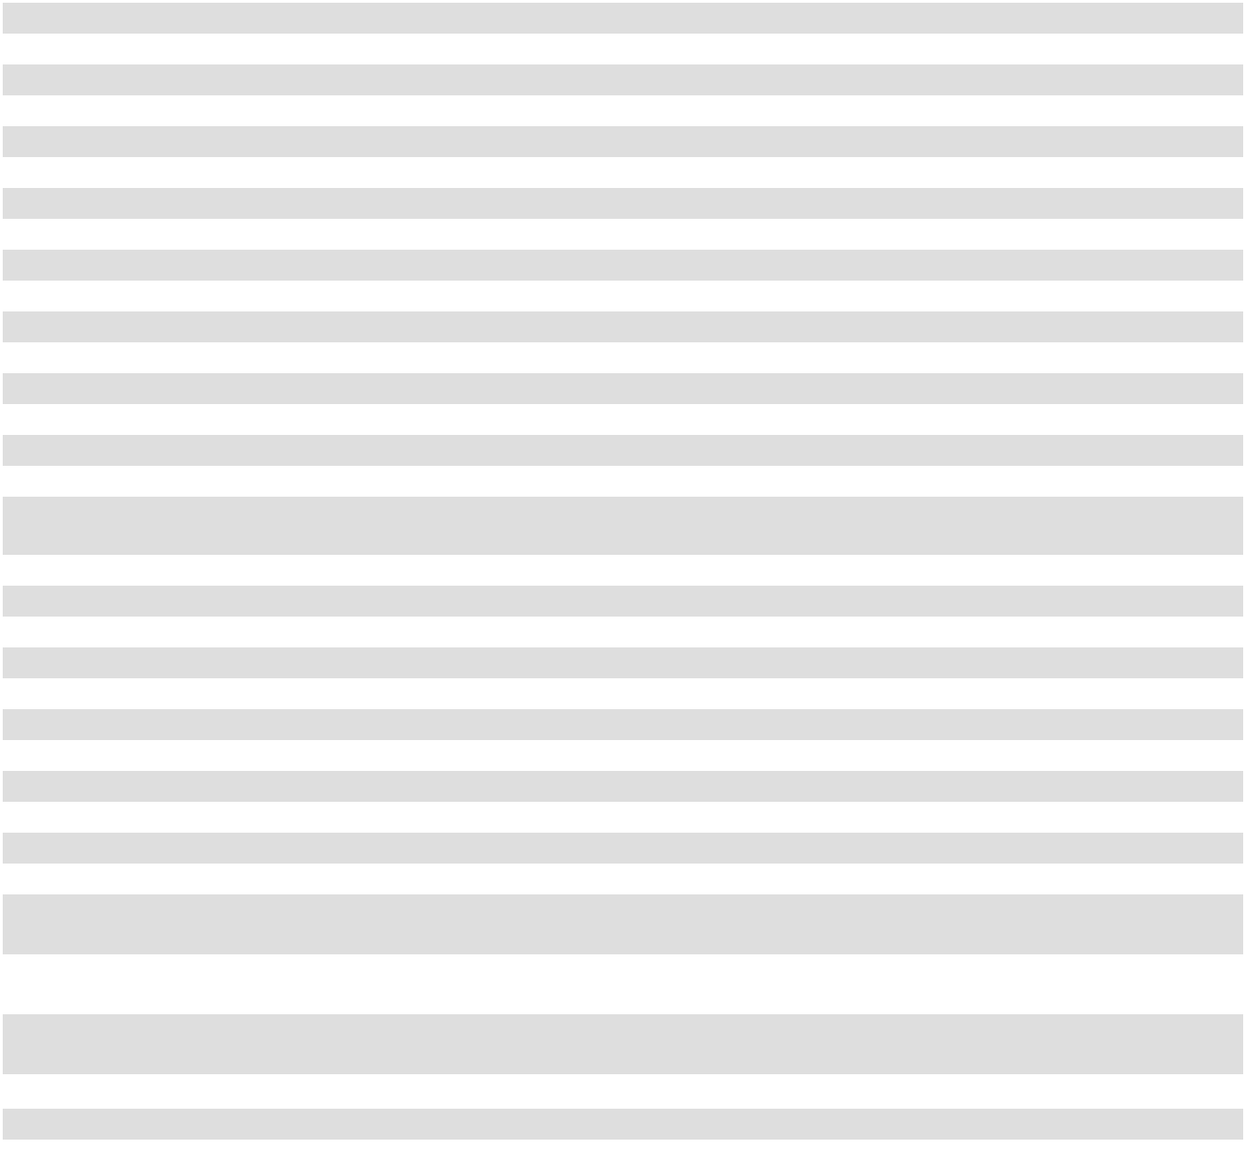

The accompanying notes are an integral part of these consolidated financial statements.

F-12

American Assets Trust, L.P.

Consolidated Statements of Partners' Capital

(In Thousands, Except Unit Data)
 | Limited Partners' Capital ⁽¹⁾ |  |  |  |  | General Partner's Capital ⁽²⁾ |  |  |  | Accumulated
 |  |  |  |  |  |  |  |  |  |  | Other
 | Units |  |  | Amount |  | Units |  | Amount |  | Comprehensive |  |  | Total Capital
 | Units |  |  | Amount |  | Units |  | Amount |  | Income (Loss)
Balance at December 31, 2022 | 16,181,537 | $ |  | (39,127) | 60,718,653 |  | $ 1,210,641 |  | $ |  | 14,011 | $ |  | 1,185,525
Net income | — |  |  | 13,551 |  | — | 51,139 |  |  |  | — |  |  | 64,690
Issuance of restricted units | — |  |  | — | 300,889 |  |  | — |  |  | — |  |  | —
Forfeiture of restricted units | — |  |  | — | (82,481) |  |  | — |  |  | — |  |  | —
Distributions | — |  |  | (21,360) |  | — | (80,211) |  |  |  | — |  |  | (101,571)
Stock-based compensation | — |  |  | — |  | — | 8,838 |  |  |  | — |  |  | 8,838
Units withheld for employee taxes | — |  |  | — | (41,275) |  | (831) |  |  |  | — |  |  | (831)
Other comprehensive loss - change
in value of interest rate swaps | — |  |  | — |  | — |  | — |  |  | (1,827) |  |  | (1,827)
Reclassification of amortization of
forward starting swaps included in | — |  |  | — |  | — |  | — |  |  | (1,149) |  |  | (1,149)
interest expense | — |  |  | — |  | — |  | — |  |  | (1,149) |  |  | (1,149)
Balance at December 31, 2023 | 16,181,537 |  |  | (46,936) | 60,895,786 |  | 1,189,576 |  |  |  | 11,035 |  |  | 1,153,675
Net income | — |  |  | 15,234 |  | — | 57,585 |  |  |  | — |  |  | 72,819
Issuance of restricted units | — |  |  | — | 303,648 |  |  | — |  |  | — |  |  | —
Forfeiture of restricted units | — |  |  | — | (10,397) |  |  | — |  |  | — |  |  | —
Distributions | — |  |  | (21,683) |  | — | (81,685) |  |  |  | — |  |  | (103,368)
Stock-based compensation | — |  |  | — |  | — | 7,110 |  |  |  | — |  |  | 7,110
Units withheld for employee taxes | — |  |  | — | (50,799) |  | (1,445) |  |  |  | — |  |  | (1,445)
Other comprehensive loss - change
in value of interest rate swaps | — |  |  | — |  | — |  | — |  |  | (2,748) |  |  | (2,748)
Other comprehensive loss - | — |  |  | — |  | — |  | — |  |  | (1,345) |  |  | (1,345)
unrealized loss on treasury locks | — |  |  | — |  | — |  | — |  |  | (1,345) |  |  | (1,345)
Reclassification of amortization of
forward-starting swaps included in
interest expense, net | — |  |  | — |  | — |  | — |  |  | (377) |  |  | (377)
Balance at December 31, 2024 | 16,181,537 |  |  | (53,385) | 61,138,238 |  | 1,171,141 |  |  |  | 6,565 |  |  | 1,124,321
Net income | — |  |  | 14,870 |  | — | 56,500 |  |  |  | — |  |  | 71,370
Issuance of restricted units | — |  |  | — | 402,735 |  |  | — |  |  | — |  |  | —
Forfeiture of restricted units | — |  |  | — | (27,261) |  |  | — |  |  | — |  |  | —
Distributions | — |  |  | (22,007) |  | — | (83,247) |  |  |  | — |  |  | (105,254)
Stock-based compensation | — |  |  | — |  | — | 7,397 |  |  |  | — |  |  | 7,397
Units withheld for employee taxes | — |  |  | — | (122,776) |  | (2,393) |  |  |  | — |  |  | (2,393)
Other comprehensive loss - change | — |  |  | — |  | — |  | — |  |  | (3,205) |  |  | (3,205)
in value of interest rate swaps | — |  |  | — |  | — |  | — |  |  | (3,205) |  |  | (3,205)
Reclassification of amortization of
forward-starting swaps included in | — |  |  | — |  | — |  | — |  |  | (1,031) |  |  | (1,031)
interest expense, net | — |  |  | — |  | — |  | — |  |  | (1,031) |  |  | (1,031)
Balance at December 31, 2025 | 16,181,537 | $ |  | (60,522) | 61,390,936 |  | $ 1,149,398 |  | $ |  | 2,329 | $ |  | 1,091,205


- Consists of limited partnership interests held by third parties.

- Consists of general and limited partnership interests held by American Assets Trust, Inc.

The accompanying notes are an integral part of these consolidated financial statements.

F-13

American Assets Trust, L.P.

Consolidated Statements of Cash Flows

(In Thousands)

 |  | Year Ended December 31,
OPERATING ACTIVITIES |  | 2025 |  |  | 2024 |  |  | 2023
OPERATING ACTIVITIES | $ | 71,370 | $ |  | 72,819 | $ |  | 64,690
Net income
Adjustments to reconcile net income to net cash provided by operating
activities: |  | 920 |  |  | (5,781) |  |  | (7,239)
Deferred rent revenue and amortization of lease intangibles |  | 920 |  |  | (5,781) |  |  | (7,239)
Depreciation and amortization |  | 127,312 |  |  | 125,461 |  |  | 119,500
Amortization of debt issuance costs and debt discounts |  | 2,891 |  |  | 3,652 |  |  | 3,388
Provision for uncollectable rental income |  | 540 |  |  | 1,517 |  |  | 1,439
Gain on sale of real estate |  | (44,476) |  |  | — |  |  | —
Stock-based compensation expense |  | 7,397 |  |  | 7,110 |  |  | 8,838
Settlement of treasury locks |  | — |  |  | (1,345) |  |  | —
Other noncash interest expense, net |  | (1,031) |  |  | (377) |  |  | (1,149)
Other, net |  | 3,233 |  |  | 1,161 |  |  | 266
Changes in operating assets and liabilities |  | 726 |  |  | (1,787) |  |  | (870)
Change in accounts receivable and deferred rent receivables |  | 726 |  |  | (1,787) |  |  | (870)
Change in other assets |  | (1,225) |  |  | (1,266) |  |  | (1,141)
Change in accounts payable and accrued expenses |  | (1,160) |  |  | 5,577 |  |  | 765
Change in security deposits payable |  | 931 |  |  | 140 |  |  | 181
Change in other liabilities and deferred credits |  | (313) |  |  | 225 |  |  | 83
Net cash provided by operating activities |  | 167,115 |  |  | 207,106 |  |  | 188,751
INVESTING ACTIVITIES |  | (67,879) |  |  | — |  |  | —
Acquisition of real estate, net |  | (67,879) |  |  | — |  |  | —
Capital expenditures |  | (72,255) |  |  | (70,205) |  |  | (82,980)
Proceeds from sale of real estate, net of selling costs |  | 117,784 |  |  | — |  |  | —
Leasing commissions |  | (8,165) |  |  | (7,202) |  |  | (6,907)
Net cash used in investing activities |  | (30,515) |  |  | (77,407) |  |  | (89,887)
FINANCING ACTIVITIES |  | — |  |  | 100,000 |  |  | —
Proceeds from unsecured line of credit |  | — |  |  | 100,000 |  |  | —
Repayment of unsecured line of credit |  | — |  |  | (100,000) |  |  | (36,000)
Proceeds from unsecured term loan |  | — |  |  | — |  |  | 225,000
Repayment of unsecured term loan |  | (225,000) |  |  | — |  |  | (150,000)
Proceeds from unsecured notes payable |  | — |  |  | 523,273 |  |  | —
Repayment of unsecured notes payable |  | (100,000) |  |  | (200,000) |  |  | —
Debt issuance costs |  | (250) |  |  | (5,388) |  |  | (2,145)
Distributions |  | (105,254) |  |  | (103,368) |  |  | (101,571)
Shares withheld for employee taxes |  | (2,393) |  |  | (1,445) |  |  | (831)
Net cash provided by (used in) financing activities |  | (432,897) |  |  | 213,072 |  |  | (65,547)
Net (decrease) increase in cash, cash equivalents |  | (296,297) |  |  | 342,771 |  |  | 33,317
Cash and cash equivalents, beginning of year |  | 425,659 |  |  | 82,888 |  |  | 49,571
Cash and cash equivalents, end of year | $ | 129,362 |  | $ | 425,659 |  | $ | 82,888


The accompanying notes are an integral part of these consolidated financial statements.

F-14

American Assets Trust, Inc. and American Assets Trust, L.P.

Notes to Consolidated Financial Statements

NOTE 1. SUMMARY OF SIGNIFICANT ACCOUNTING POLICIES Business and Organization

American Assets Trust, Inc. (which may be referred to in these financial statements as the “company,” “we,” “us,” or “our”) is a Maryland corporation formed on July 16, 2010 that did not have any operating activity until the consummation of our initial public offering (the “Offering”) and the related acquisition on January 19, 2011 of certain assets of a combination of entities whose assets included entities owned and/or controlled by Ernest S. Rady and his affiliates, including the Rady Trust, which in turn owned (1) controlling interests in entities owning 17 properties and the property management business of American Assets, Inc. and (2) noncontrolling interests in entities owning four properties. The company is the sole general partner of American Assets Trust, L.P., a Maryland limited partnership formed on July 16, 2010 (the “Operating Partnership”). The company's operations are carried on through our Operating Partnership and its subsidiaries, including our taxable REIT subsidiary. Since the formation of our Operating Partnership, the company has controlled our Operating Partnership as its general partner and has consolidated its assets, liabilities and results of operations.

We are a vertically integrated and self-administered REIT with 232 employees providing substantial in-house expertise in asset management, property management, property development, leasing, tenant improvement construction, acquisitions, repositioning, redevelopment and financing.

Any reference to the number of properties or units, square footage or acres, employees; or references to beneficial ownership interests, are unaudited and outside the scope of our independent registered public accounting firm's audit of our financial statements in accordance with the standards of the United States Public Company Accounting Oversight Board.

As of December 31, 2025, we owned or had a controlling interest in 31 office, retail, multifamily and mixed-use operating properties, the operations of which we consolidate. Additionally, as of December 31, 2025, we owned land at two of our properties that we classify as held for development and construction in progress. A summary of the properties owned by us is as follows:

Retail
Carmel Country Plaza | Gateway Marketplace
Carmel Mountain Plaza | Geary Marketplace
South Bay Marketplace | The Shops at Kalakaua
Lomas Santa Fe Plaza | Waikele Center
Solana Beach Towne Centre | Alamo Quarry Market
Office
La Jolla Commons | First & Main
Torrey Point | Lloyd Portfolio
Solana Crossing | City Center Bellevue
The Landmark at One Market | 14Acres
One Beach Street | Timber Ridge
Multifamily
Loma Palisades | Hassalo on Eighth - Multifamily
Imperial Beach Gardens | Genesee Park
Mariner's Point
Santa Fe Park RV Resort
Pacific Ridge Apartments

Mixed-Use

Waikiki Beach Walk Retail and Embassy Suites™ Hotel

Held for Development and Construction in Progress Solana Crossing – Land
Lloyd Portfolio – Construction in Progress

Hassalo on Eighth - Retail

Timber Springs

Coastal Collection at Torrey Reserve (formerly known as Torrey Reserve Campus)

F-15

Basis of Presentation

Our consolidated financial statements include the accounts of the company, our Operating Partnership and our subsidiaries. The equity interests of other investors in our Operating Partnership are reflected as noncontrolling interests.

The company follows the Financial Accounting Standards Board (the “FASB”) guidance for determining whether an entity is a variable interest entity (“VIE”) and requires the performance of a qualitative rather than a quantitative analysis to determine the primary beneficiary of a VIE. Under this guidance, an entity would be required to consolidate a VIE if it has (i) the power to direct the activities that most significantly impact the entity’s economic performance and (ii) the obligation to absorb losses of the VIE or the right to receive benefits from the VIE that could be significant to the VIE. American Assets Trust, Inc. has concluded that the Operating Partnership is a VIE, and because American Assets Trust, Inc. has both the power and the rights to control the Operating Partnership, American Assets Trust, Inc. is the primary beneficiary and is required to continue to consolidate the Operating Partnership. Substantially all of the assets and liabilities of the company are related to the operating partnership VIE.

All intercompany transactions and balances are eliminated in consolidation.

Use of Estimates

The preparation of financial statements in conformity with accounting principles generally accepted in the United States of America, referred to as “GAAP,” requires management to make estimates and assumptions that in certain circumstances affect the reported amounts of assets and liabilities, disclosure of contingent assets and liabilities, and revenues and expenses. These estimates are prepared using management's best judgment, after considering past, current and expected events and economic conditions. Actual results could differ from these estimates.

Consolidated Statements of Cash Flows-Supplemental Disclosures

The following table provides supplemental disclosures related to the Consolidated Statements of Cash Flows (in thousands):

 |  | Year Ended December 31,
 |  | 2025 |  |  | 2024 |  |  | 2023
Supplemental cash flow information
Total interest costs incurred | $ | 79,550 |  | $ | 82,030 |  | $ | 72,479
Interest capitalized
Interest capitalized | $ | 1,430 |  | $ | 7,503 |  | $ | 7,773
Interest expense, net
Interest expense, net | $ | 78,120 |  | $ | 74,527 |  | $ | 64,706
Cash paid for interest, net of amounts capitalized
Cash paid for interest, net of amounts capitalized | $ | 79,272 |  | $ | 64,413 |  | $ | 62,003
Cash paid for income taxes
Cash paid for income taxes | $ | 934 |  | $ | 1,247 |  | $ | 1,427
Supplemental schedule of noncash investing and financing activities
Accounts payable and accrued liabilities for construction in progress | $ | 19,874 |  | $ | 14,396 |  | $ | 16,103
Accrued leasing commissions
Accrued leasing commissions | $ | 4,014 |  | $ | 2,197 |  | $ | 1,726
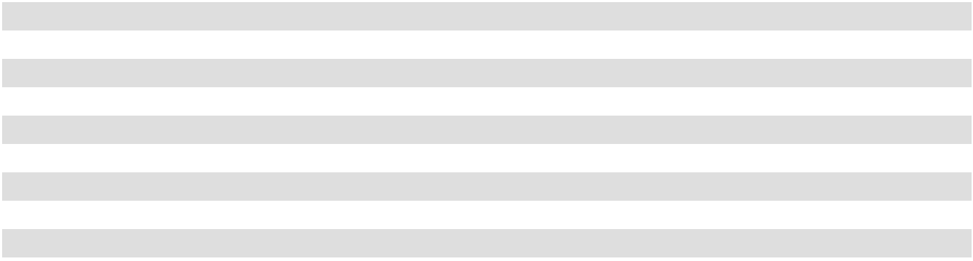

F-16

Revenue Recognition and Accounts Receivable

Our leases with tenants are classified as operating leases. Substantially all such leases contain fixed rent escalations which occur at specified times during the term of the lease. Base rents are recognized on a straight-line basis from when the tenant controls the space through the term of the related lease, based on management's assessment of credit, collection and other business risks. When we determine that we are the owner of tenant improvements and the tenant has reimbursed us for a portion or all of the tenant improvement costs, we consider the amount paid to be additional rent, which is recognized on a straight-line basis over the term of the related lease. For first generation tenants, in instances in which we fund tenant improvements and the improvements are deemed to be owned by us, revenue recognition will commence when the improvements are substantially completed and possession or control of the space is turned over to the tenant. When we determine that the tenant is the owner of tenant improvements, tenant allowances are recorded as lease incentives and we commence revenue recognition and lease incentive amortization when possession or control of the space is turned over to the tenant for tenant work to begin. Percentage rents, which represent additional rents based upon the level of sales achieved by certain tenants, are recognized at the end of the lease year or earlier if we have determined the required sales level is achieved and the percentage rents are collectible. Real estate tax and other cost reimbursements are recognized on an accrual basis over the periods in which the related expenditures are incurred.

Other property income includes parking income, general excise tax billed to tenants and fees charged to tenants at our multifamily properties. Other property income is recognized when we satisfy performance obligations as evidenced by the transfer of control of our services to customers. We measure other property income based on the amount of consideration we expect to be entitled to in exchange for the services provided. We recognize general excise tax gross, with the amounts billed to tenants and customers recorded in other property income and the related taxes paid as rental expense. The general excise tax included in other property income was $3.7 million, $3.8 million and $3.7 million for the years ended December 31, 2025, 2024 and 2023, respectively. For a tenant to terminate its lease agreement prior to the end of the agreed term, we may require that they pay a fee to cancel the lease agreement. Lease termination fees for which the tenant has relinquished control of the space are generally recognized on the later of the termination date or the satisfaction of all conditions precedent to the lease termination, including, without limitation, payment of all lease termination fees. When a lease is terminated early but the tenant continues to control the space under a modified lease agreement, the lease termination fee is generally recognized evenly over the remaining term of the modified lease agreement.

Current accounts receivable from tenants primarily relate to contractual minimum rent and percentage rent as well as real estate tax and other cost reimbursements. Accounts receivable from straight-line rent is typically longer term in nature and relates to the cumulative amount by which straight-line rental income recorded to date exceeds cash rents billed to date under the contractual lease agreement.

Hotel revenue recognized at Waikiki Beach Walk Embassy Suites™ Hotel is in accordance with Accounting Standards Codification (“ASC”) 606, “Revenue from Contracts with Customers,” and is included within rental income on the statement of comprehensive income.

We recognize revenue on the hotel portion of our mixed-use property from the rental of hotel rooms and guest services when we satisfy performance obligations as evidenced by the transfer of control when the rooms are occupied and services have been provided. Food and beverage sales are recognized when the customer has been served or at the time the transaction occurs. Revenue from room rental is included in rental revenue on the statement of comprehensive income. Revenue from other sales and services provided is included in other property income on the statement of comprehensive income.

The company recognizes hotel revenue when earned. Revenues are recorded net of any sales, general excise or transient accommodations occupancy tax collected from the company’s guests. Additionally, some of the company’s hotel rooms are booked through independent internet travel intermediaries. If the guest pays the independent internet travel intermediary directly, revenue for the room is booked by the company at the price the company sold the room to the independent internet travel intermediary, less any discount or commission paid. If the guest pays the company directly, revenue for the room is booked by the company on a gross basis. The company participates in frequent guest programs sponsored by the brand owners of the company’s hotel and the company expenses the charges associated with those programs, as incurred.

Room revenue is generated through contracts with customers whereby the customer agrees to pay a daily rate for the right to use a hotel room. The company’s contract performance obligations are fulfilled at the end of each day the room is provided to the customer and revenue is recognized daily at the contract rate. The company records contract liabilities in the form of advanced deposits when a customer or group of customers provides a deposit for a future stay at the company’s hotel. Advanced deposits for room revenue are included in the balance of other liabilities on the consolidated balance sheets and are recognized as revenue at the time of the guest’s stay.

F-17

We make estimates of the collectability of our current accounts receivable and straight-line rents receivable which requires significant judgment by management. The collectability of receivables is affected by numerous different factors including current economic trends, tenant bankruptcies, the status of collectability of current cash rents receivable, tenants' recent and historical financial and operating results, changes in our tenants' credit ratings, communications between our operating personnel and tenants, the extent of security deposits and letters of credits held with respect to tenants, and the ability of the tenant to perform under the terms of their lease agreement when evaluating the adequacy of the allowance for doubtful accounts. If our assessment of these factors indicates that it is no longer probable that we will be able to collect substantially all rents, we recognize a charge to rental income and limit our rental income to the lesser of lease income on a straight-line basis plus variable rents when they become accruable or cash collected. If we change our conclusion regarding the probability of collecting rent payments required by a lessee, we may recognize an adjustment to rental income in the period we make a change to our prior conclusion.

At December 31, 2025 and December 31, 2024, our allowance for doubtful accounts was $1.3 million and $2.0 million, respectively. Total collectability related adjustments for rental income, which includes the allowance for doubtful accounts and deferred rent receivables, was $0.6 million, $1.5 million and $1.5 million for the years ended December 31, 2025, 2024 and 2023, respectively.

Real Estate

Land, buildings and improvements are recorded at cost. Depreciation is computed using the straight-line method. Estimated useful lives range generally from 30 years to a maximum of 40 years on buildings and major improvements. Minor improvements, furniture and equipment are capitalized and depreciated over useful lives ranging from 3 years to 15 years. Maintenance and repairs that do not improve or extend the useful lives of the related assets are charged to operations as incurred. Tenant improvements are capitalized and depreciated over the life of the related lease or their estimated useful life, whichever is shorter. If a tenant vacates its space prior to the contractual termination of its lease, the undepreciated balance of any tenant improvements are written off if they are replaced or have no future value. For the years ended December 31, 2025, 2024 and 2023, real estate depreciation expense was $113.1 million, $111.7 million and $106.3 million, respectively.

Acquisitions of properties are accounted for in accordance with the authoritative accounting guidance on acquisitions and business combinations. Our methodology of allocating the cost of acquisitions to assets acquired and liabilities assumed is based on estimated fair values, replacement cost and appraised values. When we acquire operating real estate properties, the purchase price is allocated to land and buildings, intangibles such as in-place leases, and to current assets and liabilities acquired, if any. Such valuations include a consideration of the noncancelable terms of the respective leases as well as any applicable renewal periods. The fair values associated with below market renewal options are determined based on a review of several qualitative and quantitative factors on a lease-by-lease basis at acquisition to determine whether it is probable that the tenant would exercise its option to renew the lease agreement. These factors include: (1) the type of tenant in relation to the property it occupies, (2) the quality of the tenant, including the tenant's long term business prospects and (3) whether the fixed rate renewal option was sufficiently lower than the fair rental of the property at the date the option becomes exercisable such that it would appear to be reasonably assured that the tenant would exercise the option to renew. The value allocated to in-place leases is amortized over the related lease term and reflected as depreciation and amortization in the statement of comprehensive income.

The value of above and below market leases associated with the original noncancelable lease terms are amortized to rental income over the terms of the respective noncancelable lease periods and are reflected as either an increase (for below market leases) or a decrease (for above market leases) to rental income in the statement of comprehensive income. The value of the leases associated with below market lease renewal options that are likely to be exercised are amortized to rental income over the respective renewal periods. If a tenant vacates its space prior to contractual termination of its lease or the lease is not renewed, the unamortized balance of any in-place lease value is written off to rental income and amortization expense.

Transaction costs related to the acquisition of a business, such as broker fees, transfer taxes, legal, accounting, valuation, and other professional and consulting fees, are expensed as incurred and included in “general and administrative expenses” in our consolidated statements of comprehensive income. For asset acquisitions not meeting the definition of a business, transaction costs are capitalized as part of the acquisition cost.

F-18

Capitalized Costs

We capitalize certain costs related to the development and redevelopment of real estate including pre-construction costs, real estate taxes, insurance and construction costs and salaries and related costs of personnel directly involved. Additionally, we capitalize interest costs related to development and significant redevelopment activities. Capitalization of these costs begins when the activities and related expenditures commence and cease when the project is substantially complete and ready for its intended use, at which time the project is placed in service and depreciation commences. Additionally, we make estimates as to the probability of certain development and redevelopment projects being completed. If we determine that the completion of development or redevelopment is no longer probable, we expense all capitalized costs which are not recoverable.

Impairment of Long Lived Assets

We review for impairment on a property by property basis whenever events or changes in circumstances indicate that the carrying value of a property may not be fully recoverable. Impairment is recognized on properties held for use when the expected undiscounted cash flows for a property are less than its carrying amount at which time the property is written-down to fair value. Properties held for sale are recorded at the lower of the carrying amount or the expected sales price less costs to sell. Accordingly, the reduction of estimated future cash flows could result in the recognition of an impairment charge on certain of our long-lived assets. Management has not identified indicators that the value of our real estate investments was impaired at December 31, 2025 or December 31, 2024. There were no impairment charges during the years ended December 31, 2025, 2024 and 2023.

Financial Instruments

The estimated fair values of financial instruments are determined using available market information and appropriate valuation methods. Considerable judgment is necessary to interpret market data and develop estimated fair values. The use of different market assumptions or estimation methods may have a material effect on the estimated fair value amounts. Accordingly, estimated fair values are not necessarily indicative of the amounts that could be realized in current market exchanges.

Derivative Instruments

At times, we may use derivative instruments to manage exposure to variable interest rate risk. We may enter into interest rate swaps to manage our exposure to variable interest rate risk. If and when we enter into derivative instruments, we ensure that such instruments qualify as cash flow hedges and would not enter into derivative instruments for speculative purposes.

Any interest rate swaps associated with our cash flow hedges are recorded at fair value on a recurring basis. We assess effectiveness of our cash flow hedges both at inception and on an ongoing basis. The effective portion of changes in fair value of the interest rate swaps associated with our cash flow hedges is recorded in accumulated other comprehensive income (loss) and is subsequently reclassified into interest expense as interest is incurred on the related variable rate debt. Our cash flow hedges become ineffective if critical terms of the hedging instrument and the debt instrument do not perfectly match such as notional amounts, settlement dates, reset dates, calculation period and LIBOR or Secured Overnight Financing Rate. In addition, we evaluate the default risk of the counterparty by monitoring the credit worthiness of the counterparty. When ineffectiveness exists, the ineffective portion of changes in fair value of the interest rate swaps associated with our cash flow hedges is recognized in earnings in the period affected. See the discussion under Note 8 for certain quantitative details related to interest rate swaps and for a discussion on how we value derivative financial instruments.

Cash and Cash Equivalents

We define cash and cash equivalents as cash on hand, demand deposits with financial institutions and short term liquid investments with an initial maturity of less than 3 months. Cash balances in individual banks may exceed the federally insured limit of $250,000 by the Federal Deposit Insurance Corporation (the “FDIC”). No losses have been experienced related to such accounts. At December 31, 2025 and December 31, 2024, we had $76.1 million and $350.7 million, respectively, in excess of the FDIC insured limit. At December 31, 2025 and December 31, 2024, we had $46.1 million and $71.2 million, respectively, in money market funds that are not FDIC insured.

F-19

Restricted Cash

Restricted cash consists of amounts held by lenders to provide for future real estate tax expenditures, insurance expenditures and reserves for capital improvements. As of December 31, 2025 and 2024, we had no restricted cash.

Other Assets

Other assets consist primarily of lease costs, lease incentives, acquired in-place leases and acquired above market leases. Capitalized lease costs are direct costs incurred which were essential to originate a lease and would not have been incurred had the leasing transaction not taken place and include third-party commissions related to obtaining a lease. Capitalized lease costs are amortized over the life of the related lease and included in depreciation and amortization expense on the statement of comprehensive income. If a tenant vacates its space prior to the contractual termination of its lease, the unamortized balance of any lease costs are written off. We view these lease costs as part of the up-front initial investment we made in order to generate a long-term cash inflow. Therefore, we classify cash outflows for lease costs as an investing activity in our consolidated statements of cash flows.

Variable Interest Entities

Certain entities that do not have sufficient equity at risk for the entity to finance its activities without additional subordinated financial support from other parties or in which equity investors do not have the characteristics of a controlling financial interest qualify as VIEs. VIEs are required to be consolidated by their primary beneficiary. The primary beneficiary of a VIE is the party that has a controlling interest in the VIE. Identifying the party with the controlling interest requires a focus on which entity has the power to direct the activities of the VIE that most significantly impact the VIE's economic performance and (1) the obligation to absorb the expected losses of the VIE or (2) the right to receive the benefits from the VIE. At December 31, 2025 and December 31, 2024 we had no investments in real estate joint ventures, and no other interests in VIEs to be evaluated for consolidated.

Stock-Based Compensation

We grant stock-based compensation awards to our employees and directors typically in the form of restricted shares of common stock, options to purchase common stock and/or shares of common stock. For the grants of performance and market-based restricted stock awards in December 2023 (the “2023 grant”), December 2024 (the “2024 grant”), and December 2025 (the “2025 grant”), we measure stock-based compensation expense based on the fair value of the award on the grant date, adjusted for changes to probabilities of achieving performance targets, and recognize expense ratably over the vesting period.

Modifications of stock-based compensation awards are treated as an exchange of the original award for a new award with the resulting total compensation cost equal to the grant-date fair value of the original award plus the incremental value of the modification to the award. The calculation of the incremental value is based on the excess of the fair value of the new (modified) award based on current circumstances over the fair value of the original award measured immediately before its terms are modified.

Deferred Compensation

Our Operating Partnership has adopted the American Assets Trust Executive Deferral Plan V (“EDP V”) and the American Assets Trust Executive Deferral Plan VI (“EDP VI”). These plans were adopted by our Operating Partnership as successor plans to those deferred compensation plans maintained by American Assets, Inc. (“AAI”) in which certain employees of AAI, who were transferred to us in connection with the Offering (the “Transferred Participants”), participated prior to the Offering. EDP V and EDP VI contain substantially the same terms and conditions as these predecessor plans. AAI transferred to our Operating Partnership the Transferred Participants' account balances under the predecessor plans. These transferred account balances represent amounts deferred by the Transferred Participants prior to the Offering while they were employed by AAI.

At the time eligible participants defer compensation, we record compensation cost and a corresponding deferred compensation plan liability, which is included in other liabilities and deferred credits on our consolidated balance sheets. This liability is adjusted to fair value at the end of each accounting period based on the performance of the benchmark funds selected by each participant, and the impact of adjusting the liability to fair value is recorded as an increase or decrease to compensation cost.

F-20

Income Taxes

We elected to be taxed as a REIT under the Internal Revenue Code of 1986, as amended (the “Code”), commencing with the taxable year ended December 31, 2011. To maintain our qualification as a REIT, we are required to distribute at least 90% of our REIT taxable income to our stockholders and meet the various other requirements imposed by the Code relating to such matters as operating results, asset holdings, distribution levels and diversity of stock ownership. Provided we maintain our qualification for taxation as a REIT, we are generally not subject to corporate level income tax on the earnings distributed currently to our stockholders. If we fail to maintain our qualification as a REIT in any taxable year, and are unable to avail ourselves of certain savings provisions set forth in the Code, all of our taxable income would be subject to regular U.S. federal income tax. We are subject to certain state and local income taxes.

We, together with one of our subsidiaries, have elected to treat such subsidiary as a taxable REIT subsidiary (a “TRS”) for federal income tax purposes. Certain activities that we undertake must be conducted by a TRS, such as non-customary services for our tenants, and holding assets that we cannot hold directly. A TRS is subject to federal and state income taxes.

Segment Information

Segment information is prepared on the same basis that our management reviews information for operational decision-making purposes. We operate in four reportable segments: the acquisition, redevelopment, ownership and management of office real estate, retail real estate, multifamily real estate and mixed-use real estate. The products for our retail segment primarily include rental of retail space and other tenant services, including tenant reimbursements, parking and storage space rental. The products for our office segment primarily include rental of office space and other tenant services, including tenant reimbursements, parking and storage space rental. The products for our multifamily segment include rental of apartments and other tenant services. The products of our mixed-use segment include rental of retail space and other tenant services, including tenant reimbursements, parking and storage space rental and operation of a 369-room all-suite hotel.

Recent Accounting Pronouncements

In December 2023, the FASB issued Accounting Standards Update (“ASU”) 2023-09, Improvements to Income Tax Disclosures. This pronouncement requires enhanced income tax disclosures, primarily through standardization and disaggregation of rate reconciliation categories and income taxes paid by jurisdiction. This pronouncement is effective for annual periods in fiscal years beginning after December 15, 2024, and should be applied either prospectively or retrospectively. We adopted ASU 2023-09 during the year ended December 31, 2025. The adoption has no material impact on our consolidated financial statements or related disclosures.

In November 2024, the FASB issued ASU 2024-03, Income Statement-Reporting Comprehensive Income-Expense Disaggregation Disclosures. This pronouncement requires public entities to disclose additional information about specific expense categories in the notes to the financial statements on an interim and annual basis. ASU 2024-03 is effective for fiscal years beginning after December 15, 2026, and for interim periods beginning after December 15, 2027, and should be applied either prospectively or retrospectively, with early adoption permitted. The company is currently evaluating the impact of adopting ASU 2024-03.

F-21

NOTE 2. REAL ESTATE

A summary of our real estate investments is as follows (in thousands):

 |  | Retail |  |  | Office |  |  | Multifamily |  |  | Mixed-Use |  |  | Total
December 31, 2025
Land | $ | 226,899 | $ |  | 297,947 | $ |  | 99,793 | $ |  | 76,635 | $ |  | 701,274
Buildings |  | 449,400 |  |  | 1,525,289 |  |  | 446,092 |  |  | 131,884 |  |  | 2,552,665
Land improvements |  | 44,162 |  |  | 19,526 |  |  | 9,947 |  |  | 2,606 |  |  | 76,241
Tenant improvements |  | 82,203 |  |  | 263,064 |  |  | — |  |  | 2,729 |  |  | 347,996
Furniture, fixtures, and equipment |  | 789 |  |  | 7,693 |  |  | 12,972 |  |  | 13,142 |  |  | 34,596
Construction in progress ⁽¹⁾ |  | 3,449 |  |  | 42,382 |  |  | 4,272 |  |  | 752 |  |  | 50,855
 |  | 806,902 |  |  | 2,155,901 |  |  | 573,076 |  |  | 227,748 |  |  | 3,763,627
Accumulated depreciation |  | (337,169) |  |  | (568,585) |  |  | (166,913) |  |  | (71,592) |  |  | (1,144,259)
Net real estate | $ | 469,733 | $ |  | 1,587,316 | $ |  | 406,163 | $ |  | 156,156 | $ |  | 2,619,368
December 31, 2024
Land | $ | 226,899 | $ |  | 297,947 | $ |  | 72,668 | $ |  | 76,635 | $ |  | 674,149
Buildings |  | 446,775 |  |  | 1,407,244 |  |  | 407,297 |  |  | 130,594 |  |  | 2,391,910
Land improvements |  | 40,658 |  |  | 16,779 |  |  | 8,515 |  |  | 2,606 |  |  | 68,558
Tenant improvements |  | 78,126 |  |  | 240,099 |  |  | — |  |  | 3,020 |  |  | 321,245
Furniture, fixtures, and equipment |  | 629 |  |  | 6,241 |  |  | 12,273 |  |  | 13,019 |  |  | 32,162
Construction in progress ⁽¹⁾ |  | 3,302 |  |  | 132,742 |  |  | 1,685 |  |  | 611 |  |  | 138,340
 |  | 796,389 |  |  | 2,101,052 |  |  | 502,438 |  |  | 226,485 |  |  | 3,626,364
Accumulated depreciation |  | (318,352) |  |  | (503,594) |  |  | (151,422) |  |  | (65,510) |  |  | (1,038,878)
Net real estate ⁽²⁾ | $ | 478,037 | $ |  | 1,597,458 | $ |  | 351,016 | $ |  | 160,975 | $ |  | 2,587,486
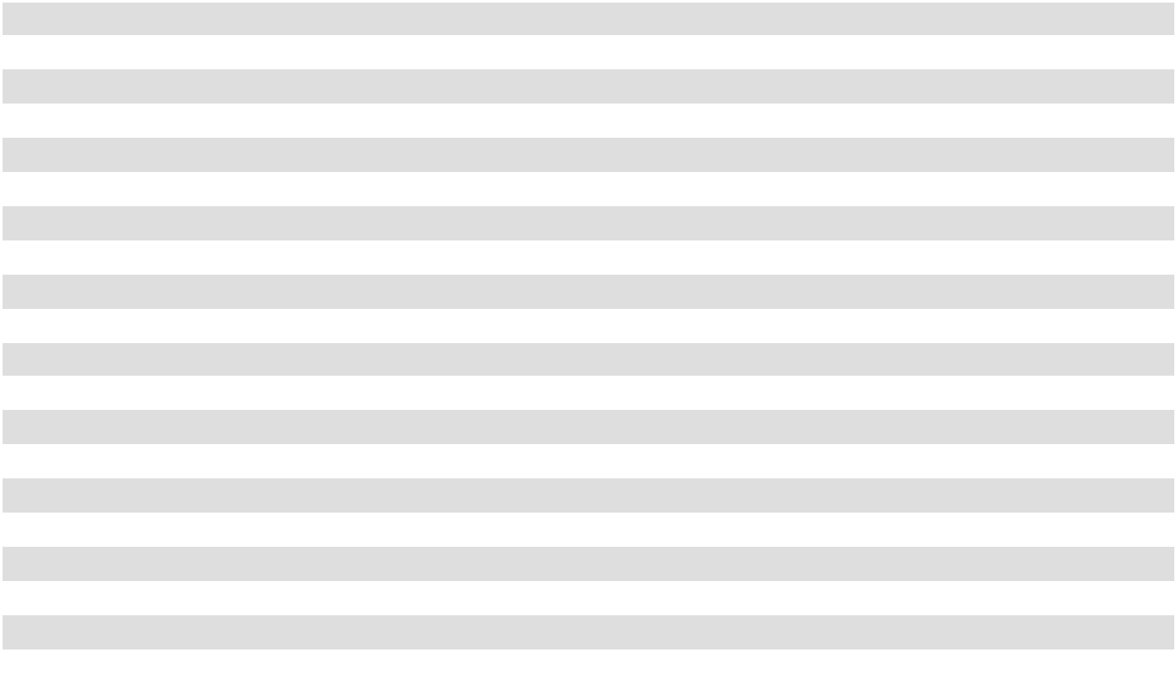

- Land related to held for development and construction in progress is included in the Held for Development and Construction in Progress classifications on the consolidated balance sheets.
- Excludes net real estate assets held for sale

Acquisitions

On February 28, 2025, we acquired Genesee Park in San Diego, California, consisting of a 192-unit apartment community. The purchase price was $67.9 million, excluding closing costs of approximately $0.1 million.

The property was acquired using cash on hand, primarily from the proceeds received on the sale of Del Monte Center on February 25, 2025.

The financial information set forth below summarizes the company’s purchase price allocation for Genesee Park during the year ended December 31, 2025 (in thousands):

F-22

 |  | Genesee Park
Land | $ | 27,125
Building |  | 38,101
Land improvements |  | 1,156
Furniture, fixtures, and equipment |  | 274
Total real estate |  | 66,656
Lease intangibles |  | 1,373
Prepaid expenses and other assets |  | 114
Assets acquired | $ | 68,143
Security deposits payable
Security deposits payable |  | (236)
Other liabilities and deferred credits |  | (28)
Liabilities assumed | $ | (264)
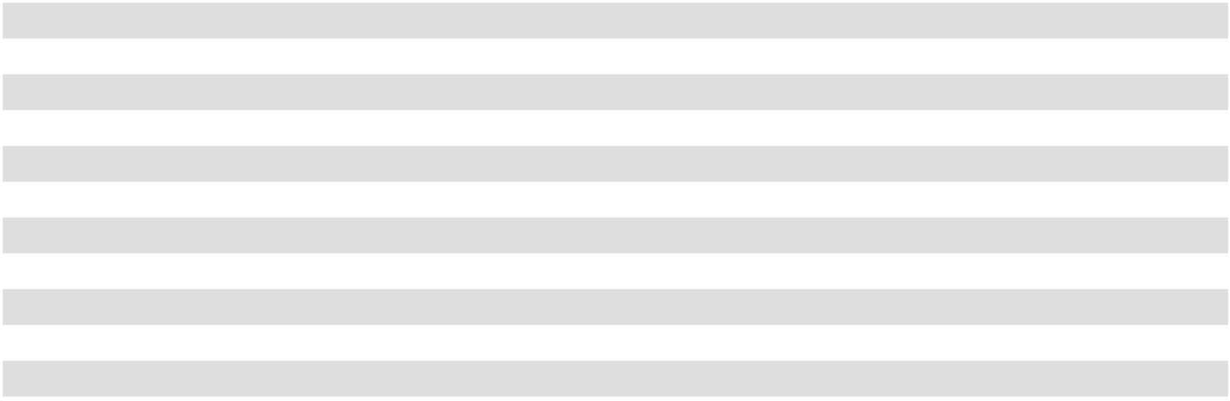

The value allocated to lease intangibles is amortized over six-months as depreciation and amortization expense in the statement of comprehensive income, which is fully amortized as of December 31, 2025.

The following table summarizes the operating results for Genesee Park included in the company's historical consolidated statement of operations for the period of acquisition through December 31, 2025 (in thousands):

 |  | Genesee Park
Revenues | $ | 3,909
Operating expenses |  | 5,021
Operating loss |  | (1,112)
Other income, net |  | 2
Net income attributable to American Assets Trust, Inc. | $ | (1,110)
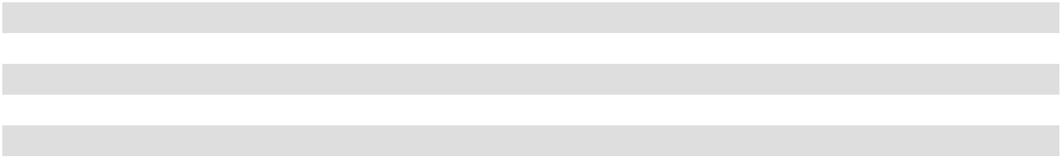

Dispositions

On February 25, 2025, we sold Del Monte Center, which is located in Monterey, California and was previously included in our retail segment. The sale price of this property was $123.5 million, less closing costs and prorations, resulting in net proceeds of approximately $117.8 million. Accordingly, we recorded a gain on sale of approximately $44.5 million for the year ended December 31, 2025.

NOTE 3. ACQUIRED IN-PLACE LEASES AND ABOVE/BELOW MARKET LEASES

The following summarizes our acquired lease intangibles, which are included in other assets and other liabilities and deferred credits (in thousands):

 |  | December 31, 2025 |  |  | December 31, 2024
In-place leases | $ |  | 48,489 | $ |  | 49,813
Accumulated amortization |  |  | (38,280) |  |  | (35,798)
Above market leases |  |  | 432 |  |  | 432
Accumulated amortization |  |  | (429) |  |  | (403)
Acquired lease intangible assets, net |  | $ | 10,212 |  | $ | 14,044
Below market leases
Below market leases |  | $ | 38,446 |  | $ | 42,420
Accumulated accretion |  |  | (27,523) |  |  | (29,344)
Acquired lease intangible liabilities, net |  | $ | 10,923 |  | $ | 13,076
 | F-23

The value allocated to in-place leases is amortized over the related lease term as depreciation and amortization expense in the statement of comprehensive income. Above and below market leases are amortized over the related lease term as additional rental income for below market leases or a reduction of rental income for above market leases in the statement of comprehensive income. Rental income (loss) includes net amortization from acquired above and below market leases of $2.1 million, $2.7 million and $3.1 million in 2025, 2024 and 2023, respectively. The remaining weighted-average amortization period as of December 31, 2025, is 3.8 years, 0.2 years and 12.6 years for in-place leases, above market leases and below market leases, respectively. Below market leases include $4.5 million related to below market renewal options, and the weighted-average period prior to the commencement of the renewal options is 11.3 years.

Increases (decreases) in net income as a result of amortization of our in-place leases, above market leases and below market leases are as follows (in thousands):

 |  | Year Ended December 31,
 |  | 2025 |  |  | 2024 |  |  | 2023
Amortization of in-place leases | $ | (5,180) | $ |  | (4,583) | $ |  | (4,928)
Amortization of above market leases |  | (26) |  |  | (38) |  |  | (41)
Amortization of below market leases |  | 2,153 |  |  | 2,721 |  |  | 3,127
 | $ | (3,053) | $ |  | (1,900) | $ |  | (1,842)

As of December 31, 2025, the amortization for acquired leases during the next five years and thereafter, assuming no early lease terminations, is as follows (in thousands):

 |  | In-Place |  |  | Above Market |  |  | Below Market
 |  | Leases |  |  | Leases |  |  | Leases
Year Ending December 31,
2026 | $ | 3,227 | $ |  | 3 | $ |  | 1,559
2027 |  | 3,009 |  |  | — |  |  | 1,278
2028 |  | 2,801 |  |  | — |  |  | 1,011
2029 |  | 773 |  |  | — |  |  | 661
2030 |  | 73 |  |  | — |  |  | 455
Thereafter |  | 326 |  |  | — |  |  | 5,958
 | $ | 10,209 | $ |  | 3 | $ |  | 10,923
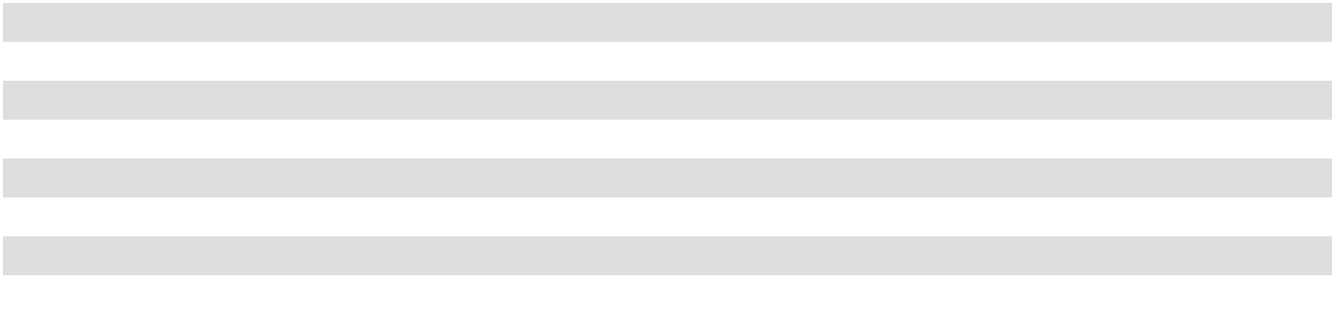

NOTE 4. FAIR VALUE OF FINANCIAL INSTRUMENTS

A fair value measurement is based on the assumptions that market participants would use in pricing an asset or liability.

The hierarchy for inputs used in measuring fair value is as follows:

- Level 1 Inputs—quoted prices in active markets for identical assets or liabilities

- Level 2 Inputs—observable inputs other than quoted prices in active markets for identical assets and liabilities

- Level 3 Inputs—unobservable inputs

The carrying values of cash and cash equivalents, accounts receivable, accounts payable and accrued liabilities are reasonable estimates of fair value, using Level 1 inputs, because of the short-term nature of these instruments. In certain cases, the inputs used to measure fair value may fall into different levels of the fair value hierarchy. In such cases, for disclosure purposes, the level within which the fair value measurement is categorized is based on the lowest level input that is significant to the fair value measurement.

We measure the fair value of our deferred compensation liability, which is included in other liabilities and deferred credits on the consolidated balance sheet, on a recurring basis using Level 2 inputs. We measure the fair value of this liability based on prices provided by independent market participants that are based on observable inputs using market-based valuation techniques.

F-24

The fair value of the interest rate swap agreements are based on the estimated amounts we would receive or pay to terminate the contract at the reporting date and are determined using interest rate pricing models and interest rate related observable inputs. The changes in the fair value of the derivatives that are designated as cash flow hedges are being recorded in accumulated other comprehensive income (loss) and will be subsequently reclassified into earnings during the period in which the hedged forecasted transaction affects earnings.

We incorporate credit valuation adjustments to appropriately reflect both our own non-performance risk and the respective counterparty’s non-performance risk in the fair value measurements. In adjusting the fair value of our derivative contracts for the effect of non-performance risk, we considered the impact of netting and any applicable credit enhancements, such as collateral postings, thresholds, mutual puts, and guarantees.

Although we have determined that the majority of the inputs used to value our derivatives fall within Level 2 of the fair value hierarchy, the credit valuation adjustments associated with our derivatives utilize Level 3 inputs, such as estimates of current credit spreads to evaluate the likelihood of default by itself and its counterparties. However, as of December 31, 2025 we have assessed the significance of the impact of the credit valuation adjustments on the overall valuation of our derivative position and have determined that the credit valuation adjustments are not significant to the overall valuation of our derivative. As a result, we have determined that our derivative valuation in its entirety is classified in Level 2 of the fair value hierarchy.

A summary of our financial liabilities that are measured at fair value on a recurring basis by level within the fair value hierarchy is as follows (in thousands):

 |  |  |  | December 31, 2025 |  |  |  |  |  |  |  |  | December 31, 2024
 |  | Level 1 |  | Level 2 |  | Level 3 |  | Total |  |  | Level 1 |  | Level 2 |  | Level 3 |  | Total
Deferred compensation liability | $ | — | $ | 3,380 | $ | — | $ | 3,380 | $ |  | — | $ | 2,968 | $ | — | $ | 2,968
Interest rate swap asset | $ | — | $ | 2,011 | $ | — | $ | 2,011 | $ |  | — | $ | 5,215 | $ | — | $ | 5,215
Interest rate swap liability | $ | — | $ | — | $ | — | $ | — | $ |  | — | $ | — | $ | — | $ | —

The fair value of our secured notes payable and unsecured notes payable is sensitive to fluctuations in interest rates. Discounted cash flow analysis (Level 2) is generally used to estimate the fair value of our mortgages and notes payable, using rates ranging from 5.8% to 6.8%.

Considerable judgment is necessary to estimate the fair value of financial instruments. The estimates of fair value presented herein are not necessarily indicative of the amounts that could be realized upon disposition of the financial instruments. The carrying values of our line of credit and term loan set forth below are deemed to be at fair value since the outstanding debt is directly tied to monthly SOFR contracts. A summary of the carrying amount and fair value of our financial instruments, all of which are based on Level 2 inputs, is as follows (in thousands):

 |  | December 31, 2025 |  |  |  |  |  | December 31, 2024
 | Carrying Value |  |  |  | Fair Value |  | Carrying Value |  |  |  | Fair Value
Secured notes payable | $ | 74,849 | $ |  | 74,728 | $ |  | 74,759 | $ |  | 74,231
Unsecured term loan | $ | 99,869 | $ |  | 100,000 | $ |  | 324,739 | $ |  | 325,000
Unsecured senior guaranteed notes | $ | 499,437 | $ |  | 483,339 | $ |  | 599,172 | $ |  | 571,543
Senior unsecured notes, net | $ | 1,013,455 | $ |  | 989,549 | $ |  | 1,011,845 | $ |  | 959,234

F-25

NOTE 5. OTHER ASSETS

Other assets consist of the following (in thousands):

 | December 31, 2025 |  |  | December 31, 2024
Leasing commissions, net of accumulated amortization of $56,094 and $51,068,
respectively | $ | 36,223 | $ |  | 34,862
Interest rate swap asset |  | 2,011 |  |  | 5,215
Acquired above market leases, net |  | 3 |  |  | 29
Acquired in-place leases, net |  | 10,209 |  |  | 14,015
Lease incentives, net of accumulated amortization of $1,239 and $1,171, respectively |  | 2,110 |  |  | 1,760
Other intangible assets, net of accumulated amortization of $2,361 and $2,062,
respectively |  | 1,489 |  |  | 1,560
Debt issuance costs on line of credit, net of accumulated amortization of $2,591 and
$1,943, respectively |  | 250 |  |  | 648
Right-of-use lease asset, net |  | 17,246 |  |  | 18,993
Prepaid expenses, deposits and other |  | 10,956 |  |  | 10,655
Total other assets | $ | 80,497 | $ |  | 87,737
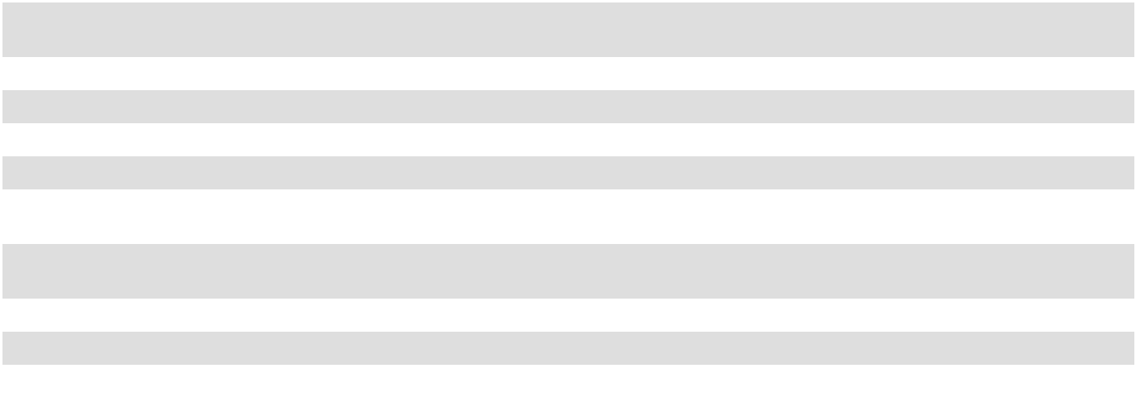

Lease incentives are amortized over the term of the related lease and included as a reduction of rental income in the statement of comprehensive income.

NOTE 6. OTHER LIABILITIES AND DEFERRED CREDITS

Other liabilities and deferred credits consist of the following (in thousands):

 | December 31, 2025 |  |  | December 31, 2024
Acquired below market leases, net | $ | 10,923 | $ |  | 13,076
Prepaid rent and deferred revenue |  | 20,670 |  |  | 17,408
Straight-line rent liability |  | 6,880 |  |  | 7,692
Deferred compensation |  | 3,380 |  |  | 2,968
Deferred tax liability |  | 638 |  |  | 781
Lease liability |  | 18,774 |  |  | 20,638
Other liabilities |  | 39 |  |  | 25
Total other liabilities and deferred credits, net | $ | 61,304 | $ |  | 62,588
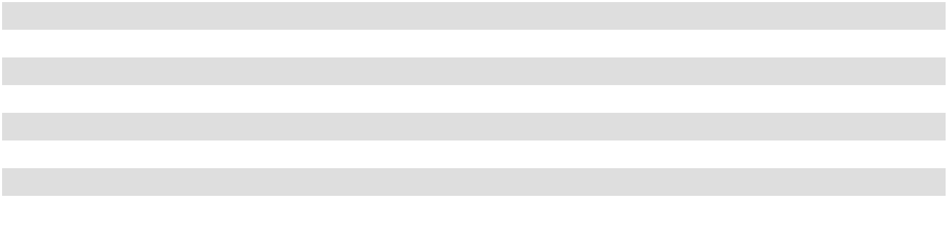

Straight-line rent liability relates to leases which have rental payments that decrease over time or one-time upfront payments for which the rental revenue is deferred and recognized on a straight-line basis.

F-26

NOTE 7. DEBT

Debt of American Assets Trust, Inc.

American Assets Trust, Inc. does not hold any indebtedness. All debt is held directly or indirectly by the Operating Partnership; however, American Assets Trust, Inc. has guaranteed the Operating Partnership's obligations under the (i) 3.375% and 6.150% senior notes, (ii) senior guaranteed notes, (iii) third amended and restated credit facility, and (iv) amended and restated term loan agreement, each discussed below.

Debt of American Assets Trust, L.P.

Secured notes payable

The following is a summary of the Operating Partnership's total secured notes payable outstanding as of December 31, 2025 and December 31, 2024 (in thousands):

 |  | Principal Balance as of |  |  |  |  | Stated Interest Rate
Description of Debt | December 31, 2025 |  |  | December 31, 2024 |  |  | as of December 31, 2025 |  | Stated Maturity Date
City Center Bellevue ⁽¹⁾ | $ | 75,000 | $ |  | 75,000 | 5.08 % |  |  | October 1, 2027
 |  | 75,000 |  |  | 75,000
Debt issuance costs, net of accumulated
amortization of $723 and $632, |  | (151) |  |  | (241)
respectively |  | (151) |  |  | (241)
Total Secured Notes Payable | $ | 74,849 | $ |  | 74,759


(1) Interest only.

The Operating Partnership has provided a carve-out guarantee on the mortgage at City Center Bellevue. Certain loans require the Operating Partnership to comply with various financial covenants. As of December 31, 2025, the Operating Partnership was in compliance with these financial covenants.

Unsecured notes payable

The following is a summary of the Operating Partnership's total unsecured notes payable outstanding as of December 31,
2025 and December 31, 2024 (in thousands):

 | Principal Balance as of |  |  |  | Stated Interest Rate
Description of Debt | December 31, 2025 |  | December 31, 2024 |  | as of December 31, | Stated Maturity Date
Description of Debt | December 31, 2025 |  | December 31, 2024 |  | 2025 | Stated Maturity Date
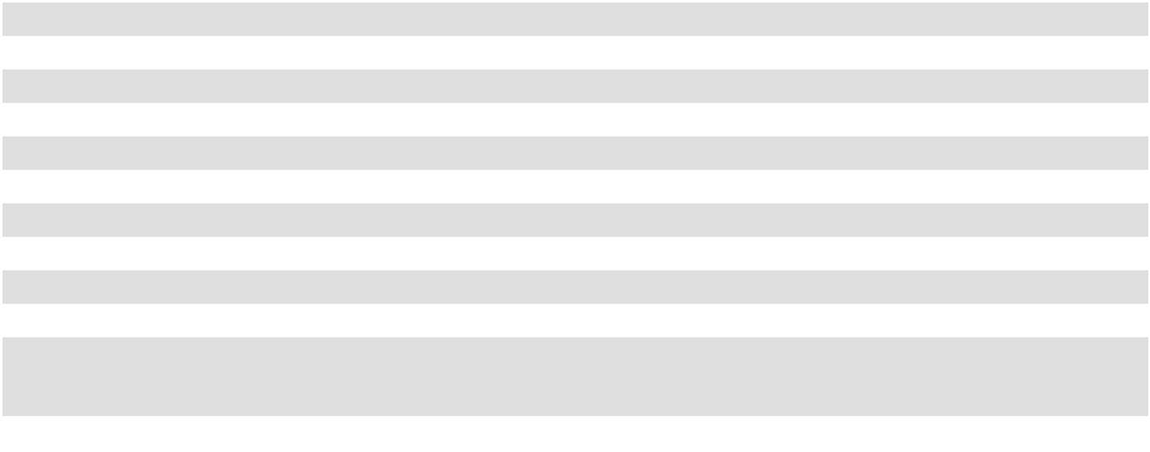

Term Loan A | $ | 100,000 | $ |  | 100,000 | Variable ⁽¹⁾ | January 5, 2027
Term Loan B |  | — |  |  | 150,000 | Variable ⁽³⁾ | January 5, 2025
Term Loan C |  | — |  |  | 75,000 | Variable ⁽³⁾ | January 5, 2025
Senior Guaranteed Notes, Series C |  | — |  |  | 100,000 | 4.50 % | April 1, 2025
Senior Guaranteed Notes, Series D |  | 250,000 |  |  | 250,000 | 4.29 % ⁽⁵⁾ | March 1, 2027
Senior Guaranteed Notes, Series E |  | 100,000 |  |  | 100,000 | 4.24 % ⁽⁶⁾ | May 23, 2029
Senior Guaranteed Notes, Series G |  | 150,000 |  |  | 150,000 | 3.91 % ⁽⁷⁾ | July 30, 2030
3.375% Senior Unsecured Notes |  | 500,000 |  |  | 500,000 | 3.38 % | February 1, 2031
6.150% Senior Notes |  | 525,000 |  |  | 525,000 | 6.15 % ⁽⁸⁾ | October 1, 2034
 |  | 1,625,000 |  |  | 1,950,000
Debt discount and issuance costs, net of
accumulated amortization of $8,720 and |  | (12,239) |  |  | (14,244)
$9,890, respectively |  | (12,239) |  |  | (14,244)
Total Unsecured Notes Payable | $ | 1,612,761 |  | $ | 1,935,756

(2)

(2)

(4)

- The Operating Partnership has entered into two interest rate swap agreements that are intended to fix the interest rate associated with Term Loan A at approximately 2.70% through its maturity date, subject to adjustments based on our consolidated leverage ratio.
- On January 2, 2025, we repaid the entirety of Term Loan B and Term Loan C.

F-27

- The Operating Partnership entered into interest rate swap agreements that are intended to fix the effective interest rate associated with Term Loan B and Term Loan C, subject to adjustments based on our consolidated leverage ratio, at, 5.47% from January 5, 2023 to January 4, 2024 and at 5.57% from January 5, 2024 to January 4, 2025.
- The Senior C Notes were prepaid in full on February 3, 2025, without penalty or premium.

- The Operating Partnership entered into forward-starting interest rate swap contracts on March 29, 2016 and April 7, 2016, which were settled on January 18, 2017 at a gain of approximately $10.4 million. The forward-starting interest swap rate contracts were deemed to be highly effective cash flow hedges, accordingly, the effective interest rate is approximately 3.87% per annum.
- The Operating Partnership entered into a treasury lock contract on April 25, 2017, which was settled on May 11, 2017 at a gain of approximately $0.7 million. The treasury lock contract was deemed to be a highly effective cash flow hedge, accordingly, the effective interest rate is approximately 4.18% per annum.
- The Operating Partnership entered into a treasury lock contract on June 20, 2019, which was settled on July 17, 2019 at a gain of approximately $0.5 million. The treasury lock contract was deemed to be a highly effective cash flow hedge, accordingly, the effective interest rate is approximately 3.88% per annum.
- The Operating Partnership entered into a treasury lock contract on September 9, 2024 for $150 million and September 10, 2024 for an additional

$150 million, which were both settled on September 10, 2024 at a combined loss of approximately $1.3 million. The treasury lock contract was deemed to be a highly effective cash flow hedge, accordingly, the effective interest rate is approximately 6.209% per annum.

Scheduled principal payments on secured and unsecured notes payable as of December 31, 2025 are as follows (in thousands):
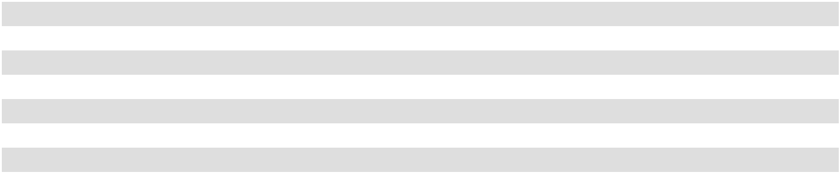
2026 | $ | —
2027 |  | 425,000
2028 |  | —
2029 |  | 100,000
2030 |  | 150,000
Thereafter |  | 1,025,000
 | $ | 1,700,000

Senior Notes

On January 26, 2021, the Operating Partnership issued $500 million of senior unsecured notes (the "3.375% Senior Notes") that mature February 1, 2031 and bear interest at 3.375% per annum. The 3.375% Senior Notes were priced at 98.935% of the principal amount with a yield to maturity of 3.502%. The net proceeds of the 3.375% Senior Notes, after the issuance discount, underwriting fees, and other costs were approximately $489.7 million, which were primarily used to (i) prepay our $150 million Senior Guaranteed Notes, Series A, with a make-whole payment (as defined in the Note Purchase Agreement for the Series A Notes) thereon of approximately $3.9 million, on January 26, 2021, (ii) repay our $100 million then outstanding balance under our then-existing revolver loan on January 26, 2021, (iii) fund the development of the La Jolla Commons III office building and (iv) for general corporate purposes.

On September 17, 2024, the Operating Partnership issued $525 million of senior unsecured notes (the “6.150% Senior Notes”) that mature October 1, 2034, and bear interest at 6.150% per annum. The 6.150% Senior Notes were priced at 99.671% of the principal amount with a yield to maturity of 6.194%. The net proceeds of the 6.150% Senior Notes, after the issuance discount, underwriting fees, and other costs, were approximately $518.2 million. To date, the net proceeds were used to repay the $100 million then outstanding balance under our Revolver Loan on September 19, 2024, our Series B Notes in the amount of $100 million on December 2, 2024 and our Series C Notes in the amount of $100 million on February 3, 2025. The remaining net proceeds are intended to be used for working capital and general corporate purposes.

Prior to the issuance of the 6.150% Senior Notes, the Operating Partnership entered into a treasury lock contract on September 9, 2024 for $150 million and September 10, 2024 for an additional $150 million, which were both settled on September 10, 2024 at a combined loss of approximately $1.3 million. As a result of the loss on these treasury lock contracts and the debt discount, the effective rate on our 6.150% Senior Notes is 6.209% per annum. The treasury lock contracts have been deemed to be highly effective cash flow hedges and have been designated as accounting hedges. Any gains or losses incurred upon the settlement of these treasury lock contracts are included in accumulated other comprehensive income and are amortized to interest expense over the life of the 6.150% Senior Notes.

The 3.375% Senior Notes and the 6.150% Senior Notes include a number of customary financial covenants, including:

- A maximum aggregate debt ratio of 60%,

F-28

- A minimum debt service ratio of 1.5x,

- A maximum secured debt ratio of 40%,

- A minimum maintenance of total unencumbered assets of 150%.

As of December 31, 2025, the Operating Partnership was in compliance with all then in-place 3.375% Senior Notes and 6.15% Senior Notes covenants.

Senior Guaranteed Notes

On October 31, 2014, the Operating Partnership entered into a note purchase agreement (the “Note Purchase Agreement”) with a group of institutional purchasers that provided for the private placement of an aggregate of $350 million of senior guaranteed notes, of which (i) $150 million are designated as 4.04% Senior Guaranteed Notes, Series A, due October 31, 2021 (the “Series A Notes”), (ii) $100 million are designated as 4.45% Senior Guaranteed Notes, Series B, due February 2, 2025 (the “Series B Notes”) and (iii) $100 million are designated as 4.50% Senior Guaranteed Notes, Series C, due April 1, 2025 (the “Series C Notes”). The Series A Notes were issued on October 31, 2014, the Series B Notes were issued on February 2, 2015 and the Series C Notes were issued on April 2, 2015. The Series A Notes, the Series B Notes and the Series C Notes will pay interest quarterly on the last day of January, April, July and October until their respective maturities. On January 26, 2021, we repaid the entirety of the $150.0 million Series A Notes with a make-whole payment (as defined in the Note Purchase Agreement) of approximately $3.9 million. On December 2, 2024, we repaid the entirety of the $100 million Series B Notes. On February 3, 2025, we repaid the entirety of the $100 million Series C Notes.

On March 1, 2017, the Operating Partnership entered into a Note Purchase Agreement for the private placement of $250 million of 4.29% Senior Guaranteed Notes, Series D, due March 1, 2027 (the “Series D Notes”). The Series D Notes were issued on March 1, 2017 and pay interest quarterly on the last day of January, April, July and October until their respective maturities.

On May 23, 2017, the Operating Partnership entered into a Note Purchase Agreement for the private placement of $100 million of 4.24% Senior Guaranteed Notes, Series E, due May 23, 2029 (the “Series E Notes”). The Series E Notes were issued on May 23, 2017 and pay interest semi-annually on the 23rd of May and November until their respective maturities.

On July 19, 2017, the Operating Partnership entered into a Note Purchase Agreement for the private placement of

$100 million of 3.78% Senior Guaranteed Notes, Series F, due July 19, 2024 (the “Series F Notes”). The Series F Notes were

issued on July 19, 2017 and pay interest semi-annually on the 31st of January and July until their respective maturities. On July

18, 2024, we borrowed $100 million on our Revolver Loan to repay the entirety of our $100 million Series F Notes upon their

maturity on July 19, 2024.

On July 30, 2019, the Operating Partnership entered into a Note Purchase Agreement for the private placement of

$150 million of 3.91% Senior Guaranteed Notes, Series G, due July 30, 2030 (the “Series G Notes” and collectively with the Series D Notes and Series E Notes are referred to herein as, the “Notes”.) The Series G Notes were issued on July 30, 2019 and pay interest semi-annually on the 30th of July and January until their maturity.

The Operating Partnership may prepay at any time all, or from time to time any part of, the Notes, in an amount not less than 5% of the aggregate principal amount of any series of the Notes then outstanding in the case of a partial prepayment, at 100% of the principal amount so prepaid plus a Make-Whole Amount.

The Note Purchase Agreements contain a number of customary financial covenants, including, without limitation, tangible net worth thresholds, secured and unsecured leverage ratios and fixed charge coverage ratios. Subject to the terms of the Note Purchase Agreement and the Notes, upon certain events of default, including, but not limited to, (i) a default in the payment of any principal, Make-Whole Amount or interest under the Notes, and (ii) a default in the payment of certain other indebtedness by us or our subsidiaries, the principal, accrued and unpaid interest, and the Make-Whole Amount on the outstanding Notes will become due and payable at the option of the purchasers.

The Operating Partnership's obligations under the Notes are fully and unconditionally guaranteed by the Operating Partnership and certain of the Operating Partnership's subsidiaries.

Certain loans require the Operating Partnership to comply with various financial covenants, including the maintenance of minimum debt coverage ratios. As of December 31, 2025, the Operating Partnership was in compliance with all loan covenants.

F-29

Third Amended and Restated Credit Facility

On January 5, 2022, the Operating Partnership entered into the third amended and restated credit facility (the “Third Amended and Restated Credit Facility”) , which amended and restated our then-existing credit facility. The Third Amended and Restated Credit Facility provides for aggregate, unsecured borrowings of up to $500 million, consisting of a revolving line of credit of $400 million (the “Revolver Loan”) and a term loan of $100 million (“Term Loan A”). The Revolver Loan was initially scheduled to mature on January 5, 2026, subject to two, six-month extension options. On November 13, 2025, we exercised the first of the extension options, which extended the maturity date to July 5, 2026, subject to our option to extend the Revolver Loan for one additional six-month period. Term Loan A matures on January 5, 2027, with no further extension options. As of December 31, 2025, the entirety of the principal amount of Term Loan A was outstanding, there were no amounts outstanding under the Revolver Loan, and the Operating Partnership had incurred approximately $0.25 million of net debt issuance costs which are recorded in other assets, net on the consolidated balance sheet. For the year ended December 31, 2025, the weighted average interest rate on the Revolver Loan was 5.45%.

Borrowings under the Third Amended and Restated Credit Agreement bear interest at floating rates equal to, at the Operating Partnership’s option, either (1) the applicable SOFR, plus the applicable SOFR Adjustment and a spread which ranges from (a) 1.05%-1.50% (with respect to the Revolver Loan) and (b) 1.20% to 1.70% (with respect to Term Loan A), in each case based on our consolidated leverage ratio, or (2) a base rate equal to the highest of (a) the prime rate, (b) the federal funds rate plus 50 bps, (c) the Term SOFR Screen Rate with a term of one month plus 100 bps and (d) 1.00%, plus a spread which ranges from (i) 0.10%-0.50% (with respect to the Revolver Loan) and (ii) 0.20% to 0.70% (with respect to Term Loan A), in each case based on our consolidated leverage ratio. On January 14, 2022, the Operating Partnership entered into an interest rate swap agreement intended to fix the interest rate associated with the Term Loan A at approximately 2.70% through January 5, 2027, subject to adjustments based on our consolidated leverage ratio.

The Third Amended and Restated Credit Facility includes a number of customary financial covenants, including:

- A maximum leverage ratio (defined as total indebtedness net of certain cash and cash equivalents to total asset value) of 60%,

- A maximum secured leverage ratio (defined as total secured debt to secured total asset value) of 40%,

- A minimum fixed charge coverage ratio (defined as consolidated earnings before interest, taxes, depreciation and amortization to consolidated fixed charges) of 1.50x,

- A minimum unsecured interest coverage ratio of 1.75x,

- A maximum unsecured leverage ratio of 60%, and

- Recourse indebtedness at any time cannot exceed 15% of total asset value.

The Third Amended and Restated Credit Facility also provides that our annual distributions may not exceed the greater of

- 95% of our FFO or (2) the amount required for us to (a) qualify and maintain our REIT status and (b) avoid the payment of federal or state income or excise tax. If certain events of default exist or would result from a distribution, we may be precluded from making distributions other than those necessary to qualify and maintain our status as a REIT.

As of December 31, 2025, the Operating Partnership was in compliance with all then in-place Third Amended and Restated Credit Facility covenants.

Amended and Restated Term Loan Agreement

On January 5, 2023, we entered into the amended and restated term loan agreement he (the “Amended and Restated Term Loan Agreement”), which amended and restated our then-existing term loan agreement. The Amended and Restated Term Loan Agreement provides to the Operating Partnership a term loan of $150 million (“Term Loan B”) and a term loan of $75 million (“Term Loan C”), each maturing on January 5, 2025, with one, twelve-month extension option, subject to certain conditions. On January 2, 2025, we repaid the entirety of Term Loan B and Term Loan C.

F-30

NOTE 8. DERIVATIVE AND HEDGING ACTIVITIES

Our objectives in using derivatives are to add stability to interest expense and to manage exposure to interest rate movement. To accomplish these objectives, we use interest rate swaps as part of our interest rate risk management

strategy. Interest rate swaps designated as cash flow hedges involve the receipt of variable-rate amounts from a counterparty in exchange for us making fixed-rate payments over the life of the agreements without exchange of the underlying notional amount.

The following is a summary of the terms of the interest rate swaps as of December 31, 2025 (dollars in thousands):

Swap Counterparty |  |  | Notional Amount |  | Effective Date |  | Maturity Date |  |  | Fair Value
Bank of America, N.A. | $ |  | 50,000 | 1/14/2022 |  | 1/5/2027 |  | $ |  | 1,004
Wells Fargo Bank, N.A. | $ |  | 50,000 | 1/14/2022 |  | 1/5/2027 |  | $ |  | 1,007

These forward-starting interest rate swap contracts are designed to fix the effective interest rates (1) associated with Term Loan A at 2.70% through its maturity date, subject to adjustments based on our consolidated leverage ratio, (2) associated with Term Loan B at 5.47% from January 5, 2023 to January 4, 2024 and at 5.57% from January 5, 2024 to January 4, 2025, subject to adjustments based on our consolidated debt ratio and (3) associated with Term Loan C at 5.47% from January 5, 2023 to January 4, 2024 and at 5.57% from January 5, 2024 to January 4, 2025, subject to adjustments based on our consolidated debt ratio. The forward-starting interest rate swap contracts associated with Term Loan A, Term Loan B, and Term Loan C each have accrual periods designed to match the respective tenors of these term loans.

Prior to the issuance of the 6.150% Senior Notes, the Operating Partnership entered into a treasury lock contract on September 9, 2024 for $150 million and September 10, 2024 for an additional $150 million, which were both settled on September 10, 2024 at a combined loss of approximately $1.3 million. As a result of the loss on these treasury lock contracts and the debt discount, the effective rate on our 6.150% Senior Notes is 6.209% per annum. The treasury lock contracts have been deemed to be highly effective cash flow hedges and have been designated as accounting hedges. Any gains or losses incurred upon the settlement of these treasury lock contracts are included in accumulated other comprehensive income and are amortized to interest expense over the life of the 6.150% Senior Notes.

We also previously entered into forward-starting interest rate swap contracts in connection with our Series D Notes (the “Series D Interest Rate Swaps”), which we subsequently settled. The Series D Interest Rate Swaps fixed the effective interest rate of the Series D Notes at 3.87% per annum. All of the forward-starting interest rate swap contracts that we have entered into have been deemed to be highly effective cash flow hedges and have been designated as accounting hedges.

In addition, we have entered into treasury lock contracts from time to time in connection with the Operating Partnership’s Notes to reduce their interest rate variability exposure. As a result of these treasury lock contracts (1) the effective interest rate of our Series E Notes is 4.18% per annum, (2) the effective interest rate of our Series F Notes is 3.85% per annum, and (3) the effective interest rate of our Series G Notes is 3.88% per annum. These treasury lock contracts have been deemed to be highly effective cash flow hedges and have been designated as accounting hedges. Any gains or losses incurred upon the settlement of these treasury lock contracts are included in accumulated other comprehensive income and are amortized to interest expense over the life of the related series of Notes.

The effective portion of changes in the fair value of the derivatives that are designated as cash flow hedges are being recorded as accumulated other comprehensive income and will be subsequently reclassified into earnings during the period in which the hedged forecasted transaction affects earnings. For the next twelve months, we estimate that $1.0 million will be reclassified as a decrease to interest expense.

The valuation of these derivatives is determined using widely accepted valuation techniques including discounted cash flow analysis on the expected cash flows of the derivative. This analysis (1) reflects the contractual terms of the derivative, including the period to maturity, (2) considers the counterparty credit risk and (3) uses observable market-based inputs, including interest rate curves, and implied volatilities. The fair value of the interest rate swaps is determined using the market standard methodology of netting the discounted future fixed cash receipts (or payments) and the discounted expected variable cash payments (or receipts). The variable cash payments (or receipts) are based on an expectation of future interest rates (forward curves) derived from observable market interest rate curves.

F-31

NOTE 9. PARTNERS' CAPITAL OF AMERICAN ASSETS TRUST, L.P.

As of December 31, 2025, the Operating Partnership had 16,181,537 common units (the “Noncontrolling Common Units”) outstanding. American Assets Trust, Inc. owned 78.95% of the Operating Partnership at December 31, 2025. The remaining 21.05% of the partnership interests are owned by non-affiliated investors and certain of our directors and executive officers. Common units and shares of the company's common stock have essentially the same economic characteristics in that common units and shares of the company's common stock share equally in the total net income or loss distributions of the Operating Partnership.

American Assets Trust, Inc. is the Operating Partnership’s general partner and is responsible for the management of the Operating Partnership’s business. As the general partner of the Operating Partnership, the company effectively controls the ability to issue common stock of American Assets Trust, Inc. upon a limited partner’s notice of redemption. Investors who own common units have the right to cause the Operating Partnership to redeem any or all of their common units for cash equal to the then-current market value of one share of the company's common stock, or, at the company's election, shares of the company's common stock on a one-for-one basis. In addition, American Assets Trust, Inc. has generally acquired common units upon a limited partner’s notice of redemption in exchange for shares of the company's common stock. The redemption provisions of common units owned by limited partners that permit the Operating Partnership to settle in either cash or common stock at the option of the company are further evaluated in accordance with applicable accounting guidance to determine whether temporary or permanent equity classification on the balance sheet is appropriate. The Operating Partnership evaluated this guidance, including the requirement to settle in unregistered shares, and determined that these common units meet the requirements to qualify for presentation as permanent equity.

During the years ended December 31, 2025, 2024 and 2023, no common units were converted into shares of the company's common stock.

F-32

NOTE 10. EQUITY OF AMERICAN ASSETS TRUST, INC.

Stockholders' Equity

On December 3, 2021, we entered into an ATM equity program with five sales agents pursuant to which we may, from time to time, offer and sell shares of our common stock having an aggregate offering price of up to $250 million. The sale of shares of our common stock made through the ATM equity program, as amended, are made in “at-the-market” offerings as defined in Rule 415 of the Securities Act of 1933, as amended. For the year ended December 31, 2025, no shares of common stock were sold through the ATM equity program.

We intend to use the net proceeds from the ATM equity program to fund our development or redevelopment activities, repay amounts outstanding from time to time under our revolving line of credit or other debt financing obligations, fund potential acquisition opportunities and/or for general corporate purposes. As of December 31, 2025, we had the capacity to issue up to $250 million in shares of our common stock under our current ATM equity program. Actual future sales will depend on a variety of factors including, but not limited to, market conditions, the trading price of our common stock and our capital needs. As of December 31, 2025, we have no obligation to sell the remaining shares available for sale under the ATM equity program.

Preferred Stock Authorized Shares

We have been authorized to issue 10,000,000 shares of preferred stock with a par value of $0.01, of which no shares were outstanding at December 31, 2025. Upon issuance, our board of directors has the ability to define the terms of the preferred shares, including voting rights, liquidation preferences, conversion and redemption provisions and dividend rates.

Dividends

The following table lists the dividends declared and paid on our shares of common stock and Noncontrolling Common Units for the years ended December 31, 2025, 2024 and 2023:

Period |  |  | Amount per |  | Period Covered |  | Dividend Paid Date
Period |  |  | Share/Unit |  | Period Covered |  | Dividend Paid Date
First Quarter 2023 | $ |  | 0.330 |  | January 1, 2023 to March 31, 2023 |  | March 23, 2023
Second Quarter 2023 | $ |  | 0.330 |  | April 1, 2023 to June 30, 2023 |  | June 22, 2023
Third Quarter 2023 | $ |  | 0.330 |  | July 1, 2023 to September 30, 2023 |  | September 21, 2023
Fourth Quarter 2023 | $ |  | 0.330 |  | October 1, 2023 to December 31, 2023 |  | December 21, 2023
First Quarter 2024 | $ |  | 0.335 |  | January 1, 2024 to March 31, 2024 |  | March 21, 2024
Second Quarter 2024 | $ |  | 0.335 |  | April 1, 2024 to June 30, 2024 |  | June 20, 2024
Third Quarter 2024 | $ |  | 0.335 |  | July 1, 2024 to September 30, 2024 |  | September 19, 2024
Fourth Quarter 2024 | $ |  | 0.335 |  | October 1, 2024 to December 31, 2024 |  | December 19, 2024
First Quarter 2025 | $ |  | 0.340 |  | January 1, 2025 to March 31, 2025 |  | March 20, 2025
Second Quarter 2025 | $ |  | 0.340 |  | April 1, 2025 to June 30, 2025 |  | June 18, 2025
Third Quarter 2025 | $ |  | 0.340 |  | July 1, 2025 to September 30, 2025 |  | September 18, 2025
Fourth Quarter 2025 | $ |  | 0.340 |  | October 1, 2025 to December 31, 2025 |  | December 18, 2025
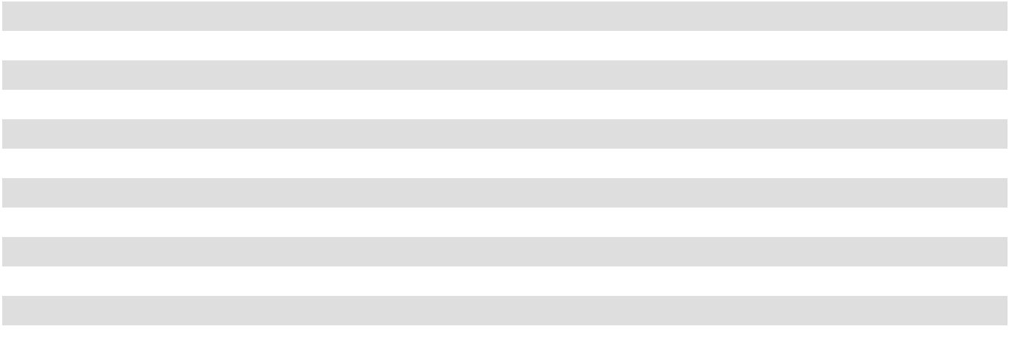

F-33

Taxability of Dividends

Earnings and profits, which determine the taxability of distributions to stockholders and holders of common units, may differ from income reported for financial reporting purposes due to the differences for federal income tax purposes in the treatment of loss on extinguishment of debt, revenue recognition and compensation expense and in the basis of depreciable assets and estimated useful lives used to compute depreciation. A summary of the income tax status of dividends per share paid is as follows:

 |  |  |  |  |  |  | Year Ended December 31,
 |  | 2025 |  |  |  |  |  | 2024 |  |  |  |  |  | 2023
 |  | Per Share |  |  | % |  |  | Per Share |  |  | % |  | Per Share |  |  |  | %
Ordinary income | $ | 0.56 |  |  | 41.3 % | $ |  | 1.09 |  |  | 81.5 % | $ |  | 1.20 |  |  | 90.6 %
Capital gain |  | 0.24 |  |  | 17.6 % |  |  | — |  |  | — % |  |  | — |  |  | — %
Return of capital |  | 0.56 |  |  | 41.1 % |  |  | 0.25 |  |  | 18.5 % |  |  | 0.12 |  |  | 9.4 %
Total | $ | 1.36 |  |  | 100.0 % | $ |  | 1.34 |  |  | 100.0 % | $ |  | 1.32 |  |  | 100.0 %


Stock-Based Compensation

The company has established the 2011 Equity Incentive Award Plan, which provides for grants to directors, employees and consultants of the company and the Operating Partnership of stock options, restricted stock, dividend equivalents, stock payments, performance shares, LTIP units, stock appreciation rights and other incentive awards. In June 2020, at the annual shareholder meeting, the shareholders approved the Amended and Restated 2011 Equity Incentive Award Plan (the “Amended and Restated 2011 Plan”). An aggregate of 4,054,411 shares of our common stock are authorized for issuance under awards granted pursuant to the Amended and Restated 2011 Plan, and as of December 31, 2025, 1,296,829 shares of common stock remain available for future issuance.

The following shares of restricted common stock have been issued as of December 31, 2025:

Grant |  | Fair Value at Grant Date |  | Number
June 5, 2023 ⁽¹⁾ |  | 19.33 |  | 10,348
December 7, 2023 ⁽²⁾ |  | 14.65 - 15.54 |  | 290,541
June 3, 2024 ⁽¹⁾ |  | 21.79 |  | 9,180
December 4, 2024 ⁽³⁾ |  | 19.83 - 20.79 |  | 236,052
December 4, 2024 ⁽⁴⁾ |  | 28.47 |  | 58,416
June 2, 2025 ⁽¹⁾ |  | 20.21 |  | 17,812
December 3, 2025 ⁽⁵⁾ |  | 13.36 - 14.32 |  | 384,923
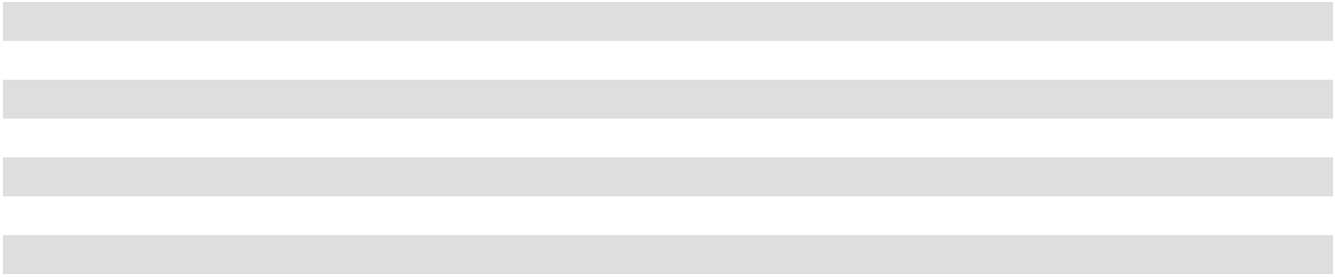

- Restricted common stock issued to members of the company's non-employee directors. These awards of restricted stock will vest subject to the director's continued service on the Board of Directors on the earlier of (i) the one year anniversary of the date of grant or (ii) the date of the next annual meeting of our stockholders, if such non-employee director continues his or her service on the Board of Directors until the next annual meeting of stockholders, but not thereafter, pursuant to our independent director compensation policy.

- Restricted common stock issued to certain of the company's senior management and other employees, which are subject to quantitative and qualitative performance criteria based vesting. Up to one-third of the shares of restricted stock may vest based on such performance criteria determined as of November 30, 2024, 2025 and 2026, subject to the employee's continued employment on those dates.
- Restricted common stock issued to certain of the company's senior management and other employees, which are subject to quantitative and qualitative performance criteria based vesting. Up to one-third of the shares of restricted stock may vest based on such performance criteria determined as of November 30, 2025, 2026 and 2027, subject to the employee's continued employment on those dates.
- Time-based restricted common stock issued to Mr. Wyll related to his transition to Chief Executive Officer, which are eligible to vest in substantially equal one-third tranches on December 4, 2025, December 4, 2026 and December 4, 2027, subject to Mr. Wyll's continued employment on those dates.
- Restricted common stock issued to certain of the company's senior management and other employees, which are subject to quantitative and qualitative performance criteria based vesting. Up to one-third of the shares of restricted stock may vest based on such performance criteria determined as of November 30, 2026, 2027 and 2028, subject to the employee's continued employment on those dates.

F-34

For the 2023, 2024, and 2025 grants, the fair value of the awards was estimated using a Monte Carlo Simulation model. For the 2023, 2024, and 2025 grants, vesting is subject to multiple vesting conditions as follows: (1) a service condition which requires continued employment of the employee as of each vesting date during the three-year vesting term for the employee to be eligible for vesting, (2) a performance condition with respect to our FFO per share for the FFO performance periods and (3) a market condition with respect to our relative total shareholder return performance over a one-year, two-year and three-year performance as compared to a pre-determined index. On each measurement date the performance condition and market condition performance will determine the number of shares that vest. We measure stock-based compensation expense based on the fair value of the award on the grant date, adjusted for changes to probabilities of achieving performance targets, and recognize expense over the vesting period. For the restricted stock grants that are time-vesting, issued to our non-employee directors, we estimate the stock compensation expense based on the fair value of the stock at the grant date.

The following table summarizes the activity of non-vested restricted stock awards during the year ended December 31,

2025:

 | 2025
 |  |  | Weighted Average
 | Units |  |  | Grant Date Fair
 | Units |  |  | Value
Balance at beginning of year | 600,938 | $ |  | 19.40
Granted | 402,735 |  |  | 14.13
Vested | (283,155) |  |  | 22.60
Forfeited | (27,261) |  |  | 18.42
Balance at end of year | 693,257 | $ |  | 16.58

We recognize noncash compensation expense ratably over the vesting period, and accordingly, we recognized $7.4 million, $7.1 million and $8.8 million in noncash compensation expense for the years ended December 31, 2025, 2024 and 2023, respectively, each of which is included in general and administrative expense on the statement of comprehensive income. Unrecognized compensation expense was $9.3 million at December 31, 2025, which will be recognized over a weighted-average period of 1.56 years.

Earnings Per Share

We have calculated earnings per share (“EPS”) under the two-class method. The two-class method is an earnings allocation methodology whereby EPS for each class of common stock and participating security is calculated according to dividends declared and participation rights in undistributed earnings. For the years ended December 31, 2025, 2024 and 2023, we had a weighted average of approximately 609,312 shares, 583,512 shares and 573,344 unvested shares outstanding, respectively, which are considered participating securities. Therefore, we have allocated our earnings for basic and diluted EPS between common shares and unvested shares.

Diluted EPS is calculated by dividing the net income attributable to common stockholders for the period by the weighted average number of common and dilutive instruments outstanding during the period using the treasury stock method. For the year ended December 31, 2025, diluted shares exclude incentive restricted stock as these awards are considered contingently issuable. Additionally, the unvested restricted stock awards subject to time vesting are anti-dilutive for all periods presented and accordingly, have been excluded from the weighted average common shares used to compute diluted EPS.

Earnings Per Unit of the Operating Partnership

Basic earnings per unit (“EPU”) of the Operating Partnership is computed by dividing income (loss) applicable to unitholders by the weighted average Operating Partnership units outstanding, as adjusted for the effect of participating securities. Operating Partnership units granted in equity-based payment transactions are considered participating securities prior to vesting. The impact of unvested Operating Partnership unit awards on EPU has been calculated using the two-class method whereby earnings are allocated to the unvested Operating Partnership unit awards based on distributions and the unvested Operating Partnership units’ participation rights in undistributed earnings (losses).

The calculation of diluted EPU for the year ended December 31, 2025, 2024 and 2023 does not include 609,312, 583,512, and 573,344 unvested weighted average Operating Partnership units, respectively, as these equity securities are either considered contingently issuable or the effect of including these equity securities was anti-dilutive to income from continuing operations and net income attributable to the unitholders.

F-35

The computation of basic and diluted EPS for American Assets Trust, Inc. is presented below (dollars in thousands, except share and per share amounts):

 |  | Year Ended December 31,
 |  | 2025 |  |  | 2024 |  |  | 2023
NUMERATOR
Net income | $ | 71,370 | $ |  | 72,819 | $ |  | 64,690
Less: Net income attributable to restricted shares |  | (852) |  |  | (787) |  |  | (761)
Less: Income attributable to unitholders in the Operating Partnership |  | (14,870) |  |  | (15,234) |  |  | (13,551)
Net income attributable to common stockholders—basic | $ | 55,648 | $ |  | 56,798 | $ |  | 50,378
Income attributable to American Assets Trust, Inc. common stockholders
 | $ | 55,648 | $ |  | 56,798 | $ |  | 50,378
—basic
Plus: Income attributable to unitholders in the Operating Partnership |  | 14,870 |  |  | 15,234 |  |  | 13,551
Net income attributable to common stockholders—diluted | $ | 70,518 | $ |  | 72,032 | $ |  | 63,929
DENOMINATOR
Weighted average common shares outstanding—basic |  | 60,555,010 |  |  | 60,333,055 |  |  | 60,158,976
Effect of dilutive securities—conversion of Operating Partnership units |  | 16,181,537 |  |  | 16,181,537 |  |  | 16,181,537
Weighted average common shares outstanding—diluted |  | 76,736,547 |  |  | 76,514,592 |  |  | 76,340,513
Earnings per common share, basic
Earnings per common share, basic | $ | 0.92 |  | $ | 0.94 |  | $ | 0.84
Earnings per common share, diluted
Earnings per common share, diluted | $ | 0.92 | $ |  | 0.94 | $ |  | 0.84
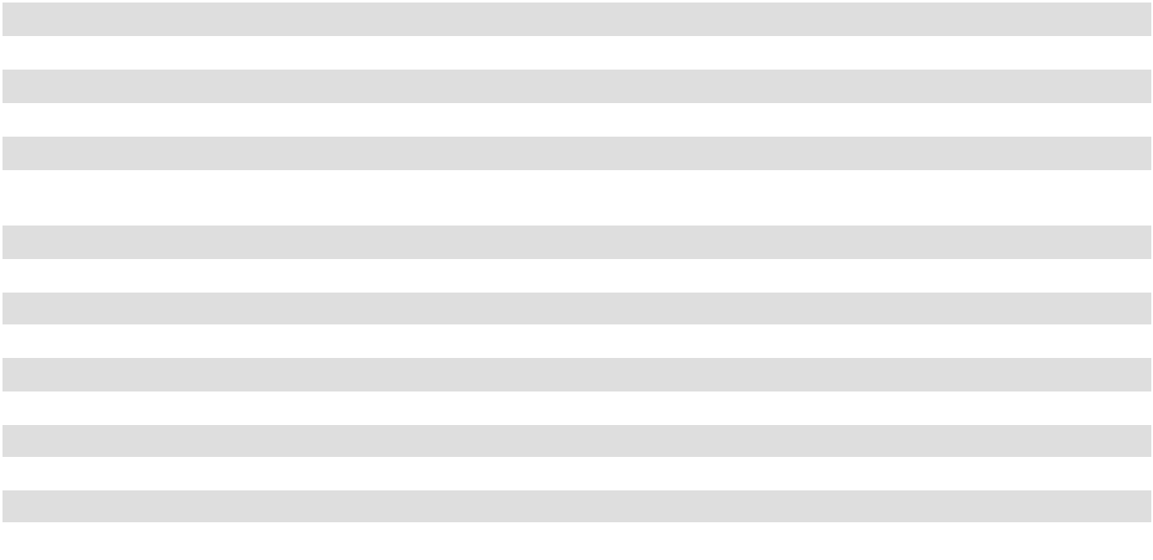

NOTE 11. INCOME TAXES

We elected to be taxed as a REIT and operate in a manner that allows us to qualify as a REIT for federal income tax purposes commencing with our taxable year ended December 31, 2011. As a REIT, we are generally not subject to corporate level income tax on the earnings distributed currently to our stockholders. Our Operating Partnership is subject to state and local income taxes and our TRS is subject to federal and state income taxes.

We lease our hotel property to a wholly owned TRS that is subject to federal and state income taxes. We account for income taxes using the asset and liability method, under which deferred tax assets and liabilities are recognized for the future tax consequences attributable to differences between GAAP carrying amounts and their respective tax bases. Additionally, we classify certain state taxes as income taxes for financial reporting purposes in accordance with ASC Topic 740, Income Taxes.

A deferred tax asset is included in our consolidated balance sheets of $1.0 million and $1.0 million, and a deferred tax liability is included in our consolidated balance sheets of $0.6 million and $0.8 million as of December 31, 2025 and 2024, respectively, in relation to real estate asset basis differences and prepaid expenses for our TRS.

The income tax provision included in other income (expense) on the consolidated statement of comprehensive income is as follows (in thousands):
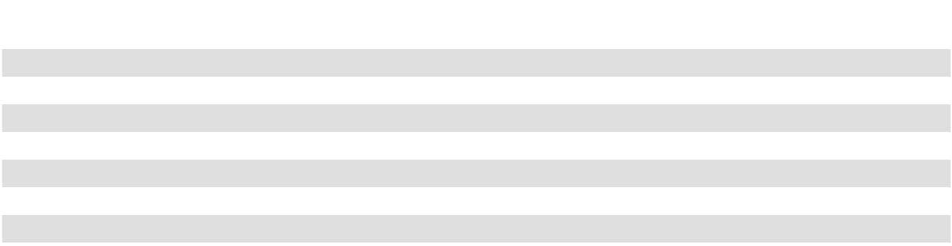

 |  | Year Ended December 31,
 | 2025 |  |  |  | 2024 |  |  |  | 2023
Current:
Federal | $ | 15 | $ |  | 31 |  |  | $ | 86
State |  | 931 |  |  | 962 |  |  |  | 1,191
Deferred:
Federal |  | (31) |  |  | — |  |  |  | (21)
State |  | (145) |  |  | (107) |  |  |  | (215)
Provision for income taxes | $ | 770 | $ |  | 886 |  |  | $ | 1,041

F-36

NOTE 12. COMMITMENTS AND CONTINGENCIES

Legal

We are sometimes involved in various disputes, lawsuits, warranty claims, environmental and other matters arising in the ordinary course of business. Management makes assumptions and estimates concerning the likelihood and amount of any potential loss relating to these matters.

We are currently a party to various legal proceedings. We accrue a liability for litigation if an unfavorable outcome is probable and the amount of loss can be reasonably estimated. If an unfavorable outcome is probable and a reasonable estimate of the loss is a range, we accrue the best estimate within the range; however, if no amount within the range is a better estimate than any other amount, the minimum within the range is accrued. As of December 31, 2025, no litigation liabilities have been accrued. Legal fees related to litigation are expensed as incurred. We do not believe that the ultimate outcome of these matters, either individually or in the aggregate, could have a material adverse effect on our financial position or overall trends in results of operations; however, litigation is subject to inherent uncertainties. Also, under our leases, tenants are typically obligated to indemnify us from and against all liabilities, costs and expenses imposed upon or asserted against us as owner of the properties due to certain matters relating to the tenants' operations at our properties.

Commitments

See Footnote 13 for a description of our leases, as a lessee.

We have management agreements with Outrigger Hotels & Resorts or an affiliate thereof (“Outrigger”) pursuant to which Outrigger manages each of the retail and hotel portions of the Waikiki Beach Walk property. Under the management agreement with Outrigger relating to the retail portion of Waikiki Beach Walk (the “retail management agreement”), we pay Outrigger a monthly management fee of 3.0% of net revenues from the retail portion of Waikiki Beach Walk. Pursuant to the terms of the retail management agreement, if the agreement is terminated in certain instances, including our election not to repair damage or destruction at the property, a condemnation or our failure to make required working capital infusions, we would be obligated to pay Outrigger a termination fee equal to the sum of the management fees paid for the two months immediately preceding the termination date. The retail management agreement may not be terminated by us or by Outrigger without cause. Under our management agreement with Outrigger relating to the hotel portion of Waikiki Beach Walk (the “hotel management agreement”), we pay Outrigger a monthly management fee of 6.0% of the hotel's gross operating profit, as well as 3.0% of the hotel's gross revenues; provided that the aggregate management fee payable to Outrigger for any year shall not exceed 3.5% of the hotel's gross revenues for such fiscal year. Pursuant to the terms of the hotel management agreement, if the agreement is terminated in certain instances, including upon a transfer by us of the hotel or upon a default by us under the hotel management agreement, we would be required to pay a cancellation fee calculated by multiplying (1) the management fees for the previous 12 months by (2) (a) eight, if the agreement is terminated in the first 11 years of its term, or (b) four, three, two or one, if the agreement is terminated in the twelfth, thirteenth, fourteenth or fifteenth year, respectively, of its term. The hotel management agreement may not be terminated by us or by Outrigger without cause. Additionally, we have entered into a management agreement with Outrigger pursuant to which Outrigger manages our Waikele Center and Shops at Kalakaua. In connection with such management agreement, we pay Outrigger a fixed management fee of $12,000 per month in the aggregate plus additional amounts for any lease renewal services provided by Outrigger at our request. This management agreement may be terminated by us at any time and for any reason on at least 30 days' notice without payment of any cancellation or termination fees.

A wholly owned subsidiary of our Operating Partnership, WBW Hotel Lessee LLC, entered into a franchise license agreement with Embassy Suites Franchise LLC, the franchisor of the brand “Embassy Suites™,” to obtain the non-exclusive right to operate the hotel under the Embassy Suites brand for 20 years. The franchise license agreement provides that WBW Hotel Lessee LLC must comply with certain management, operational, record keeping, accounting, reporting and marketing standards and procedures. In connection with this agreement, we are also subject to the terms of a product improvement plan pursuant to which we expect to undertake certain actions to ensure that our hotel's infrastructure is maintained in compliance with the franchisor's brand standards. In addition, we must pay to Embassy Suites Franchise LLC a monthly franchise royalty fee equal to 5.0% of the hotel's gross room revenue, as well as a monthly program fee equal to 4.0% of the hotel's gross room revenue. If the franchise license is terminated due to our failure to make required improvements or to otherwise comply with its terms, we may be liable to the franchisor for a termination payment, which could be as high as $7.9 million based on operating performance through December 31, 2025.

F-37

Concentrations of Credit Risk

Our properties are located in Southern California, Northern California, Washington, Oregon, Texas and Hawaii. The ability of the tenants to honor the terms of their respective leases is dependent upon the economic, regulatory and social factors affecting the markets in which the tenants operate. Sixteen of our consolidated properties, representing 43.8% and 43.2% of our total revenue for the year ended December 31, 2025 and 2024, respectively, are located in Southern California, which exposes us to greater economic risks than if we owned a more geographically diverse portfolio. Our mixed-use property located in Honolulu, Hawaii accounted for 15.1% and 14.8% of total revenues for the year ended December 31, 2025 and 2024, respectively.

Tenants in the office industry accounted for 47.2% and 47.1% of total revenues for the years December 31, 2025 and 2024, respectively. This makes us susceptible to demand for office rental space and subject to the risks associated with an investment in real estate with a concentration of tenants in the office industry.

Tenants in the retail industry accounted for 21.8% and 23.8% of total revenues for the years December 31, 2025 and 2024, respectively. This makes us susceptible to demand for retail rental space and subject to the risks associated with an investment in real estate with a concentration of tenants in the retail industry. Two retail properties, Alamo Quarry Market and Waikele Center combined accounted for 9.3% and 8.8% of total revenues for the years ended December 31, 2025 and 2024, respectively.

For the years ended December 31, 2025 and 2024, no tenant accounted for more than 10.0% of our total rental revenue. At December 31, 2025, Google LLC at The Landmark at One Market accounted for 9.8% of total annualized base rent. Three other tenants (LPL Holdings, Inc., Autodesk, Inc. , and Smartsheet, Inc.) comprise 15% of our total annualized base rent at December 31, 2025, in the aggregate. No other tenants represent greater than 2.0% of our total annualized base rent. Total annualized base rent used for the percentage calculations includes the annualized base rent as of December 31, 2025 for our office properties, retail properties and the retail portion of our mixed-use property.

NOTE 13. LEASES

Lessor Operating Leases

We determine if an arrangement is a lease at inception. Our lease agreements are generally for real estate, and the determination of whether such agreements contain leases generally does not require significant estimates or judgments. We lease real estate under operating leases.

Our leases with office, retail, mixed-use and residential tenants are classified as operating leases. Leases at our office and retail properties and the retail portion of our mixed-use property generally range from three years to ten years (certain leases with anchor tenants may be longer), and in addition to minimum rents, usually provide for cost recoveries for the tenant’s share of certain operating costs. Our leases may also include variable lease payments in the form of percentage rents based on the tenant’s level of sales achieved in excess of a breakpoint threshold. Leases on apartments generally range from seven months to fifteen months, with a majority having 12 month lease terms. Rooms at the hotel portion of our mixed-use property are rented on a nightly basis.

Leases at our office and retail properties and the retail portion of our mixed-use property may contain lease extension options, at our lessee's discretion. The extension options are generally for 3 to 10 years and contain primarily rent at fixed rates or the prevailing market rent. The extension options are generally exercisable 6 to 12 months prior to the expiration of the lease and require the lessee to not be in default of the lease terms.

We attempt to maximize the amount we expect to derive from the underlying real estate property following the end of a lease, to the extent it is not extended. We maintain a proactive leasing and capital improvement program that, combined with the quality and locations of our properties, has made our properties attractive to tenants. However, the residual value of a real estate property is still subject to various market-specific, asset-specific, and tenant-specific risks and characteristics.

At December 31, 2025, our office, retail and mixed-use properties are located in five states: California, Washington, Oregon, Texas and Hawaii. At December 31, 2025, we had approximately 801 leases with office and retail tenants, including the retail portion of our mixed-use property. Our multifamily properties are located in Southern California and Portland, Oregon, and we had 2,041 leases with residential tenants at December 31, 2025, excluding Santa Fe Park RV Resort.

F-38

As of December 31, 2025, minimum future rentals from noncancelable operating leases before any reserve for uncollectible amounts and assuming no early lease terminations, at our office and retail properties and the retail portion of our mixed-use property are as follows for the years ended December 31 (in thousands):

2026 | $ | 256,537
2027 |  | 245,106
2028 |  | 205,330
2029 |  | 146,129
2030 |  | 90,673
Thereafter |  | 216,878
Total | $ | 1,160,653

The above future minimum rentals exclude residential leases, which typically range from seven months to fifteen months, and exclude the hotel, as rooms are rented on a nightly basis.

Lessee Operating Leases

We determine if an arrangement is a lease at inception. Our lease agreements are generally for real estate, and the determination of whether such agreements contain leases generally does not require significant estimates or judgments. We lease real estate under operating leases.

At The Landmark at One Market, we lease, as lessee, a building adjacent to The Landmark at One Market under an operating lease effective through June 30, 2031 (the “Annex Lease”). The lease payments under the Annex Lease are equal to the fair rental value at the time the extension option was exercised. In June 2025, we exercised the final five-year extension option to extend the Annex Lease through June 30, 2031, which was memorialized in a lease amendment executed in August 2025.

Our lease agreements do not contain any residual value guarantees or material restrictive covenants. As our leases do not provide an implicit rate, we use our incremental borrowing rate based on the information available at commencement in determining the present value of lease payments.

Current annual payments under the operating leases are as follows, as of December 31, 2025 (in thousands):
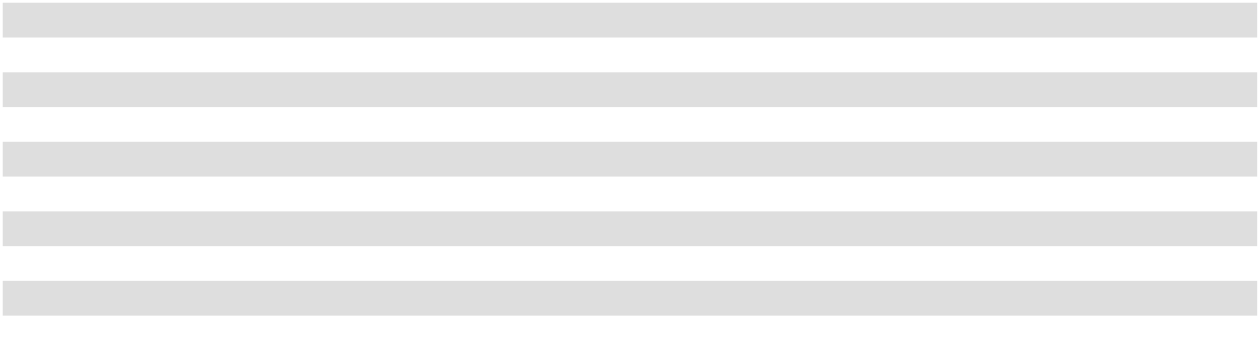

Year Ending December 31,
2026 | $ | 3,584
2027 |  | 3,637
2028 |  | 3,746
2029 |  | 3,859
2030 |  | 3,975
Thereafter |  | 2,017
Total lease payments |  | 20,818
Imputed interest |  | (2,044)
Present value of lease liability | $ | 18,774

F-39

Lease costs under the operating leases are as follows (in thousands):
 |  | Year Ended December 31,
 |  | 2025 |  | 2024
Operating lease cost | $ | 3,731 | $ | 3,727
Sublease income |  | (3,429) |  | (3,445)
Total lease cost | $ | 302 | $ | 282
Weighted-average remaining lease term - operating leases (in years) |  | 5.5
Weighted-average discount rate - operating leases |  | 3.19 | %
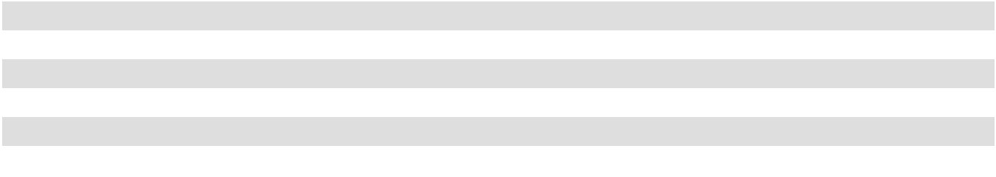

Supplemental cash flow information and non-cash activity related to our operating leases are as follow (in thousands):

Year Ended December 31,

2025 2024

Operating cash flow information:

Cash paid for amounts included in the measurement of lease liabilities $ 3,531 $ 3,428

Subleases

At The Landmark at One Market, we (as sublandlord) sublease the Annex Lease building under operating leases effective through June 30, 2031. The subleases contain extension options, subject to our ability to extend the Annex Lease, that can extend the subleases through December 31, 2039 at the fair rental value at the time the extension option is exercised.

NOTE 14. COMPONENTS OF RENTAL INCOME AND EXPENSE

The principal components of rental income are as follows (in thousands):

 |  | Year Ended December 31,
 |  | 2025 |  |  | 2024 |  |  | 2023
Minimum rents
Office | $ | 196,056 | $ |  | 197,256 | $ |  | 200,870
Retail |  | 92,220 |  |  | 102,848 |  |  | 99,504
Multifamily |  | 64,635 |  |  | 61,112 |  |  | 57,643
Mixed-Use |  | 13,194 |  |  | 12,359 |  |  | 12,194
Percentage rent |  | 1,876 |  |  | 4,353 |  |  | 3,625
Hotel revenue |  | 39,914 |  |  | 43,030 |  |  | 42,881
Other |  | 2,598 |  |  | 2,652 |  |  | 2,656
Total rental income | $ | 410,493 | $ |  | 423,611 | $ |  | 419,373
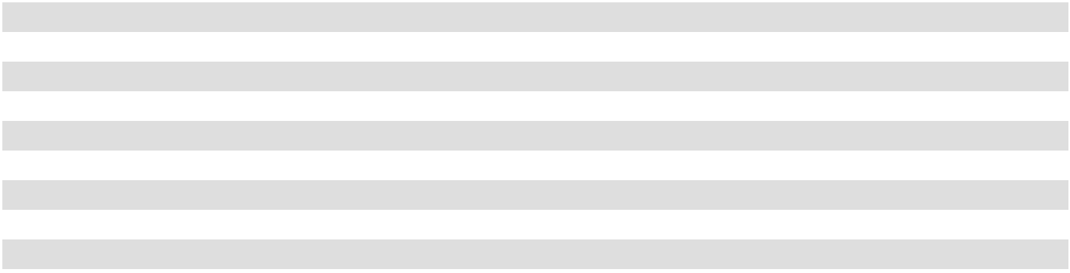

Minimum rents include $2.5 million, $3.1 million and $3.9 million for the years ended December 31, 2025, 2024 and 2023, respectively, to recognize minimum rents on a straight-line basis. In addition, minimum rents include $2.1 million, $2.7 million and $3.1 million for the years ended December 31, 2025, 2024 and 2023, respectively, to recognize the amortization of above and below market leases.

F-40

The principal components of rental expenses are as follows (in thousands):

 |  | Year Ended December 31,
 |  | 2025 |  |  | 2024 |  |  | 2023
Rental operating | $ | 58,301 | $ |  | 56,810 | $ |  | 53,028
Hotel operating |  | 29,440 |  |  | 29,903 |  |  | 29,380
Repairs and maintenance |  | 24,145 |  |  | 23,214 |  |  | 22,639
Marketing |  | 2,552 |  |  | 3,054 |  |  | 3,485
Rent |  | 3,480 |  |  | 3,585 |  |  | 3,536
Hawaii excise tax |  | 4,337 |  |  | 4,516 |  |  | 4,387
Management fees |  | 2,346 |  |  | 2,421 |  |  | 2,346
Total rental expenses | $ | 124,601 | $ |  | 123,503 | $ |  | 118,801

NOTE 15. OTHER INCOME

The principal components of other income, net are as follows (in thousands):

 |  | Year Ended December 31,
 |  | 2025 |  |  | 2024 |  |  | 2023
Interest and investment income | $ | 4,328 | $ |  | 9,031 | $ |  | 2,175
Income tax expense |  | (770) |  |  | (886) |  |  | (1,041)
Other non-operating income |  | — |  |  | 10,002 |  |  | 6,515
Total other income | $ | 3,558 | $ |  | 18,147 | $ |  | 7,649


For the year ended December 31, 2024, other non-operating income includes the net settlement payment of approximately $10.0 million received on January 2, 2024 related to building specifications for one of the existing buildings at our office project in University Town Center (San Diego). For the year ended December 31, 2023, other non-operating income includes the settlement payment of approximately $6.5 million received on January 3, 2023 related to certain building systems at our Hassalo on Eighth property.

NOTE 16. RELATED PARTY TRANSACTIONS

At Torrey Point, the company leases space to American Assets, Inc. (“AAI”), an entity owned and controlled by Mr. Rady, for an initial lease term of ten years at an average annual rental rate of $0.2 million. Rental revenue recognized on the lease of $0.3 million, $0.3 million and $0.3 million for the years ended December 31, 2025, 2024 and 2023, respectively, is included in rental income on the consolidated statements of comprehensive income.

At Coastal Collection at Torrey Reserve, the company leases space to Ensight, Inc. an entity majority owned and controlled by Mr. Rady, at an average annual rental rate of $0.1 million. Rent revenue recognized on the lease of $0.1 million, $0.1 million and $0.1 million for the years ended December 31, 2025, 2024 and 2023, respectively, is included in rental income on the consolidated statements of comprehensive income.

On occasion, the company utilizes aircraft services provided by AAI Aviation, Inc. (“AAIA”), an entity owned and controlled by Mr. Rady. For the years ending December 31, 2025, 2024 and 2023, we incurred approximately $0.1 million, $0.2 million and $0.2 million, respectively, of expenses related to aircraft services of AAIA or reimbursement to Mr. Rady (or his trust) for use of the aircraft owned by AAIA. These expenses are recorded as general and administrative expenses in our consolidated statements of comprehensive income.

As of December 31, 2025, Mr. Rady and his affiliates owned approximately 16.5% of our outstanding common stock and 19.3% of our outstanding common units, which together represent an approximate 35.6% beneficial interest in our company on a fully diluted basis.

F-41

The Waikiki Beach Walk entities have a 47.7% investment in WBW CHP LLC, an entity that was formed to, among other things, construct a chilled water plant to provide air conditioning to the property and other adjacent facilities. The operating expenses of WBW CHP LLC are recovered through reimbursements from its members, and reimbursements to WBW CHP LLC of $1.1 million, $1.1 million and $1.1 million were made for the years ended December 31, 2025, 2024 and 2023, respectively, and included in rental expenses on the statements of comprehensive income.

NOTE 17. SEGMENT REPORTING

For the year ended December 31, 2025, the CODM for the company was comprised of our President and Chief Executive Officer and our Chief Financial Officer.

Segment information is prepared on the same basis that our management reviews information for operational decision-making purposes. We review operating and financial information for each property on an individual basis and therefore, each property represents an individual operating segment. However, we have aggregated our properties into reportable segments as the properties share similar long-term economic characteristics and have other similarities including the fact that they are operated using consistent business strategies.

We operate in four reportable business segments: the acquisition, redevelopment, ownership and management of retail real estate, office real estate, multifamily real estate and mixed-use real estate. The products for our retail segment primarily include rental of retail space and other tenant services, including tenant reimbursements, parking and storage space rental. The products for our office segment primarily include rental of office space and other tenant services, including tenant reimbursements, parking and storage space rental. The products for our multifamily segment include rental of apartments and other tenant services. The products of our mixed-use segment include rental of retail space and other tenant services, including tenant reimbursements, parking and storage space rental and operation of a 369-room all-suite hotel.

Regular reportable segment updates are provided directly to the CODM. These updates include the performance of our segments based on segment profit which is defined as property revenue less property expenses, and this serves as the profit or loss measure used by the CODM for performance assessment and resource allocation. We consider segment profit to be an appropriate supplemental measure to net income because it assists both investors and the CODM in understanding the core operations of our properties. Segment profit provides a performance measure that, when compared year over year, reflects the revenues and expenses directly associated with owning and operating commercial real estate and the impact to operations from trends in occupancy rates, rental rates, and operating costs, providing a perspective on operations not immediately apparent from net income.

Segment profit is not a measure of operating income or cash flows from operating activities as measured by GAAP, and it is not indicative of cash available to fund cash needs and should not be considered an alternative to cash flows as a measure of liquidity. Not all companies calculate segment profit in the same manner. General and administrative expenses, interest expense, depreciation and amortization expense and other income and expense are not included in segment profit as our internal reporting addresses these items on a corporate level.

A significant segment expense is a category of expenses and amounts regularly provided to the CODM that is included in the calculation of each reported measure of segment profit or loss. Further, the CODM will use this measure to assess segment performance in deciding how to allocate resources. Significant expenses included in the reportable segment profit or loss measure are presented by rental expenses and real estate taxes for each reportable segment. Rental expenses includes facilities service expense, utilities expense, repairs and maintenance expense, insurance expense and other costs.

F-42

The following table represents the significant segment expenses and operating activity within our reportable segments (in thousands):

 |  | Year Ended December 31,
 |  | 2025 |  |  | 2024 |  |  | 2023
Total Office | $ | 206,037 | $ |  | 215,778 | $ |  | 207,856
Property revenue
Rental expenses |  | 46,223 |  |  | 43,181 |  |  | 40,627
Real estate taxes |  | 20,675 |  |  | 19,053 |  |  | 20,712
Property expense |  | 66,898 |  |  | 62,234 |  |  | 61,339
Segment profit |  | 139,139 |  |  | 153,544 |  |  | 146,517
Total Retail |  | 95,122 |  |  | 109,040 |  |  | 104,767
Property revenue |  | 95,122 |  |  | 109,040 |  |  | 104,767
Rental expenses |  | 14,823 |  |  | 18,578 |  |  | 18,008
Real estate taxes |  | 11,961 |  |  | 13,930 |  |  | 13,432
Property expense |  | 26,784 |  |  | 32,508 |  |  | 31,440
Segment profit |  | 68,338 |  |  | 76,532 |  |  | 73,327
Total Multifamily |  | 68,961 |  |  | 65,372 |  |  | 61,830
Property revenue |  | 68,961 |  |  | 65,372 |  |  | 61,830
Rental expenses |  | 23,810 |  |  | 21,603 |  |  | 20,788
Real estate taxes |  | 8,141 |  |  | 7,186 |  |  | 7,237
Property expense |  | 31,951 |  |  | 28,789 |  |  | 28,025
Segment profit |  | 37,010 |  |  | 36,583 |  |  | 33,805
Total Mixed-Use |  | 66,084 |  |  | 67,665 |  |  | 66,711
Property revenue |  | 66,084 |  |  | 67,665 |  |  | 66,711
Rental expenses |  | 39,745 |  |  | 40,141 |  |  | 39,378
Real estate taxes |  | 4,217 |  |  | 4,055 |  |  | 3,775
Property expense |  | 43,962 |  |  | 44,196 |  |  | 43,153
Segment profit |  | 22,122 |  |  | 23,469 |  |  | 23,558
Total segments’ profit | $ | 266,609 | $ |  | 290,128 | $ |  | 277,207


The following table is a reconciliation of segment profit to net income attributable to stockholders (in thousands):

 |  | Year Ended December 31,
 |  | 2025 |  |  | 2024 |  |  | 2023
Total segments' profit | $ | 266,609 | $ |  | 290,128 | $ |  | 277,207
General and administrative |  | (37,841) |  |  | (35,468) |  |  | (35,960)
Depreciation and amortization |  | (127,312) |  |  | (125,461) |  |  | (119,500)
Interest expense, net |  | (78,120) |  |  | (74,527) |  |  | (64,706)
Gain on sale of real estate |  | 44,476 |  |  | — |  |  | —
Other income, net |  | 3,558 |  |  | 18,147 |  |  | 7,649
Net income |  | 71,370 |  |  | 72,819 |  |  | 64,690
Net income attributable to restricted shares |  | (852) |  |  | (787) |  |  | (761)
Net income attributable to unitholders in the Operating Partnership |  | (14,870) |  |  | (15,234) |  |  | (13,551)
Net income attributable to American Assets Trust, Inc. stockholders | $ | 55,648 | $ |  | 56,798 | $ |  | 50,378
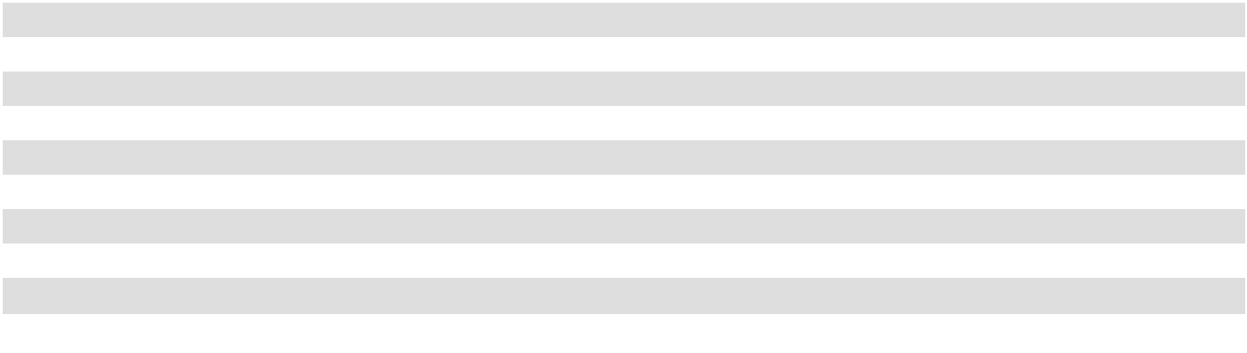

F-43

The following table shows net real estate and secured note payable balances for each of the reportable segments, along with their capital expenditures for each year (in thousands):

 | December 31, 2025 |  |  | December 31, 2024
Net real estate
Office | $ | 1,587,316 | $ |  | 1,597,458
Retail ⁽¹⁾ |  | 469,733 |  |  | 478,037
Multifamily |  | 406,163 |  |  | 351,016
Mixed-Use |  | 156,156 |  |  | 160,975
 | $ | 2,619,368 | $ |  | 2,587,486
Secured Notes Payable ⁽²⁾
Office | $ | 75,000 | $ |  | 75,000
Retail |  | — |  |  | —
 | $ | 75,000 | $ |  | 75,000
Capital Expenditures ⁽³⁾
Office | $ | 61,510 | $ |  | 56,720
Retail |  | 11,510 |  |  | 13,568
Multifamily |  | 5,094 |  |  | 5,637
Mixed-Use |  | 2,306 |  |  | 1,482
 | $ | 80,420 | $ |  | 77,407
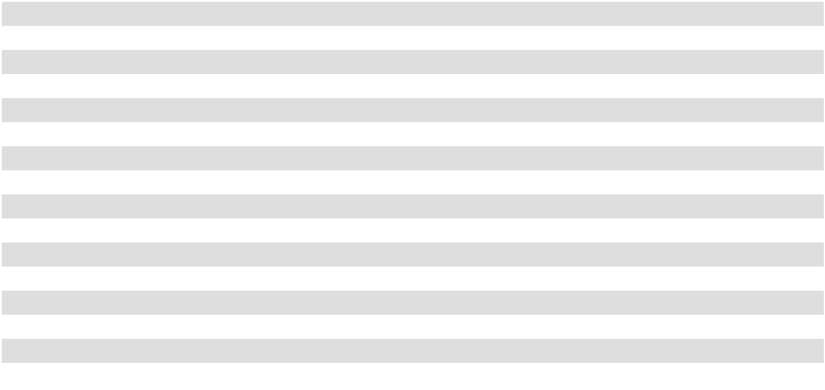

- Excludes the real estate assets held for sale as of December 31, 2024.

- Excludes unamortized debt issuance costs of $0.2 million and $0.2 million as of December 31, 2025 and 2024, respectively.

- Capital expenditures represent cash paid for capital expenditures during the year and includes leasing commissions paid.

NOTE 18. QUARTERLY FINANCIAL INFORMATION (UNAUDITED)

The tables below reflect selected American Assets Trust, Inc. quarterly information for 2025 and 2024 (in thousands, except per shares data):

 |  |  |  |  | Three Months Ended
 |  | December 31, |  |  | September 30, |  |  | June 30, |  |  | March 31,
 |  | 2025 |  |  | 2025 |  |  | 2025 |  |  | 2025
Total revenue | $ | 110,086 | $ |  | 109,578 | $ |  | 107,933 | $ |  | 108,607
Operating income |  | 23,215 |  |  | 24,767 |  |  | 25,978 |  |  | 71,972
Net income |  | 4,221 |  |  | 5,921 |  |  | 7,121 |  |  | 54,107
Net income attributable to restricted shares |  | (236) |  |  | (207) |  |  | (206) |  |  | (203)
Net income attributable to unitholders in the Operating |  | (837) |  |  | (1,205) |  |  | (1,459) |  |  | (11,369)
Partnership |  | (837) |  |  | (1,205) |  |  | (1,459) |  |  | (11,369)
Net income attributable to American Assets Trust, Inc. | $ | 3,148 | $ |  | 4,509 | $ |  | 5,456 | $ |  | 42,535
stockholders
Net income per share attributable to common stockholders | $ | 0.05 | $ |  | 0.07 | $ |  | 0.09 | $ |  | 0.70
- basic and diluted
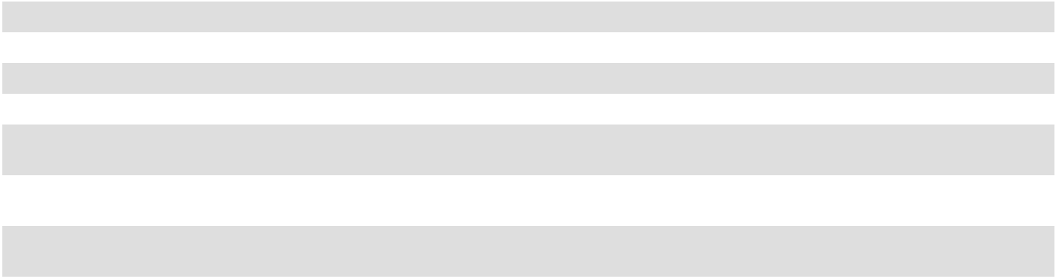

F-44

 |  |  |  |  | Three Months Ended
 |  | December 31, |  |  | September 30, |  |  | June 30, |  |  | March 31,
 |  | 2024 |  |  | 2024 |  |  | 2024 |  |  | 2024
Total revenue | $ | 113,460 | $ |  | 122,810 | $ |  | 110,890 | $ |  | 110,695
Operating income |  | 30,048 |  |  | 37,808 |  |  | 30,794 |  |  | 30,549
Net income |  | 11,584 |  |  | 21,318 |  |  | 15,294 |  |  | 24,623
Net income attributable to restricted shares |  | (202) |  |  | (194) |  |  | (195) |  |  | (196)
Net income attributable to unitholders in the Operating
Partnership |  | (2,405) |  |  | (4,467) |  |  | (3,195) |  |  | (5,167)
Net income attributable to American Assets Trust, Inc.
stockholders | $ | 8,977 | $ |  | 16,657 | $ |  | 11,904 | $ |  | 19,260
Net income per share attributable to common stockholders
- basic and diluted | $ | 0.15 | $ |  | 0.28 | $ |  | 0.20 | $ |  | 0.32
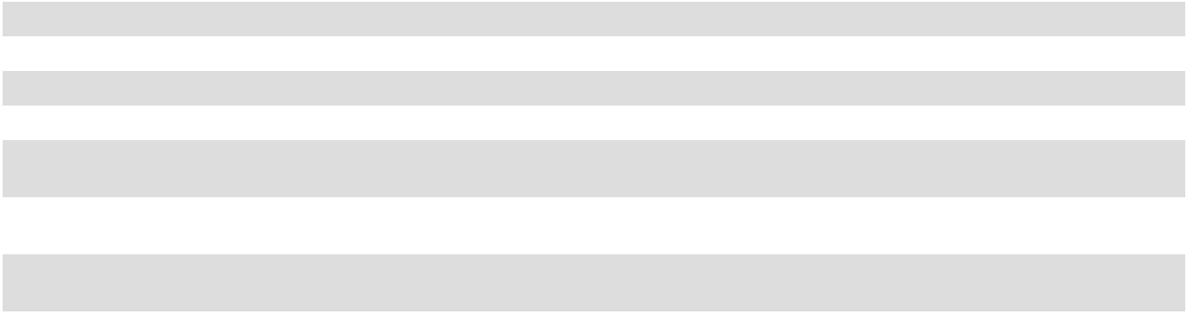

The tables below reflect selected American Assets Trust, L.P. quarterly information for 2025 and 2024 (in thousands, except per shares data):

 |  |  |  |  | Three Months Ended
 |  | December 31, |  |  | September 30, |  |  | June 30, |  |  | March 31,
 |  | 2025 |  |  | 2025 |  |  | 2025 |  |  | 2025
Total revenue | $ | 110,086 | $ |  | 109,578 | $ |  | 107,933 | $ |  | 108,607
Operating income |  | 23,215 |  |  | 24,767 |  |  | 25,978 |  |  | 71,972
Net income |  | 4,221 |  |  | 5,921 |  |  | 7,121 |  |  | 54,107
Net income attributable to restricted shares |  | (236) |  |  | (207) |  |  | (206) |  |  | (203)
Net income attributable to American Assets Trust, L.P. | $ | 3,985 | $ |  | 5,714 | $ |  | 6,915 | $ |  | 53,904
unit holders
Net income per unit attributable to unit holders - basic and | $ | 0.05 | $ |  | 0.07 | $ |  | 0.09 | $ |  | 0.70
diluted
 |  |  |  |  | Three Months Ended
 |  | December 31, |  |  | September 30, |  |  | June 30, |  |  | March 31,
 |  | 2024 |  |  | 2024 |  |  | 2024 |  |  | 2024
Total revenue | $ | 113,460 | $ |  | 122,810 | $ |  | 110,890 | $ |  | 110,695
Operating income |  | 30,048 |  |  | 37,808 |  |  | 30,794 |  |  | 30,549
Net income |  | 11,584 |  |  | 21,318 |  |  | 15,294 |  |  | 24,623
Net income attributable to restricted shares |  | (202) |  |  | (194) |  |  | (195) |  |  | (196)
Net income attributable to American Assets Trust, L.P.
unit holders | $ | 11,382 | $ |  | 21,124 | $ |  | 15,099 | $ |  | 24,427
Net income per unit attributable to common unit holders -
basic and diluted | $ | 0.15 | $ |  | 0.28 | $ |  | 0.20 | $ |  | 0.32
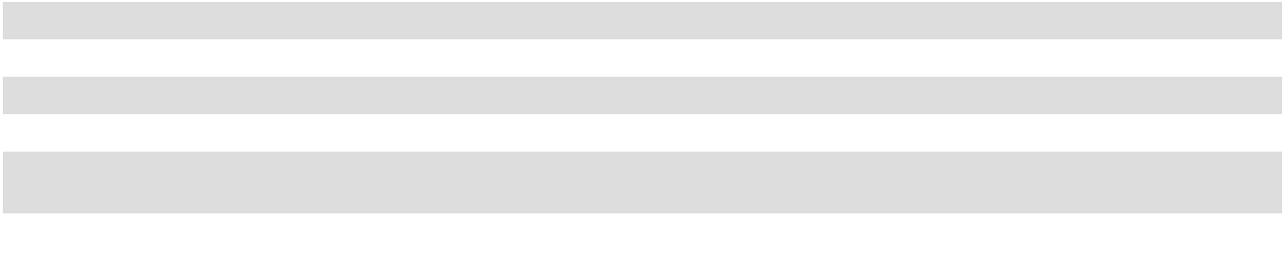

F-45

F-46

American Assets Trust, Inc. and American Assets Trust, L.P.

SCHEDULE III—Consolidated Real Estate and Accumulated Depreciation

(In Thousands)

 | Encumbrance |  |  | Initial Cost |  |  |  |  |  | Cost |  | Gross Carrying Amount |  |  |  |  | Accumulated |  |  |  |  |  |  | Life on which
 |  |  |  |  |  |  |  |  | Capitalized |  |  | at December 31, 2025 |  |  |  |  |  |  |  |  |  |  |  | depreciation in
 |  | as of |  |  |  |  |  |  | Subsequent |  |  |  |  |  |  |  | Depreciation |  |  | Year Built/ |  |  |  | latest income
 |  |  |  |  |  | Building and |  |  |  |  |  |  |  | Building and |  |  |  |  |  |  |  | Date |  | latest income
Description | December 31, |  |  | Land |  |  |  |  |  | to |  | Land |  |  |  |  |  | and |  | Most Recent |  | Date |  | statements is
Description |  | 2025 |  | Land |  | Improvements |  |  | Acquisition |  |  | Land |  | Improvements |  |  | Amortization |  |  | Renovation |  | Acquired |  | computed
Alamo Quarry Market | $ | — |  | $ 26,396 |  | $ | 109,294 |  | $ | 40,803 |  | $ 26,816 |  | $ | 149,677 |  | $ | (87,378) |  | 1997/1999 |  | 12/9/2003 |  | 35 years
Carmel Country Plaza |  | — |  | 4,200 |  |  | — |  |  | 15,449 |  | 4,200 |  |  | 15,449 |  |  | (11,208) | 1991 |  | 1/10/1989 |  |  | 35 years
Carmel Mountain Plaza |  | — |  | 22,477 |  |  | 65,217 |  |  | 43,814 |  | 31,034 |  |  | 100,474 |  |  | (63,784) | 1994/2020 |  | 3/28/2003 |  |  | 35 years
Gateway Marketplace |  | — |  | 17,363 |  |  | 21,644 |  |  | 973 |  | 17,363 |  |  | 22,617 |  |  | (6,894) | 1997/2016 |  | 7/6/2017 |  |  | 35 years
Geary Marketplace |  | — |  | 8,239 |  |  | 12,353 |  |  | 381 |  | 8,239 |  |  | 12,734 |  |  | (5,199) | 2012 |  | 12/19/2012 |  |  | 35 years
Hassalo on Eighth - Retail |  | — |  | — |  |  | — |  |  | 27,915 |  | 597 |  |  | 27,318 |  |  | (12,345) | 2015 |  | 7/1/2011 |  |  | 35 years
Lomas Santa Fe Plaza |  | — |  | 8,600 |  |  | 11,282 |  |  | 14,863 |  | 8,620 |  |  | 26,125 |  |  | (21,595) | 1972/1997 |  | 6/12/1995 |  |  | 35 years
The Shops at Kalakaua |  | — |  | 13,993 |  |  | 10,817 |  |  | 157 |  | 14,006 |  |  | 10,961 |  |  | (6,671) | 1971/2006 |  | 3/31/2005 |  |  | 35 years
Solana Beach Towne Centre |  | — |  | 40,980 |  |  | 38,842 |  |  | 5,952 |  | 40,980 |  |  | 44,794 |  |  | (20,649) | 1973/2004 |  | 1/19/2011 |  |  | 35 years
South Bay Marketplace |  | — |  | 4,401 |  |  | — |  |  | 13,040 |  | 4,401 |  |  | 13,040 |  |  | (9,922) | 1997/2018 |  | 9/16/1995 |  |  | 35 years
Waikele Center |  | — |  | 55,593 |  |  | 126,858 |  |  | 45,007 |  | 70,644 |  |  | 156,814 |  |  | (91,524) | 1993/2008 |  | 9/16/2004 |  |  | 35 years
City Center Bellevue |  | 75,000 |  | 25,135 |  |  | 190,998 |  |  | 60,922 |  | 25,135 |  |  | 251,920 |  |  | (101,706) | 1987/2023 |  | 8/21/2012 |  |  | 40 years
14Acres |  | — |  | 35,822 |  |  | 82,737 |  |  | 21,380 |  | 35,822 |  |  | 104,117 |  |  | (14,104) | 1985/2024 |  | 7/7/2021 |  |  | 40 years
Timber Ridge |  | — |  | 23,203 |  |  | 55,992 |  |  | 6,690 |  | 23,203 |  |  | 62,682 |  |  | (9,479) | 1986 |  | 9/10/2021 |  |  | 40 years
Timber Springs |  | — |  | 13,744 |  |  | 30,339 |  |  | 3,753 |  | 13,744 |  |  | 34,092 |  |  | (4,492) | 1983 |  | 3/8/2022 |  |  | 40 years
First & Main |  | — |  | 14,697 |  |  | 109,739 |  |  | 14,211 |  | 14,697 |  |  | 123,950 |  |  | (51,873) | 2010 |  | 3/11/2011 |  |  | 40 years
The Landmark at One Market |  | — |  | 34,575 |  |  | 141,196 |  |  | 36,478 |  | 34,575 |  |  | 177,674 |  |  | (77,190) | 1917/2000 |  | 6/30/2010 |  |  | 40 years
Lloyd Portfolio |  | — |  | 18,660 |  |  | 61,401 |  |  | 114,049 |  | 11,845 |  |  | 182,265 |  |  | (80,428) | 1940/2022 |  | 7/1/2011 |  |  | 40 years
One Beach Street |  | — |  | 15,332 |  |  | 18,017 |  |  | 44,005 |  | 15,332 |  |  | 62,022 |  |  | (6,610) | 1924/2024 |  | 1/24/2012 |  |  | 40 years
Solana Crossing: |  | — |  | 7,111 |  |  | 17,100 |  |  | 12,685 |  | 7,111 |  |  | 29,785 |  |  | (11,674) | 1982/2022 |  | 1/19/2011 |  |  | 40 years
Solana Crossing I-II |  |  |  | 7,111 |  |  | 17,100 |  |  | 12,685 |  | 7,111 |  |  | 29,785 |  |  | (11,674) |  |  |  |  |  | 40 years
Solana Crossing III-IV |  | — |  | 7,298 |  |  | 27,887 |  |  | 12,690 |  | 7,298 |  |  | 40,577 |  |  | (15,805) | 1982/2022 |  | 1/19/2011 |  |  | 40 years
Solana Crossing Land |  | — |  | 487 |  |  | — |  |  | — |  | 487 |  |  | — |  |  | — |  | N/A | 1/19/2011 |  |  | N/A
Coastal Collection at Torrey Reserve:
Torrey Plaza |  | — |  | 4,095 |  |  | — |  |  | 63,850 |  | 5,408 |  |  | 62,537 |  |  | (31,711) | 1996-1997/2014 |  | 6/6/1989 |  |  | 40 years
Pacific North Court |  | — |  | 3,263 |  |  | — |  |  | 40,589 |  | 4,309 |  |  | 39,543 |  |  | (20,376) | 1997-1998 |  | 6/6/1989 |  |  | 40 years
Pacific South Court |  | — |  | 3,285 |  |  | — |  |  | 39,829 |  | 4,226 |  |  | 38,888 |  |  | (21,452) | 1996-1997 |  | 6/6/1989 |  |  | 40 years
Pacific VC |  | — |  | 1,413 |  |  | — |  |  | 10,939 |  | 2,148 |  |  | 10,204 |  |  | (7,349) | 1998-2000 |  | 6/6/1989 |  |  | 40 years
Pacific Torrey Daycare |  | — |  | 715 |  |  | — |  |  | 1,990 |  | 911 |  |  | 1,794 |  |  | (1,266) | 1996-1997 |  | 6/6/1989 |  |  | 40 years
Coastal Collection at Torrey Reserve
Building 6 |  | — |  | — |  |  | — |  |  | 6,886 |  | 682 |  |  | 6,204 |  |  | (2,076) | 2013 |  | 6/6/1989 |  |  | 40 years
Coastal Collection at Torrey Reserve
Building 5 |  | — |  | — |  |  | — |  |  | 4,403 |  | 1,017 |  |  | 3,386 |  |  | (714) | 2014 |  | 6/6/1989 |  |  | 40 years
Coastal Collection at Torrey Reserve
Building 13 & 14 |  | — |  | — |  |  | — |  |  | 16,668 |  | 2,188 |  |  | 14,480 |  |  | (6,193) | 2015 |  | 6/6/1989 |  |  | 40 years
Torrey Point |  | — |  | 2,073 |  |  | 741 |  |  | 49,864 |  | 5,050 |  |  | 47,628 |  |  | (14,282) | 2018 |  | 5/9/1997 |  |  | 40 years
La Jolla Commons |  |  |  |  |  |  |  |  |  | 28,683 |  |  |  |  |  |  |  |  |  |  |  |  |  | 40 years
La Jolla Commons I-II |  | — |  | 62,312 |  |  | 393,662 |  |  | 28,683 |  | 62,312 |  |  | 422,345 |  |  | (86,665) | 2008 |  | 6/20/2019 |  |  | 40 years
La Jolla Commons III |  | — |  | 20,446 |  |  | — |  |  | 141,862 |  | 20,446 |  |  | 141,862 |  |  | (3,141) | 2025 |  | 6/20/2019 |  |  | 40 years
Imperial Beach Gardens |  | — |  | 1,281 |  |  | 4,820 |  |  | 8,767 |  | 1,281 |  |  | 13,587 |  |  | (9,226) | 1959/2023 |  | 7/31/1985 |  |  | 30 years


American Assets Trust, Inc. and American Assets Trust, L.P.

SCHEDULE III—Consolidated Real Estate and Accumulated Depreciation

(In Thousands)

 | Encumbrance |  |  | Initial Cost |  |  |  |  | Cost |  | Gross Carrying Amount |  |  |  |  | Accumulated |  |  |  |  |  | Life on which
 |  |  |  |  |  |  |  |  | Capitalized |  | at December 31, 2025 |  |  |  |  | Accumulated |  |  |  |  |  | depreciation in
 |  | as of |  |  |  |  |  |  | Subsequent |  |  |  |  |  |  | Depreciation |  | Year Built/ |  |  |  | latest income
 |  |  |  |  |  | Building and |  |  |  |  |  |  | Building and |  |  |  |  |  |  | Date |  | latest income
 | December 31, |  |  | Land |  |  |  |  | to |  | Land |  |  |  |  | and |  | Most Recent |  | Date |  | statements is
Description |  | 2025 |  | Land |  | Improvements |  |  | Acquisition |  | Land |  | Improvements |  |  | Amortization |  | Renovation |  | Acquired |  | computed
Loma Palisades |  | — |  | 14,000 |  |  | 16,570 |  | 40,361 |  | 14,052 |  |  | 56,879 |  | (36,258) |  | 1958/2022 |  | 7/20/1990 |  | 30 years
Mariner’s Point |  | — |  | 2,744 |  |  | 4,540 | 2,191 |  |  | 2,744 |  |  | 6,731 | (4,790) |  | 1986 |  | 5/9/2001 |  |  | 30 years
Santa Fe Park RV Resort |  | — |  | 401 |  |  | 928 | 1,584 |  |  | 401 |  |  | 2,512 | (1,822) |  | 1971/2008 |  | 6/1/1979 |  |  | 30 years
Pacific Ridge Apartments |  | — |  | 47,971 |  |  | 178,497 | 1,523 |  |  | 47,971 |  |  | 180,020 | (54,769) |  | 2013 |  | 4/28/2017 |  |  | 30 years
Genesee Park |  | — |  | 27,125 |  |  | 39,532 | 2,423 |  |  | 27,125 |  |  | 41,955 | (1,166) |  | 1983 |  | 2/28/2025 |  |  | 30 years
Hassalo on Eighth - Multifamily |  | — |  | — |  |  | — | 177,817 |  |  | 6,219 |  |  | 171,598 | (58,881) |  | 2015 |  | 7/1/2011 |  |  | 30 years
Waikiki Beach Walk:
Retail |  | — |  | 45,995 |  |  | 74,943 | 2,547 |  |  | 45,995 |  |  | 77,490 | (34,347) |  | 2006 |  | 1/19/2011 |  |  | 35 years
Hotel |  | — |  | 30,640 |  |  | 60,029 | 13,594 |  |  | 30,640 |  |  | 73,623 | (37,245) |  | 2008/2020 |  | 1/19/2011 |  |  | 35 years
 | $ | 75,000 |  | $666,065 |  | $ | 1,905,975 |  | $ 1,191,587 |  | $701,274 |  | $ | 3,062,353 |  | $ (1,144,259)
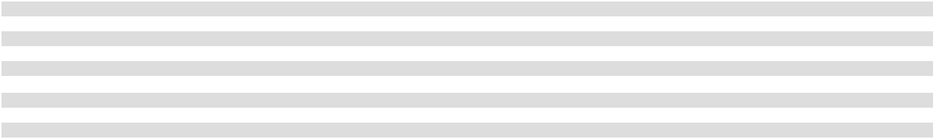

(1) For Federal tax purposes, the aggregate tax basis is approximately $2.5 billion as of December 31, 2025.

F-47

American Assets Trust, Inc. and American Assets Trust, L.P.

SCHEDULE III—Consolidated Real Estate and Accumulated Depreciation -(Continued)

(In Thousands)

 |  | Year Ended December 31,
 |  | 2025 |  |  | 2024 |  |  | 2023
Real estate assets
Balance, beginning of period | $ | 3,626,364 |  |  | 3,741,768 |  |  | 3,671,469
Additions:
Property acquisitions |  | 66,657 |  |  | — |  |  | —
Improvements |  | 80,631 |  |  | 68,484 |  |  | 78,249
Deductions:
Real estate assets held for sale |  | — |  |  | (154,134) |  |  | —
Other ⁽¹⁾ |  | (10,025) |  |  | (29,754) |  |  | (7,950)
Balance, end of period | $ | 3,763,627 | $ |  | 3,626,364 | $ |  | 3,741,768
Accumulated depreciation
Accumulated depreciation | $ | 1,038,878 | $ |  | 1,036,453 | $ |  | 936,913
Balance, beginning of period
Additions—depreciation |  | 113,109 |  |  | 111,727 |  |  | 106,306
Deductions:
Real estate assets held for sale |  | — |  |  | (80,435) |  |  | —
Other ⁽²⁾ |  | (7,728) |  |  | (28,867) |  |  | (6,766)
Balance, end of period | $ | 1,144,259 | $ |  | 1,038,878 | $ |  | 1,036,453
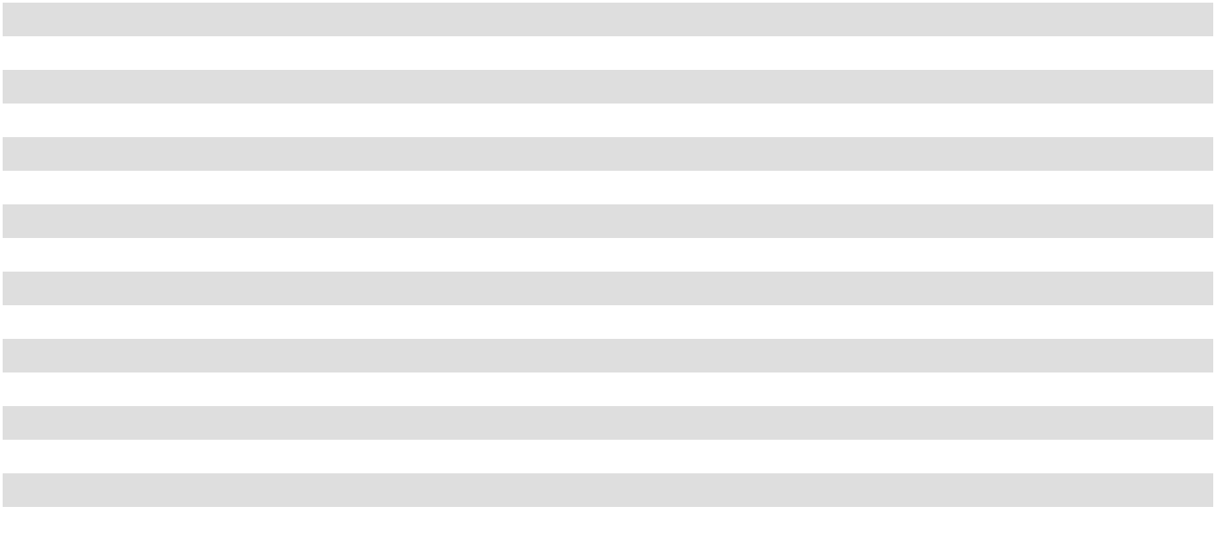

- Other deductions for the years ended December 31, 2025, 2024 and 2023 represent the write-off of fully depreciated assets and certain incomplete development costs written off.
- Other deductions for the years ended December 31, 2025, 2024 and 2023 represent the write-off of fully depreciated assets.

F-48

CORPORATE INFORMATION

NAMED EXECUTIVE OFFICERS

Ernest Rady

Executive Chairman

Adam Wyll

President and

Chief Executive Officer

Robert Barton

Executive Vice President

and Chief Financial Officer

Jerry Gammieri

Senior Vice President of

Construction and Development

BOARD OF DIRECTORS

Ernest Rady

Thomas Olinger

Joy Schaefer

Dr. Robert Sullivan

Nina Tran

CORPORATE HEADQUARTERS

3420 Carmel Mountain Road, Suite 100 San Diego, CA 92121 Phone: (858) 350-2600 Fax: (858) 350-2620

INDEPENDENT AUDITORS

Ernst & Young LLP

San Diego, CA

LEGAL COUNSEL

Latham & Watkins LLP

San Diego, CA

STOCK EXCHANGE LISTING

NYSE Symbol: AAT

REGISTRAR & TRANSFER AGENT

Equiniti Trust Company, LLC

55 Challenger Road 2nd Floor

Ridgefield Park, NJ 07660

Call Center: (800) 937-5449

equiniti.com/us/ast-access

WEBSITE

For additional information on the

Company, visit our website at

AmericanAssetsTrust.com



A HISTORY OF SUCCESS

A FUTURE OF OPPORTUNITY

3420 CARMEL MOUNTAIN ROAD, SUITE 100

SAN DIEGO, CA 92121

PHONE: (858) 350-2600 // FAX: (858) 350-2620

(NYSE: AAT)

AMERICANASSETSTRUST.COM

